
Ministry of education and science of Ukraine
Kharkiv national university of radioelectronics

INFORMATICS
for foreign students
of preparatory faculties

Kharkiv 2019
"Informatics" for foreign students of preparatory faculties/ Yu.P. Gorelov, I.V. Kobzev, V.A Lukyanova, L.Yu. Morozova – Kharkiv: NURE, 2019. – 280 p.

Authors:
Yu.P. Gorelov, PhD, Associate Professor, Department of Information Technologies and Cybersecurity of Kharkiv National University of Internal Affairs;
I.V Kobzev ,PhD, Associate Professor, Department of Natural Sciences NURE
V.A Lukyanova, PhD, Head of the Department of Natural Sciences NURE
L.Yu. Morozova, PhD, Associate Professor of the Department of Natural Sciences NURE

Peer reviewers:
Yu.G. Mashkavrov – Dr.Sc, Prof., Professor, Department of Information Technologies and Control Systems, Kharkiv Regional Institute of Public Administration, National Academy of Public Administration under the President of Ukraine;
K.E Petrov – Dr.Sc, Prof., Professor, Department of Artificial Intelligence, NURE.

CONTENTS

Preface 9
Chapter 1. Computer Basics 10
1.1 Introduction 10
1.2 Evolution of computers 12
1.3 Generations of computers 15
1.3.1 First Generation (1940 to 1956): Vacuum Tubes 15
1.3.2 Second Generation (1956 to 1963): Transistors 17
1.3.3 Third Generation (1964 to Early 1970s): Integrated Circuits 18
1.3.4 Fourth Generation (Early 1970s to Till Date): Microprocessors 19
1.3.5 Fifth Generation (Present and Beyond): Artificial Intelligence 20
1.4 Classification of computers 21
1.4.1 Microcomputers 21
1.4.2 Minicomputers 23
1.4.3 Mainframes 24
1.4.4 Supercomputers 25
1.5 The computer system 26
1.5.1 Components of a Computer System 26
1.5.2 How Does a Computer Work? 29
1.6 Applications of computers 30
Exercises 34
Chapter 2. Computer Organization and Architecture 38
2.1 Introduction 38
2.2 Central processing unit 39
2.2.1 Arithmetic/Logic Unit 39
2.2.2 Registers 40
2.2.3 Control Unit 42
2.2.4 System Bus 43
2.2.5 Main Memory Unit 45
2.2.6 Cache Memory 45
2.3 Communication among various units 47
2.3.1 Processor to Memory Communication 47
2.3.2 Processor—I/O Devices Communication 48
2.4 Instruction cycle 49
2.5 Inside a computer 52
2.5.1 Power Supply (SMPS) 53
2.5.2 Motherboard 54
2.5.3 Ports and Interfaces 56
2.5.4 Expansion Cards 57
2.5.5 Ribbon Cables 59
2.5.6 Memory Chips 59
2.5.7 Storage Devices 61
2.5.8 Processors 61
2.6 Data representation in computers 62
2.6.1 Types of Number System 63
2.6.2 Conversion Between Number Bases 66
Exercises 72
Chapter 3. Computer Memory and Storage 78
3.1 Introduction 78
3.2 Memory hierarchy 79
3.3 Random access memory 81
3.4 Read only memory 83
3.5 Types of secondary storage devices 85
3.6 Hard Disk 86
3.7 Universal serial bus (USB) 87
3.7.1 Pen Drive 88
3.7.2 External Hard Disk Drive 89
Exercises 91
Chapter 4. Input Output Media 93
4.1 Introduction 93
4.2 Types of input devices 94
4.2.1 Keyboard 95
4.2.2 Pointing Devices 96
4.2.3 Scanners 101
4.2.4 Bar Code Reader 102
4.3 Types of output devices 103
4.3.1 Printers 104
4.3.2 Plotters 109
4.3.4 Monitor 110
4.3.5 Projector 113
4.3.6 Headphone and Headset 114
Exercises 117
Chapter 5. Operating System 122
5.1 Introduction 122
5.2 Operating system: definition 122
5.3 Evolution of operating system 124
5.4 Types of operating systems 124
5.5 Functions of operating systems 125
5.5.1 Process Management 126
5.5.2 Memeory Management 127
5.5.3 File Management 129
5.5.4 Device Management 130
5.5.5 Security Management 131
5.5.6 User Interface 132
Exercises 134
Chapter 6. Overview of Microsoft Windows 7 138
6.1 Introduction 138
6.2 Different editions of windows 7 138
6.3 New style of windows 7 139
6.3.1 Aero Themes 140
6.3.2 Gadgets 142
6.3.3 Taskbar 143
6.3.4 Start Menu 145
Exercises 147
Chapter 7. Computer Programming and Languages 152
7.1 Introduction 152
7.1.1 Developing a Program 152
7.1.2 Program Development Cycle 153
7.2 Algorithm 155
7.3 Flowchart 156
7.3.1 Flowchart Symbols 157
7.3.2 Guidelines for Preparing Flowcharts 159
7.3.3 Benefits of Flowcharts 159
7.3.4 Limitations of Flowcharts 161
7.4 Decision tables 161
7.4.1 Steps to Develop a Decision Table 162
7.5 Pseudocode 163
7.5.1 Pseudocode Guidelines 164
7.5.2 Benefits of Pseudocode 165
7.5.3 Limitations of Pseudocode 165
7.6 Program control structures 165
7.6.1 Sequence Control Structure 166
7.6.2 Selection Control Structure 167
7.6.3 Repetition Control Structure 168
7.7 Characteristics of a good program 169
7.8 Programming languages 171
7.9 Generations of programming languages 171
Exercises 175
Chapter 8. Computer Sofware 178
8.1 Introduction 178
8.2 Software: definition 178
8.3 Categories of software 180
8.3.1 System Software 180
8.3.2 Application Software 185
8.4 Installing and uninstalling software 191
8.5 Software piracy 192
8.6 Software terminologies 194
Exercises 197
Chapter 9. Introduction to Microsoft Office 2007 201
9.1 Introduction 201
9.2 Introduction to office 2007 user interface 201
9.3 Microsoft office applications 207
9.3.1 Microsoft Office Word 2007 207
9.3.2 Microsoft Office Excel 2007 208
9.3.3 Microsoft Office Access 2007 209
9.3.4 Microsoft Office PowerPoint 2007 210
Exercises 212
Chapter 10. Data Communication and Computer Networks 216
10.1 Introduction 216
10.2 Data communication 217
10.2.1 Components of Data Communication 217
10.2.2 Data Transmission Mode 218
10.2.3 Analog and Digital Data Transmission 219
10.2.4 Data Communication Measurement 220
10.3 Transmission media 221
10.3.1 Guided/Wired Media 221
10.3.2 Unguided/Wireless Media 224
10.4 Computer network. Types of Computer Networks 229
10.5 Network topologies 235
10.5.1 Bus Topology 235
10.5.2 Ring Topology 236
10.5.3 Star Topology 237
10.5.4 Tree Topology 238
10.5.5 Mesh Topology 238
10.6 Communication protocol. The OSI Model 239
10.7 Network devices 242
Exercises 247
Chapter 11. The Internet 252
11.1 Introduction 252
11.2 Evolution of internet 253
11.3 Basic internet terms 254
11.4 Getting connected to the internet 260
11.5 Internet applications 263
11.5.1 Electronic Mail (E-mail) 263
11.5.2 File Transfer Protocol (FTP) 264
11.5.3 Telnet 264
11.5.4 Video Conferencing 265
11.5.5 Commerce through the Internet 267
11.6 Data over the internet 268
11.6.1 Static Component 268
11.6.2 Dynamic Component 268
Exercises 271
Bibliography 276

Preface

The term “informatics” broadly describes the study, design, and development of information technology for the good of people, organizations, and society.
The Informatics major was designed to be conceptual and practical, academic and professional, and focused on the human and humanistic dimensions of the design and use of information systems. .
The world today is witnessing a new kind of revolution—the Information Revolution—ushered in by tchnology. This revolution is far more sweeping than any other revolution in history in its reach and influence, bringing fundamental changes in all aspects of our life.
Information technology (IT) is the engine used to drive useful information systems. This includes computers, software, Internet/intranet and telecommunication systems. IT provides the means for collecting, storing, encoding, processing, analyzing, transmitting, receiving and printing text, audio or video information.
In the present context, IT is not merely the matter of machines and microchips. In fact, now it regulates all aspects of our lives including how we live, how we work, how we communicate, how we relax, how we travel and how we talk. This universal applicability of IT has made it the most important part of all technological curricula throughout the world. The future of IT promises to be more dynamic. Researches in the field of processor performance, chip miniaturization, artificial intelligence (AI) and other areas are setting up new standards every day. Keeping pace with these changing trends and to meet the requirements of modern curricula, the book has been revised.
The main objective is to teach IT concepts to people who will be the end users and to those who need some insight into IT. Our approach is to strike a balance between the why and the how of IT use.

TARGET AUDIENCE
- Primary usage as a textbook for students offered by computer science, computer engineering and IT departments in colleges and universities.
- As a self-study guide for non-computer science professionals.

Chapter 1. Computer Basics
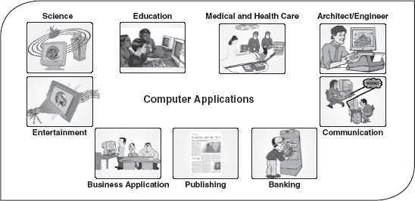

1.1 Introduction
In the beginning of the civilization, people used fingers and pebbles for computing purposes. In fact, the word digitus in Latin actually means finger and calculus means pebble. This gives a clue into the origin of early computing concepts. With the development of civilization, the computing needs also grew. The need for a mechanism to perform lengthy calculations led to the invention of, first, calculator and then computers.
The term computer is derived from the word compute, which means to calculate. A computer is an electronic machine devised for performing calculations and controlling operations that can be expressed either in logical or in numerical terms. In simple words, a computer is an electronic device that performs diverse operations with the help of instructions to process the data in order to achieve desired results. Although the application domain of a computer depends totally on human creativity and imagination, it covers a huge area of applications including education, industries, government, medicine, scientific research, law, and even music and arts.
Computers are one of the most influential forces available in modern times. Harnessing the power of computers enables relatively limited and fallible human capacities for memory, logical decision making, reaction and perfection to be extended to almost infinite levels. Millions of complex calculations can be done in a mere fraction of time; difficult decisions can be made with unerring accuracy for comparatively little cost. Computers are widely seen as instruments for future progress and as tools to achieve sustainability by way of improved access to information with the help of video-conferencing and e-mail. Indeed, computers have left such an impression on modern civilization that we call this era as the “information age”.
Characteristics of Computers
The human race developed computers so that it could perform intricate operations, such as calculation and data processing, or simply for entertainment. Today, much of the world'sinfrastructure runs on computers and it has profoundly changed our lives, mostly for the better. Let us discuss some of the characteristics of computers, which make them an essential part of every emerging technology and such a desirable tool in human development.
- Speed: The computers process data at an extremely fast rate, at millions or billions of instructions per second. A computer can perform a huge task in a few seconds that otherwise a normal human being may take days or even years to complete. The speed of a computer is calculated in MHz (megahertz), that is, one million instructions per second. At present, a powerful computer can perform billions of operations in just one second.
- Accuracy: Besides the efficiency, the computers are also very accurate. The level of accuracy depends on the instructions and the type of machines being used. Since the computer is capable of doing only what it is instructed to do, faulty instructions for data processing may lead to faulty results. This is known as Garbage In Garbage Out (GIGO).
- Diligence: Computer, being a machine, does not suffer from the human traits of tiredness and lack of concentration. If four million calculations have to be performed, then the computer will perform the last four-millionth calculation with the same accuracy and speed as the first calculation.
- Reliability: Generally, reliability is the measurement of the performance of a computer, which is measured against some predetermined standard for operation without any failure. The major reason behind the reliability of the computers is that, at hardware level, it does not require any human intervention between its processing operations. Moreover, computers have built-in diagnostic capabilities, which help in the continuous monitoring of the system.
- Storage Capability: Computers can store large amounts of data and can recall the required information almost instantaneously. The main memory of the computer is relatively small and it can hold only a certain amount of data; therefore, the data are stored on secondary storage devices such as magnetic tape or disks. Small sections of data can be accessed very quickly from these storage devices and brought into the main memory, as and when required, for processing.
- Versatility: Computers are quite versatile in nature. It can perform multiple tasks simultaneously with equal ease. For example, at one moment it can be used to draft a letter, another moment it can be used to play music and in between, one can print a document as well. All this work is possible by changing the program (computer instructions).
- Resource Sharing: In the initial stages of development, computers used to be isolated machines. With the tremendous growth in computer technologies, computers today have the capability to connect with each other. This has made the sharing of costly resources like printers possible. Apart from device sharing, data and information can also be shared among groups of computers, thus creating a large information and knowledge base.

1.2 Evolution of computers
The need for a device to do calculations along with the growth in commerce and other human activities explains the evolution of computers. Having the right tool to perform these tasks has always been important for human beings. In their quest to develop efficient computing devices, humankind developed many apparatuses. However, many centuries elapsed before technology was adequately advanced to develop computers.
In the beginning, when the task was simply counting or adding, people used either their fingers or pebbles along lines in the sand. In order to conveniently have the sand and pebbles all the time, people in Asia Minor built a counting device called abacus. This device allowed users to do calculations using a system of sliding beads arranged on a rack. The abacus was simple to operate and was used worldwide for centuries. In fact, it is still used in many countries (Figure 1.1).
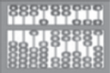
Figure 1.1 Abacus

With the passage of time, humankind invented many computing devices, such as Napier bones and slide rule. It took many centuries, however, for the next significant advancement in computing devices. In 1642, a French mathematician, Blaise Pascal, invented the first functional automatic calculator. This brass rectangular box, also called a Pascaline, used eight movable dials to add numbers up to eight figures long (Figure 1.2).

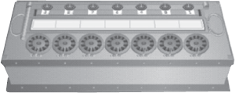
Figure 1.2 Pascaline

In 1694, a German mathematician, Gottfried Wilhem von Leibniz, extended Pascal's design to perform multiplication, division and to find square root. This machine is known as the Stepped Reckoner. It was the first mass-produced calculating device, which was designed to perform multiplication by repeated addition. Like its predecessor, Leibniz's mechanical multiplier worked by a system of gears and dials. The only problem with this device was that it lacked mechanical precision in its construction and was not very reliable.
The real beginning of computers as we know them today, however, lay with an English mathematics professor, Charles Babbage. In 1822, he proposed a machine to perform differential equations, called a Difference Engine. Powered by steam and as large as a locomotive, the machine would have a stored program and could perform calculations and print the results automatically. However, Babbage never quite made a fully functional difference engine and in 1833 he quitted working on this machine to concentrate on the Analytical Engine. The basic design of this engine included input devices in the form of perforated cards containing operating instructions and a “store” for memory of 1,000 numbers of up to 50 decimal digits long. It also contained a control unit to allow processing instructions in any sequence and output devices to produce printed results. Babbage borrowed the idea of punch cards to encode the machine's instructions from Joseph-Marie Jacquard's loom. Although the analytical engine was never constructed, it outlined the basic elements of a modern computer.
In 1889, Herman Hollerith, who worked for the US Census Bureau, also applied Jacquard's loom concept to computing. Unlike Babbage's idea of using perforated cards to instruct the machine, Hollerith's method used cards to store the data, which he fed into a machine that compiled the results mechanically (Figure 1.3).

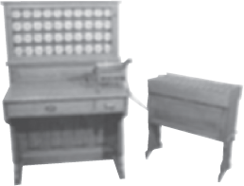
Figure 1.3 Hollerith's Tabulator

The start of World War II produced a substantial need for computer capacity, especially for military purposes. One early success was the Mark I, which was built as a partnership between Harvard Aiken and IBM in 1944. This electronic calculating machine used relays and electromagnetic components to replace mechanical components. In 1946, John Eckert and John Mauchly of the Moore School of Engineering at the University of Pennsylvania developed the Electronic Numerical Integrator and Calculator (ENIAC). This computer used electronic vacuum tubes to make the internal parts of the computer. It embodied almost all the components and concepts of today's high-speed, electronic computers. Later on, Eckert and Mauchly also proposed the development of the Electronic Discrete Variable Automatic Computer (EDVAC). It was the first electronic computer to use the stored program concept introduced by John Von Neumann. It also had the capability of conditional transfer of control, that is, the computer could stop any time and then resume operations. In 1949, at theCambridge University, a team headed by Maurice Wilkes developed the Electronic Delay Storage Automatic Calculator (EDSAC), which was also based on John Von Neumann's stored program concept. This machine used mercury delay lines for memory and vacuum tubes for logic. The Eckert–Mauchly Corporation manufactured the Universal Automatic Computer (UNIVAC) in 1951 and its implementation marked the real beginning of the computer era.
In the 1960s, efforts to design and develop the fastest possible computer with the greatest capacity reached a turning point with the Livermore Advanced Research Computer (LARC), which had access time of less than 1 μs (pronounced as microsecond) and the total capacity of 100,000,000 words. During this period, the major computer manufacturers began to offer a range of capabilities and prices, as well as accessories such as card feeders, page printers and cathode ray tube displays. During the 1970s, the trend shifted towards a larger range of applications for cheaper computer systems. During this period, many business organizations adopted computers for their offices. The vacuum deposition of transistors became the norm and entire computer assemblies became available on tiny “chips”.
In the 1980s, Very Large Scale Integration (VLSI) design, in which hundreds of thousands of transistors were placed on a single chip, became increasingly common. The “shrinking” trend continued with the introduction of personal computers (PCs), which are programmable machines small enough and inexpensive enough to be purchased and used by individuals. Microprocessors equipped with the read-only memory (ROM), which stores constantly used and unchanging programs, performed an increased number of functions. By the late 1980s, some PCs were run by microprocessors that were capable of handling 32 bits of data at a time and processing about 4,000,000 instructions per second. By the 1990s, PCs became part of everyday life. This transformation was the result of the invention of the microprocessor, a processor on a singleintegrated circuit (IC) chip. The trend continued leading to the development of smaller and smaller microprocessors with a proportionate increase in processing powers. The computer technology continues to experience huge growth. Computer networking, electronic mail and electronic publishing are just a few applications that have grown in recent years. Advances in technologies continue to produce cheaper and more powerful computers, offering the promise that in the near future, computers or terminals will reside in most, if not all, homes, offices and schools.

1.3 Generations of computers
The history of computer development is often discussed with reference to the different generations of computing devices. In computer terminology, the word generation is described as a stage of technological development or innovation. A major technological development that fundamentally changed the way computers operate, resulting in increasingly smaller, cheaper, more powerful, and more efficient and reliable devices, characterizes each generation of computers. According to the type of “processor” installed in a machine, there are five generations of computers.

1.3.1 First Generation (1940 to 1956): Vacuum Tubes
First-generation computers were vacuum tubes/thermionic valve-based machines. These computers used vacuum tubes for circuitry and magnetic drums for memory. A magnetic drum is a metal cylinder coated with magnetic iron oxide material on which data and programs can be stored. The input was based on punched cards and paper tape, and the output was in the form of printouts (Figure 1.4).

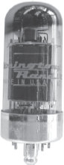
Figure 1.4 Vacuum Tube

First-generation computers relied on binary-coded language also called machine language(language of 0s and 1s) to perform operations and were able to solve only one problem at a time. Each machine was fed with different binary codes and hence, were difficult to program. This resulted in lack of versatility and speed. In addition, to run on different types of computers, instructions must be rewritten or recompiled.

Characteristics of First-generation Computers
- These computers were based on vacuum tube technology.
- These were the fastest computing devices of their times (computation time was in milliseconds).
- These computers were very large and required a lot of space for installation.
- Since thousands of vacuum tubes were used, they generated a large amount of heat. Therefore, air conditioning was essential.
- These were non-portable and very slow equipments.
- They lacked in versatility and speed.
- They were very expensive to operate and used a large amount of electricity.
- These machines were unreliable and prone to frequent hardware failures. Hence, constant maintenance was required.
- Since machine language was used, these computers were difficult to program and use.
- Each individual component had to be assembled manually. Hence, commercial appeal of these computers was poor.

1.3.2 Second Generation (1956 to 1963): Transistors
Second-generation computers used transistors, which were superior to vacuum tubes. A transistor is made up of semiconductor material like germanium and silicon. It usually has three leads (see Figure 1.5) and performs electrical functions such as voltage, current or power amplification with low power requirements. Since a transistor is a small device, the physical size of computers was greatly reduced. Computers became smaller, faster, cheaper, energy efficient and more reliable than their predecessors. In second-generation computers, magnetic cores were used as the primary memory and magnetic disks as the secondary storage devices. However, they still relied on punched cards for the input and printouts for the output.


Figure 1.5 Transistor

One of the major developments of this generation includes the progress from machine language to assembly language. Assembly language uses mnemonics (abbreviations) for instructions rather than numbers, for example, ADD for addition and MULT for multiplication. As a result, programming became less cumbersome. Early high-level programming languages such as COBOL and FORTRAN also came into existence in this period.

Characteristics of Second-generation Computers
- These machines were based on transistor technology.
- These were smaller as compared to the first-generation computers.
- The computational time of these computers was reduced to microseconds from milliseconds.
- These were more reliable and less prone to hardware failure. Hence, they required less frequent maintenance.
- These were more portable and generated less amount of heat.
- Assembly language was used to program computers. Hence, programming became more time-efficient and less cumbersome.
- Second-generation computers still required air conditioning.
- Manual assembly of individual components into a functioning unit was still required.

1.3.3 Third Generation (1964 to Early 1970s): Integrated Circuits
The development of the integrated circuit, also called an IC, was the trait of the third-generation computers. An IC consists of a single chip (usually silicon) with many components such as transistors and resistors fabricated on it. ICs replaced several individually wired transistors. This development made computers smaller in size, reliable and efficient (Figure 1.6).

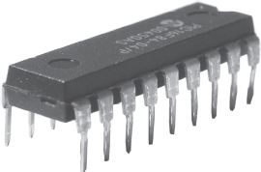
Figure 1.6 Integrated Circuit

Instead of punched cards and printouts, users interacted with third-generation computers through keyboards and monitors, and interfaced with the operating system. This allowed the device to run many different applications simultaneously with a central program that monitored the memory. For the first time, computers became accessible to mass audience because they were smaller and cheaper than their predecessors.

Characteristics of Third-generation Computers
- These computers were based on IC technology.
- These were able to reduce the computational time from microseconds to nanoseconds.
- These were easily portable and more reliable than the second-generation computers.
- These devices consumed less power and generated less heat. In some cases, air conditioning was still required.
- The size of these computers was smaller as compared to previous-generation computers.
- Since hardware rarely failed, the maintenance cost was quite low.
- Extensive use of high-level languages became possible.
- Manual assembling of individual components was not required, so it reduced the large requirement of labour and cost. However, highly sophisticated technologies were required for the manufacturing of IC chips.
- Commercial production became easier and cheaper.

1.3.4 Fourth Generation (Early 1970s to Till Date): Microprocessors
The fourth generation is an extension of third generation technology. Although, the technology of this generation is still based on the IC, these have been made readily available to us because of the development of the microprocessor (circuits containing millions of transistors). The Intel 4004 chip, which was developed in 1971, took the IC one step further by locating all the components of a computer (CPU, memory and I/O controls) on a minuscule chip. A microprocessor is built on to a single piece of silicon, known as chip. It is about 0.5 cm along one side and no more than 0.05 cm thick.
The fourth-generation computers led to an era of Large Scale Integration (LSI) and VLSI technology. LSI technology allowed thousands of transistors to be constructed on one small slice of silicon material, whereas VLSI squeezed hundreds of thousands of components on to a single chip. Ultra Large Scale Integration (ULSI) increased that number to the millions. This way computers became smaller and cheaper than ever before (Figure 1.7).
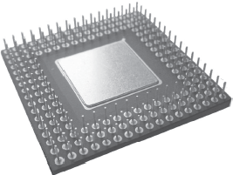
Figure 1.7 Microprocessor

The fourth-generation computers became more powerful, compact, reliable and affordable. As a result, it gave rise to the PC revolution. During this period, magnetic core memories were substituted by semiconductor memories, which resulted in faster random access main memories. Moreover, secondary memories such as hard disks became economical, smaller and bigger in capacity. The other significant development of this era was that these computers could be linked together to form networks, which eventually led to the development of the Internet. This generation also saw the development of the Graphical User Interfaces (GUIs), mouse and handheld devices. Despite many advantages, this generation required complex and sophisticated technology for the manufacturing of the CPU and the other components.

Characteristics of Fourth-generation Computers
- These computers are microprocessor-based systems.
- These are very small in size.
- These are the cheapest among all the other generation computers.
- These are portable and quite reliable.
- These machines generate negligible amount of heat, hence do not require air conditioning.
- Hardware failure is negligible so minimum maintenance is required.
- The production cost is very low.
- The GUI and pointing devices enabled users to learn to use the computer quickly.
- Interconnection of computers led to better communication and resource sharing.

1.3.5 Fifth Generation (Present and Beyond): Artificial Intelligence
The dream of creating a human-like computer that would be capable of reasoning and reaching at a decision through a series of “what-if-then” analyses has existed since the beginning of computer technology. Such a computer would learn from its mistakes and possess the skill of experts. These are the objectives for creating the fifth generation of computers. The starting point for the fifth generation of computers had been set in the early 1990s. The process of developing fifth-generation computers is still in the development stage. However, the expert system concept is already in use. Theexpert system is defined as a computer system that attempts to mimic the thought process and reasoning of experts in specific areas. Three characteristics can be identified with the fifth-generation computers. These are:
Mega Chips: Fifth-generation computers will use Super Large Scale Integrated (SLSI) chips, which will result in the production of microprocessors having millions of electronic components on a single chip. In order to store instructions and information, fifth-generation computers require a great amount of storage capacity. Mega chips may enable the computer to approximate the memory capacity of the human mind.
Parallel Processing: Computers with one processor access and execute only one instruction at a time. This is called serial processing. However, fifth-generation computers will use multiple processors and perform parallel processing, thereby accessing several instructions at once and working on them at the same time.
Artificial Intelligence (AI): It refers to a series of related technologies that try to simulate and reproduce human behavior, including thinking, speaking and reasoning. AI comprises a group of related technologies: expert systems (ES), natural language processing (NLP), speech recognition, vision recognition and robotics.

1.4 Classification of computers
These days, computers are available in many sizes and types. Some computers can fit in the palm of the hand, while some can occupy the entire room. Computers also differ based on their data-processing abilities. Based on the physical size, performance and application areas, we can generally divide computers into four major categories: micro, mini, mainframe and supercomputers (Figure 1.8).

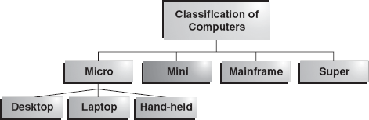

Figure 1.8 Classification of Computers

1.4.1 Microcomputers
A microcomputer is a small, low-cost digital computer, which usually consists of a microprocessor, a storage unit, an input channel and an output channel, all of which may be on one chip inserted into one or several PC boards. The addition of power supply and connecting cables, appropriate peripherals (keyboard, monitor, printer, disk drives and others), an operating system and other software programs can provide a complete microcomputer system. The micro-computer is generally the smallest of the computer family. Originally, these were designed for individual users only, but nowadays they have become powerful tools for many businesses that, when networked together, can serve more than one user. IBM-PC Pentium 100, IBM-PC Pentium 200 and Apple Macintosh are some of the examples of microcomputers. Microcomputers include desktop, laptop and hand-heldmodels such as Personal Digital Assistants (PDAs).
Desktop Computer: The desktop computer, also known as the PC, is principally intended for stand-alone use by an individual. These are the most-common type of microcomputers. These microcomputers typically consist of a system unit, a display monitor, a keyboard, an internal hard disk storage and other peripheral devices. The main reason behind the importance of the PCs is that they are not very expensive for the individuals or the small businesses. Some of the major PC manufacturers are APPLE, IBM, Dell and Hewlett-Packard (Figure 1.9).

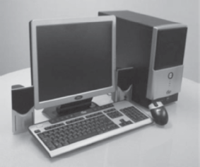
Figure 1.9 Desktop Computer

Laptop: A laptop is a portable computer that a user can carry around. Since the laptop resembles a notebook, it is also known as the notebook computer. Laptops are small computers enclosing all the basic features of a normal desktop computer. The biggest advantage of laptops is that they are lightweight and one can use them anywhere and at anytime, especially when one is travelling. Moreover, they do not need any external power supply as a rechargeable battery is completely self-contained in them. However, they are expensive as compared to desktop computers (Figure 1.10).

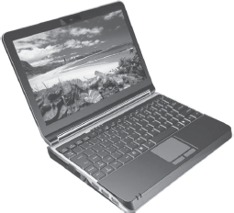
Figure 1.10 Laptop

Hand-held Computers: A hand-held computer such as a PDA is a portable computer that can conveniently be stored in a pocket (of sufficient size) and used while the user is holding it. PDAs are essentially small portable computers and are slightly bigger than the common calculators. A PDA user generally uses a pen or electronic stylus, instead of a keyboard for input. As shown in (Figure 1.11), the monitor is very small and is the only apparent form of output. Since these computers can be easily fitted on the top of the palm, they are also known as palmtop computers. Handheld computers usually have no disk drive; rather, they use small cards to store programs and data. However, they can be connected to a printer or a disk drive to generate output or store data. They have limited memory and are less powerful as compared to desktop computers. Some examples of hand-held computers are Apple Newton, Casio Cassiopeia and Franklin eBookMan.

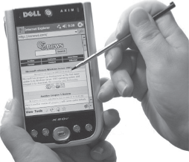
Figure 1.11 Personal Digital Assistant

1.4.2 Minicomputers
In the early 1960s, Digital Equipment Corporation (DEC) started shipping its PDP series computer, which the press described and referred to as minicomputers. A minicomputer is a small digital computer, which normally is able to process and store less data than a mainframe but more than a microcomputer, while doing so less rapidly than a mainframe but more rapidly than a microcomputer. It is about the size of a two-drawer filing cabinet. Generally, these computers are used as desktop devices that are often connected to a mainframe in order to perform the auxiliary operations (Figure 1.12).

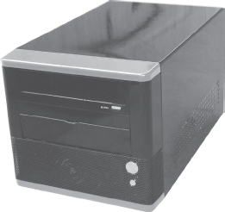
Figure 1.12 Minicomputer

A minicomputer (sometimes called a mid-range computer) is designed to meet the computing needs of several people simultaneously in a small- to medium-sized business environment. It is capable of supporting from four to about 200 simultaneous users. It serves as a centralized storehouse for a cluster of workstations or as a network server. Minicomputers are usually multi-user systems so these are used in interactive applications in industries, research organizations, colleges and universities. They are also used for real-time controls and engineering design work. Some of the widely used minicomputers are PDP 11, IBM (8000 series) and VAX 7500.

1.4.3 Mainframes
A mainframe is an ultra-high performance computer made for high-volume, processor-intensive computing. It consists of a high-end computer processor, with related peripheral devices, capable of supporting large volumes of data processing, high-performance online transaction processing, and extensive data storage and retrieval. Normally, it is able to process and store more data than a minicomputer and far more than a microcomputer. Moreover, it is designed to perform at a faster rate than a minicomputer and at even more faster rate than a microcomputer. Mainframes are the second largest (in capability and size) of the computer family, the largest being the supercomputers. However, mainframes can usually execute many programs simultaneously at a high speed, whereas supercomputers are designed for a single process (Figure 1.13).

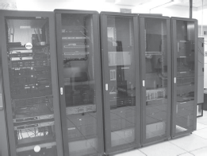
Figure 1.13 Mainframe

The mainframe allows its users to maintain a large amount of data storage at a centralized location and to access and process these data from different computers located at different locations. It is typically used by large businesses and for scientific purposes. Some examples of the mainframe are IBM's ES000, VAX 8000 and CDC 6600.

1.4.4 Supercomputers
Supercomputers are the special-purpose machines, which are especially designed to maximize the numbers of floating point operations per second (FLOPS). Any computer below one gigaflop per second is not considered a supercomputer. A supercomputer has the highest processing speed at a given time for solving scientific and engineering problems. Essentially, it contains a number of CPUs that operate in parallel to make it faster. Its processing speed lies in the range 400–10,000 MFLOPS (millions of floating point operations per second). Due to this feature, supercomputers help in many applications including information retrieval and computer-aided designing (Figure 1.14).

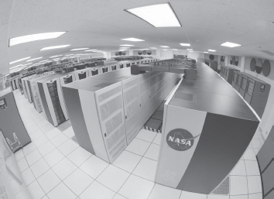
Figure 1.14 Supercomputer

A supercomputer can process a great deal of data and make extensive calculations very quickly. It can resolve complex mathematical equations in a few hours, which would have taken many years when performed using a paper and pencil or using a hand calculator. It is the fastest, costliest and most powerful computer available today. Typically, supercomputers are used to solve multivariant mathematical problems of existent physical processes, such as aerodynamics, metrology and plasma physics. They are also required by the military strategists to simulate defence scenarios. Cinematic specialists use them to produce sophisticated movie animations. Scientists build complex models and simulate them in a supercomputer. However, a supercomputer has limited broad-spectrum use because of its price and limited market. The largest commercial uses of supercomputers are in the entertainment/advertising industry. CRAY-3, Cyber 205 and PARAM are some well-known supercomputers.

1.5 The computer system
A computer can be viewed as a system, which consists of a number of interrelated components that work together with the aim of converting data into information. In a computer system, processing is carried out electronically, usually with little or no intervention from the user.
The general perception of people regarding the computer is that it is an “intelligent thinking machine”. However, this is not true. Every computer needs to be instructed exactly what to do and how to do. The instructions given to computers are called programs. Without programs, computerswould be useless. The physical parts that make up a computer (the CPU, input, output and storage unit) are known as hardware. Any hardware device connected to the computer or any part of the computer outside the CPU and working memory is known as a peripheral. Some examples of peripherals are keyboards, mouse and monitors.

1.5.1 Components of a Computer System
There are several computer systems in the market with a wide variety of makes, models and peripherals. In general, a computer system comprises the following components:
- CPU: This unit performs processing of instructions and data inside the computer.
- Input Unit: This unit accepts instructions and data.
- Output Unit: This unit communicates the results to the user.
- Storage Unit: This unit stores temporary and final results (Figure 1.15).

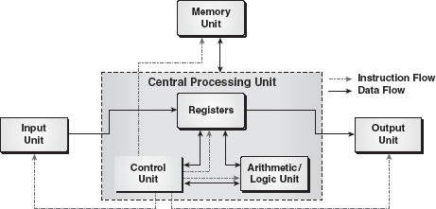

Figure 1.15 Components of a Computer System

Central Processing Unit: The CPU, also known as a processor, is the brain of the computer system that processes data (input) and converts it into meaningful information (output). It is referred to as the administrative section of the computer system that interprets the data and instructions, coordinates the operations, and supervises the instructions. The CPU works with data in discrete form, that is, either 1 or 0. It counts, lists, compares and rearranges the binary digits of data in accordance with the detailed program instructions stored within the memory. Eventually, the results of these operations are translated into characters, numbers and symbols that can be understood by the user. The CPU itself has three parts:
Arithmetic Logic Unit (ALU): This unit performs the arithmetic (add, subtract) and logical operations (and, or) on the data made available to it. Whenever an arithmetic or logical operation is to be performed, the required data are transferred from the memory unit to the ALU, the operation is performed and the result is returned to the memory unit. Before the completion of the processing, data may need to be transferred back and forth several times between these two sections.
Control Unit: This unit checks the correctness of the sequence of operations. It fetches the program instructions from the memory unit, interprets them and ensures correct execution of the program. It also controls the I/O devices and directs the overall functioning of the other units of the computer.
Registers: These are the special-purpose, high-speed temporary memory units that can hold varied information such as data, instructions, addresses and intermediate results of calculations. Essentially, they hold the information that the CPU is currently working on. The registers can be considered as the CPU's working memory, an additional storage location that provides the advantage of speed.
Note: The circuits necessary to create a CPU for a PC are fabricated on a microprocessor.
Input, Output and Storage Unit: The user must enter instructions and data into the computer system before any operation can be performed on the given data. Similarly, after processing the data, the information must go out from the computer system to the user. For this, every computer system incorporates the I/O unit that serves as a communication medium between the computer system and the user.
An input unit accepts instructions and data from the user with the help of input devices such as keyboard, mouse, light pen, etc. Since the data and instructions entered through different input devices will be in different form, the input unit converts them into the form that the computer can understand. After this, the input unit supplies the converted instructions and data to the computer for further processing.
The output unit performs just opposite to that of input unit. It accepts the output (which is in machine-coded form) produced by the computer, converts them into the user-understandable form and supplies the converted results to the user with the help of an output device such as printer, monitor and plotter.
Besides, a computer system incorporates a storage unit to store the input entered through the input unit before processing starts and to store the results produced by the computer before supplying them to the output unit. The storage unit of a computer comprises two types of memory/storage:primary and secondary. The primary memory, also called the main memory, is the part of a computer that holds the instructions and data currently being processed by the CPU, the intermediate results produced during the course of calculations and the recently processed data. While the instructions and data remain in the main memory, the CPU can access them directly and quickly. However, the primary memory is quite expensive and has a limited storage capacity.
Due to the limited size of the primary memory, a computer employs the secondary memory, which is extensively used for storing data and instructions. It supplies the stored information to the other units of the computer as and when required. It is less expensive and has higher storage capacity than the primary memory. Some commonly used secondary storage devices are floppy disks, hard disks and tape drives (Figure 1.16).

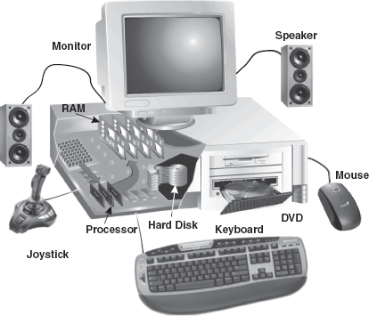
Figure 1.16 Typical Hardware and Peripherals in a Computer System

1.5.2 How Does a Computer Work?
A computer performs three basic steps to complete any task: input, processing and output. A task is assigned to a computer in a set of step-by-step instructions, which is known as a program. These instructions tell the computer what to do with the input in order to produce the required output. A computer functions in the following manner:

Step 1 | The computer accepts the input. The computer input is whatever entered or fed into a computer system. The input can be supplied by the user (such as by using a keyboard) or by another computer or device (such as a diskette or CD-ROM). Some examples of input include the words and symbols in a document, numbers for a calculation, instructions for completing a process, and so on.
Step 2 | The computer processes the data. During this stage, the computer follows the instructions using the data that have been input. Examples of processing include calculations, sorting lists of words or numbers and modifying documents according to user instructions.
Step 3 | The computer produces output. Computer output is the information that has been produced by a computer. Some examples of computer output include reports, documents and graphs. Output can be in several formats, such as printouts, or displayed on the screen (Figure 1.17).
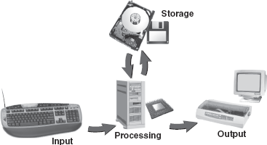
Figure 1.17 Basic Computer Operations

1.6 Applications of computers
In the last few decades, computer technology has revolutionized the businesses and other aspects of human life all over the world. Practically, every company, large or small, is now directly or indirectly dependent on computers for data processing. Computer systems also help in the efficient operation of railway and airway reservation, hospital records, accounts, electronic banking and so on. Computers not only save time, but also save paper work. Some of the areas where computers are being used are listed below.
Science: Scientists have been using computers to develop theories, to analyse and to test the data. The fast speed and the accuracy of the computer allow different scientific analyses to be carried out. They can be used to generate detailed studies of how earthquakes affect buildings or pollution affects weather pattern. Satellite-based applications would not have been possible without the use of computers. It would also not be possible to get the information of our solar system and the cosmos without computers.
Education: Computers have also revolutionized the whole process of education. Currently, the classrooms, libraries and museums are utilizing computers to make the education much more interesting. Unlike recorded television shows, computer-aided education (CAE) and computer-based training (CBT) packages are making learning much more interactive.
Medicine and Healthcare: There has been an increasing use of computers in the field of medicine. Now, doctors are using computers right from diagnosing the illness to monitoring a patient's status during complex surgery. By using automated imaging techniques, doctors are able to look inside a person's body and can study each organ in detail (such as CAT scans or MRI scans), which was not possible few years ago. There are several examples of special-purpose computers that can operate within the human body such as a cochlear implant, a special kind of hearing aid that makes it possible for deaf people to hear.
Engineering/Architecture/Manufacturing: The architects and engineers are extensively using computers in designing and drawings. Computers can create objects that can be viewed from all the three dimensions. By using techniques like virtual reality, architects can explore houses that have been designed but not built. The manufacturing factories are using computerized robotic arms in order to perform hazardous jobs. Besides, computer-aided manufacturing (CAM) can be used in designing the product, ordering the parts and planning production. Thus, computers help in coordinating the entire manufacturing process.
Entertainment: Computers are finding greater use in the entertainment industry. They are used to control the images and sounds. The special effects, which mesmerize the audience, would not have been possible without the computers. In addition, computerized animation and colourful graphics have modernized the film industry.
Communication: E-mail or electronic mail is one of the communication media in which computers are used. Through an e-mail, messages and reports are passed from one person to one or more persons with the aid of computers and telephone lines. The advantage of this service is that while transferring the messages it saves time, avoids wastage of paper, and so on. Moreover, the person who is receiving the messages can read the messages whenever he is free and can save it, reply it, forward it or delete it from the computer.
Business Application: This is one of the important uses of the computer. Initially, computers were used for batch processing jobs, where one does not require the immediate response from the computer. Currently, computers are mainly used for real-time applications (like at the sales counter) that require immediate response from the computer. There are various concerns for which computers are used such as in business forecasting, to prepare pay bills and personal records, in banking operations and data storage, in various types of life insurance business, and as an aid to management. Businesses are also using the networking of computers, where a number of computers are connected together to share the data and the information. Use of an e-mail and the Internet has changed the ways of doing business.
Publishing: Computers have created a field known as Desktop Publishing (DTP). In DTP, with the help of a computer and a laser printer one can perform the publishing job all by oneself. Many of the tasks requiring long manual hours, such as making a table of contents and an index, can be automatically performed using the computers and DTP software.
Banking: In the field of banking and finance, computers are extensively used. People can use the Automated Teller Machine (ATM) services 24 hours a day in order to deposit and withdraw cash. When the different branches of the bank are connected through the computer networks, the inter-branch transactions, such as drawing cheques and making drafts, can be performed by the computers without any delay (Figure 1.18).

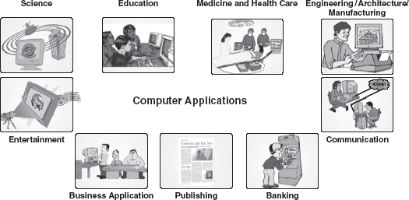

Figure 1.18 Application Areas of Computer

LET US SUMMARIZE
- Computer is an electronic device that performs diverse operations with the help of instructions to process the data in order to achieve desired results. Speed, accuracy, reliability, versatility, diligence, storage capability and resource sharing characterize the computers.
- Many devices, which humans developed for their computing requirements, preceded computers. Some of those devices were Sand Tables, Abacus, Napier Bones, Slide Rule, Pascaline, Stepped Reckoner, Difference Engine, Analytical Engine and Hollerith's Tabulator.
- Computer development is divided into five main generations. With every generation, computer technology has fundamentally changed, resulting in an increasingly smaller, cheaper, more powerful, more efficient and reliable devices.
- First-generation computers were vacuum tube based machines. These computers were very large, required a lot of space for installation, generated a large amount of heat were non-portable and have very slow equipments. In addition, these machines were unreliable and prone to frequent hardware failures.
- Second-generation computers used transistors in place of vacuum tubes. Since a transistor is a small device, the physical size of computers was greatly reduced. Computers became smaller, faster, cheaper, energy-efficient and more reliable than their predecessors.
- Third-generation computers were IC-based machines. The IC replaced several individually wired transistors, making computers smaller in size, reliable and efficient.
- Fourth-generation computers use microprocessors (circuits containing millions of transistors) as their basic processing device. These computers are the most powerful, compact, reliable and affordable as compared to their predecessors.
- Fifth-generation computers are still in the development stage. These computers will use megachips, which will result in the production of microprocessors having millions of electronic components on a single chip. They will use intelligent programming (AI) and knowledge-based problem-solving techniques.
- A microcomputer is a small, low-cost digital computer, which usually consists of a microprocessor, a storage unit, and an input and output channel, all of which may be on one chip inserted into one or several PC boards. Microcomputers include desktop, laptop and hand-held models, such as PDAs.
- A minicomputer is a small digital computer, which normally is able to process and store less data than a mainframe but more than a microcomputer, while doing so less rapidly than a mainframe but more rapidly than a microcomputer.
- A mainframe is an ultrahigh performance computer made for high-volume, processor-intensive computing. It is capable of supporting large volumes of data processing, high-performance online transaction processing, and extensive data storage and retrieval.
- Supercomputers are the special-purpose machines, which are specifically designed to maximize the number of FLOPS. Any computer below one gigaflop per second is not considered as a supercomputer.
- A computer can be viewed as a system that comprises several units (CPU, input unit, output unit and storage unit). These individual units work together to convert data into information.
- The CPU interprets, coordinates the operations and supervises the instructions. It has three parts: ALU, CU and registers. The ALU performs arithmetic (add, subtract) and logical operations (and, or) on the stored numbers. The CU checks the correctness of the sequence of operations, controls the I/O devices and directs the overall functioning of the other units of the computer. The registers are special-purpose, high-speed temporary memory units that can hold varied information such as data, instructions, addresses and intermediate results of calculations.
- The input unit involves the receipt of data or instructions from the user, in a computer acceptable form. The computer takes in the data through input devices like keyboard, mouse, light pen, etc.
- The output unit supplies the resulting data obtained from the data processing to the user. Monitors, printers and plotters are some of the examples of output devices.

Exercises

Fill in the Blanks
- The basic component of first-generation computers was ..................
- The speed of a computer is calculated in ..................
- Third-generation computers were .................. based machines.
- Keyboard is an .................. device.
- Laptops are also known as ..................
- Computers can be classified as .................., .................., .................. and .................. computers.
- A computer performs three basic steps to complete any task, which are .................., .................. and ..................
- PDA stands for ...................................................
- The CPU consists of .................., .................. and ..................
- Physical components on which the data are stored permanently are called ..................

Multiple-choice Questions
- The development of computers can be divided ............ into generations.
  - 3
  - 4
  - 5
  - 6
- Choose the odd one out.
  - Microcomputer
  - Minicomputer
  - Supercomputer
  - Digital computer
- .................. is a very small computer that can be held in the palm of the hand.
  - PDA
  - PC
  - Laptop
  - Minicomputer
- Analytical engine was developed by ..................
  - Gottfried Wilhem Von Leibriz
  - Charles Babbage
  - Herman Hollerith
  - Joseph-Marie Jacquard
- The main distinguishing feature of fifth-generation computers will be ..................
- Liberal use of microprocessors
- Artificial Intelligence
- Extremely low cost
- Versatility
- The computer that is not considered as a portable computer is ..................
  - Laptop
  - PDA
  - Minicomputer
  - None of these
- The CPU stands for ..................
  - Central protection unit
  - Central processing unit
  - Central power unit
  - Central prerogative unit
- UNIVAC is an example of ..................
  - First-generation computer
  - Second-generation computer
  - Third-generation computer
  - Fourth-generation computer
- The unit that performs the arithmetic and logical operations on the stored numbers is known as ..................
  - Arithmetic logic unit
  - Control unit
  - Memory unit
  - Both (a) and (b)
- The .................. is the “administrative” section of the computer system.
  - Input unit
  - Output unit
  - Memory unit
  - Central processing unit

State True or False
- The ALU is responsible for performing the arithmetic and logical operations.
- Microcomputers are more powerful than minicomputers.
- Laptop is also known as a notebook.
- Vacuum tubes were a part of third-generation computers.
- EDVAC was a second-generation computer.
- LSI and VLSI technology are part of fifth-generation computers.
- A laptop is a portable computer.
- Primary memory and main memory are synonyms.
- Computer development is divided into four main generations.
- PARAM is an example of a portable computer.

Descriptive Questions
- Discuss the characteristics of computers.
- What are the advantages of transistors over vacuum tubes?
- Discuss various types of computers in detail.
- List out various applications of computers.
- Discuss various computer generations along with the key characteristics of the computers of each generation.
- Discuss the basic organization of a computer system and explain the functions of various units of a computer system.

ANSWERS

Fill in the Blanks
- Vacuum tube
- Megahertz
- Integrated circuits
- Input
- Notebook computers
- Micro, Mini, Mainframe, Super
- Input, Processing, Output
- Personal digital assistant
- ALU, CU, registers
- Secondary storage devices

Multiple-choice Questions
- (c)
- (d)
- (a)
- (b)
- (b)
- (c)
- (b)
- (a)
- (a)
- (d)

State True or False
- True
- False
- True
- False
- False
- False
- True
- True
- False
- False

Chapter 2. Computer Organization and Architecture

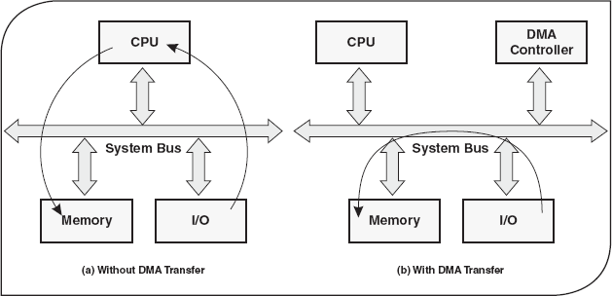

2.1 Introduction
Just as a tall building has different levels of detail, including the number of storeys, the size of rooms, door and window placement, etc., each computer has a visible structure, which is referred to as itsarchitecture. One can look at a computer's architecture at similar levels of hardware elements, which in turn depends on the type of the computer (personal computer, supercomputer, etc.) required. Therefore, when we talk about architecture in terms of a computer, it is defined as the science of selecting and interconnecting hardware components to create computers that meet functional, performance and cost goals.
Extending the concept of the architecture and making these hardware components work in a harmonized manner to achieve a common objective in an environment is known as computer organization. Computer organization is like a group of people who work together to achieve a common goal, for example, a football team where different members of the team play specific roles in the game. The role of the goalkeeper is to safeguard the goal. Similarly, other members of the team (striker, mid-fielder and defender) have their respective roles to perform. However, the ultimate objective of the team as a whole is to defeat the opponent by scoring more goals than the opponent. Hence, the study of computer organization focuses more on the collective contribution from the hardware peripherals than individual electronic components.

2.2 Central processing unit
The central processing unit (CPU) is referred to as the “brain” of a computer system and it converts data (input) into meaningful information (output). It is a highly complex, extensive set of electronic circuitry, which executes stored program instructions. It controls all internal and external devices, performs arithmetic and logic operations, and operates only on binary data, that is, data composed of 1s and 0s. In addition, it also controls the usage of the main memory to store data and instructions, and controls the sequence of operations (Figure 2.1).

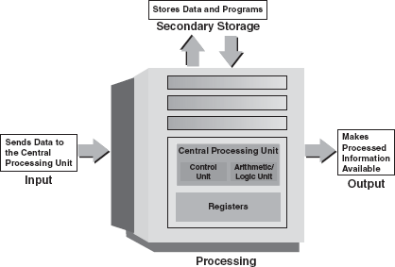

Figure 2.1 The Central Processing Unit

The CPU consists of three main subsystems, the Arithmetic/Logic Unit (ALU), the Control Unit (CU)and the registers. The three subsystems work together to provide operational capabilities to a computer.

2.2.1 Arithmetic/Logic Unit
The arithmetic/logic unit (ALU) contains the electronic circuitry that executes all arithmetic and logical operations on the data made available to it. The data required to perform the arithmetic and logical functions are inputs from the designated registers. The ALU comprises two units: Arithmetic Unit (AU) and Logic Unit (LU).
Arithmetic Unit: The AU contains the circuitry that is responsible for performing the actual computing and carrying out arithmetic calculations, such as addition, subtraction, multiplication, and division. It can perform these operations at a very high speed.
Logic Unit: The LU enables the CPU to make logical operations based on the instructions provided to it. These operations are logical comparisons between data items. The LU can compare numbers, letters or special characters and then take action based on the result of the comparison. Logical operations of the LU test for three conditions:
- Equal-to Condition: In a test for this condition, the ALU compares two values to determine if they are equal. For example, if the number of tickets sold equals the number of seats in a cinema hall, then housefull is declared.
- Less-than Condition: To test this condition, the ALU compares values to determine if one is less than the other; for example, if a person purchases less than two tickets, then no discount rate is given.
- Greater-than Condition: In this type of comparison, the computer determines if one value is greater than the other; for example, if a person purchases greater than two tickets, then the discount rate is 5 per cent.

2.2.2 Registers
The registers are special-purpose, high-speed temporary memory units. These are temporary storage areas for holding various types of information, such as data, instructions, addresses and intermediate results of calculations. Essentially, they hold the information that the CPU is currently working on. The registers can be thought of as the CPU's working memory, a special additional storage location that offers the advantage of speed. The registers work under the direction of the CU to accept, hold, and transfer instructions or data, and perform arithmetic or logical comparisons at high speed. The CU uses a data-storage register in the similar way a store owner uses a cash register as a temporary, convenient place to store the transactions. As soon as a particular instruction or piece of data is processed, the next instruction immediately replaces it, and the information that results from the processing is returned to the main memory. Figure 2.2 reveals the types of registers present inside the CPU.

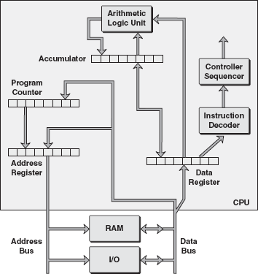

Figure 2.2 Register in the CPU

Instruction addresses are normally stored in consecutive registers and are executed sequentially. The CU reads an instruction from the memory by a specific address in the register and executes it. The next instruction is then fetched from the sequence and executed, and so on. This type of instruction sequencing is possible only if there is a counter to calculate the address of the instruction that has been executed. This counter is one of the registers, which stores intermediate data used during the execution of the instructions after they are read from the memory. Table 2.1 lists some of the important registers used in the CPU.

Table 2.1 Registers and Functions
Register Name | Function
Program Counter (PC) | The PC keeps track of the next instruction to be executed
Instruction Register (IR) | The IR holds the instruction to be decoded by the CU
Memory Address Register (MAR) | The MAR holds the address of the next location in the memory to be accessed
Memory Buffer Register (MBR) | The MBR is used for storing data either coming to the CPU or data being transferred by the CPU
Accumulator (ACC) | The ACC is a general-purpose register used for storing temporary results and results produced by the ALU
Data Register (DR) | The DR is used for storing the operands and other data

2.2.3 Control Unit
The control unit (CU) of the CPU contains circuitry that uses electrical signals to direct the entire computer system to carry out, or execute, stored program instructions. This resembles an orchestra leader who himself does not play a musical instrument but directs other people to play the musical instrument in a harmonized manner. The CU also does not execute program instructions; rather, it directs other parts of the system to do so by communicating with both the ALU and the memory.
The CU controls the I/O devices and transfer of data to and from the primary storage. The CU itself is controlled by individual instructions in programs located in the primary storage. Instructions are retrieved from the primary storage, one at a time. For this, the CU uses the IR for holding the current instruction and an instruction pointer to hold the address of the next instruction. Each instruction is interpreted (decoded) so that it can be executed. Based on the instructions, the CU controls how other parts of the CPU and, in turn, the rest of the computer system should work so that the instructions are executed in a correct manner. An analogy can be considered between the CU and the traffic police; the control unit decides which action will occur just as the traffic police takes decisions on which lanes the traffic will move or stop.
Figure 2.3 illustrates how the CU instructs other parts of the CPU (ALU and registers) and the I/O devices on what to do and when to do. It also determines what data are needed, where they are stored and where to store the results of the operation, as well as sends the control signals to the devices involved in the execution of the instructions. It administers the movement of a large amount of instructions and data used by the computer. In order to maintain the proper sequence of events required for any processing task, the CU uses clock inputs.

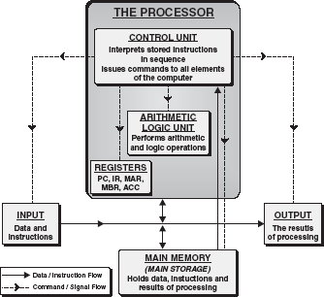

Figure 2.3 Control Unit

2.2.4 System Bus
A bus is a set of connections between two or more components/devices, which are designed to transfer several/all bits of a word from the source to the destination. It is a shared medium of information transfer. A bus consists of multiple paths, which are also termed lines, and each line is capable of transferring one bit at a time. Thus, to transmit 8 bits simultaneously over a bus, eight lines are required. In addition, some other lines are needed to control this transfer. A bus can be unidirectional (transmission of data can be in only one direction) or bi-directional (transmission of data can be in both directions). In a shared bus, only one source can transmit data at one time, while one or more than one can receive that signal. A bus that connects to all three components (CPU, memory, I/O devices) is called a system bus (see Figure 2.4). A system bus consists of 50–100 separate lines. These lines are broadly categorized into three functional groups.

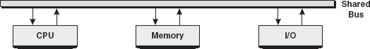

Figure 2.4 System Bus
Data Lines: Data lines provide a path for moving data between the system modules. Data lines are collectively known as a data bus. Normally, a data bus consists of 8, 16 or 32 separate lines. The number of lines present in a data bus is called the width of the data bus. Data bus width limits the maximum number of bits, which can be transferred simultaneously between two modules. The width of a data bus helps in determining the overall performance of a computer system.
Address Lines: Address lines are used to designate the source of data for a data bus. As the memory may be divided into a linear array of bytes or words, for reading or writing any information on to the memory, the CPU needs to specify the address of a particular location. This address is supplied by the address bus (address lines are collectively called an address bus). Thus, the width of the address bus specifies the maximum possible memory supported by a system; for example, if a system has a 16-bit-wide address bus, it can support memory size of equal to 2¹⁶ (or 65,536) bytes.
Control Lines: Control lines are used to control the access to data and the address bus; this is required as a bus is a shared medium. The control lines are collectively called a control bus (seeFigure 2.5). These lines are used for transmission of commands and timing signals (which validate data and addresses) between the system modules. Timing signals indicate whether data and address information is valid, whereas command signals specify which operations are to be performed. Some of the control lines of a bus are required to provide clock signals to synchronize operations and reset signals to initialize the modules. Control lines are also required for reading/writing to I/O devices or the memory. Control lines if used as a bus request indicate that a module needs to gain control of the bus. The bus grant control line is used to indicate whether the requesting module has been granted control of the bus.

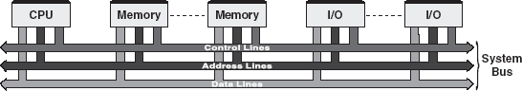

Figure 2.5 Bus Interconnection
Note: Physically, a bus is a number of parallel electrical conductors. These circuits are normally imprinted on printed circuit boards. The bus normally extends across most of the system components, which can be tapped into the bus lines.

2.2.5 Main Memory Unit
The memory is that part of the computer that holds data and instructions for processing. Logically, it is an integral component of the CPU, but, physically, it is a separate part placed on the computer's motherboard. The memory stores program instructions or data for only as long as the program they pertain to is in operation. The CPU accesses the main memory in a random manner, that is, the CPU can access any location of this memory to either read information from it or store information in it. The primary memory is of two types: the first is called the Random Access Memory (RAM) and the second is the Read Only Memory (ROM).
The RAM directly provides the required information to the processor. It can be defined as a block of sequential memory locations, each of which has a unique address determining the location and those locations contain a data element. Storage locations in the main memory are addressed directly by the CPU's instructions. It is volatile in nature, which means the information stored in it remains as long as the power is switched on. As soon as the power is switched off, the information contained in the RAM is lost.
The ROM stores the initial start-up instructions and routines in the Basic Input/Output System (BIOS), which can only be read by the CPU, each time it is switched on. The contents of the ROM are not lost even in the case of a sudden power failure, thus making it non-volatile in nature. The instructions in the ROM are built into the electronic circuits of the chip, called firmware. The ROM is also randomly accessible in nature, which means the CPU can randomly access any location within the ROM. Improvement in technology for constructing a flexible ROM comes in various types, namely Programmable Read Only Memory (PROM), Erasable Programmable Read Only Memory (EPROM) and Electrically Erasable Programmable Read Only Memory (EEPROM).

2.2.6 Cache Memory
The cache is a very high speed, expensive piece of memory, which is used to speed up the memory-retrieval process. Due to its higher cost, the CPU comes with a relatively small amount of cache compared with the main memory. Without the cache memory, every request from the CPU to access data would be sent to the main memory, which in response sends the data back to the CPU through the system bus. This is a slow process in computing terms. The idea of introducing cache is that this extremely fast memory would store data that are frequently accessed and, if possible, the data that are around it. This is to achieve the quickest possible response time to the CPU.
Let us consider an example of a library system for a better understanding of the cache concept. When a person comes into the library and asks for a book, the librarian searches for the requested book in the bookshelves, retrieves the book and delivers it to the person. After the person reads the book, it is returned to the library. At the same time, if any other person comes in requesting the same book, which is still placed on the librarian's desk, the librarian does not have to go through the process of searching the book in the bookshelves. This results in saving of precious time in retrieving the requested book and thus improving the efficiency of the work.
The above analogy can be related to the computer's cache system. The computer uses logic to determine which data are the most-frequently accessed and keeps them in the cache. A cache is a piece of very fast memory made from a high-speed static RAM that reduces the access time of the data. It is very expensive and generally incorporated in the processor, where valuable data and program segments are kept. The cache memory can be categorized into three levels: L1 cache, L2 cache and L3 cache (see Figure 2.6).

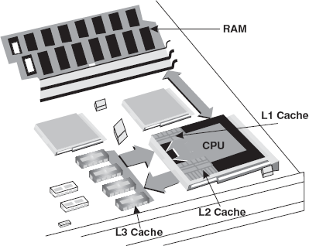

Figure 2.6 Various Levels of Cache

L1 Cache: This cache is closest to the processor and hence is termed as the primary or L1 cache. Each time the processor requests information from the memory, the cache controller on the chip uses special circuitry to first check if the requested data are already in the cache. If they are present, then the system is spared from time-consuming access to the main memory. In a typical CPU, the primary cache ranges in size from 8 to 64 KB, with larger amounts on the newer processors. This type of cache memory is very fast because it runs at the speed of the processor since it is integrated into it. There are two different ways that the processor can organize its primary cache: first, some processors have a single cache to handle both command instructions and program data (called a unified cache), while others have a separate data and instruction cache called split cache. However, the overall performance difference between integrated and separate primary cache is not significant.
L2 Cache: The L2 cache is larger but slower in speed than L1 cache. It is used to see recent accesses that is not picked by the L1 cache and is usually 64 to 2 MB in size. The L2 cache is also found on the CPU. If the L1 and L2 cache are used together, then the missing information that is not present in the L1 cache can be retrieved quickly from the L2 cache.
L3 Cache: The L3 cache memory is an enhanced form of memory present on the motherboard of the computer. It is an extra cache built into the motherboard between the processor and main memory to speed up the processing operations. It reduces the time gap between the request and retrieval of the data and instructions, thereby accessing data much more quickly than the main memory. The L3 cache is being used with processors nowadays having more than 3 MB of storage in it.

2.3 Communication among various units
All units in a computer system work in conjunction with each other to formulate a functional computer system. To have proper coordination among these units (processor, memory and I/O devices), a reliable and robust means of communication is required. Let us discuss one of the most important functions in the computer system, that is, the communication between these units.

2.3.1 Processor to Memory Communication
The whole process of communication between the processor and memory can be divided into two steps, namely, information transfer from the memory to processor and writing information in the memory. The following sequence of events takes place when information is transferred from the memory to the processor (see Figure 2.7 also):

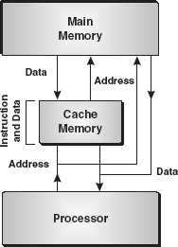

Figure 2.7 Processor-Memory

- The processor places the address in the MAR through the address bus.
- The processor issues a READ command through the control bus.
- The memory places required data on the data bus, which are then transferred to the processor.
Based on the read time of the memory, a specific number of processor clock intervals are allotted for completion of this operation. During this interval, the processor is forced to wait. Similarly, the following sequence of events takes place when information is written in the memory:
- The processor places the address in the MAR through the address bus.
- The processor places the data to be written in the memory on the data bus.
- The processor issues a WRITE command to the memory by the control bus.
- The data are written in the memory at the address specified in the MAR.
The main concern in the processor-memory communication is the speed mismatch between the memory and processor. The memory speed is slower than the CPU's speed. Hence, the CPU is forced to wait for the data. As already discussed, this speed mismatch is reduced by using the small fast memory (called cache) as an intermediate buffer between the processor and memory.

2.3.2 Processor—I/O Devices Communication
The I/O units are connected to the computer system through the system bus. Each I/O device in a computer system is first met with the controller, called the Direct Memory Access (DMA) controller, which controls the operation of that device. The controller is connected to the buses to perform a sequence of data transfers on behalf of the CPU (see Figure 2.8). It is capable of taking over control of the system bus from the CPU, which is required to transfer data to and from the memory over the system bus. The DMA controller can directly access the memory and is used to transfer data from one memory location to another or from an I/O device to the memory and vice versa. The DMA controller can use the system bus only when the CPU does not require it or it should suspend the operations currently being processed by the CPU.

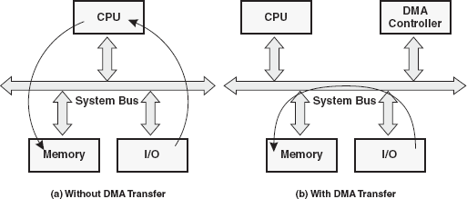

Figure 2.8 Processor—I/O Communication

With the DMA controller, a dedicated data-transfer device reads the incoming data from a device and stores that data in a system memory buffer for later retrieval by the CPU. The DMA controller allows peripheral devices to access the memory for both read and write operations without affecting the state of the computer's central processor. As a result, the data-transfer rate is significantly increased, thus improving the system efficiency. When a large amount of data is to be transferred from the CPU, the DMA controller can be used. The DMA controller allows the I/O unit to exchange data directly with the memory without going through the CPU except at the beginning (to issue the command) and at the end (to clean up after the command is processed). While the I/O operation is being performed by the DMA controller, the CPU can start execution of some other part of the same program or can start executing some other program. Thus, the DMA controller increases the speed of I/O operations by taking over buses and thus eliminating the CPU's intervention.

2.4 Instruction cycle
The basic function performed by the CPU is the execution of a program. The program to be executed is a set of instructions, which are stored in the memory. The CPU executes the instructions of the program to complete a given task. The CPU fetches instructions stored in the memory and then executes the fetched instructions within the CPU before it can proceed to fetch the next instruction from the memory. This process is continued until specified to stop. The instruction execution takes place in the CPU registers, which are used as temporary storage areas and have limited storage space. These CPU registers have been discussed earlier.
In the simplest form, the instruction processing consists of two cycles, fetch cycle and execute cycle, as shown in Figure 2.10. Here, the CPU fetches (reads) instructions from the memory, one at a time, and performs the operation specified by this instruction. The instruction fetching involves reading of an instruction from a memory location to the CPU; the execution of this instruction may involve several operations depending on the nature of instructions. The processing needed for a single instruction (fetch and execution) is referred to as the instruction cycle.

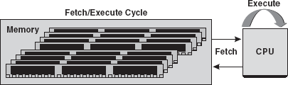

Figure 2.10 Two-step Instruction Cycle

Fetch Cycle: In the beginning, the address, which is stored in the PC, is transferred to the MAR. The CPU then transfers the instruction located at the address stored in the MAR to the MBR through the data lines connecting the CPU to memory. This transfer from the memory to the CPU is coordinated by the CU. To finish the cycle, the newly fetched instruction is transferred to the IR and, unless instructed otherwise, the CU increments the PC to point to the next address location in the memory.
Figure 2.11 illustrates the fetch cycle, which can be summarized in the following points:

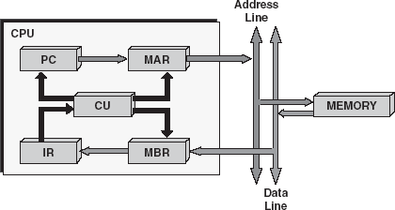

Figure 2.11 Fetch Cycle
- PC=>MAR
- MAR => MEMORY=>MBR
- MBR=>IR
- CU increments PC
After the CPU has finished fetching an instruction, the CU checks the contents of the IR and determines which type of execution is to be carried out next. This process is known as the decoding phase. The instruction is now ready for the execution cycle.
Execution Cycle: Once an instruction has been loaded into the IR and the CU has examined and decoded the fetched instruction and determined the required course of action to take, the execution cycle can commence. Unlike the fetch cycle and the interrupt cycle, both of which have a set of instruction sequences, the execution cycle can contain some complex operations. The actions within the execution cycle can be categorized into the following four groups:
- CPU to Memory: Data may be transferred from the memory to the CPU or from the CPU to the memory.
- CPU to I/O: Data may be transferred from the I/O module to the CPU and vice versa.
- Data Processing: The CPU may perform some arithmetic or logic operation on the data via the ALU.
- Control: An instruction may specify that the sequence of operation may be altered; for example, the PC may be updated with a new memory address to reflect that the next instruction fetched should be read from this new location.
For simplicity, the example [LOAD ACC, memory] (illustrated in Figure 2.12) deals with one operation that can occur. The example [LOAD ACC, memory] can be classified as a memory-reference instruction. Instructions that can be executed without leaving the CPU are referred to as non-memory reference instructions.

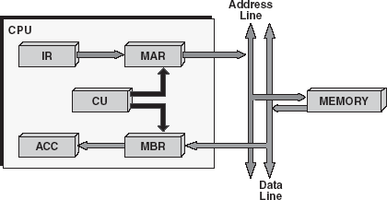

Figure 2.12 Execution Cycle

This operation loads the accumulator with data that is stored in the memory location specified in the instruction. The operation starts by transferring the address portion of the instruction from the IR to the MAR. The CPU then transfers the instruction located at the address stored in the MAR to the MBR via the data lines connecting the CPU to the memory. This transfer from the memory to the CPU is coordinated by the CU. To finish the cycle, the newly fetched data is transferred to the ACC.
The illustrated LOAD operation (see Figure 2.12)can be summarized in the following points:
- IR [adderess portion] =>MAR
- MAR =>MEMORY=>MBR
- MBR =>ACC
After the execution cycle completes, the next instruction is fetched and the process starts again.

2.5 Inside a computer
Computing machines are complex devices made from numerous electronic components. Many of these components are small, sensitive, expensive and operate with other components to provide better performance to the computing machines. Therefore, to ensure better performance and increase in the life of these components, they are placed inside a metal enclosure called the system case or cabinet (see Figure 2.13). The system case is a metal and plastic box that houses the main components of the computer. It protects electronics hardware against the heat, light, temperature, etc. It serves important roles in the functioning of a properly designed and well-built computer. Several areas where the system case plays an important role are:

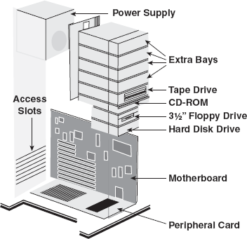

Figure 2.13 System Case
- Structure: The system case provides a rigid structural framework to the components, which ensures that everything fits together and works in a well-organized manner.
- Protection: The system case protects the inside of the system from physical damage and electrical interference.
- Cooling: The case provides a cooling system to the vital components. Components that run under cool temperature last longer and are less troublesome.
- Organization and Expandability: The system case is a key to the organization of physical systems. If a system case is poorly designed, upgradation or expansion of a peripheral is limited.
- Status Display: The system case contains lights or LEDs that provide varied information pertaining to the working of the system to the user.
The system case encloses all the components, which are essential in running the computer system. These components include the motherboard, processors, memory, power supply, expansion slots, cables, removable drives, etc.

2.5.1 Power Supply (SMPS)
Power supply or Switched Mode Power Supply (SMPS) is a transformer and voltage control device in a computer that furnishes power to all the electronic components by converting incoming AC into the low-voltage DC supply. When a computer is turned on, the power supply allows the converted electricity to travel to other components inside the computer. The modern-day power supply provides protection against surge and spikes in the power, which could damage vital components of the computer. Nowadays, the computer power supply is capable of providing different voltages, at different strengths, and manages additional signals for the motherboard. The power supply plays an important role in the following areas of the computer system (see Figure 2.14):

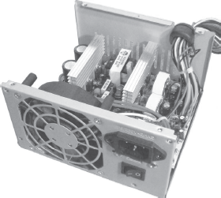

Figure 2.14 Power Supply
- Stability: A high-quality power supply with sufficient capacity to meet the demands of the computer provides years of stable power for the computer.
- Cooling: The power supply contains the main fan that controls the flow of air through the system case. This fan is a major component in the computer cooling system.
- Expandability: The capacity of the power supply determines the ability to add new drives to the system or upgrade to a more powerful motherboard or processor.

2.5.2 Motherboard
The motherboard, also known as the system board, is a large multilayered printed circuit board inside a computer. The motherboard contains the CPU, the BIOS ROM chip and the CMOS Setup information. It has expansion slots for installing different adapter cards like the video card, sound card, network interface card and modem. The circuit board provides a connector for the keyboard as well as housing to the keyboard controller chip. It possesses RAM slots for the system's RAM chips, and enables the system's chipset, controllers and underlying circuitry (bus system) to tie everything together. In a typical motherboard, the circuitry is imprinted on the surface of a firm planar surface and is usually manufactured in a single piece. The most common design of the motherboard in today's desktop computers is the ATX design. In ATX designs, the computer components included are processor, co-processors (optionally), memory, BIOS, expansion slot and interconnecting circuitry. Additional components can be added to a motherboard through its expansion slot. Nowadays, they are designed to put peripherals as integrated chips directly onto the motherboard. Initially, this was confined to audio and video chips, but in recent times, the peripherals integrated in this way include SCSI, local area network (LAN) and RAID controllers. Though, there is cost benefit to this approach, the biggest downside is the restriction of future upgrade options. Figure 2.15 provides an insight into various components on motherboards.

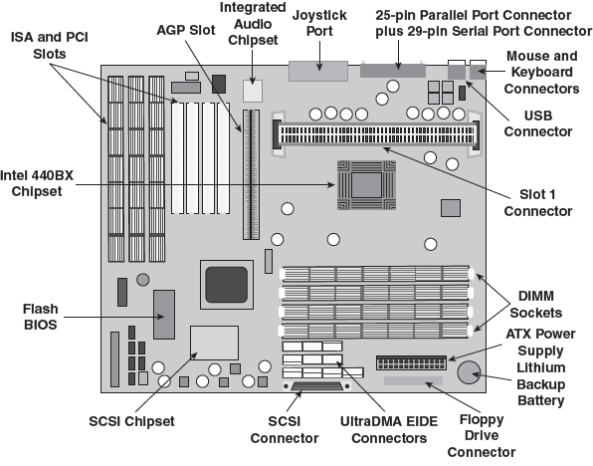

Figure 2.15 Motherboard
BIOS: The BIOS comprises a set of several routines and start-up instructions inside the ROM. This gives two advantages to the computer. First, the code and data in the ROM BIOS need not be reloaded each time the computer is started. Secondly, they cannot be corrupted by wayward applications that are accidentally written into the wrong part of the memory. As the machine is switched on, the control is transferred to the bootstrap procedure of the BIOS. This procedure inspects the computer to determine what hardware is fitted and then conducts a simple test (power-on self test) for normal functionality. If all the tests are passed, the ROM then determines the drive to boot the machine. Most computers have the BIOS set to check for the presence of an operating system in the primary hard disk drive. Once the machine is booted, the BIOS serves a different purpose by presenting the DOS with a standardized Application Program Interface (API) for the computer hardware.
CMOS: The motherboard includes a separate block of memory called the complementary metal oxide silicon (CMOS) chip that consumes very low power. This chip is kept alive by a battery even when the computer's power is off. The function of the CMOS chip is to store basic information about the computer's configuration, such as the type of hard disks and floppy drives, memory capacity, etc. The other important data, which is kept in the CMOS memory, is the system time and date. The clock, CMOS chip and batteries are usually all integrated into a single chip.

2.5.3 Ports and Interfaces
Ports and interfaces are a generic name for the various “holes” (and their associated electronics) found at the back of the computer, using which external devices are connected to the computer's motherboard. Different interfaces and ports run at varying speeds and work best with specific types of devices (see Figure 2.16).

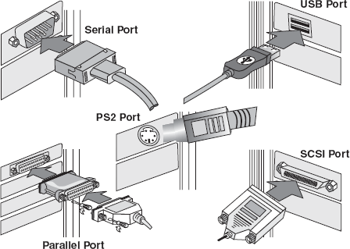

Figure 2.16 Different Types of Ports
PS/2 Ports: It is a standard serial port connector used to plug the computer mouse and keyboards into the personal computer. It consists of six pins in a small, round-shape socket.
Serial Ports: It is a general-purpose communications port through which data are passed serially, that is, one bit at a time. These ports are used for transmitting data over long distances. In the past, most digital cameras were connected to a computer's serial port in order to transfer images to the computer. However, because of its slow speed, these ports are used with the computer mouse and modem.
Parallel Port: It is an interface on a computer, which supports transmission of multiple bits of data (usually 8 bits) at the same time. This port transmits data faster than a serial port and is exclusively used for connecting peripherals such as printers and CD-ROM drives.
SCSI Port: These ports are used in transmitting data up to seven devices in the “daisy chain” fashion and at a speed faster than serial and parallel ports (usually 32 bits at a time). In the daisy chain fashion, several devices are connected in series to each other, so that data for the seventh device need to go through the entire six devices first. These ports are hardware interfaces, which include an expansion board that plugs into the computer called the SCSI host adapter or SCSIcontroller. Devices which can be connected to SCSI ports are hard-disk drives and network adapters.
Universal Serial Bus (USB) Port: The USB port is a plug-and-play hardware interface for connecting peripherals such as the keyboard, mouse, joystick, scanner, printer and modem. It supports a maximum bandwidth of 12 MB per second and has the capability to connect up to 127 devices. With the USB port, a new device can be added to the computer without adding an adapter card. These ports are the replacement for the parallel and serial ports.

2.5.4 Expansion Cards
An expansion card, also called an adapter card, is a circuit board that provides additional capabilities to the computer system. Adapter cards are made up of large-scale integrated circuit components Sound Card installed on it. The cards are plugged into the expansion sockets present on the computer's motherboard to provide the computer an added functionality. Common available expansion cards connect monitors (for enhanced graphics) and microphones (for sound), each having a special purpose to perform (see Figure 2.17). However, nowadays most of the adapters come in-built on the motherboard and no expansion card is required, unless the need for high performance is required.

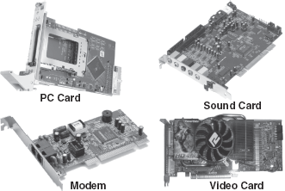

Figure 2.17 Expansion Card

Sound Cards: An expansion card that allows the computer to output sound through connected speakers, to record sounds from a microphone and to manipulate sounds stored on the computer is called a sound card. It contains special circuits for operating the computer's sound and allows playback and recording of sound from the CD-ROM.
Video Cards: A video card, also called the display adapter, is used for enhancing graphics images that are seen on the computer's monitor. The card converts the images created in the computer to electronic signals required by the monitor. Generally, a good card with a graphics accelerator is preferred for editing digital videos. There are different video cards with varying capabilities related to the size of the monitor and total number of displayable colours.
Network Interface Card: A network interface card is a computer circuit board that is installed in a computer so that it can be connected to other computers in a network. Personal computers and workstations on a LAN contain a network interface card specifically designed for transmitting data across LANs. Network interface cards provide a dedicated, full-time connection to a network.
Modem: Modem is an expansion card that allows two computers to communicate over ordinary phone lines. It converts digital data from computers into analog data, transmits over the telephone lines and also converts incoming analog signals back to digital signals for the receiving computer. Modems do not provide high bandwidth for the data communication and as a result, they do not support high-speed Internet access as current modems can run up to 56 KBps.
PC Card: A PC card is a removable device, approximately the size of a credit card, which is designed to plug into a Personal Computer Memory Card International Association (PCMCIA) slot. It is a standard formulated by the PCMCIA for providing expansion capabilities to computers. The PCMCIA standard supports input-output devices, memory, fax/modem, SCSI and networking products. The card fits into a notebook or laptop computer.

2.5.5 Ribbon Cables
Ribbon cables are wide, flat and insulated cables, which are flexible enough to fit into areas with little space. These cables are made up of numerous tiny wires (traces and electronic pathways) called the bunch, where one bunch carries data/information around to different components on the motherboard and another bunch connects these components to the various devices attached to the computer. These cables connect the hard drive, floppy drive and CD-ROM drive to the connectors on the motherboard and control the drives by getting and sending data from and to them. These cables connect different external devices, peripherals, expansion slots, I/O ports and drive connections to the rest of the computer (see Figure 2.18)

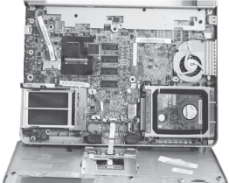

Figure 2.18 Ribbon Cables

2.5.6 Memory Chips
The memory is the place where the computer holds programs and data that are currently in use. The system memory 4.25” 72-pins SIMM on the motherboard is arranged in groups called the memory banks. The number of the memory banks and their configurations vary from computer to computer because these are determined by the CPU and the 168-pins DIMM way it receives information. The speed of Fi220 SIMM and DIMM RAM Chips the CPU determines the number of memory sockets required in a bank. For the main memory, either of the two types of memory chips is used: Single In-Line Memory Modules (SIMM) or Dual In-Line Memory Modules (DIMM) (see Figure 2.19).

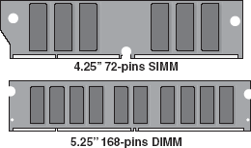

Figure 2.19 SIMM and DIMM RAM Chips
SIMM: SIMM are small circuit boards designed to accommodate surface-mount memory chips. A typical SIMM chip comprises a number of RAM chips on a printed circuit board (PCB), which fits into a SIMM socket on a computer's motherboard. These chips are packed into small plastic or ceramic dual inline packages (DIPs), which are assembled into a memory module. A typical motherboard offers four SIMM sockets capable of taking either single-sided or double-sided SIMMs with module sizes of 4, 8, 16, 32 or even 64 MB. When 32-bit SIMM chips are used with processors, they have to be installed in pairs, with each pair of modules making up a memory bank. These chips support 32-bit data paths and are originally used with 32-bit CPUs. The CPU then communicates with the memory bank as one logical unit. SIMM chips usually come in the following two formats:
- A 30-pin SIMM used in older system boards, which deliver 1 byte of data.
- A larger 72-pin SIMM used in modern PCs, which deliver 4 bytes of data (plus parity) in every memory request.
DIMM: With the increase in speed and bandwidth capability, a new standard for the memory was adopted called dual in-line memory module (DIMM). These chips have 168 pins in two (or dual) rows of contacts; one on each side of the card. With the additional pins, a CPU retrieves information from the DIMM chip at 64 bits as compared to a 32- or 16-bit transfer with SIMMs. Some of the physical differences between 168-pin DIMMs and 72-pin SIMMs include the length of the module, the number of notches on the module and the way the module is installed. The main difference between the two is that on a SIMM, opposing pins on either side of the board are tied together to form one electrical contact, while on a DIMM, opposing pins remain electrically isolated to form two separate contacts. DIMMs are often used in computer configurations that support a 64-bit or wider memory bus (like Intel's Pentium 4).

2.5.7 Storage Devices
Disk drives are the important components present inside the system case. These drives are used to read and write information to and from the processor. The three most common disk drives located inside a system case are the hard drive, floppy disk drive and CD-ROM. These drives are high-storage devices, which enable the user to store large amount of data. Out of these drives, the hard disk drive provides the largest storage space for saving. All the vital applications ranging from the operating system to word processor are stored in the hard disk drive. The hard disk drive is costly and not robust enough to transfer data physically; therefore, CD-ROMs and floppy disks are used as an alternative means to transfer data physically.

2.5.8 Processors
Processor, often called the CPU, is the central component of the computer. It is referred to as the brain of a computer responsible for carrying out operations in an efficient and effective manner. A processor holds the key for carrying out all the processing and computational work. Every work that is done by the user on the computer is performed either directly or indirectly by the processor. The following factors should be considered while choosing a processor of a computer system:
- Performance: The processor's capabilities dictate the maximum performance of a system. It is the most important single determinant of system performance (in terms of speed and accuracy) in the computer.
- Speed: The speed of a processor defines how fast it can perform operations. There are many ways to indicate speed, but the most obvious way to measure is through the internal clock speed of the CPU. The faster the speed of the internal clock of the processor, the faster the CPU will work and, therefore, hardware will be more expensive.
- Software Support: New and faster processors support resource-consuming software in a better manner. For example, new processors such as the Pentium 4 enable the use of specialized software, which were not supported on earlier machines.
- Reliability and Stability: The reliability of the computer system directly depends on the type and quality of the processor.
- Energy Consumption and Cooling: Although processors consume relatively little power compared to other system devices, a newer processor consumes a great deal of power resulting in the impact on everything from the cooling method selection to overall system reliability.
- Motherboard Support: The type of processor used in the system is a major determining factor of the chipset used on the motherboards. The motherboard, in turn, dictates many facets of the system's capabilities and performance.

2.6 Data representation in computers
Since the early days of human civilisation, people have been using their fingers, sticks, etc., for counting things. The need for counting probably originated when man started to use animals for domestic purposes and practise animal breeding for fulfilling his needs and requirements. As daily activities became more complex, numbers became more important in trade, time, distance and in all other spheres of human life. Ever since people discovered that it was necessary to count objects, they have been looking for easier ways of counting. To count large numbers, man soon started to count in groups and various number systems were formed.
As manual counting had a limited role for carrying out a simple computing task, computation that was more complex made humans to depend on the machines to perform the computing task efficiently and accurately. With the advancement of machines, different number systems were formed to make the task simple, accurate and fast. These number systems worked on the principle of a digital logic design present in the modern-day computer system and opened a gateway to overcome complex computation barriers. In a precise manner, a number system defines a set of values used to represent “quantity”. Generally, one talks about a number of students attending a class and a number of modules taken by each student as well as uses numbers to represent grades achieved by students in tests. Quantifying values and items in relation to each other is helpful for us to make sense of our environment. The number system can be categorized into two broad categories:
- Non-Positional Number Systems: In ancient times, people used to count with their fingers. When fingers became insufficient for counting, stones and pebbles were used to indicate the values. This method of counting is called the non-positional number system. It was very difficult to perform arithmetic operations with such a number system, as it had no symbol for zero. The most common non-positional number system is the Roman number system. These systems are often clumsy and it is very difficult to do calculations for large numbers.
- Positional Number Systems: A positional number system is any system that requires a finite number of symbols/digits of the system to represent arbitrarily large numbers. When using these systems, the execution of numerical calculations becomes simplified because a finite set of digits are used. The value of each digit in a number is defined not only by the symbol, but also by the symbol's position. The most popular positional number system being used today is the decimal number system.
Base (or Radix) of System: The word base (or radix) means the quantity of admissible marks used in a given number system. The admissible marks are the characters such as Arabic numerals, Latin letters or other recognisable marks, which are used to present the numerical magnitude of a “quantity.” The decimal number system originated in India. This number system has 10 as the base and is indicated by a subscript 10 (decimal number) following the value of the number. For example, (7592)10 represents a number (7592) in the base 10 number system. Similarly, we have number systems with base other than 10. For example, (214)8 represents a number (214) in the base 8 number system.
For a computer, everything is in the digital form (binary form) whether it is a number, alphabet, punctuation mark or instruction (Table 2.2). Let us illustrate this with the help of an example. Consider the word “INDIA” that appears on the computer screen as a series of alphabetic characters. However, for the computer, it is a combination of numbers. On the basis of the American Standard Code for Information Interchange (ASCII) value (discussed later in this chapter) of each character, it appears to the computer as follows:

Table 2.2 Types of Number System
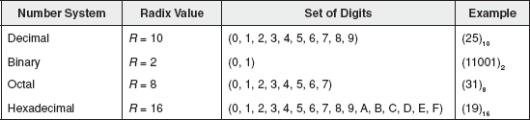

2.6.1 Types of Number System
Generally, a user is least aware of the fact that actual operations in a computer are done with a binary number system. Traditionally, the two possible states for the binary system are represented by the digits 0 and 1. Long before the introduction of octal and hexadecimal numbers, programmers used a convenient method of handling large binary numbers in either 3-bit or 4-bit groupings. Later, the actual machine code for the computer instructions was replaced by mnemonics, which comprised of three to four letters of the assembly language for a particular CPU. It was also possible to use more than one base number for writing instructions/programs in the assembly languages, so programmers made sure their assemblers could understand octal, hexadecimal and binary numbers. Octal and hexadecimal numbers are more compact than binary numbers, which a computer understands. Thus, octal and hexadecimal numbers prevent unwieldy strings that were written in binary. For example, the three-digit decimal number 513 requires 10 digits in pure binary (1000000001) but only three (201) in hexadecimal. Table 2.2 lists the types of number system.
Binary Number System: The digital computer provides accurate solutions to the problems by performing arithmetic computations. The numbers are not expressed as decimal numbers within the computer because it is not suitable for machine processes. Computers are not only powered by electricity, but also compute with electricity. They shift voltage pulses around internally. When numbers are represented in a computer's memory by means of small electrical circuits, a number system with only two symbols is used. These symbols are ON or OFF state of the circuit. This system of representing numbers is known as the binary number system. Circuits allow electricity to flow or to be blocked depending on the type of the circuit. A computer circuit is made up of transistors, which have only two states, ON and OFF. ON is interpreted as 1, while OFF as 0. Similar to the decimal system, the position of a digit in a number indicates its value. Instead of ones, tens, hundreds, thousands, etc., as in the decimal system, the columns in the binary system contain ones, twos, fours, eights, etc. Each column represents a number in powers of 2; starting with 20 for the leftmost column, the power is incremented by 1 for each additional column to the right. In other words, each place in the number represents two times (2×'s) the place to its right. Table 2.3represents the first 10 decimal numbers in binary.

Table 2.3 Representing Decimal Numbers in Binary
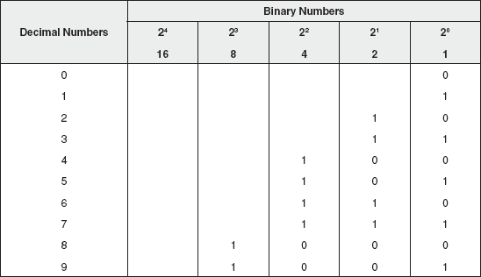
Octal Number System: The octal number system is a base 8 system, having eight admissible marks: 0, 1, 2, 3, 4, 5, 6 and 7 with no 8 or 9 in the system. This system is a positional notation number system. The octal number system uses powers of 8 to determine the number (see Table 2.4).

Table 2.4 Representing Binary and Decimal in Octal
Decimal Number | Binary Number | Octal Number
0 | 0000 | 000 (0 × 8⁰)
1 | 0001 | 001 (1 × 8⁰)
2 | 0001 | 002 (2 × 8⁰)
3 | 0011 | 003 (3 × 8⁰)
4 | 0100 | 004 (4 × 8⁰)
5 | 0101 | 005 (5 × 8⁰)
6 | 0110 | 006 (6 × 8⁰)
7 | 0111 | 007 (7 × 8⁰)
8 | 1000 | 010 (1 × 8¹ + 0 × 8⁰)
9 | 1001 | 011 (1 × 8¹ + 1 × 8⁰)
Hexadecimal Number System: The hexadecimal number system uses 0–9 and A–F to represent a number, where A is equivalent to decimal 10 and the largest hexadecimal digit F is equivalent to decimal 15. The base for a hexadecimal number is 16 (see Table 2.5).

Table 2.5 Comparing Decimal, Binary, Octal and Hexadecimal
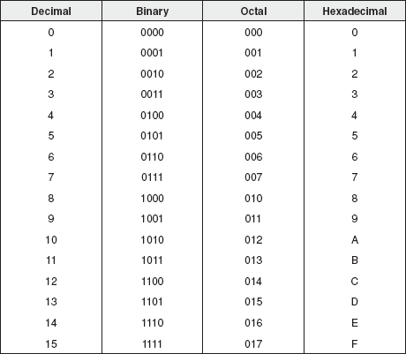

2.6.2 Conversion Between Number Bases
Computers and other digital systems process information as their primary function. Therefore, it is necessary to have methods and systems for representing information in forms, which can be manipulated and stored electronically. As discussed earlier, internally, a computer uses binary numbers for data representation, whereas, externally, it uses decimal numbers. It means a computer performs the decimal to binary conversion and vice versa. In general, any number in one number system can be represented in another number system.
Converting Decimal to Binary, Octal and Hexadecimal: The method used for the conversion of a decimal number into other number systems is often done using the “remainder” method. This method involves the following steps:
- Divide the decimal number by the base of the target number system. That is, to convert decimal to binary, divide the decimal number with 2 (the base of the binary number system), 8 for octal and 16 for hexadecimal.
- Note the remainder separately. In case of hexadecimal, if the remainder exceeds 9, then convert the remainder into an equivalent hexadecimal form; for example, if the remainder is 10, then note the remainder as A.
- Continually repeat the process of dividing until the quotient is zero and keep writing the remainders after each step of division.
- Finally, when no more division can occur, write down the remainders in reverse order.
Example 1: Determine the binary equivalent of (36)₁₀.

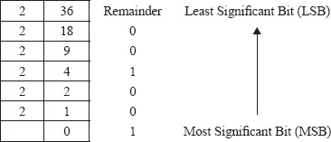

Taking remainders in the reverse order, we have 100100. Thus, the binary equivalent of (36)₁₀ is (100100)₂.
Example 2: Determine the octal equivalent of (359)₁₀.

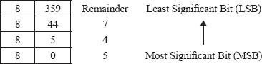

Thus, the octal equivalent of (359)₁₀ is (547)₈.
Example 3: Determine the hexadecimal equivalent of (5112)₁₀.

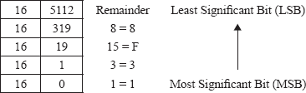

Thus, the hexadecimal equivalent of (5112)₁₀ is (13F8)₁₆.
Converting Binary, Octal and Hexadecimal to Decimal: The method used for the conversion of a binary, octal or hexadecimal number to decimal number involves each digit of the binary, octal or hexadecimal number to be multiplied by its weighted position and then each of the weighted values is added together to get the decimal number.
Example 1: Determine the decimal equivalent of (11010)₂.

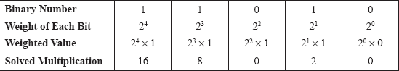

Sum of weight of all bits = 16 + 8 + 0 + 2 + 0 = 26. Thus, the decimal equivalent of (11010)₂ is (26)₁₀.
Example 2: Determine the decimal equivalent of (456)₈.

Sum of weight of all bits = 256 + 40 + 6 = 302. Thus, the decimal equivalent of (456)₈ is (302)₁₀.
Example 3: Determine the decimal equivalent of (B14)₁₆.

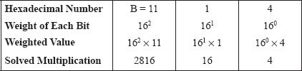

Sum of weight of all bits = 2816 + 16 + 4 = 2836. Thus, the decimal equivalent of (B14)₁₆ is (2836)₁₀.
Converting Among Binary, Octal and Hexadecimal: Converting among binary, octal and hexadecimal can be accomplished easily without converting to decimal first, as the base numbers of all three systems (2, 8 and 16, respectively) are powers of 2. Any octal digit can be written as a group of three binary digits, while a hexadecimal number will comprise four binary digits.
Example 1: Determine the octal equivalent of (010111)₂
Binary Number | 010 | 111
Octal Number | 2 | 7
The octal equivalent of (010111)₂ is (27)₈.
Example 2: Determine the hexadecimal equivalent of (11001011)₂.
Binary Number | 1100 | 1011
Decimal Number | 12 | 11
Hexadecimal Number | C | B
The hexadecimal equivalent of (11001011)₂ is (CB)₁₆.
Example 3: Determine the binary equivalent of (231)₈.

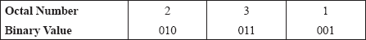

Thus, the binary equivalent of (231)₈ is (010011001)₂.
Example 4: Determine the binary equivalent of (5AF)₁₆.

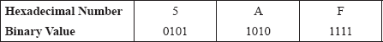

Thus, the binary equivalent of (5AF)₁₆ is (010110101111)₂.
Converting Between Octal and Hexadecimal: The method used for the conversion of an octal number to hexadecimal number is accomplished by the following steps:
- Convert each octal digit to 3-bit binary form.
- Combine all the 3-bit binary numbers.
- Segregate the binary numbers into the 4-bit binary form by starting the first number from the right bit (LSB) towards the number on the left bit (MSB).
- Finally, convert these 4-bit blocks into their respective hexadecimal symbols.
Example 1: Determine the hexadecimal equivalent of (2327)8.

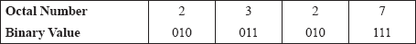

Combining the 3-bit binary blocks, we have 010011010111. Separating the group of binary numbers (from the left side) into the 4-bit binary number and by converting these blocks into their respective hexadecimal symbols, we have
0100 | 1101 | 0111
4 | D | 7
Thus, the hexadecimal equivalent of (2327)₈ is (4D7)₁₆.
The method used for the conversion of a hexadecimal number to octal number is the same as that used for the octal to hexadecimal conversion, except that each hexadecimal digit is converted into 4-bit binary form and then after grouping of all the 4-bit binary blocks, it is converted into the 3-bit binary form. Finally, these 3-bit binary forms are converted into octal symbols.
Example 2: Determine the octal equivalent of (2B6)₁₆.

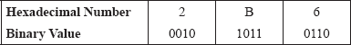

Combining all the 4-bit binary blocks, we have 001010110110. Separating the group of binary numbers into the 3-bit binary blocks and by converting these blocks into octal symbols, we have
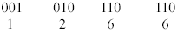
Thus, the octal equivalent of (2B6)₁₆ is (1266)₈.

LET US SUMMARIZE
- The CPU or the processor is a chip inside the system plugged onto the motherboard and controls all internal and external devices as well as performs arithmetic and logic operations. The unit consists of three main subsystems, the CU, the ALU and the registers.
- The functions of a processor include carrying out arithmetic and logic functions, controlling the use of the main memory to store data and instructions, and controlling the sequence of operations and all the parts of the computer system.
- The set of wires used for interconnection of various units is known as the system bus. The system bus is divided into three logical units, namely the address bus, the data bus and the control bus.
- The registers are special-purpose, high-speed temporary memory units. They hold various types of information pertaining to data, instructions, addresses and the intermediate results of calculations. Some of the important registers within the CPU are the PC, IR, MAR, MBR, ACC and DR.
- The ALU carries out arithmetic and logical operations on the data made available to it. The ALU contains the circuitry that is responsible for performing the actual computing and carrying out the arithmetic calculations. On the other hand, the importance of the ALU is to facilitate the CPU to make logical operations based on the instructions provided to it.
- The CPU controls the I/O devices and transfers data to and from the primary storage. It repeats a set of four basic operations: fetching, decoding, executing and storing.
- The main memory unit is a collection of registers, logically integrated to the processor but physically separate from the processor. It is implemented by two types of memory technologies, namely RAM and ROM.
- A cache memory, sometimes called a cache store, is a portion of the memory made up of the high-speed static RAM (SRAM) instead of the slower and comparatively cheaper dynamic RAM (DRAM) used for the main memory. It is very expensive and generally incorporated in the processor, where valuable data and program segments are kept.
- In the processor to memory communication, the whole process can be divided into two steps, namely information transfer from the memory to the processor and writing information in the memory.
- In the processor to I/O devices communication, the I/O units are connected to the computer through the system bus. In addition, it buffers the flow of data from the device to the processor and vice versa.
- The instruction cycle is sequence of well-defined instructions in the form of programs, which consist of the following steps: fetch cycle (fetching the instruction from the memory), decode cycle (decoding the instruction), execute cycle (executing the instruction) and store cycle (storing the result back to the memory).
- The instruction set of a processor is a limited set of basic operations built into the processor. Based upon the instruction sets, there are two common types of architectures: CISC and RISC.
- A system case or cabinet is a metal and plastic box that houses the main components of the computer. It protects all the vital electronic components against heat, light and temperature.
- A power supply or SMPS is a transformer and voltage control device in the computer that furnishes power to all the electronic components by converting incoming AC supply into the low-voltage DC supply. When a computer is turned on, the power supply allows the converted electricity to travel to other components inside the computer.
- A motherboard is a large multilayered printed circuit board inside a computer. It contains the CPU, BIOS ROM chip, CMOS setup information and is equipped with expansion slots for installing different adapter cards, the connector for the keyboard, slots for the system's RAM, etc.
- Ports and interfaces are a generic name for the various sockets, found at the back of the computer, using which external devices are connected to the computer's motherboard.
- An expansion card is a circuit board that provides additional capabilities to the computer system. These cards are made up of large-scale integrated circuit components installed on it. The cards are plugged into the expansion sockets present in the computer's motherboard to give the computer an added functionality.
- Ribbon cables are wide, flat and insulated cables, which are flexible to fit into areas with little space. These cables connect the hard drive, floppy drive and CD-ROM drive to the connectors on the motherboard and control the drives by getting and sending data from and to them.
- A number system defines a set of values used to represent a “quantity”. These are of two types: non-positional and positional number systems.
- In a non-positional number system, special symbols or characters are used to indicate the values. It is very difficult to perform arithmetic operations with such a number system, as it has no symbol for zero.
- In a positional number system, the value of each digit in a number is not only defined by the symbols, but also defined by the symbol's position. These symbols are called digits.
- The positional number system, which is being used nowadays, is called as the decimal number system. Apart from this number system, there are some other positional number systems, such as the binary number system, octal number system and hexadecimal number system.
- The base or radix of the number system tells about the number of symbols or digits used in the system. The base of the decimal number system is 10, of binary number system is 2, of octal number system is 8 and of hexadecimal number system is 16.

Exercises

Fill in the Blanks
- The .................. controls the I/O devices and transfer of data to and from the primary storage.
- .................. enables the processor to access data quickly whenever they are needed.
- The .................. informs the CPU about the location of the data residing in the memory.
- The .................. is responsible for recognizing which operation the bit pattern represents.
- Decoding and executing instructions are complicated and time-consuming in the .................. processor architecture.
- A metal and plastic box that houses the main components of the computer and protects against the heat, light, temperature and other means is called ..................
- .................. is a large multilayered printed circuit board inside a computer that contains CPU, BIOS ROM chip and the CMOS setup information
- .................. is a general-purpose communications port through which data are passed slowly over long distances.
- .................. is an expansion card that allows two computers to communicate over ordinary phone lines.
- The number systems can be categorized into two broad categories: .................. and ..................

Multiple-choice Questions
- The processor is a .................. chip plugged onto the motherboard in a computer system.
  - LSI
  - VLSI
  - ULSI
  - XLSI
- The set of wires, which carry information in a controlled manner, is called ..................
  - System bus
  - Public bus
  - Private bus
  - None of these
- The ALU works on the instructions and data held in the ..................
  - Notebook
  - Registers
  - Copy Pad
  - I/O devices
- A register that keeps track of the next instruction to be executed is called a ..................
  - Program Counter
  - Instruction register
  - Accumulator
  - Data register
- The fastest memory in a computer system is ..................
  - ROM
  - RAM
  - Cache
  - None of these
- In the sequence of events that takes place in an instruction cycle, the first cycle is ..................
  - Store cycle
  - Execute cycle
  - Fetch cycle
  - Decode cycle
- .................. is a type of the processor architecture that utilizes a small, highly optimized set of instructions.
  - CISC
  - RISC
  - VISC
  - LISC
- RISC processors are ideal for embedded applications, such as mobile phones and PDAs, because ..................
  - They are smaller in size and consume less power.
  - They are large in size and consume less power.
  - They are smaller in size and consume more power.
  - They are larger in size and consume large amount of power.
- The concept of the CISC architecture is to accomplish the task in ..................
  - As longer lines of code as possible
  - As few lines of code as possible
  - Both (a) and (b)
  - None of these
- An expansion card that allows the computer to output sound through connected speakers is ..................
  - Video Card
  - Network Interface Card
  - PC Card
  - Sound Card

State True or False
- A processor only operates on binary data, that is, data composed of 1s and 0s.
- The address bus informs the CPU about the location of the data residing in the memory.
- Registers are special-purpose, high-speed permanent memory units.
- A program counter is a general-purpose register used for storing temporary results and results produced by the ALU.
- The L2 cache is usually 64 KB–2 MB in size.
- A power supply is a transformer that converts power into the low-voltage AC supply.
- A USB port is a plug-and-play hardware interface that supports maximum bandwidth of 12 Mbit per second.
- The PC card is a removable device, approximately the size of a credit card.
- SIMM chips are faster than DIMM chips.
- The Unicode is a character-encoding standard developed by the Unicode Consortium.

Descriptive Questions
- What do you understand by the CPU? Describe in details the various units of the CPU.
- What are registers in a CPU? Name five registers with their functions.
- Write a detailed note on the instruction cycle describing the various steps involved.
- Compare the RISC and CISC architecture briefly. Also, discuss their advantages and disadvantages.
- What is a system bus? Name the various units of the system bus.
- With an appropriate example, explain the conversion of:
  - Binary to octal and vice versa
  - Binary to hexadecimal and vice versa
  - Octal to hexadecimal and vice versa
- What are expansion cards? How many types of expansion cards can be used in a computer system?
- Write short notes on:
  - Motherboard
  - Power supply
  - Ports
  - Ribbon cables
- Perform the following conversions:
  - Convert binary 00011011 to decimal
  - Convert decimal 278 to binary
  - Convert decimal 0.625 to binary
- What is a radix or base of the system? With the help of this system, brief the various types of number systems.

ANSWERS

Fill in the Blanks
- CU
- Cache
- Address bus
- Decode cycle
- CISC
- System case
- Motherboard
- Serial port
- Modem
- Non-positional number system, positional number system

Multiple-choice Questions
- (b)
- (a)
- (b)
- (a)
- (c)
- (c)
- (b)
- (a)
- (b)
- (d)

State True or False
- True
- True
- False
- False
- True
- False
- True
- True
- False
- True

Chapter 3. Computer Memory and Storage

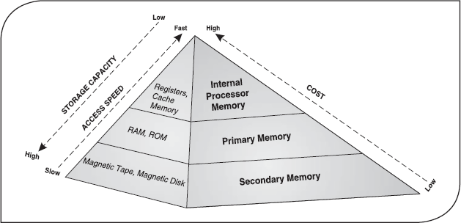

3.1 Introduction
Computers are used to perform various tasks in science, engineering, business, education, entertainment and many other fields. They work at high speed, can handle large volumes of data with great accuracy and have the ability to carry out a specified sequence of operations without human intervention. The CPU handles the processing of data and after processing, presents the results with the help of output devices. However, the CPU requires memory to process the data, hold the intermediate results and to store the output. Computer memory refers to the electronic holding place for instructions and data where the processor can reach quickly. It can be classified into two broad categories: primary memory (to process the data and hold the intermediate results) and secondary memory (to store the output).
The primary memory allows the computer to store data for immediate manipulation and to keep track of what is currently being processed. The major limitation of this type of memory is that it is volatile. It means that when the power is turned off, the contents of primary memory are lost forever. Hence, to store the data permanently, a computer requires some nonvolatile storage medium like a hard disk. This kind of storage is known as secondary memory. Such memories store all the data (files) and instructions (computer programs) even after the power is turned off. The secondary storage devices have a larger storage capacity; they are less expensive as compared to primary storage devices, but slow in comparison.
All quantities, physical or otherwise, are measured in units. For example, length is measured in metres and mass in grams. Likewise, for measuring computer memory, a standard unit is required. Digital computers work on only two states: ON (1) and OFF (0). These two values are represented by two different voltages within the circuit. For example, 0 volt represents a false value (0), and +5 volt represents a true value (1). Each of these values (either 0 or 1) is called a binary digit or bit and can be considered a symbol for a piece of information. Although the smallest unit of data that a computer can deal with is a bit, computers generally do not deal with a single bit. Instead, they deal with a group of eight bits, which is referred to as a byte. A byte can have 256 different bit patterns, and thus can represent 256 different symbols. Various units used to measure computer memory are as follows:
- Bit: It is the smallest unit of data on a machine and a single bit can hold only one of two values: 0 or 1. Bit is represented by a lower case b.
- Byte: A unit of eight bits is known as a byte. Hence, a byte is able to contain any binary number between 00000000 and 11111111. It is represented by an upper case B.
- Kilobyte: In a decimal system, kilo stands for 1000, but in a binary system, kilo refers to 1024. Therefore, a kilobyte is equal to 1024 bytes. It is usually represented as KB.
- Megabyte: It comprises 1024 kilobytes, or 1,048,576 bytes. However, since this number is hard to remember, a megabyte can be thought of as a million bytes. Megabyte is the standard unit of measurement for RAM and is represented as MB.
- Gigabyte: It consists of 1024 megabytes (1,073,741,824 bytes). It is the standard unit of measurement for hard disks and is often represented as GB.
- Terabyte: It refers to 1024 gigabytes. Often represented as TB, terabyte memory is usually associated with super computers only.
Note: In modern computers, groupings of bytes (usually 2 or 4), called computer words can represent larger “chunks” of information.

3.2 Memory hierarchy
The processor is the “brain” of the computer where all the essential computing takes place. But unlike a human brain, a computer processor has very limited memory. Thus, it has to rely on other kinds of memories to hold data and instructions and to store results. The memory in a computer system is of three fundamental types:
- Internal Processor Memory: This memory is placed within the CPU (processor) or is attached to a special fast bus. Internal memory usually includes cache memory and special registers, both of which can be directly accessed by the processor. This memory is used for temporary storage of data and instructions on which the CPU is currently working. Processor memory is the fastest among all the memories but is the most expensive also. Therefore, a very diminutive part of internal processor memory is used in the computer system. It is generally used to compensate for the speed gap between the primary memory and the processor.
- Primary Memory: Random access memory (RAM) and read only memory (ROM) fall under the category of the primary memory, also known as main memory. Every computer comes with a small amount of ROM, which contains the boot firmware (called BIOS). This holds enough information to enable the computer to check its hardware and load its operating system into its RAM at the time of system booting. RAM is the place where the computer temporarily stores its operating system, application programs and current data so that the computer's processor can reach them quickly and easily. It is volatile in nature, that is, when the power is switched off, the data in this memory are lost. Unlike RAM, ROM is non-volatile. Even when the computer is switched off, the contents of the ROM remain available.
- Secondary Memory: Also known as auxiliary memory, secondary memory provides backup storage for instructions (computer programs) and data. The most commonly used secondary storage devices are magnetic disk and magnetic tapes. These are the least expensive and also have much larger storage capacity than the primary memory. The instructions and data stored on secondary storage devices are permanent in nature. They can only be removed if the user wants it so or if the device is destroyed. Secondary memory can also be used as overflow memory (also known as virtual memory), when the capacity of the main memory is surpassed. Note that unlike processor memory and main memory, secondary memory is not directly accessible to the processor. Firstly, the data and instructions from the secondary memory have to be shifted to the main memory and then to the processor.
Figure 3.1 illustrates the memory hierarchy. The CPU accesses memory according to a distinct hierarchy. When the data come from permanent storage (for example, hard disk), they first go in RAM. The reason behind it is that if the CPU has to access the hard disk constantly to retrieve every piece of required data, it would operate very slowly. When the data are kept in primary memory, the CPU can access them more quickly. Subsequently, the CPU stores the required pieces of data and instructions in processor memory (cache and registers) to process the data.

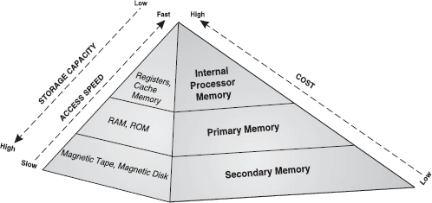

Figure 3.1 Memory Hierarchy

3.3 Random access memory
RAM is like the computer's scratch pad. It allows the computer to store data for immediate manipulation and to keep track of what is currently being processed. It is the place in a computer where the operating system, application programs and data in current use are kept so that they can be accessed quickly by the computer's processor. RAM is much faster to read from and write to than the other kinds of storage in a computer, like the hard disk or floppy disk. However, the data in RAM stay there only as long as the computer is running. When the computer is turned off, RAM loses all its contents. When the computer is turned on again, the operating system and other files are once again loaded into RAM. When an application program is started, the computer loads it into RAM and does all the processing there. This allows the computer to run the application faster. Any new information that is created is kept in RAM and since RAM is volatile in nature, one needs to continuously save the new information to the hard disk.
Let us take a simple example of why RAM is used by the computer. Whenever a user enters a command from the keyboard, the CPU interprets the command and instructs the hard disk to “load” the command or program into main memory (see Figure 3.2). Once the data are loaded into memory, the CPU is able to access them much quickly. The reason behind this is that the main memory is much faster than secondary memory. The process of putting things that the CPU needs in a single place from where it can get them more quickly is similar to placing various documents, which the user needs, into a single file folder. By doing so, the user finds all the required files handy and avoids searching in several places every time he needs them.

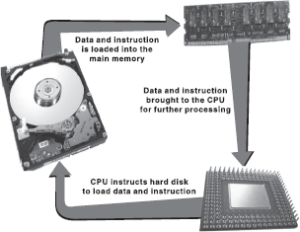

Figure 3.2 Interaction of Memory and Storage with Processor

RAM is of two types:
- Static RAM (SRAM): The word “static” indicates that the memory retains its contents as long as power is being supplied. However, as soon as the power goes down, the data are lost. This makes SRAM a volatile memory as opposed to ROM. SRAM does not need to be “refreshed” (pulse of current through all the memory cells) periodically. It is very fast but much more expensive than DRAM (Dynamic RAM). SRAM is often used as cache memory due to its high speed.
- Dynamic RAM (DRAM): It is named so because it is very unstable. The data continue to move in and out of the memory as long as power is available. Unlike SRAM, DRAM must be continually refreshed in order to maintain the data. This is done by placing the memory on a refresh circuit that rewrites the data several hundred times per second. DRAM is used for most system memory because it is inexpensive and small.
The primary difference between SRAM and DRAM is the life of the data they store. SRAM retains its contents as long as electrical power is supplied to the chip. If the power is turned off, its contents are lost. On the other hand, DRAM must be continuously refreshed after about every 15 microseconds. This is true even when power is supplied constantly. SRAM chips are not as dense as DRAM chips, that is, the total number of cells in the SRAM chip is less than that on DRAM chip. SRAM is beneficial because it is fast, has low latency (the time lag between a request and the action being performed), and does not need to be refreshed. However, it is large and expensive, requires more power to operate, and produces a lot of heat. DRAM is simple, small, and space efficient. It may be slower and may have a longer latency than SRAM, but it is still very useful. Typical access time of SRAM is 25 nanoseconds while of DRAM 60 nanoseconds.
SRAM is useful for low amount of memory. Anything over 4 MB is very bulky. SRAM is good for internal memory in processors, and cache, but DRAM is best for the system's main memory. DRAM is used where its small size and power efficiency outweigh its slowness as compared to SRAM. SRAM is less dense than DRAM (fewer bits per unit area) and is, therefore, not suitable for high-capacity, low-cost-per-megabyte applications. The power consumption of SRAM varies widely depending on its speed. Fast SRAM is much more power-hungry than DRAM and some ICs can consume power of the order of a watt at full speed. Slow SRAM can have very low power consumption in the region of a microwatt. Currently, the technology does not exist to produce small SRAMs so that they can replace DRAMs. Thus, DRAM is still used in computers.

3.4 Read only memory
Just as a human being needs instructions from the brain to perform actions in a certain event, a computer also needs special instructions every time it is started. This is required because during the start up operation, the main memory of the computer is empty due to its volatile property so there have to be some instructions (special boot programs) stored in a special chip that could enable the computer system to perform start up operations and transfer the control to the operating system. This special chip, where the start up instructions are stored, is called ROM. It is non-volatile in nature, that is, its contents are not lost when the power is switched off. The data and instructions stored in ROM can only be read and used but cannot be altered, thereby making ROM much safer and secure than RAM. ROM chips are used not only in the computer but also in other electronic items like washing machines and microwave ovens.
Generally, designers program ROM chips at the time of manufacturing circuits. Burning appropriate electronic fuses to form patterns of binary information does the programming. These patterns of binary information are meant for specific configurations, which is why different categories of computers are meant for performing different tasks. For example, a micro program called system boot program contains a series of start-up instructions to check for the hardware, that is, I/O devices, memory and operating system in the memory. These programs deal with low-level machine functions and are alternate for additional hardware requirement. ROM performs the necessary BIOS (basic input output system) function to start the system and then transfers the control over to the operating system.
ROM can have data and instructions written into it only one time. Once a ROM chip is programmed, it cannot be reprogrammed or rewritten. If it is erroneous, or the data need to be reorganized, one has to replace it with the new chip. Thus, the programming of ROM chips should be perfect, having all the required data at the time of its manufacturing. Note that in some instances, ROM can be changed using certain tools. For example, flash ROM (a type of ROM) is non-volatile memory that occasionally can be changed, such as when a BIOS chip must be updated. The ROM chips consume very little power, are extremely reliable, and in the case of most small electronic devices, contain all the necessary programming to control the device.

Types of ROM
Memories in the ROM family are distinguished by the methods used to write data on them and the number of times they can be rewritten. This classification reflects the evolution of ROM devices from “hard-wired” to programmable to erasable-and-programmable. One common feature of all these devices is their ability to retain data and programs even during a power failure. ROMs come in following varieties:
- Masked ROM: The very first ROMs, known as masked ROMs, were hard-wired devices that contained a pre-programmed set of data or instructions. The contents of such ROMs had to be specified before chip production so the actual data could be used to arrange the transistors inside the chip.
- Programmable ROM (PROM): Creating a ROM chip from scratch is a time-consuming and an expensive process. For this reason, developers created a type of ROM known as programmable read only memory (PROM), which can be programmed. Blank PROM chips can be bought economically and coded by the users with the help of a special device known as PROM-programmer. However, once a PROM has been programmed, its contents can never be changed. As a result, PROM is also known as one-time programmable (OTP) device. Like other ROMs, PROM is also non-volatile. However, it is more fragile than other ROMs as a jolt of static electricity can easily cause the fuses in the PROM to burn out, thus changing the bit pattern from 1 to 0. Nevertheless, blank PROMs are economical and are great for prototyping the data for a ROM before committing to the costly ROM fabrication process.
- Erasable Programmable ROM (EPROM): An EPROM is programmed in exactly the same manner as a PROM. However, unlike PROM, an EPROM can be erased and reprogrammed repeatedly. It can be erased by simply exposing the device to a strong source of ultraviolet light for a certain amount of time. Note that an EPROM eraser is not selective; it will erase the entire EPROM. Although EPROM is more expensive than PROM, its ability to be reprogrammed makes it more useful.
- Electrically Erasable Programmable ROM (EEPROM): This type of ROM can be erased by an electrical charge and then written to by using slightly higher-than-normal voltage. EEPROM can be erased one byte at a time, rather than erasing the entire chip with ultraviolet light. Hence, the process of reprogramming is flexible, but slow. Also, changing the contents does not require any additional committed equipment. As these chips can be changed without opening a casing, they are often used to store programmable instructions in devices like printers.
- Flash ROM: A flash ROM also called flash BIOS or flash memory, is a type of constantly powered non-volatile memory that can be erased and reprogrammed in blocks. It is a variation of EEPROM, which, unlike flash memory, is erased and rewritten at the byte level. Flash memory is often used to hold the control code such as the BIOS in a personal computer. When BIOS needs to be changed or rewritten, the flash memory can be written in block (rather than byte) sizes, thus making it easier to update. Flash memory gets its name because the microchip is organized so that a section of memory cells are erased in a single action or “flash”. Flash memory is used in digital cellular phones, digital cameras and other devices.

3.5 Types of secondary storage devices
Secondary storage devices facilitate storing of data and instructions permanently. The data stored on a secondary storage device can be accessed depending upon how it is stored on the device. Primarily, there are two methods of accessing data from the secondary storage devices (see Figure 3.3):

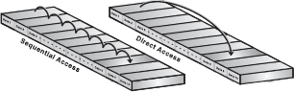

Figure 3.3 Sequential and Direct Access

- Sequential Access: Sequential access means the computer system must search the storage device from the beginning until the desired data is found. The most common sequential access storage device is magnetic tape where data is stored and processed sequentially. Suppose, a tape contains information regarding employees of an organization. Now, to look for employee number 100's information, the computer will have to start with employee number 1 and then go past 2, 3 and so on, until it finally comes to 100. The sequential access method is quite simple than other methods but searching for data is slow.
- Direct Access: Direct access, also known as random access, means that the computer can go directly to the location, where the data that the user wants, are stored. The most common direct access storage devices are magnetic disk and optical disk. In these devices, the data are stored as sequentially numbered blocks. Thus, one can access block 12, then access block 78, then block 2 and so on. The direct access method is ideal for applications like airline reservation systems or computer-based directory assistance operations. In these cases, there is no fixed pattern of requests for data.
Based on the access method, secondary storage devices can be classified as shown in Figure 3.4.

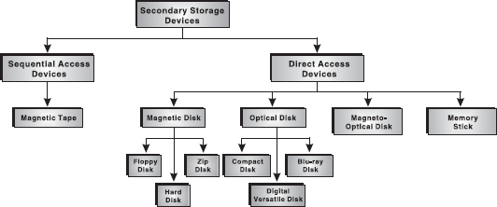

Figure 3.4 Classification of Secondary Storage Devices

3.6 Hard Disk
The hard disk, also called the hard drive or fixed disk, is the primary storage unit of the computer. It consists of a stack of disk platters that are made up of aluminium alloy or glass substrate coated with a magnetic material and protective layers (see Figure 3.5). They are tightly sealed to prevent any dust particle, which causes head crash, from getting inside. A hard disk can be external (removable) or internal (fixed) and can hold a large amount of data. The capacity, that is, the amount of information that a hard disk can store, is measured in bytes. A typical computer today comes with 80–320 GB of hard disk. The storage capacity of hard disk has increased dramatically since the day it was introduced. The hard disk speed is measured in terms of access time (typically in milliseconds). A hard disk with lower access time is faster than a hard disk with higher access time; the lower the access time, the faster the hard disk.

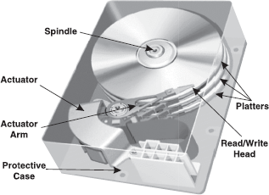

Figure 3.5 Hard Disk

Read/Write Operation of a Hard Disk: A hard disk uses round, flat disks (platters) made up of glass or metals which are coated on both sides with a special material designed to store information in the form of magnetic patterns. Each platter has its information recorded in tracks, which are further broken down into smaller sectors. Making a hole in the centre of platters and stacking them onto a spindle mount the platters. The platters rotate at high speed, driven by a special motor connected to the spindle. Special electromagnetic read/write heads are mounted onto sliders and are used to either record data onto the disk or read data from it. The sliders are mounted onto arms, all of which are mechanically connected into a single assembly and positioned over the surface of the disk by a device called actuator. Each platter has two heads, one on the top of the platter and one on the bottom, so a hard disk with three platters would have six surfaces and six heads.
Data are recorded onto the magnetic surface of the disk in exactly the same way as they are on floppies. However, a disk controller is attached to the hard disk drive that handles the read/write commands issued by the operating system. Each read/write command specifies a disk address that comprises the surface number, track number and sector number. With this information, the read/write head moves to the desired sector that data can be read from or written to. Usually, the next set of data to be read is sequentially located on the disk.

3.7 Universal serial bus (USB)
Universal serial bus (USB), developed by Intel, is a set of connectivity specifications that establishes communication between personal computers and devices such as mouse, keyboard, pen drive, external hard disk drives, etc. Nowadays, almost every computer or laptop is equipped with one or more USB ports. The USB connector is a narrow socket around 1 cm wide and 0.5 cm high.
All USB devices come with a USB connector that is plugged into the USB port on the computer. As you plug in a USB device, it is detected by the computer and the required software is configured automatically; there is no need to restart the computer. Another advantage of USB is that it determines (and provides) the electrical power required by the device connected to it.

3.7.1 Pen Drive
A pen/flash drive is a removable storage device that is frequently used nowadays to transfer audio, video, and data files from one computer to another. A pen drive consists of a small printed circuit board, which is fitted inside a plastic, metal, or rubber casing to protect it. The USB connector which is present at one end of pen drive is protected by either a removable cap or pulling it back in the casing. Figure 3.6 shows a pen drive.

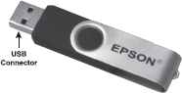

Figure 3.6 Pen Drive

The pen drive is a high-storage–capacity (ranging from 1 GB to 32 GB) device and is physically small enough to fit into a pocket. In addition, it is fast, robust and reliable and requires very less power to operate, which it gets through a USB port, and hence no battery is required.
Using a pen drive is easy. Following are the steps to use pen drive.
- Insert the pen drive in the USB port of a computer. The computer detects the device, configures the necessary software and displays a drive corresponding to the pen drive in My Computer.
- Perform any of the following actions:
  - Double-click the drive icon in My Computer to access the files stored in the pen drive.
  - Right-click the file or folder you want to send to the pen drive, which displays a menu. SelectSend To and select the drive corresponding to the pen drive from the sub menu that appears.
- After performing all your actions, left-click the Safely Remove Hardware icon in the system tray to display a menu containing Safely remove USB Mass Storage Device option.
- Select this option to display a notification icon indicating that it is now safe to remove the hardware and plug-out the pen drive.

3.7.2 External Hard Disk Drive
External hard disk drive is a type of hard drive that resides in its own enclosure (called hard drive cage) outside the computer case and is connected to the system through interfaces like USB (Figure 3.7). With the addition of USB interfaces in the personal computer, external hard drive has become quite popular in the computer market. The storage capacity of external hard disk ranges from 20 GB to several TBs and it is compatible with operating systems that support interface standards such as USB MSC (mass storage class) and IEEE1394.

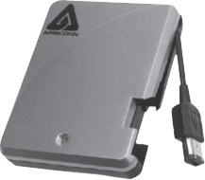

Figure 3.7 An External Hard Disk Drive with USB Connector

The internal structure and functioning of an external hard disk drive is similar to the internal hard disk drive. Hence, the external hard disk drive is a reliable and high capacity storage media. In addition, it is portable and provides the plug and play feature. It means just plug in the connector of external hard drive into the USB interface and access the stored data as well as transfer data to/from the external hard disk drive.
These features of external hard disk make it suitable to be used for taking backup. Using an external hard disk drive as a means of backup for important (or sensitive) data is advantageous. This is because you can unplug the external hard drive when not in use to protect your data from being compromised by online or offline activities.

LET US SUMMARIZE
- Computer memory refers to the electronic holding place for instructions and data where the processor can reach quickly.
- Various units that are used to measure computer memory are bit, byte, kilobyte, megabyte, gigabyte and terabyte.
- A computer's memory can be categorized into three fundamental types: internal processor memory, primary memory and secondary memory.
- Internal processor memory is placed within the CPU (processor) and usually includes cache memory and special registers, both of which can be directly accessed by the processor. This memory is used for temporary storage of data and instructions on which the CPU is currently working.
- Primary memory consists of RAM, which is volatile in nature, and ROM, which is nonvolatile in nature.
- RAM, also called main memory, allows the computer to store data for immediate manipulation and to keep track of what is currently being processed. It is the place in a computer where the operating system, application programs and data in current use are kept so that they can be accessed quickly by the computer's processor.
- SRAM stands for static random access memory. It retains its contents as long as power is being supplied and does not require constant periodic refreshing. It is often used as cache memory due to its high speed.
- DRAM stands for dynamic random access memory. The data on DRAM continues to move in and out of the memory as long as power is available, and thus DRAM must be continually refreshed in order to maintain the data. DRAM is slower and less expensive than SRAM.
- The non-volatile memory chip, where the start-up instructions (special boot program) are stored is called ROM. These chips are programmed by burning appropriate fuses to form patterns of binary information.
- The hard disk is the primary storage unit of the computer. It consists of a stack of disk platters that are made up of aluminium alloy or glass substrate coated with a magnetic material and protective layers. It plays a significant role in: performance, storage capacity, software support and reliability.
- USB, developed by Intel, is a set of connectivity specification that establishes communication between personal computers and devices such as mouse, keyboard, pen drive, external hard disk drives, etc.
- In order to achieve a vast amount of storage capacity in a computer system, multiple units of similar kinds of storage media are associated together to form a chain of mass storage devices. These storage media include multiple arrays of magnetic disks or CD-ROMs as a secondary storage device.

Exercises

Fill in the Blanks
- .................. refers to the electronic holding place for instructions and data in a computer system.
- The time period lag between a request made and the action being performed is called ..................
- The memory that requires constant refreshing to preserve the information is called ..................
- .................. memory provides backup storage for instructions and data that are not currently being used by the processor.
- The two types of data access methods available with secondary storage devices are .................. and ..................

Multiple-choice Questions
- Which of the following is the largest memory size?
  - Terabyte
  - Gigabyte
  - Kilobyte
  - Megabyte
- The access time refers to
  - Time required to locate and retrieve stored data
  - Time required to locate the lost data
  - Time required to delete specific data on a certain memory location
  - None of these

State True or False
- A terabyte comprises 1024 megabytes.
- The ROM chip, which can be rewritten several times and requires the action of ultraviolet radiations to erase its contents, is EPROM.
- The memory which is utmost accessible to the processor is hard disk.
- The speed of memory depends upon the access time of data that is stored.
- Floppy disk can be made write-protected.

Descriptive Questions
- What are the types of memories available in the computer system? How are they organized in a hierarchy?
- What is ROM? Differentiate between EPROM and EEPROM.
- With the help of diagrams, explain how RAM, ROM and CPU interact with each other.
- What are mass storage devices? How are they useful in storing large amounts of data?
- Explain how read/write operation is carried out in an optical disk.

ANSWERS

Fill in the Blanks
- Memory
- Latency
- DRAM
- Auxiliary
- Sequential access, Direct access

Multiple-choice Questions
- (a)
- (a)

State True or False
- False
- True
- False
- True
- True

Chapter 4. Input Output Media

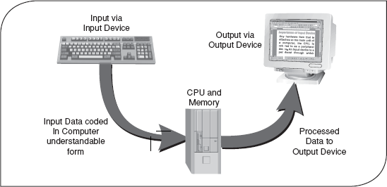

4.1 Introduction
Previously, we discussed that a computer accepts input and processes it to get a desired output according to the sequence of instructions. Essentially, a computer system consists of four components: input devices, CPU, output devices and memory. Input devices are used to provide data to the CPU for processing. After processing, the input data is converted into meaningful information and this output is presented to the user with the help of output devices. In computer terminology, a device can be referred to as a unit of hardware, which is capable of providing input to the computer or receiving output, or both.
An input device is an electromechanical device that allows the user to feed information into the computer for analysis, storage and to give commands to the computer. Data and instructions are entered into the computer's memory through an input device. It captures information and translates it into a form that can be processed and used by the other parts of the computer. After processing the input data, the computer provides the results with the help of output devices. An output device converts machine-readable information into human-readable form. The basic functioning of the output device is just the opposite of the input device, that is, the data is “fed into” the computer system through the input device while the output is “taken out” from the computer through the output device. However, the output, which comes out from the CPU, is in the form of digital signals (see Figure 4.1). The output devices display the processed information by converting them into graphical, alphanumeric, or audio-visual form.

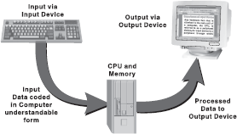

Figure 4.1 Data Processing

As we know, the processing of the data by the computer system can be viewed as a three-step process:

Step 1 | Data input via an input device.
Step 2 | Processing of data.
Step 3 | Data output via an output device.

Input devices play a major role in the processing of any data via the computer system because the output of the computer is always based on the given input. Generally, data that is given to the input devices is raw. Therefore, it is the function of the input devices to manipulate the raw data and then send them for further processing. The preparation of the computerized input is the initial step in the creation of useful output. This output must be supplied to the outside world, which is done through output devices.

4.2 Types of input devices
Computer accepts input in two ways, either manually or directly. In case of manual data entry, the user enters the data into computer by hand, for example, by using keyboard and mouse. A user can also enter data directly by transferring information automatically from a source document (like from a cheque using MICR) into the computer. The user does not need to enter information manually. Direct data entry is accomplished by using special direct data entry devices like a barcode reader. Some of the commonly used input devices are keyboard, pointing devices like mouse and joystick, speech recognition, digital camera and scanners.

4.2.1 Keyboard
A keyboard is the most common data entry device. Using a keyboard, the user can type text and commands. The keyboard is designed to resemble a regular typewriter with a few additional keys (seeFigure 4.2). Data is entered into the computer by simply pressing keys. The layout of the keyboard has changed very little since it was introduced. In fact, the most common change in its technology has simply been the natural evolution of adding more keys that provide additional functionality. The number of keys on a typical keyboard varies from 84 to 104.

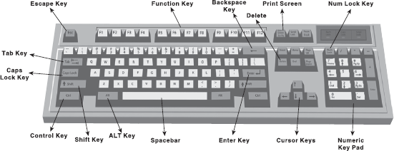

Figure 4.2 Keyboard

Portable computers such as laptops quite often have custom keyboards that have slightly different key arrangements than a standard keyboard. In addition, many system manufacturers add special buttons to the standard layout. A keyboard is the easiest input device, as it does not require any special skill. Usually, it is supplied with a computer so no additional cost is incurred. The maintenance and operational cost of a keyboard is also less. However, using a keyboard for data entry may be a slow process because the user has to manually type all the text. In addition, it can be difficult for people suffering from muscular disorders.
How does the keyboard work? A keyboard is a series of switches connected to a small keyboard microprocessor that monitors the state of each switch and initiates a specific response to a change in state. When the user presses a key, it causes a change in the amount of current flowing through the circuit associated specifically with that key. The keyboard microprocessor detects this change in current flow. By doing this, the processor can tell when a key has been pressed and when it is being released. Depending upon which key's Figure 4.3 Working of a Keyboard circuit carries a signal to the microprocessor, the processor generates the associative code, known as scan code, of the key and sends it to the operating system (see Figure 4.3). A copy of this code is also stored in the keyboard's memory. When the operating system reads the scan code, it informs the same to the keyboard and the scan code stored in keyboard's memory is then erased.

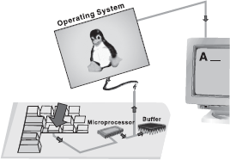

Figure 4.3 Working of a Keyboard

Initially, the processor filters all the tiny current fluctuations out of the signal and treats it as a single key press. If the user continues to hold down a key, the processor determines that the user wishes to send that character repeatedly to the computer. In this process, the delay between each instance of character can normally be set in the operating system, typically ranging from 2–30 characters/second (cps).

4.2.2 Pointing Devices
Most computers come with an alphanumeric keyboard but in some applications, the keyboard is not convenient. For example, if the user wants to select an item from a list, the user can identify that item's position by selecting it through the keyboard. However, this action could be performed quickly by pointing at the correct position. A pointing device is used to communicate with the computer by pointing to locations on the monitor screen. Such devices do not require keying of characters; instead the user can move a cursor on the screen and perform move, click, or drag operations. Some of the commonly used pointing devices are mouse, trackball, joystick, light pen, touch screen and trackpad.
Mouse: A Mouse is a small handheld pointing device with a rubber ball embedded at its lower side and buttons on the top. Usually, a mouse contains two or three buttons, which can be used to input commands or information (see Figure 4.4). It may be classified as a mechanical mouse or an optical mouse, based on the technology it uses. A mechanical mouse uses a rubber ball at the bottom surface, which rotates as the mouse is moved along a flat surface, to move the cursor. It is the most common and least expensive pointing device. An optical mouse uses a light beam instead of a rotating ball to detect movement across a specially patterned mouse pad. As the user rolls the mouse on a flat surface, the cursor on the screen also moves in the direction of the mouse's movement. It is pricier than their mechanical counterparts but are accurate and often do not need a mouse pad.



Figure 4.4 Mouse
A mouse allows us to create graphic elements on the screen such as lines, curves and freehand shapes. Since it is an intuitive device, it is easier and convenient to work as compared to the keyboard. Like a keyboard, it is also supplied with a computer; therefore, no additional cost is incurred. However, it needs a flat space close to the computer. The mouse cannot easily be used with laptop (notebook) or palmtop computers. These types of computers need a trackball or a touch sensitive pad called atouchpad.
Trackball: A Trackball is another pointing device that resembles a ball nestled in a square cradle and serves as an alternative to a mouse. In general, a trackball is as if a mouse is turned upside down (see Figure 4.5). It has a ball, which can be rotated by fingers in any direction, the cursor moves accordingly. The size of the ball in the trackball varies from as large as a cue ball, to as small as a marble. Since it is a static device, instead of rolling the mouse on the top of the table the ball on the top is moved by using fingers, thumbs and palms.

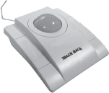

Figure 4.5 Trackball

Like the mouse, a trackball is also used to control cursor movements and the actions on a computer screen. The cursor is activated when buttons on the device are pressed. However, the trackball remains stationary on the surface, only the ball is moved with the fingers or palm of the hand. By moving just the fingers and not the entire arm, the user can get more precision and accuracy, which is why many graphic designers and gamers choose to use trackball instead of mouse. In addition, since the whole device is not moved for moving the graphic cursor, a trackball requires less space than a mouse for operation. A trackball, generally, tends to have more buttons. A lot of computer game enthusiasts and graphic designers also tend to choose to have more buttons to cut down on keyboard use. These extra buttons can also be re-programmed to suit whatever functions they require. Trackballs are not supplied normally so an additional cost is always charged. Moreover, before using them, a user has to learn how to use them.
Joystick: A joystick is a device that moves in all directions and controls the movement of the cursor. The basic design of a joystick consists of a stick that is attached to a plastic base with a flexible rubber sheath. This plastic base houses a circuit board that sits beneath the stick. The electronic circuitry measures the movement of the stick from its central position and sends the information for processing. A joystick also consists of buttons which can be programmed to indicate certain actions once a position on the screen has been selected using stick (see Figure 4.3). It offers three Figure 4.3 Joystick types of control: digital, glide and direct. Digital control allows movement in a limited number of directions such as up, down, left and right. Glide and direct control allow movements in all directions (360°). Direct control joysticks have the added ability to respond to the distance and speed with which the user moves the stick.

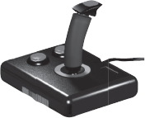

Figure 4.6 Joystick

A joystick is generally used to control the velocity of the screen cursor movement rather than its absolute position. It is used for computer games. The other applications in which it is used are flight simulators, training simulators, CAD/CAM systems and for controlling industrial robots.

Light Pen: A light pen (sometimes called mouse pen) is a hand-held electro-optical pointing device which a when touched to or aimed closely at a connected computer monitor, will allow the computer to determine where on that screen the pen is aimed. It facilitates drawing images and selects objects on the display screen by directly pointing to the objects. It is a pen-like device, which is connected to the machine by a cable (see Figure 4.7). Although named light pen, it actually does not emit light but its light-sensitive diode would sense the light coming from the screen. The light coming from the screen causes the photocell Figure 4.7 Light Pen to respond by generating a pulse. This electric response is transmitted to the processor that identifies the position to which the light pen is pointing. With the movement of light pen over the screen, the lines or images are drawn.

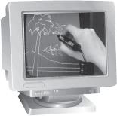

Figure 4.7 Light Pen

Light pens give the user the full range of mouse capabilities without the use of a pad or any horizontal surface. Using light pens, users can interact more easily with applications, in such modes as drag and drop, or highlighting. It is used directly on the monitor screen and it does not require any special hand–eye coordinating skills. Pushing the light pen tip against the screen activates a switch, which allows the user to make menu selections, draw and perform other input functions. Light pens are perfect for applications where desk space is limited, in harsh workplace environments, and any situation where fast accurate input is desired. It is very useful to identify a specific location on the screen. However, it does not provide any information when held over a blank part of the screen. A light pen is economically priced and requires little or no maintenance.

Touch Screen: A touch screen is a special kind of input device that allows the direct selection of a menu item or the desired icon with the touch of finger (see Figure 4.8). Essentially, it registers the input when a finger or other object is touched to the screen. It is normally used when information has to be accessed with minimum effort. However, it is not suitable for input of large amounts of data. Typically, it is used in information-providing systems like hospitals, airlines and railway reservation counters, amusement parks, and so on.

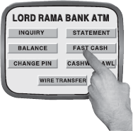

Figure 4.8 Touch Screen

Trackpad: Trackpad (also referred to as touchpad) is a stationary pointing device that works by sensing the movement of fingers across a small sensitive surface (1.5 or 2 inches) and translating them into the pointer movement on the screen (see Figure 4.9). It is generally used in laptops but can also be connected to a PC through a cord. It is also equipped in personal digital assistants (PDAs) and media players such as the iPod. Typically, a trackpad also consists of two or three buttons which work as mouse buttons. Many trackpads are also strike sensitive, that is, the user can tap on the trackpad to perform operations like selecting an object, maximizing/ minimizing the window, etc.

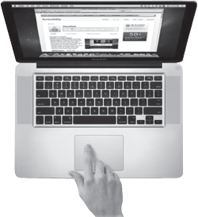

Figure 4.9 Trackpad

4.2.3 Scanners
There are a number of situations when some information (picture or text) is available on paper and is needed on the computer for further manipulation. A scanner is an input device that converts a document into an electronic format that can be stored on the disk. The electronic image can be edited, manipulated, combined and printed by using the image editing software. Scanners are also called optical scanners as they use a light beam to scan the input data.
Note that most scanners come with a utility program that allow them to communicate with the computer and save the scanned images as a graphic files on the computer. Moreover, they can store images in both greyscale and colour mode. The two most common types of scanners are hand-held scanners and flatbed scanners.
Hand-held Scanner: A hand-held scanner consists of LEDs, which are placed over the document to be scanned (Figure 4.20). This scanner performs the scanning of the document very slowly from the top to the bottom with its light on. In this process, all the documents are converted and then stored as images. While working, the scanner is dragged very steadily and carefully over the document at a constant speed without stopping or jerking in order to obtain best results. Hand-held scanners are widely used where high accuracy is not of much importance. The size of the hand-held scanners is small. They come in various resolutions, up to about 800 dpi (dots per inch) and are available in either greyscale or colour. Furthermore, they are used when the volume of the documents to be scanned is low. These devices read the data on price tags, shipping labels, inventory part numbers, book ISBNs and so on.



Figure 4.10 Hand-held Scanner

Flatbed Scanner: A flatbed scanner looks similar to a photocopier machine. It consists of a box containing a glass plate on its top and a lid that covers the glass plate (Figure 4.11). This glass plate is used for placing the document to be scanned. The light beam is placed below the glass plate and when it is activated, it moves horizontally from left to right. After scanning one line, the light beam moves in order to scan the next line and the procedure is repeated until all the lines are scanned. Scanning an A4 size document takes about 20 seconds. These scanners can scan black and white as well as colour images. Flatbed scanners are larger in size and more expensive than hand-held scanners. However, they usually produce better quality images because they employ better scanning technology.

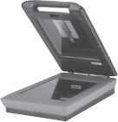

Figure 4.11 Flatbed Scanner

4.2.4 Bar Code Reader
Bar code is a machine-readable code in the form of a pattern of parallel vertical lines of varying widths. It is commonly used for labelling goods that are available in super markets and numbering books in libraries. This code is sensed and read by a bar code reader using reflective light (Figure 4.12). The information recorded in the bar code reader is then fed into the computer, which recognizes the information from the thickness and spacing of bars. Bar code readers are either hand-held or fixed-mount. Hand-held scanners are used to read bar codes on stationary items. With fixed-mount scanners, items having a bar code are passed by the scanner by hand, as in retail scanning applications or by conveyor belts in many industrial applications.

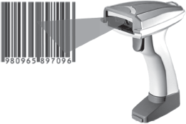

Figure 4.12 Bar Code Reader

Bar code data correction systems provide enormous benefits for just about every business with a bar code data-collection solution; capturing data is faster and more accurate. A bar code scanner can record data five to seven times faster than a skilled typist. A bar code data entry has an error rate of about 1 in 3 million. Bar coding also reduces cost in terms of labour and revenue losses resulting from data collection errors. Bar code readers are widely used in supermarkets, department stores, libraries and other places. You must have seen bar code on the back cover of certain books and greeting cards. Retail and grocery stores use a bar code reader to determine the item being sold and to retrieve the item price from a computer system.
Bar code scanners are electro-optical systems that include a means of illuminating the symbol and measuring reflected light. The light waveform data are converted from analog to digital, in order to be processed by a decoder, and then transmitted to the computer software. The process begins when a device directs a light beam over a bar code. The device contains a small sensory reading element, called sensor, which detects the light being reflected back from the bar code, and converts light energy into electrical energy. The result is an electrical signal that can be converted into alphanumeric data. The pen in the bar code unit reads the information stored in the bar code and converts it into a series of ASCII characters by which the operating system gets the information stored in the bar code.

4.3 Types of output devices
Output is data that have been processed into useful information. It can be displayed or viewed on a monitor, printed on a printer, or listened through speakers or a headset. Generally, there are two basic categories of output: the output which can be readily understood and used by humans, and which is stored on secondary storage devices so that the data can be used as input for further processing. The output which can be easily understood and used by human beings are of the following two forms:
- Hard Copy: The physical form of output is known as hard copy. In general, it refers to the recorded information copied from a computer onto paper or some other durable surface such as microfilm. Hard copy output is permanent and a relatively stable form of output. This type of output is also highly portable. Paper is one of the most widely used hard copy output media. The principal examples are printouts, whether text or graphics from printers.
- Soft Copy: The electronic version of an output, which usually resides in computer memory and/or on disk, is known as soft copy. Unlike hard copy, soft copy is not a permanent form of output. It is transient and is usually displayed on the screen. This kind of output is not tangible, that is, it cannot be touched. Soft copy output includes audio and visual form of output, which is generated using a computer. In addition, textual or graphical information displayed on a computer monitor is also a soft copy form of output.
Based on the hard copy and soft copy outputs, the output devices are classified into hard copy and soft copy output devices. Printers, plotters and microfilms are the most commonly used hard copy output devices while monitors, voice response systems, projectors, electronic whiteboards, and headphones and headsets are some commonly used soft copy output devices.

4.3.1 Printers
Ever since the dawn of computer age, producing printed output on paper has been one of the computer's principal functions. A printer prints information and data from the computer onto paper. Generally, the printer prints 80 or l32 columns of characters in each line, and prints either on single sheets or on a continuous roll of paper, depending upon the printer itself. The quality of a printer is determined by the clarity of a print it can produce, that is, its resolution. Resolution is used to describe the sharpness and clarity of an image. The higher the resolution, the better the image. For printers, the resolution is measured in dpi (dots per inch). The more the dpi, the better will be the quality of image. The dots are so small and close together that they project the image as a solid one. If a printer has a resolution of 600 dpi, it means that the printer is capable of printing 360,000 dots per square inch.
Printers are divided into two basic categories: impact printers and non-impact printers. As their names specify, impact printers work by physically striking a head or needle against an ink ribbon to make a mark on the paper. This includes dot matrix printers, daisy wheel printers and drum printers. In contrast, ink-jet and laser printers are non-impact printers. They use techniques other than physically striking the page to transfer ink onto the page.
Dot Matrix Printer: Dot matrix printer (also known as the wire matrix printer) uses the oldest printing technology and it prints one character at a time (Figure 4.13). It prints characters and images as pattern of dots. The speed of dot matrix printers is measured in characters per second (cps). Most dot matrix printers offer different speeds depending on the quality of print desired. The speed can vary from about 200 to over 500 cps. The print quality is determined by the number of pins (the mechanisms that print the dots), which can vary from 9 to 24. The more pins per inch, theFigure 4.28 Dot Matrix higher the print resolution. The best dot matrix printers Printer (24 pins) can produce near letter-quality-type image. Most dot matrix printers have a resolution ranging from 72 to 360 dpi.

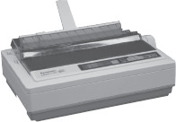

Figure 4.13 Dot Matirx Printer

Dot matrix printers are inexpensive and have low operating costs. These printers are able to use different types of fonts, different line densities and different types of paper. Many dot matrix printers are bi-directional, that is, they can print the characters from either direction— left or right. The major limitation of the dot matrix printer is that it prints only in black and white. In addition, as compared to printers like laser printers, they produce low to medium quality printing. The image printing ability is also very limited. These printers may not be able to print graphic objects adequately but can handle applications such as accounting, personnel and payroll very well. Dot matrix printers are commonly used in low-cost, low-quality applications like cash registers. These printers are limited to situations where carbon copies are needed and the quality is not too important.
Drum Printer: The dot matrix wheel printer are character or serial printers, that is, they print one character at a time. However, a drum printer (shown in Figure 4.14) is a line printer, that is, it can print a line in a single operation. Generally, a line printer is used because of its speed as it uses special tractor-fed paper with pre-punched holes along each side. This arrangement allows a continuous high-speed printing. Its printing speed varies from 300 lines to 2000 lines per minute with 96–160 characters on a 15-inch line. Although such printers are much faster than character printers, they tend to be quite loud, have limited multi-font capability and often produce lower print quality than most recent printing technologies. Line printers are designed for heavy printing applications. For example, in businesses where enormous amounts of materials are printed, the low-speed character printers are very slow; therefore, the users need high-speed line printers. Although, drum printers have high speed of printing, they are very expensive and their character fonts cannot be changed. Moreover, the strike of the hammer should be precise. A single mistimed strike of the hammer may lead to wavy and slightly blurred printing.

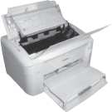

Figure 4.14 Drum Printer

Ink-jet Printer: The most common type of printer found in homes today is the ink-jet printer (seeFigure 4.15). An ink-jet printer is a printer that places extremely small droplets of ink onto paper to create an image. Being a non-impact printer, it does not touch the paper while creating an image. Instead, it uses a series of nozzles to spray drops of ink directly onto the paper. Inkjets were originally manufactured to print in monochrome (black and white) only. However, the print head has now been expanded and the nozzles increased to accommodate cyan (C), magenta (M), yellow (Y) and black (K). This combination of colours is called CMYK. It allows for printing images with nearly Figure 4.15 Ink-jet Printer the same quality as a photo development lab using certain types of coated paper.

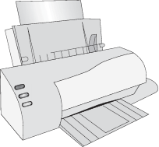

Figure 4.15 Ink-Jet Printer

Ink-jet printers are costlier than dot matrix printers and the quality is much better. These printers can print any shape of character, which a user can specify, as they produce printed output as patterns of tiny dots. This allows the printer to print many special characters, different sizes of prints, and enables it to print graphics such as charts and graphs. Ink-jet printers typically print with a resolution of 600 dpi or more. Due to the high resolution, these printers produce high quality graphics and text printouts. They are also affordable, which appeals to small businesses and home offices. These printers print documents at a medium pace but slow down if printing a document with multi-colours. These printers can print about six pages a minute and can be programmed to print symbols such as Japanese or Chinese characters.
Laser Printer: A laser printer provides the highest quality text and images for personal computers today (see Figure 4.16). It is a very fast printer, which operates on the same principle as that of a photocopy machine. Most laser printers can print text and graphics with a very high quality resolution. They are also known as page printers because they process and store the entire page before they actually print it. They produce sharp, crisp images of both text and graphics, providing resolutions from 300 to 2400 dpi. Today, the resolution of most printers is 600 dpi. They are quiet and fast, are able to print 4–32 text-only pages per minute for individual microcomputers and up to 200 pages per minute for mainframes. Laser printers can print in excess of 2000 lines per minute. Furthermore, they can print in different fonts, that is, type styles and sizes. Laser printers are often faster than ink-jet printers but are more expensive to buy and maintain than the other printers. The cost of these printers depends on a combination of costs of paper, toner replacement, and drum replacement. These printers are useful for volume printing because of their speed.

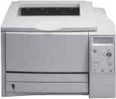

Figure 4.16 Laser Printer

Hydra Printer: Hybrid document reproduction apparatus (HYDRA) printer, popularly known as all-in-one printer, is a device that consolidates the capabilities of multiple devices in one machine (see Figure 4.17). It may include some or all of the devices like printer, scanner, photocopier and fax machine. Apart from these devices, some hydra printers contain memory card slots which facilitate easier printing of photos and also have the in-built wireless capabilities that make Figure 4.19 Hydra Printer sharing of this printer with other systems easier.

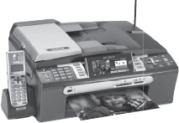

Figure 4.17 Hydra Printer

Following are the features that must be considered to evaluate these printers:
- Print speed
- Maximum resolution
- Memory card compatibility
- Scanner resolution
- Fax speed
Hydra printers are useful for small organizations due to their small size, less space requirement and cost effectiveness. The cost of these printers depend on the technology (inkjet or laser) being used. They save power to a great extent as only one power outlet is required for performing various operations. They are easy to install and maintain and have easy-to-use GUI (graphical user interface) that help users to understand their functions easily.

4.3.2 Plotters
A plotter is a pen-based output device that is attached to a computer for making vector graphics, that is, images created by a series of many straight lines. It is used to draw high-resolution charts, graphs, blueprints, maps, circuit diagrams and other line-based diagrams. It is similar to a printer, but it draws lines using a pen. As a result, it can produce continuous lines, whereas a printer can only simulate lines by printing a closely spaced series of dots. Multicolour plotter uses different coloured pens to draw different colours. Colour plots can be made by using four pens (cyan, magenta, yellow and black) and need no human intervention to change them.
Being vector-based, a plotter tends to draw much crisper lines and graphics. The lines drawn by these devices are continuous and very accurate. However, the plotter is considered a very slow output device because it requires excessive mechanical movement to plot. Furthermore, it is unable to produce solid fills and shading. Plotters are relatively expensive as compared to printers but can produce more printouts than standard printers. They are mainly used for Computer Aided Design (CAD) and Computer Aided Manufacturing (CAM) applications such as printing out plans for houses or car parts. These are also used with programs like AUTOCAD (computer assisted drafting) to give graphic outputs. As shown in Figure 4.18, there are two different types of plotters: drum plotter (where the paper moves) and flatbed plotter (where the paper is stationary).

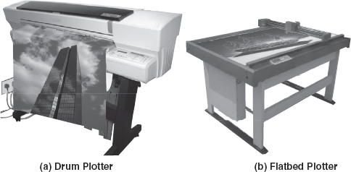

Figure 4.18 Plotters

- Drum Plotter: In drum plotters, the paper on which the design is to be printed is placed over a drum. These plotters consist of one or more pen(s) that are mounted on a carriage which is horizontally placed across the drum. The drum can rotate in either clockwise or anticlockwise direction under the control of plotting instructions sent by the computer. In case a horizontal line is to be drawn, the horizontal movement of the pen is combined with the vertical movement of the page via the drum. The curves can also be drawn by creating a sequence of very short straight lines. In these plotters, each pen can have an ink of a different colour to produce multicolour designs. Drum plotters are used to produce continuous output such as plotting earthquake activity or for long graphic output such as tall building structures.
- Flatbed Plotter: Flatbed plotters consist of a stationary, horizontal plotting surface on which paper is fixed. The pen is mounted on a carriage, which can move horizontally, vertically, leftwards or rightwards to draw lines. In flatbed plotters, the paper does not move, the pen-holding mechanism provides all the motion. These plotters are instructed by the computer on the movement of pens in the x – y coordinates on the page. These plotters are capable of working on any standard, that is, from A4 size paper to some very big beds. Depending on the size of the flatbed surface, these are used in designing of ships, aircrafts, buildings and so on. The major disadvantage of this plotter is that it is a slow output device and can take hours to complete a complex drawing.

4.3.4 Monitor
The monitor is the most frequently used output device for producing soft-copy output. A computer monitor is a TV-like display attached to the computer on which the output can be displayed and viewed. The computer monitor can either be a monochrome display or a colour display. A monochrome screen uses only one colour (usually white, green, amber or black) to display text on contrasting background. Colour screens commonly display 256 colours at one time from a selection of over 256,000 choices. Monitors are available in various sizes like 14, 15, 17, 19 and 21 inches. The size of the display is described based on two parameters: aspect ratio and screen size (see Figure 4.19). Aspect ratio is the ratio of the width of the display screen to the height, that is, the ratio of vertical points to the horizontal points necessary to produce equal-length lines in both directions on the screen. Generally, computer displays have an aspect ratio of 4:3. Like televisions, screen sizes are normally measured diagonally (in inches), the distance from one corner to the opposite corner.

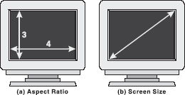

Figure 4.19 Aspect Ratio and Screen Size

Sometimes, while watching television, you may notice that the picture looks a bit blurred. The reason behind this is that the displayed image is not solid but is created by the configurations of dots. These dots are known as picture elements, pels, or simply pixels. The golden rule of a sharp image is that the more the pixels, the sharper the picture. The screen clarity depends on three basic qualities:
- Resolution: It refers to the number of pixels in the horizontal and vertical directions on the screen. In medium-resolution graphics, pixels are large, whereas in high-resolution graphics, pixels are small. The average CRT display is currently 800 × 600 or 1024 × 768. The more dots, or pixels, available to create the image, the sharper it will be. Therefore, a resolution of 1024 × 768 will produce sharper images (for example, smaller icons and more information) than one of 640 × 480.
- Dot Pitch: It is the measurement of the diagonal distance between two like-coloured (red, green or blue) pixels on a display screen. It is measured in millimetres and common dot pitches are .51 mm, .31 mm, Pixel .28 mm, .27 mm, .26 mm and .25 mm. The Figure 4.20 Dot Pitch smaller the dot pitch, the sharper will be the image when displayed on the monitor. Generally, a dot pitch of less than .31 mm provides clear images. Multimedia and desktop-publishing users typically use .25 mm dot-pitch monitors (see Figure 4.20).

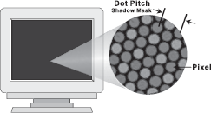

Figure 4.20 Dot Pitch

- Refresh Rate: It is the number of times per second the pixels are recharged so that their glow remains bright. Normally, screen pixels are made from phosphor. An electron beam strikes the phosphor and causes it to emit light, resulting in the display of the image. However, it needs to be Refreshed periodically because the phosphors hold their glow for just a fraction of a second. The Refresh rate for a monitor is measured in Hertz (Hz) and varies from 60 to 75 Hz. A Refresh rate of 60 Hz means image is redrawn 60 times a second. The higher the Refresh rate, the more solid the image looks on the screen, that is, it does not flicker.
Colour Depth: Colour depth, also referred to as bit depth, refers to the number of bits assigned to each pixel in the image and the number of colours that can be created from those bits. In simple words, it refers to the number of colours that a monitor can display. Different colour depths depend on the amount of display memory dedicated to each pixel. One byte is used to represent 256 colours for each pixel, 16 bits (or 2 bytes) per pixel allows up to 65535 colours, and 24-bit (or 3 bytes) colour can display 16.8 million different colours per pixel. 8-bit colour is better known as pseudo colour, 16-bit mode as high colour, and 24-bit mode is called true colour. A video display unit consists of a video card or adapter that is fitted into an expansion slot and a compatible visual display, which is compatible with the video adapter. The combination of the display modes supported by the graphics adapter and the colour capability of the monitor determine how many colours can be displayed.
Differences between LCD and CRT: Although both the CRT and LCD monitors are the most frequently used types of displays in computers, they are worlds apart in terms of what is important when making a purchase decision. Here is a brief discussion of what is different about LCD monitors.
Size: LCD is lightweight and compact, which saves desktop space as compared to a CRT.
Resolution: LCD is designed to work in a single resolution while CRT is designed for many resolutions.
Pixel Density: Pixel density of LCD is generally not as tight as the dot pitch in CRT but for most applications, the density is acceptable.
Brightness: The illuminated phosphor of a CRT is not nearly as bright as what the LCD can produce with its florescent backlight.
Power Consumption: LCD consumes significantly less power than CRT and has a low emission risk. Typically, a LCD consumes approximately half of the power of a typical CRT.
Flicker: With CRT monitors, the goal is to get a faster Refresh rate of at least 85 Hz,but LCD monitors are designed to run at a much slower Refresh rate (usually about 60 Hz) and flicker is never an issue.
Pixel Response Time: The time taken by a pixel to change its state is called pixel response time. CRT has extremely fast pixel response time but LCD can be quite slow. As a result, the user might see “ghost images” when there is movement on the screen. The fastest LCD monitors today have a response time of 25 milliseconds, which is still only about half the speed of a CRT monitor.
Viewing Angle: CRT can be viewed at almost any angle but LCD is best viewed “head on”. Even when viewing an LCD head on, narrow viewing angles can appear to have inconsistent colour and brightness.
Viewing Area: The viewing area of a CRT is usually less than its advertised area. Most 19-inch CRT monitors, for example, typically have about 18 inches of viewable area. However, the LCD monitors are measured exactly, that is, if a LCD monitor is advertised as 17.4 inch, it is the same.
Cost: Prices for LCD screens are quite high but they are coming down. They are still much more costlier than CRT.
Other Types of Monitors: Although CRT and LCD displays are the most commonly used, other kinds of displays also exist. Some of them are as follows:
- Plasma Display: A plasma display (also known as thin-panel) is constructed by filling a gas (neon or xenon) between the two glass plates. One glass plate consists of vertical conductors and the other consists of horizontal conductors. When the voltage is applied to the pair of horizontal and vertical conductors, the gas at the intersection of two conductors glows. The advantage of plasma display is that it has the capability of producing more than 16 million colours and is lighter and less bulky than CRT. However, it is heavier than LCD display and requires more power.
- Thin-film Electroluminescent Display: This display is similar to the plasma display except the fact that the space between the glass plates is filled with phosphorescent substance (usually zinc sulfide doped with manganese) instead of gas. When high voltage is applied to the crossing conductors, the phosphoric substance at the intersection of two conductors becomes conductor and generates the electrical energy. This energy is absorbed by the manganese atoms and then released as a spot of light. The main problem with thin-film electroluminescent displays is that they require more power.

4.3.5 Projector
Projectors have an important place in history, as its growth led to the first moving pictures of the late 19th century, and soon to television. They have allowed the world to share greater information pertaining to culture, technology, medicine and community. Screen image projector is an output device, which is used to project information from a computer on to a large screen, so that it can be simultaneously viewed by a large group of people.
Types of Projectors: Projectors are mainly of two types:
- LCD Projectors: LCD is the established technology used by most of the leading manufacturers. Most of today's LCD projectors contain three separate LCD glass panels, one each for red, green and blue components of the image signal being fed into the projector.
- DLP Projectors: DLP is the acronym for digital light processing. It is a proprietary technology developed by Texas Instruments. DLP uses a single digital mirror device (DMD) chip that has thousands of tiny mirrors, each representing a single pixel.

4.3.6 Headphone and Headset
Headphone is an audio device equipped with a pair of speakers attached to a headstrap worn by the users. Headphones are used with almost all electronic devices such as portable computers, CD/DVD players, mp3 players, iPod, etc. They comprise high-quality speakers, are light in weight and very comfortable to wear. They can be easily connected to a computer via a mini stereo plug.
The headphones allow the users to listen only; however, some applications like live chats, videoconferencing and telecalling services demand the user to also speak at the same time. For such applications, a headset is used instead of a headphone. A headset is a combination of one or two speakers and a Figure 4.21 Headphone and Headset microphone with both the speaker and the microphone attached to a headstrap. The speaker(s) allows the person to hear the conversation and the microphone allows the user to communicate with the person on the other end (see Figure 4.21).
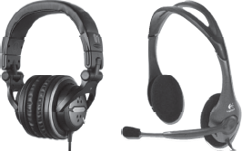

Figure 4.21 Headphone and Headset

LET US SUMMARIZE
- An input device is an electromechanical device that accepts data or information from the user and translates the information into a form which the computer can interpret.
- Keyboards are the most commonly used data entry devices. By pressing down the keys of the keyboard, data are entered into the computer.
- Pointing devices are the input devices by which we can point out and select items rapidly from the multiple options displayed on the screen. These devices can also be used to create graphic elements on the screen such as lines, curves and freehand shapes. The common types of pointing devices available are the mouse, trackball, joysticks, touch screens and light pens.
- Mouse is a small hand-held pointing device which can be used to input commands or information. It contains two or three buttons and by pressing one of the buttons, the mouse either marks a place on the screen or makes selections from the data on the screen. Common types of mouse action available are pointing, click, double-click, right-click and drag and drop.
- A trackball is an upturned mouse, with a movable ball on the top of a stationary base. It is used to control the cursor movements and the actions on a computer screen. It allows the user to perform each of these tasks separately.
- Joystick is a device that moves in all directions and controls the movement of the pointer. It activates the computer with different parts and is used to control the cursor on the screen.
- Using a light pen, one can select the objects on the monitor by directly pointing to the objects. It is useful for identifying a specific location. Since the light pen is a passive device with a sensor only, it provides no information when held over a blank part of the screen.
- A touch screen is a type of display screen device that is placed on the computer monitor in order to allow direct selection or activation of the computer when somebody touches the screen. It registers the input when a finger or other object touches the screen. It consists of three main components: a touch sensor, a controller and a software driver.
- Trackpad (also referred to as touchpad) is a stationary pointing device that works by sensing the movement of fingers across a small sensitive surface (1.5 or 2 inches) and translating them into the pointer movement on the screen.
- A scanner is a device that scans an image and transforms the image to ASCII codes. These images can be edited, manipulated, combined and then printed. The common types of scanners are: handheld and flatbed.
- Bar codes are machine-readable codes, represented in parallel vertical lines with varying widths. By the combination of these vertical lines (bars) and the spacing between them, bar codes represent the alphanumeric data. For reading these bar-coded data, a device is used, which is known as a bar code reader.
- An output device is an electromechanical device, which converts machine-readable data or information into human-readable form. The printed form of output is referred to as hard copywhile the form of output displayed on the screen is referred to as soft copy.
- Based on the hard copy and soft copy outputs, the output devices are classified into: hard copyand soft copy output devices. Printers, plotters and microfilms are the most commonly usedhard copy output devices while monitors, voice response systems, projectors, electronic whiteboards, and headphones and headsets are some commonly used soft copy output devices.
- A printer is a device that prints information from the computer on to paper. The two major categories of printer technologies are impact printers and non-impact printers.
- An impact printer forms characters and graphics on a piece of paper by striking a mechanism against an ink ribbon that comes into physical contact with the paper. It includes dot matrix printers, daisy wheel printers and drum printers.
- Printers that form characters and images without making direct contact between printing mechanism and paper are called non-impact printers. They are categorized as ink-jet printersand laser printers.
- Hybrid document reproduction apparatus (HYDRA) printer, popularly known as all-in-one printer, is a device that consolidates the capabilities of multiple devices in one machine. It may include some or all of the devices like printer, scanner, photocopier and fax machine. Plotters are special-purpose drawing devices, which reproduce graphic images on paper using a pen whose movements are controlled by the computer. The lines drawn by these devices are continuous and very accurate. Plotters are classified as pen plotters and electrostatic plotters.
- Computer monitor is used to display the keyed data on the screen and to receive messages and processed information from the computer.
- The standard computer system can talk with the addition of two components: a speechsynthesizer and a screen reading software. A speech synthesizer is a software that converts text information into spoken sentences. Screen reading software enables the user to control the synthesizer. It allows a user to access, or view text that is present on the screen.
- Headphone is an audio device equipped with a pair of speakers which are attached via a headstrap worn by the users. A headset is a combination of one or two speakers and a microphone with both the speakers and the microphone attached to a headstrap.

Exercises

Fill in the Blanks
- Mouse and light pen are examples of ............... input devices.
- Two basic methods used for optical character recognition (OCR) are ............... and
- ............... is a machine-readable code in the form of parallel vertical lines.
- MICR stands for ...............
- The bar-coded data represent the ............... and a device, which is used for reading the bar-coded data, is known as ...............
- The most used layout of a keyboard is ...............
- The printed form of output is referred to as ............... and the form of output, which is shown on a display screen, is referred to as...............
- An impact printer, which gives only alphanumeric output, is called...............
- ............... plotters are computer graphics devices that use drum or flatbed paper holder.
- A non-impact printer that forms an image by spraying ink from a matrix of tiny jets is called ...............
- The mouse may be classified as ............... or ...............
- ............... is the oldest printing technology.
- The quality of the monitor is generally judged by considering four basic terms ..............., ..............., ..............., and ...............
- The number of bits used to describe a pixel is known as ...............
- A computer can talk to persons through a device known as...............

Multiple-choice Questions
- ............... is the most commonly used input device.
  - Keyboard
  - Mouse
  - Joystick
  - Scanner
- Mouse, trackball and joystick are the examples of ...............
  - Scanning devices
  - Storing devices
  - Pointing devices
  - Multimedia devices
- Which of the following is not a computer terminal?
  - Intelligent
  - Smart
  - Both (a) and (b)
  - None of these
- Choose the most suitable device among the following for playing computer games.
  - Hand-held scanner
  - Joystick
  - Optical Mark Reader
  - Digital Camera
- Which of the following is not a pointing device?
  - Scanner
  - Trackball
  - Light Pen
  - Mouse
- Which of the following is not an output device?
  - Printer
  - Keyboard
  - Monitor
  - Plotter
- With the combinations of ..............., ............... and ............... colours, other colours can be shown.
  - Red, Black, Blue
  - Yellow, Blue, Green
  - Red, Blue, Green
  - Black, White, Yellow
- Which of the following is used for both input and output?
  - Computer Terminals
  - Pen Plotter
  - Dot Matrix Printer
  - None of these
- The ............... is also called as letter quality printer.
  - Dot Matrix Printer
  - Ink Jet Printer
  - Daisy Wheel Printer
  - Laser Printer
- An individual small dot, which one sees on the computer screen is called ...............
  - Font
  - Character
  - Screen Point
  - Pixel
- LCD stands for ...............
  - Liquid Colour Display
  - Light Colour Display
  - Lithium Crystal Display
  - Liquid Crystal Display

State True or False
- Any hardware item that is attached to the CPU is referred to as peripheral device.
- Impact printers are slower as compared to non-impact printers.
- The speed of a printer is measured by character per minute.
- Audio response is a soft copy output.
- Dot pitch can be changed by the user.
- Plotters are best suited for desktop publishing.
- Bank cheques are an example of bar code marking.
- More pixels per square inch mean better resolution.
- A digital camera's photographs can be stored in a computer's hard disk.
- The most common aspect ratio used in computer monitors is 4:4.
- Raster scan monitors draw a picture one line at a time and for this reason they are referred to as vector displays, stroke-writing, or calligraphic displays.
- Ultrasonic acoustic waves are one of the most commonly used touch screen techniques.
- 16-bits colour allows up to 256 colours.

Descriptive Questions
- Why are input and output devices necessary for a computer system?
- What are pointing devices? Discuss some of the commonly used pointing devices.
- What is a touch screen device? Explain with their advantages and disadvantages and give some typical applications for which touch screen is most suitable as an input device.
- What is a speech recognition system? Explain its types and give logical reasons. Why do currently available speech recognition devices have limited success?
- What do you mean by optical scanning devices? Explain any four such devices.
- Explain the different types of printers. Make a clear difference between them in terms of speed, cost and method of operation, and suggest suitable applications.
- Describe the application areas where plotters are useful. Discuss the various types of plotters.
- What is speech synthesizer? How does it function? Give some of its typical applications.
- What is LCD? Differentiate between CRT and LCD monitors.
- Write short notes on the following:
  - Resolution
  - Aspect ratio
  - Dot pitch
  - Refresh rate
  - Colour depth

ANSWERS

Fill in the Blanks
- Pointing
- Matrix matching, Feature extraction
- Bar code
- Magnetic ink character recognition
- Alphanumeric data, Bar code reader
- QWERTY
- Hard copy, Soft copy
- Pen
- Ink-jet
- Mechanical mouse, Optical mouse
- Dot Matrix
- Size, Resolution, Refresh rate, Dot pitch
- Resolution
- Speech synthesizer

Multiple-choice Questions
- (a)
- (c)
- (c)
- (b)
- (a)
- (b)
- (c)
- (a)
- (c)
- (a)
- (d)

State True or False
- True
- True
- False
- True
- False
- False
- False
- False
- True
- True
- False
- False
- True
- False

Chapter 5. Operating System

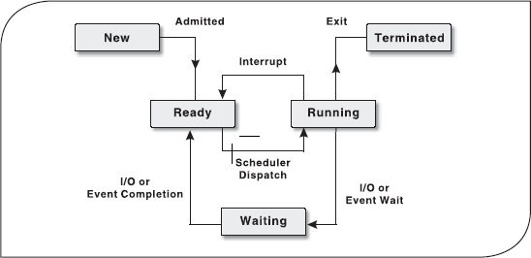

5.1 Introduction
In the early days of computer use, computers were huge machines, which were expensive to buy, run and maintain. The user at that time interacted directly with the hardware through machine language. A software was required which could perform basic tasks such as recognizing input from the keyboard, sending output to the display screen, keeping track of files and directories on the disk, and controlling peripheral devices such as printers and scanners. The search for such software led to the evolution of modern day operating system (OS). This software is loaded onto the top of memory and performs all the aforesaid basic tasks. Initially, the OS's interface was only character-based. This interface provides the user with a command prompt and the user has to type all the commands to perform various functions. As a result, the user had to memorize many commands. With the advancement in technology, OS became even more user friendly by providing graphical user interface (GUI). The GUI-based OS allows the user to interact with the system using visual objects such as windows, pull-down menus, mouse pointers and icons. Consequently, operating the computer became easy and intuitive.

5.2 Operating system: definition
An operating system is a collection of system programs that together controls the operation of a computer system. The OS along with hardware, applications, other system software and users constitute a computer system as shown in Figure 5.1. It is the most important part of any computer system. It acts as an intermediary between a user and the computer hardware. The OS has two objectives.

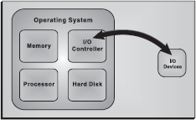

Figure 5.1 Managing Hardware

Managing Hardware: The prime objective of the OS is to manage and control various hardware resources of a computer system. These hardware resources include processor, memory, disk space, I/O devices and so on. The OS supervises which input device's data is requesting for being processed and which processed data is ready to be displayed on the output device. In addition to communicating with hardware, the OS provides an error handling procedure and displays an error notification. If a device is not functioning properly, the OS tries to communicate with the device again. If it is still unable to communicate with the device, it provides an error message notifying the user about the problem. Figure 5.2 illustrates how an OS manages the hardware resources of a computer system.

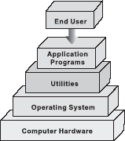

Figure 5.2 Computer System Components

Providing an Interface: The OS organizes applications so that users can easily access, Figure 5.2 Computer System use and store them. When an application is Components opened, the OS assists the application to provide the major part of the user interface. It provides a stable and consistent way for applications to deal with the hardware without the user having to know all the details of the hardware. If the application program is not functioning properly, the OS again takes control, stops the application and displays an appropriate error message.

5.3 Evolution of operating system
In the early days, the computers lacked any form of OS. The user would arrive at the machine armed with his program and data, often on punched paper tape. The program would be loaded into the machine and the machine set to work. Then came machines with libraries of support code (initial OSs), which were linked to the user's program to assist in operations such as input and output. At this stage, OSs were very diverse with each vendor producing one or more OSs specific to its particular hardware. Typically, whenever new hardware architecture was introduced, there was a need of new OS compatible with the new architecture. This state of affairs continued until 1960s when IBM developed the S/360 series of machines. Although there were enormous performance differences across the range, all the machines ran essentially the same OS called S/360.
Then came the small 4 bit and 8 bit processors known as microprocessors. The development of microprocessors provided inexpensive computing for the small businesses. This led to the widespread use of interchangeable hardware components using a common interconnection, and thus creating an increasing need for standardized OS to control them. The most important among the early OSs was CP/M-80 for the 8080/8085/Z-80 microprocessors. With the development of microprocessors like 386, 486 and the Pentium series by Intel, the whole computing world got a new dimension. AT&T and Microsoft came up with character-based OSs, namely, Unix and Disk OS, respectively, which supported the prevalent hardware architectures. After the character-based OSs, Microsoft and Apple Macintosh came with their Windows 3.1 and MAC, which were GUI-based OSs and well suited for the Desktop PC market. Today, OSs such as Windows XP and Red Hat Linux have taken the driver's seat in personal desktops. These OSs with their remarkable GUI and network support features can handle diverse hardware devices.

5.4 Types of operating systems
The OS has evolved immensely from its primitive days to the present digital era. From batch processing systems to the latest embedded systems, the different types of OSs can be classified into six broad categories.
Batch Processing OS: This type of OS was one of the first to evolve. Batch processing OS allowed only one program to run at a time. These kinds of OSs can still be found on some mainframe computers running batches of jobs. Batch processing OS works on a series of programs that are held in a queue. The OS is responsible for scheduling the jobs according to priority and the resources required. Batch processing OSs are good at churning through large numbers of repetitive jobs on large computers. For example, this OS would be best suited for a company wishing to automate their payrolls. A list of employees will be entered, their monthly salaries will be calculated, and corresponding pay slips would be printed. Batch processing is useful for this purpose since these procedures are to be repeated for every employee and each month.
Multi-user or Time-sharing OS: This system is used in computer networks which allow different users to access the same data and application programs on the same network. The multi-user OS builds a user database account, which defines the rights that users can have on a particular resource of the system.
Multi-programming OS: In this system, more than one process (task) can be executed concurrently. The processor is switched rapidly between the processes. Hence, a user can have more than one process running at a time. For example, a user on his computer can have a word processor and an audio CD player running at the same time. The multi-tasking OS allows the user to switch between the running applications and even transfer data between them. For example, a user can copy a picture from an Internet opened in the browser application and paste it into an image editing application.
Real-time OS (RTOS): This system is designed to respond to an event within a predetermined time. This kind of OS is primarily used in process control, telecommunications and so on. The OS monitors various inputs which affect the execution of processes, changing the computer's model of the environment, thus affecting the output, within a guaranteed time period (usually less than one second). As the real-time OSs respond quickly, they are often used in applications such as flight reservation systems, railway reservation systems, military applications, etc.
Multi-processor OS: This system can incorporate more than one processor dedicated to running processes. This technique of using more than one processor is often called parallel processing. The main advantage of multi-processor systems is that they increase the system throughput by getting more work done in less time.
Embedded OS: It refers to the OS that is self-contained in the device and resident in the ROM. Since embedded systems are usually not general-purpose systems, they are lighter or less resource intensive as compared to general-purpose OSs. Most of the embedded OSs also offer real-time OS qualities. Typical systems that use embedded OSs are household appliances, car management systems, traffic control systems and energy management systems.

5.5 Functions of operating systems
The main functions of a modern OS are as follows:
- Process Management: As a process manager, the OS handles the creation and deletion of processes, suspension and resumption of processes, and scheduling and synchronization of processes.
- Memory Management: As a memory manager, the OS handles the allocation and de-allocation of memory space as required by various programs.
- File Management: The OS is responsible for creation and deletion of files and directories. It also takes care of other file-related activities such as organizing, storing, retrieving, naming and protecting the files.
- Device Management: The OS provides input/output subsystem between process and device driver. It handles the device caches, buffers and interrupts. It also detects the device failures and notifies the same to the user.
- Security Management: The OS protects system resources and information against destruction and unauthorized use.
- User Interface: The OS provides the interface between the user and the hardware. The user interface is the layer that actually interacts with the computer operator. The interface consists of a set of commands or menus through which a user communicates with a program.

5.5.1 Process Management
A process is an execution of a sequence of instructions or program by the CPU. It can also be referred to as the basic unit of a program that the OS deals with, with the help of the processor. For example, a text editor program running on a computer is a process. This program may cause several other processes to begin—like it can furnish a request for printing while editing the document. Thus, we can say that the text editor is a program that initiates two processes—one for editing the text and second for printing the document.
Hence, a process is initiated by the program to perform an action, which can be controlled by the user or the OS. A process in order to accomplish a task needs certain resources like CPU time, memory allocation and I/O devices. Therefore, the idea of process management in an OS is to accomplish the process assigned by the system or the user in such a way that the resources are utilized in a proper and efficient manner.
Life Cycle of a Process: The OS is responsible for managing all the processes that are running on a computer and allocating each process a certain amount of time to use the processor. In addition, the OS also allocates various other resources that processes need during execution, such as computer memory or disk space. To keep track of all the processes, the OS maintains a table known as theprocess table. This table stores many pieces of information associated with a specific process, that is, program counter, allocated resources, process state, CPU-scheduling information, and so on.
Initially, a process is in the new state. When it becomes ready for execution and needs the CPU, it switches to the ready state. Once the CPU is allocated to the process, it switches to the running state. From the running state, the process goes back to the ready state if an interrupt occurs or to the waiting state if the process needs some I/O operation. In case the process has switched to ready state, it again comes to running state after the interrupt has been handled. On the other hand, if the process has switched to waiting state, then after the completion of I/O, it switches to ready state and then to running state. Thus, a process continues to switch among the ready, running and waiting states during its execution. Finally, it switches to terminated state after completing its execution as shown in Figure 5.3.

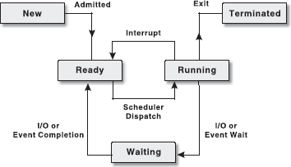

Figure 5.3 Life Cycle of a Process

5.5.2 Memeory Management
In addition to managing processes, the OS also manages the primary memory of the computer. The part of the OS that handles this job is called memory manager. Since every process must have some amount of primary memory to execute, the performance of the memory manager is crucial to the performance of the entire system. As the memory is central to the operation of any modern OS, its proper use can make a huge difference. The memory manager is responsible for allocating the main memory to processes and for assisting the programmer in loading and storing the contents of the main memory. Managing the main memory, sharing, and minimizing memory access time are the basic goals of the memory manager. The major tasks accomplished by the memory manager so that all the processes function in harmony, are as follows:
- Relocation: Each process must have enough memory to execute.
- Protection and Sharing: A process should not run into another process's memory space.
Relocation: When a process is to be executed, it has to be loaded from the secondary storage (like hard disk) to the main memory (RAM). This is called process loading. Since, the main User Space memory is limited and other processes also need it for their execution, an OS swaps the two processes, which is called swapping (see Figure 5.4). Once the process is “swapped out”, it is uncertain to say when it will be “swapped in” because of the number of processes running concurrently.

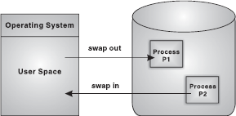

Figure 5.4 Process Swapping

Normally, when the process is swapped back into the main memory, it will be placed back to the same memory space that it occupied previously. However, in certain cases, it is not possible to place the process at the same memory location. This is not of much importance if the process is not address-sensitive. However, if the process requires some of its data or instruction to occupy the memory with a specific address, the process needs to be relocated. It is the responsibility of the memory manager to modify the addresses used in address-sensitive instructions (that use memory addresses) of the process so that it can execute correctly from the assigned area of memory.
Protection and Sharing: In multiprogrammed systems, as a number of processes may reside in the main memory at the same time, there is a possibility that a user program, during execution, may access the memory location allocated either to other user processes or to the OS. It is the responsibility of the memory manager to protect the OS from being accessed by other processes and the processes by one another. At the same time, the memory protection program should be flexible enough to allow concurrent processes to share the same proportion of the main memory. For example, consider a program that initiates different processes. If the memory manager allocates the same portion of memory to all the processes instead of different memory allocations to different processes, a lot of memory is saved. Therefore, the memory protection routine of the OS should allow controlled sharing of the memory among different processes without letting them breach the protection criteria. If a process attempts to modify the contents of memory locations that do not belong to it, the memory protection routine intervenes and usually terminates the program.
Memory Allocation: In uniprogramming systems, where only one process runs at a time, memory management is very simple. The process to be executed is loaded into the part of memory space that is unused. Early MS-DOS systems support uniprogramming. The main challenge of efficiently managing memory comes when a system has multiple processes running at the same time. In such a case, the memory manager can allocate a portion of primary memory to each process for its own use. However, the memory manager must keep track of the running processes along with the memory locations occupied by them, and must also determine how to allocate and de-allocate available memory when new processes are created and old processes have finished their execution, respectively.

5.5.3 File Management
File system is one of the most visible aspects of the OS. It provides a uniform logical view of the information storage, organized in terms of files, which are mapped onto the underlying physical device like the hard disk. While the memory manager is responsible for the maintenance of the primary memory, the file manager is responsible for the maintenance of the file system. In the simplest arrangement, the file system contains a hierarchical structure of data. This file system maintains user data and metadata (the data describing the files of the user data). The hierarchical structure usually contains the metadata in the form of directories of files and sub-directories. Each file is a named collection of data stored on the disk. The file manager implements this abstraction and provides directories for organizing files. It also provides a spectrum of commands to read/write the contents of a file, to set the read/write position, to use the protection mechanism, to change the ownership, to list files in a directory, and to remove a file. The file manager provides a protection mechanism to allow users to administer how processes executing on behalf of different users can access the information contained in different files.
The file manager also provides a logical way for users to organize files in the secondary storage. To assist users, most file managers allow files to be grouped into a bundle called a directory or a folder.This allows a user to organize his or her files according to their purpose by placing related files in the same directory. By allowing directories to contain other directories, called sub-directories, a hierarchical organization can be constructed. For example, a user may create a directory calledgames that contains sub-directories called cricket, football, golf, rugby and tennis (see Figure 5.5). Within each of these sub-directories are files that fall within that particular category. A sequence of directories within directories is called a directory path.

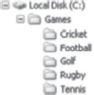

Figure 5.5 File System

5.5.4 Device Management
Device management in an OS refers to the process of managing various devices connected to the computer. The device manager manages the hardware resources and provides an interface to hardware for application programs. A device communicates with the computer system by sending signals over a cable. The device communicates with the machine through a connection point calledport. The communication using a port is done through rigidly defined protocols, like when to send the data and when to stop. These ports are consecutively connected to a bus (a set of wires) which one or more device uses to communicate with the system. The OS communicates with the hardware with the help of standard software provided by the hardware vendor called device drivers. A device driver works as a translator between the electrical signals from the hardware and the application programs of the OS. Drivers take data that the OS has defined as a file and translate them into streams of bits placed in specific locations on storage devices. There are differences in the way that the driver program functions, but most of them run when the device is required, and function much the same as any other process. The OS will frequently assign processes based on priority to drivers so that the hardware resources can be released and set free for further use.
Broadly, managing input and output is a matter of managing queues and buffers. A buffer is a temporary storage area that takes a stream of bits from a device like keyboard to a serial communication port. Buffers hold the bits and then release them to the CPU at a convenient rate so that the CPU can act on it. This task is important when a number of processes are running and taking up the processor's time. The OS instructs a buffer to continue taking the input from the device. In addition, it also instructs the buffer to stop sending data back to the CPU if the process, using the input, is suspended. When the process, requiring input, is made active once again, the OS will command the buffer to send data again. This process allows a keyboard to deal with external users at a higher speed.

5.5.5 Security Management
Security in terms of a computer system covers every aspect of its protection in case of a catastrophic event, corruption of data, loss of confidentiality and so on. Security requires not only ample protection within the system, but also from the external environment in which the system operates. In this section, we will be covering security in terms of internal protection, which is one of the most important functions of the OS. This involves protecting information residing in the system from unauthorized access. Various security techniques employed by the OS to secure the information areuser authentication and backup of data.
User Authentication: The process of authenticating users can be based on a user's possession like a key or card, user information like username and password or user attributes like fingerprints and signature. Apart from these techniques, user information is often the first and most significant line of defence in a multi-user system. After the user identifies himself by a username, he is prompted for a password. If the password supplied by the user matches the password stored in the system, the system authenticates the user and gives him access to the system. A password can also be associated with other resources (files, directories and so on), which when requested, prompts the user for password. Unfortunately, passwords can often be guessed, illegally transferred, or exposed. To avoid such situations, a user should keep the following points in mind:
- Password should be at least six characters in length.
- The system should keep track of any event about any attempt to break the password.
- The system should allow limited number of attempts for submitting a password on a particular system.
- Password based on dictionary words should be discouraged by the system. Alphanumeric passwords, such as PASS011, should be used.
Backup of Data: No matter what kind of information a system contains, backup of data is of utmost importance for its users. Backup or archiving is an important issue for a user and especially for business organizations. Typically, a computer system uses hard drives for online data storage. These drives may sometimes fail, or can be damaged in case of a catastrophic event, so care must be taken to ensure that the data is not lost. To ensure this, the OS should provide a feature of backing up of data, say from a disk to another storage device such as a floppy disk or an optical disk. The purpose of keeping backups is to restore individual files or complete file system in case of data loss. Recovery from the loss of an individual file, or of an entire disk, may be done from backup. OSs usually provide some system software that is used for taking backups of the data.

5.5.6 User Interface
OSs organize applications so that users can easily access them, use them and store application data. When an application is opened, the OS lets the application provide the majority of the user interface. The OS still has the responsibility of providing access to the hardware for whatever the application needs. If the program cannot function properly, the OS again takes control, stops the application, and displays an error message. An effective interface of an OS does not concern the user with the internal workings of the system. A good user interface should attempt to anticipate the user's requirements and assist him to gather information and use necessary tools. Common interfaces provided by different OSs can be categorized as command line interface (CLI) and graphical user interface(GUI).
Command Line Interface: In early days of computing, OSs provided the user with the facility of entering commands via an interactive terminal. Those were the only means of communication between a program and its user, based solely on textual input and output. Commands were used to initiate programs, applications and so on. A user had to learn many commands for proper operation of the system (see Figure 5.7).

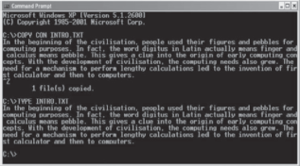
Figure 5.7 Command Line Interface

Graphical User Interface: With the development in chip designing technology, computer hardware became quicker and cheaper, which led to the birth of GUI-based OS. These OSs provide users with pictures rather than just characters to interact with the machine. The OS displays icons, buttons, dialog boxes, etc., on the screen (see Figure 5.8). The user sends instructions by moving a pointer on the screen (generally mouse) and selecting certain objects by pressing buttons on the mouse while the mouse pointer is pointing at Figure 5.8 Graphical User Interface them.

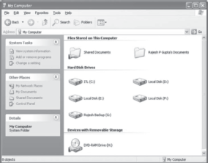
Figure 5.8 Graphical User Interface

LET US SUMMARIZE
- OS is a type of software that controls and coordinates the operation of the various types of devices in a computer system. The two objectives of an OS are controlling the computer's hardware and providing an interface between the user and the machine.
- OS has six major roles to perform: process management, memory management, file management, device management, security management and providing user interface.
- A process or task is a portion of a program in some stage of execution. A program can consist of several processes, each working on its own. It may be in one of a number of different possible states, such as new, running, waiting, ready or terminated.
- A thread is the simplest part of a process. To enhance efficiency, a process can consist of several threads, each of which execute separately.
- In the uniprogramming system, only one process can exist at a time while in themultiprogramming system, multiple processes can be initiated at a time.
- Deciding which process should run next is called process scheduling. Process scheduling is necessary, so that all programs are executed and run fairly.
- Preemptive switching means that a running process will be interrupted (forced to give up) and the processor is given to another waiting process.
- In first-come-first-served scheduling, the processes are executed in the order of their arrival in the ready queue, which means the process that enters the ready queue first, gets the CPU first. New processes are placed at the end of the queue.
- The part of the OS that manages the primary memory of the computer is called the memory manager.
- Paging is a memory management scheme that allows the processes to be stored non-contiguously in memory.
- Virtual memory is a way of showing the main memory of a computer system to appear effectively larger than it really is.
- The system that an OS uses to organize and keep track of files is known as the file management system.
- A program that controls a device is called the device driver. OS's device manager uses this program to let a user use the specific device.
- A user interface is a set of commands or menus through which a user communicates with the system.

Exercises

Fill in the Blanks
- .........is a program which acts as a mediator between the user and the hardware.
- A table where many pieces of information associated with a specific process, that is, program counter, process state, CPU-scheduling information and so on are stored, is known as...........
- ...........is also called a lightweight process.
- ...........refers to storing the jobs in the buffer so that the CPU can be efficiently utilized.
- Two main user interfaces, which an OS has, are .......... and ..........
- Four main conditions that cause deadlock to occur are ..........., ..........., ........... and ..........
- A process is said to be in a state of ......... when it is waiting for an event that will never occur.

Multiple-choice Questions
- The OS that is self-contained in a device and resident in the ROM is ..........
  - Batch Processing System
  - Real-time OS
  - Embedded OS
  - Multi-processor OS
- The example of non-preemptive scheduling is ............
  - First-Come-First-Served
  - Round Robin
  - Last-In-First-Out
  - Shortest-Job-First
- An interface where facility is provided for entering commands is ...........
  - Menu-driven
  - Command-driven
  - Graphic-driven
  - None of these
- The OS that allows only one program to run at a time is .........
  - Batch Processing
  - Embedded
  - Real-time
  - Multitasking
- The substitution made by the OS between the processes to allocate space is ...........
  - Swapping
  - Deadlock
  - Fragmentation
  - Paging
- The memory management scheme that allows the processes to be stored non-contiguously in memory is ..........
  - Paging
  - Spooling
  - Swapping
  - None of these
- The fit policy of a memory manager to place a process in the largest block of unallocated memory is ..........
  - First Fit
  - Best Fit
  - Worst Fit
  - Bad Fit
- With which memory can the system run programs that are actually larger than the primary memory of the system?
  - Cache Memory
  - Primary Memory
  - Virtual Memory
  - None of these
- What allows the user to run two or more applications on the same computer so that he/she can move from one to the other without closing the application?
  - Virtual Storage
  - Multi-processing
  - Multi-tasking
  - Multiprogramming
- The scheduler that selects a process from the ready queue and allocates CPU to it ..........
  - Short-term
  - Long-term
  - Medium-term
  - All of these

State True or False
- OS is a hardware component.
- Microsoft Windows XP is a GUI-based OS.
- A document printing process uses spooling.
- Virtual memory allows for very effective multiprogramming.
- Another term for time-sharing is multitasking.
- The directory system of Microsoft Windows operating is hierarchical.
- The job of splitting the primary memory into segments as the memory is allocated and de-allocated to the processes is known as fragmentation.

Descriptive Questions
- What is an OS? Explain various types of OS.
- Define a process. Diagrammatically explain the life cycle of a process.
- Discuss various types of interfaces in the OS.
- What is a deadlock? How can it be handled?
- Explain how memory protection and process allocation is done by an OS.
- Write down the differences between:
  - Uniprogramming and Multiprogramming
  - Preemptive and Non-preemptive Scheduling
  - Deadlock Avoidance and Deadlock Prevention

ANSWERS

Fill in the Blanks
- OS
- Process table
- Thread
- Spooling
- GUI, CLI
- Circular wait, Mutual exclusion, No preemption, Hold and wait
- Deadlock

Multiple-choice Questions
- (c)
- (a)
- (b)
- (a)
- (a)
- (a)
- (c)
- (c)
- (c)
- (a)

State True or False
- False
- True
- True
- True
- False
- True
- True
Find answers on the fly, or master something new

Chapter 6. Overview of Microsoft Windows 7

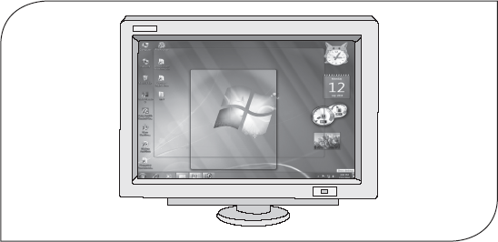

6.1 Introduction
The version of Windows operating system, that is, Windows 7 has been released by Microsoft in 2009 to be used on home and business desktops, laptops, Tablet PCs, netbooks and media Center PCs. Windows 7 provides enhanced user interface making it more user-friendly, improved performance to get the tasks done efficiently, new level of security to protect precious data from unauthorized access, and so on.
Advancements in handwriting and speech recognition, support for virtual hard disk and multi-touch, and redesigned taskbar are some of the new features in Windows 7. One more noticeable change is that some of the applications that have been included with prior releases of Windows including Windows Movie Maker, Windows Mail, Windows Calendar and Windows Photo Gallery are not included in Windows 7. The reason for removal is that these applications demand frequent updates than the operating system itself. These applications are now freely available from the Microsoft website as a separate package called Windows Live Essential.

6.2 Different editions of windows 7
Microsoft has released Windows 7 in six different editions, namely, Windows 7 Starter, Windows 7 Home Basic, Windows 7 Home Premium, Windows 7 Professional, Windows 7 Enterprise andWindows 7 Ultimate. Among these editions, only three—Home Premium, Professional and Ultimate—are widely available for sale in most countries; other editions are targeting other markets such as the developing world or are available for enterprise use only.
Windows 7 Starter: It is the most basic edition of Windows 7 and contains the fewest features of all the Windows 7 editions. It includes some strange restrictions like the inability to change the default desktop wallpaper. The Starter edition usually comes pre-installed on computers by the computer manufacturers or dealers. It has been specifically designed for notebook computers and netbooks.
Windows 7 Home Basic: It contains features that make them suitable for home users. This edition is not available in some parts of the world including North America, Australia, and Western and Central Europe.
Windows 7 Home Premium: Like the Home Basic edition, this edition is also intended for home users; however, it contains some new features such as touch-screen support, Aero effects, etc., that have been excluded from the Home Basic edition.
Windows 7 Professional: It is suited for small business users as it provides support for being used as a Remote Desktop server, location aware printing, Encrypting File System and so on.
Windows 7 Enterprise: It targets the enterprise segment with features including Multilingual User Interface, UNIX application support and BitLocker Drive Encryption. This edition is not available through retail market; instead it is sold by Microsoft through volume licensing to the companies that have Software Assurance contract with Microsoft.
Windows 7 Ultimate: It contains exactly the same features as the Windows 7 Enterprise edition. The only difference is that the Ultimate edition is available on an individual license basis. Hence, individuals can purchase the Windows 7 Ultimate edition.
Note: Each edition of Windows 7 includes features that are available in its previous edition.

6.3 New style of windows 7
As you start Windows 7, you will be greeted with a new look and style of desktop including Aero themes, gadgets, redesigned taskbar and Start menu, and Jump lists (see Figure 6.1). All the basic elements of Windows like icons, menus, dialog window, etc., have been redesigned to provide better visuals. The new Aero interface of Windows 7 takes advantage of the latest graphics hardware and provides smoother window handling, enhanced animations and glass visual effects (transparencies).

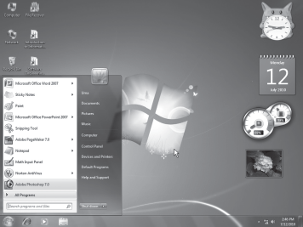

Figure 6.1 Windows 7 Desktop

6.3.1 Aero Themes
An Aero theme is the combination of one or more desktop backgrounds, window colour, sounds and screen saver. Some Aero themes include desktop icons and mouse pointers also. You can apply any of the themes to change the desktop background, window colour, sound and screen saver simultaneously. Moreover, you can make the desktop backgrounds to change automatically after a specified time interval using the desktop slide show feature of Windows 7.
To create a slide show, follow the steps given below:
- Right-click on a blank area of the desktop and select Personalize from the menu that appears. A window similar to the one shown in Figure 6.2 appears.
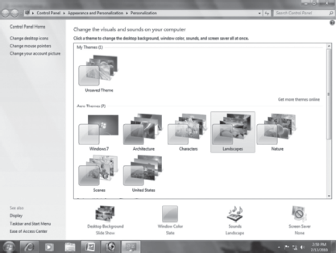

Figure 6.2 Personalization

- Click a theme under the Aero Themes section to apply it to the desktop. Note that all the Aero themes except Windows 7 include slide show.
- Click Desktop Background to change the default slide show pictures or settings of the theme. This displays the Desktop Background window (see Figure 6.3).

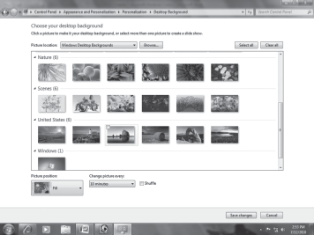

Figure 6.3 Desktop Background Window

- Select the pictures that you want to add to the slide show. For this, follow any of the steps given below:
To select the pictures provided as a part of Aero themes, place the mouse over the picture that you want to add and select the check box on the top left corner of the picture. Alternatively, click on the desired pictures while holding down the Ctrl key (see Figure 6.4).
To select all the pictures of all the Aero themes at once, click the Select All button.
To select your own pictures, click the Browse button to locate the folder on the computer from which you want to add the pictures.

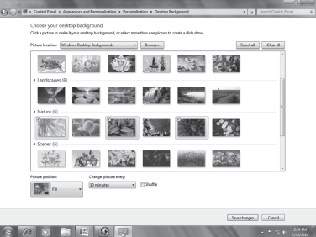

Figure 6.4 Selecting Pictures for Slide Show

Note that you must select more than one picture to create the slide show.
- Click the down arrow under the Picture position and select an option from the list. For example, select Fill to crop the pictures to fill the screen, Fit to fit the pictures to the screen,Stretch to stretch the pictures to fit to the screen, Tile to tile the pictures, or Centre to place the pictures at the centre of the screen.
- Click the down arrow under the Change picture every option and select the time from the list to specify how quickly the desktop background should change.
- Select the Shuffle check box if you want the pictures to appear in random order.
- Click the Save changes button.

6.3.2 Gadgets
Gadgets are mini programs that provide quick access to information and frequently used tools. For example, you can have a gadget that provides news headlines in order to keep yourself updated. Windows 7 includes many gadgets and you can download more gadgets from Microsoft's web site and install them on the machine.
You can place multiple gadgets or more than one instance of a gadget on the desktop. To add a gadget to the desktop, follow the steps given below:
- Right-click on a blank area of the desktop and select Gadgets from the menu that appears. This displays a window showing all the gadgets installed on the machine (see Figure 6.5).

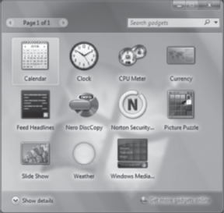

Figure 6.5 Gadgets in Windows 7

- Double-click a gadget to add it to the desktop.
Once a gadget has been added to the desktop, you can move it freely (by dragging) to place it wherever you want. In case you do not want a gadget any more on the desktop, you can remove it from the desktop. For this, right-click the gadget and select Close Gadget from the menu that appears.

6.3.3 Taskbar
The taskbar has undergone the major modifications in Windows 7. You may immediately notice that it is taller than the taskbar in the previous versions of Windows. One main reason for making it taller is to enable it to accommodate the touch screen input.
As shown in Figure 6.6, the taskbar has three main sections: the Start button (), the middle section and the notification area. The Start button, when clicked, opens the Start menu (discussed in Section 6.3.4). The middle section of the taskbar is the one that you use frequently. It shows buttons corresponding to the programs or files that you have currently open. By default, it displays only three buttons corresponding to Internet Explorer 8, Media Player and Windows Explorer program. Afterwards, every time you open a program, file or folder, Windows creates a corresponding button on the taskbar. The taskbar button of the active program is always highlighted. Each taskbar button displays an icon that helps you identify the open program. You can click a button to open the respective program as well as can switch between several open programs using the taskbar.

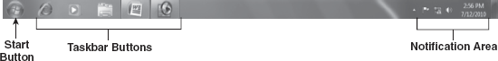

Figure 6.6 Windows 7 Taskbar

At the right side of the taskbar is the notification area (see Figure 7.6). This area contains a clock that tells the system's date and time. In addition, it contains a group of icons that indicate the status of certain programs installed on the computer and certain computer settings. For example, whether anti-virus installed on the machine is enabled, its virus definitions are up to date, and so on. As you move the mouse pointer over an icon in the notification area, the name of the icon or the status of setting appears in a tooltip. Clicking the icon opens the program or associated settings. For example, clicking the volume icon () shows the volume controls using which you can set the volume.
Note: Windows 7 hides some icons in the notification area to reduce clutter. These hidden icons can be displayed temporarily by clicking the Show hidden icons button () in the notification area.
Thumbnails: Recall that every open window has a corresponding button on the taskbar. When you place the mouse pointer over a button on the taskbar, a small preview of the open window(s) associated with that button appears over the taskbar (see Figure 6.7). This preview is calledthumbnail.

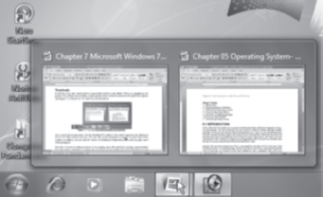

Figure 6.7 Thumbnails

As you move the mouse pointer over the thumbnail of a window, that window appears on the desktop in front of all other windows (if any). You can click on the thumbnail of any window to make it the active window. In addition, you can close the window by clicking the Close button () at the top right corner of the thumbnail.
Note that if you open multiple instances of the same program, then instead of creating a separate button for each instance, Windows 7 creates only one button on the taskbar and shows thumbnail of each instance as you place the mouse pointer over the button.

6.3.4 Start Menu
Start menu provides a common way to perform varied activities such as starting various programs, accessing commonly used folders, searching for files, folders, and programs, getting help for Windows, adjusting the computer settings, etc. You can open the Start menu by clicking the Startbutton () on the taskbar or by pressing the Windows logo key () on the keyboard.
As shown in Figure 6.8, Start menu is divided into three basic parts: left pane, right pane and search box. The left pane shows a short list of programs installed on the machine. You can view the complete list of programs by clicking All Programs. The right pane provides quick access to the commonly used folders and files as well as the computer settings. In addition, you can log off, restart or shutdown the system from the right pane. The third part of the Start menu is the search box. The search box lets you search files, folders or whatever you want. As you type in the search box, Windows searches instantly and provides you with the search results. This makes the searching easier and faster. You can also open programs by typing the name of their executable file in the search box. For example, type winword to open Microsoft Word.

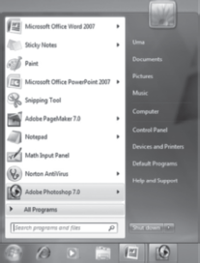

Figure 6.8 Start Menu

LET US SUMMARIZE
- The latest version of Windows operating system is Windows 7 that has been released by Microsoft in 2009 to be used on home and business desktops, laptops, Tablet PCs, netbooks and media centre PCs.
- Microsoft has released Windows 7 in six different editions, namely, Windows 7 Starter, Windows 7 Home Basic, Windows 7 Home Premium, Windows 7 Professional, Windows 7 Enterprise and Windows 7 Ultimate.
- In Windows 7, all the basic elements of Windows, like icons, menus, dialog window, etc., have been redesigned to provide better visuals. The new Aero interface takes advantage of the latest graphics hardware and provides smoother window handling, enhanced animations and glass visual effects (transparencies).
- An Aero theme is the combination of one or more desktop backgrounds, window colour, sounds, and screen saver. Some Aero themes include desktop icons and mouse pointers also. You can apply any of the themes to change the desktop background, window colour, sound and screen saver simultaneously.
- The desktop slide show feature of Windows 7 allows the desktop backgrounds to change automatically after some specified time interval.
- Gadgets are the mini programs that provide quick access to information and frequently used tools. Windows 7 includes many gadgets and you can download more gadgets from Microsoft's website and install them on the machine.
- Every time you open a program, file or folder, Windows creates a corresponding button on the taskbar. When you place the mouse pointer over a taskbar button, a small preview of the open window(s) associated with that button appears over the taskbar. This preview is calledthumbnail.
- Start menu is divided into three basic parts: left pane, right pane and search box. The left pane shows a short list of programs installed on the machine. The right pane provides quick access to the commonly used folders and files as well as the computer's settings. The search box lets you search for files, folders or whatever you want.
- Windows 7 comprises several Aero effects that not only tend to improve the visual experience but also ease the task of managing different windows. These effects include Aero Flip 3D, Aero Peek, Aero Shake and Aero Snap.
- Aero Flip 3D allows you to preview all the open files and folders simultaneously without clicking on the taskbar. Using this feature, you can preview all the open windows arranged in the form of a three-dimensional stack that you can easily flip through.
- Aero Peek allows you to temporarily view the desktop and all its folders as well as gadgets and Sticky Notes placed on it by fading down all the open windows.
- Aero Shake allows you to minimize all the open windows except the desired one. For this, click on the title bar of the window you want to keep open and drag the mouse back and forth quickly.
- Aero Snap allows you to arrange two open windows side by side on the screen. This is helpful while comparing contents of two files or copying files from one folder to another.
- Jump list is a new feature of Windows 7 that provides you quick access to the recently and frequently accessed items (such as files, folders or websites) of some specific program that is used to open those items. You can open any item appearing in the jump list by just clicking on it.
- Sticky Notes are used to write down something like a to-do list, someone's phone number, a note to make you remind of anything, etc. They are placed on the desktop.
- Math Input Panel allows you to directly write the simple or complex mathematical expressions just like on a notebook paper and the in-built math recognizer of Windows 7 recognizes your handwritten expression. You can then transfer the recognized math into your document.
- Snipping Tool is used to capture a snapshot (called snip) of any object, window or a part of a window on your desktop. Once you capture an image, you can annotate it with handwritten comments, save it as an HTML, PNG, GIF or JPEG file, or send it via e-mail from within the Snipping Tool program window.

Exercises

Fill in the Blanks
- .......... edition usually comes pre-installed on computers by the computer manufacturers or dealers.
- The ............ interface of Windows 7 takes advantage of latest graphics hardware and provides smoother window handling, enhanced animations and glass visual effects (transparencies).
- ............ are the mini programs that provide quick access to information and frequently used tools.
- By default, the taskbar displays only three buttons corresponding to ..........., Media Player, and ............ program.
- ........... provides a common way to perform varied activities such as starting various programs, accessing commonly used folders, searching for files, folders and programs, etc.
- ............ contains a group of icons that indicate the status of certain programs installed on the computer.
- ............ feature of Windows 7 lets you temporarily view the desktop along with the folders, gadgets and Sticky Notes placed on it by fading all other open windows.
- You can open the Start menu by clicking the ......... button on the taskbar or by pressing the ........... key on the keyboard.
- You can open Microsoft Word program by typing .......... in the search box on the Start menu.
- ............. provides you quick access to the recently and frequently accessed items (such as files, folders or websites) of some specific program that is used to open those items.

Multiple-choice Questions
- Windows 7 was released in ...........
  - 2009
  - 2008
  - 2010
  - None of these
- Which of the following editions of Windows 7 is not available through retail market?
  - Ultimate
  - Home Professional
  - Enterprise
  - Starter
- Which feature of Windows 7 allows the desktop backgrounds to change automatically after some specified time interval?
  - Desktop slide show
  - Gadget
  - Aero theme
  - Jump list
- Which combination of keys on the keyboard arranges all the open windows in a 3D stack that you can easily flip through?
  - Alt+Tab
  - Windows logo key+Tab
  - Ctrl+Tab
  - Shift+Tab
- Which feature allows you to arrange two open windows side by side on the screen?
  - Aero Snap
  - Aero Shake
  - Aero Peek
  - None of these
- Using Snipping Tool, you can save your snip as ..........
  - PNG file
  - GIF file
  - JPEG file
  - All of these
- The ............ snip enables to select a window like dialog box or browser window that you want to capture.
  - Rectangular
  - Window
  - Free-form
  - Full-screen
- How many editions of Windows 7 have been released by the Microsoft?
  - Five
  - Seven
  - Six
  - Four
- Which of the following applications is no longer a part of Windows 7?
  - Windows Media Player
  - WinZip
  - Windows Media Centre
  - Windows Photo Gallery
- An Aero theme is the combination of one or more desktop backgrounds, ............, ............., and screen savers.
  - Window colour, Sounds
  - Desktop icons, Gadgets
  - Sounds, Gadgets
  - Window colour, Gadgets

State True or False
- You can make any open window active by clicking on its thumbnail.
- Using the Aero Shake feature, dialog boxes cannot be minimized.
- The taskbar in Windows 7 is smaller than it was in previous versions of Windows.
- Aero Snap feature allows you to minimize all the open windows to let you view the desktop.
- If you open multiple instances of the same program, Windows 7 creates a separate button for each instance on the taskbar.
- The Math Input Panel basically has been designed to be used with a tablet pen on a tablet PC.
- In Windows 7, the Show desktop button is placed at the left-most corner of the taskbar.
- You can view the Jump list for a program on the taskbar by right-clicking on the program icon.
- The taskbar button of the active program is always highlighted.
- Windows 7 Home Basic edition includes features like touch-screen support, Aero effects, etc.

Descriptive Questions
- Describe the various editions of Windows 7 released by Microsoft.
- List the steps for creating a slide show of the pictures provided by Windows as a part of Aero themes.
- Discuss some changes that you have noticed in the taskbar in Windows 7.
- What is the purpose of the Aero Snap feature? How would you use it?
- Mention the steps for using the Snipping Tool to capture a dialog box window.
- Write short notes on:
  - Gadgets
  - Aero Shake
  - Jump lists
  - Thumbnails
- What do you mean by Sticky Notes? Write down the steps for creating a Sticky Note.
- What is Math Input Panel? How can we use it?

ANSWERS

Fill in the Blanks
- Windows 7 Starter
- Aero
- Gadgets
- Internet Explorer 8, Windows Explorer
- Start menu
- Notification area
- Aero Peek
- Start, Windows logo
- Winword
- Jump list

Multiple-choice Questions
- (a)
- (c)
- (a)
- (b)
- (a)
- (d)
- (b)
- (c)
- (d)
- (a)

State True or False
- True
- True
- False
- False
- False
- True
- False
- True
- True
- False

Chapter 7. Computer Programming and Languages

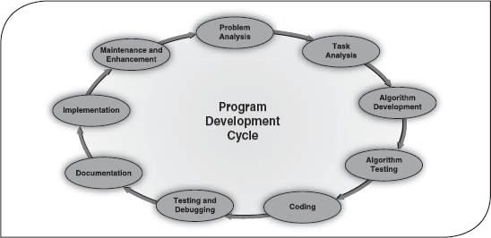

7.1 Introduction
The computer has emerged as the most useful machine in recent times. It can perform a variety of tasks like receiving data, processing it and producing useful results. However, being a machine, the computer cannot perform on its own. A computer needs to be instructed to perform even a simple task like adding two numbers. Computers work on a set of instructions called computer program, which clearly specify the ways to carry out a task. An analogy of this may be thought of as the instructions given by the manager or team leader to its team. The team members follow those instructions and accordingly perform their duties. Similarly, a computer also takes instructions in the form of computer programs to carry out the requested task.
Now the question that arises is how human beings instruct computers. We, as human beings, use natural languages such as English, Spanish or French to communicate. Similarly, a user communicates with the computer in a language understood by it. Note that human beings cannot interact directly with the computer using natural languages because thus far we have not developed such computers that can comprehend natural languages. Rather, the instructions, provided in the form of computer programs, are developed using computer or programming languages. This chapter provides some of the most prominent concepts related to computer programming and languages.

7.1.1 Developing a Program
As discussed earlier, a program consists of a series of instructions that a computer processes to perform the required operation. In addition, it also includes some fixed data required to perform the instructions and the process of defining those instructions and data. Thus, in order to design a program, a programmer must determine three basic rudiments:
- The instructions to be performed.
- The order in which those instructions are to be performed.
- The data required to perform those instructions.
To perform a task using a program, a programmer has to consider various inputs of the program along with the process, which is required to convert the input into desired output. Suppose we want to calculate the sum of two numbers, A and B, and store the sum in C; here A and B are the inputs, addition is the process, and C is the output of the program (see Figure 7.1).

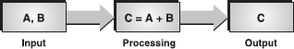

Figure 7.1 Program Performing a Task

A program is a set of instructions that instructs a computer on how to perform a specific task. It is written in a programming language that can be implemented on a number of different processors. A collection of programs can be compared to a recipe book, where each recipe can be assumed as a program. Every recipe has a list of ingredients (fixed data) and a list of instructions detailing exactly what to do with those ingredients. When you follow a recipe, you are actually executing a program.

7.1.2 Program Development Cycle
Before starting the process of writing a program (coding), the programmer has to determine the problem that needs to be solved. There are different approaches to problem solving. One common approach is to use the program development cycle, with the number of steps that may vary according to the person who has formalized the development. Often the process runs in a loop, for example, as the current process is completed, new demands appear and the development process commences again. Illustrated in Figure 7.2 is the development cycle of a program, which includes the following phases.

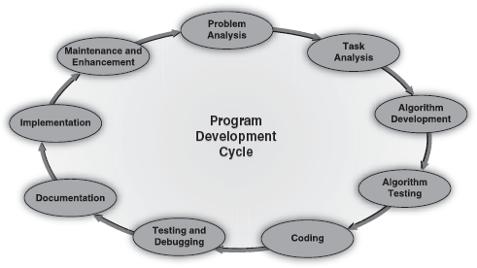

Figure 7.2 Program Development Cycle

Problem Analysis: The problem is analysed precisely and completely. Based on understanding, the developer knows about the scope within which the problem needs to be developed.
Task Analysis: After analysing the problem, the developer needs to develop various solutions to solve the given problem. From these solutions, the optimum solution is chosen, which can solve the problem comfortably and economically.
Algorithm Development: After selecting the appropriate solution, an algorithm is developed to depict the basic logic of the selected solution. An algorithm depicts the solution in logical steps (sequence of instructions). Further, an algorithm is represented by flowcharts, decision tables and pseudocodes. These tools make the program logic clear and they eventually help in coding.
Algorithm Testing: Before converting the algorithms into actual code, it should be checked for accuracy. The main purpose of checking the algorithm is to identify major logical errors at an early stage because logical errors are often difficult to detect and correct at later stages. The testing also ensures that the algorithm is a “true” one and it should work for both normal as well as unusual data.
Coding: After meeting all the design considerations, the actual coding of the program takes place in the chosen programming language. Depending upon the application domain and available resources, a program can be written by using computer languages of different levels such as machine, assembly or high-level languages (HLL).
Testing and Debugging: It is common for the initial program code to contain errors. A program compiler and programmer-designed test data machine tests the code for syntax errors. The results obtained are compared with results calculated manually from these test data. Depending upon the complexity of the program, several rounds of testing may be required.
Documentation: Once the program is free from all the errors, it is the duty of the program developers to ensure that the program is supported by suitable documentation. These documents should be supplied to the program users. Documenting a program enables the user to operate the program correctly. It also enables other persons to understand the program clearly so that it may, if necessary, be modified, or corrected by someone other than the original programmer.
Implementation: After documentation, the program is installed on the end user's machine and the user is also provided with all the essential documents in order to understand how the program works. The implementation can be viewed as the final testing because only after using the program the user can point out the drawbacks (if any) and report them to the developers. Based on the feedback from users, the programmers can modify or enhance the program.
Maintenance and Enhancement: After the program is implemented, it should be properly maintained by taking care of the changing requirements of its users and the system. The program should be regularly enhanced by adding additional capabilities. This phase is also concerned with detecting and fixing the errors, which were missed in the testing phase. Since this step generates user feedback, the programming cycle continues as the program is modified or reconstructed to meet the changing needs.

7.2 Algorithm
Algorithms are one of the most basic tools that are used to develop the problem-solving logic. Analgorithm is defined as a finite sequence of explicit instructions that when provided with a set of input values produces an output and then terminates. To be an algorithm, the steps must be unambiguous and after a finite number of steps, the solution of the problem should be achieved. However, algorithms can have steps that repeat (iterate) or require decisions (logic and comparison) until the task is completed.
Algorithms are not computer programs, as they cannot be executed by a computer. Some properties of algorithm are as follows.
- There must be no ambiguity in any instruction.
- There should not be any uncertainty about which instruction is to be executed next.
- The description of the algorithm must be finite. An algorithm cannot be open ended.
- The algorithm should terminate after a finite number of steps.
- The algorithm must be general enough to deal with any contingency.
Different algorithms may accomplish the same task, with a different set of instructions, in more or less the same time, space and efforts. For example, two different recipes for preparing tea: one “add the sugar” while “boiling the water” and the other “after boiling the water” produce the same result. However, performing an algorithm correctly does not guarantee a solution, if the algorithm is flawed or not appropriate to the context. For example, preparing the tea algorithm will fail if there are no tea leaves present; even if all the motions of preparing the tea are performed as if the tea leaves were there. We use algorithms in our daily life. For example, to determine the largest number out of three numbers A, B and C, the following algorithm may be used.

Algorithm: To Determine Largest of Three Numbers
- Start
- Read three numbers A, B, C
- Find the larger number between A and B and store it in MAX_AB
- Find the larger number between MAX_AB and C and store it in MAX
- Display MAX
- Stop
The above-mentioned algorithm terminates after six steps. This explains the feature of finiteness. Every action of the algorithm is precisely defined, hence there is no scope for ambiguity.
Once an algorithm has been designed, it can be represented as a flowchart, pseudocode or decision table, which are further expressed in programming language to develop computer programs.

7.3 Flowchart
A flowchart is a pictorial representation of an algorithm in which the steps are drawn in the form of different shapes of boxes and the logical flow is indicated by interconnecting arrows. The boxes represent operations and the arrows represent the sequence in which the operations are implemented. The primary purpose of the flowchart is to help the programmer in understanding the logic of the program. Therefore, it is always not necessary to include all the required steps in detail. Flowcharts outline the general procedure. Since they provide an alternative, visual way of representing the information flow in a program, program developers often find them very valuable.

7.3.1 Flowchart Symbols
Flowcharts can be compared with the blueprint of a building. Just as an architect draws a blueprint before starting the construction of a building, a programmer draws a flowchart before writing a computer program. As in the case of the drawing of a blueprint, the flowchart is drawn according to defined rules and using standard flowchart symbols prescribed by American National Standard Institute (ANSI). Some standard symbols that are frequently required for flowcharts are shown inTable 7.1.

Table 7.1 Flowchart Symbols
Symbol | Symbol Name | Description
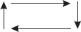 | Flow Lines | Flow lines are used to connect symbols. These lines indicate the sequence of steps and the direction of flow of control.
 | Terminal | This symbol is used to represent the beginning (start), the termination (end) or halt (pause) in the program logic.
 | Input/Output | This symbol represents information entering or leaving the system such as customer order (input) and servicing (output).
 | Processing | This symbol is used for representing arithmetic and data movement instructions. It can represent a single step (“add two cups of flour”), or an entire sub-process (“make bread”) within a larger process.
 | Decision | This symbol denotes a decision (or branch) to be made. The program should continue along one of the two routes (IF/ELSE). This symbol has one entry and two exit paths. The path chosen depends on whether the answer to a question is “yes” or “no”.
 | Connector | This symbol is used to join different flow lines.
 | Off-page Connector | This symbol is used to indicate that the flowchart continues on the next page.
 | Document | This symbol is used to represent a paper document produced during the flowchart process.
 | Annotation | This symbol is used to provide additional information about another flowchart symbol. The content may be in the form of descriptive comments, remarks or explanatory notes.
 | Manual Input | This symbol represents input to be given by a developer/programmer.
 | Manual Operation | This symbol shows that the process has to be done by a developer/programmer.
 | Online Storage | This symbol represents the online data storage such as hard disks, magnetic drums, or other storage devices.
 | Offline Storage | This symbol represents the offline data storage such as sales on OCR and data on punched cards.
 | Communication Link | This symbol is used to represent data received or to be transmitted from an external system.
 | Magnetic Disk | This symbol is used to represent read from or write to a magnetic disk.
Note: Some sample flowchart's have been represented in Section 7.6.

7.3.2 Guidelines for Preparing Flowcharts
The following guidelines should be used for creating a flowchart:
- The flowchart should be clear, neat, and easy to follow.
- The flowchart must have a logical start and finish.
- In drawing a proper flowchart, all necessary requirements should be listed in logical order.
- Only one flow line should come out from a process symbol.

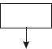

- Only one flow line should enter a decision symbol. However, two or three flow lines (one for each possible answer) may leave the decision symbol.

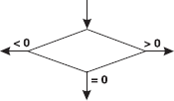

- Only one flow line is used with a terminal symbol.

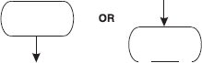

- Write briefly within standard symbols. If necessary, use the annotation symbol to describe data or process more clearly.
- In case of complex flowcharts, connector symbols are used to reduce the number of flow lines.
- Intersection of flow lines should be avoided to make it a more effective and better way of representing communication.
- It is useful to test the validity of the flowchart by passing through it with normal/ unusual test data.

7.3.3 Benefits of Flowcharts
A flowchart helps to clarify how things are currently working and how they could be improved. It also assists in finding the key elements of a process by drawing clear lines between the end of one process and the start of next one. Developing a flowchart establishes a common understanding among the participants about the process. Flowcharts help in revealing redundant or misplaced steps. They also help in establishing important areas for monitoring or data collection and to identify areas for improvement or increase in efficiency. The reasons for using flowcharts as a problem-solving tool are given below.
Makes Logic Clear: The main advantage of using a flowchart to plan a task is that it provides a pictorial representation of the task, which makes the logic easier to follow. The symbols are connected in such a way that they show the movement (flow) of information through the system visibly. The steps and how each step is connected to the next can be clearly seen. Even less experienced personnel can trace the actions represented by a flowchart, that is, flowcharts are ideal for visualizing fundamental control structures employed in computer programming.
Communication: Being a graphical representation of a problem-solving logic, flowcharts are a better way of communicating the logic of a system to all concerned. The diagrammatical representation of logic is easier to communicate to all the interested parties as compared to actual program code as the users may not be aware of all the programming techniques and jargons.
Effective Analysis: With the help of a flowchart, the problem can be analysed in an effective way. This is because the analysing duties of the programmers can be delegated to other persons, who may or may not know the programming techniques, as they have a broad idea about the logic. Being outsiders, they often tend to test and analyse the logic in an unbiased manner.
Useful in Coding: The flowcharts act as a guide or blueprint during the analysis and program development phase. Once the flowcharts are ready, the programmers can plan the coding process effectively as they know where to begin and where to end, making sure that no steps are omitted. As a result, error-free programs are developed in HLL and that too at a faster rate.
Proper Testing and Debugging: By nature, a flowchart helps in detecting the errors in a program, as the developers know exactly what the logic should do. Developers can test various data for a process so that the program can handle every contingency.
Appropriate Documentation: Flowcharts serve as a good program documentation tool. Since normally programs are developed for novice users, they can take the help of the program documentation to know what the program actually does and how to use the program.

7.3.4 Limitations of Flowcharts
A flowchart can be used for designing the basic concept of the program in pictorial form but cannot be used for programming purposes. Some of the limitations of the flowchart are given below.
Complex: The major disadvantage in using flowcharts is that when a program is very large, the flowcharts may continue for many pages, making them hard to follow. Flowcharts tend to get large very quickly and it is difficult to follow the represented process. It is also very laborious to draw a flowchart for a large program. You can very well imagine the nightmare when a flowchart is to be developed for a program, consisting of thousands of statements.
Costly: Drawing flowcharts are viable only if the problem-solving logic is straightforward and not very lengthy. However, if flowcharts are to be drawn for a huge application, the time and cost factor of program development may get out of proportion, making it a costly affair.
Difficult to Modify: Due to its symbolic nature, any changes or modification to a flowchart usually requires redrawing the entire logic again, and redrawing a complex flowchart is not a simple task. It is not easy to draw thousands of flow lines and symbols along with proper spacing, especially for a large complex program.
No Update: Usually programs are updated regularly. However, the corresponding update of flowcharts may not take place, especially in the case of large programs. As a result, the logic used in the flowchart may not match with the actual program's logic. This inconsistency in flowchart update defeats the main purpose of the flowcharts, that is, to give the users the basic idea about the program's logic.

7.4 Decision tables
Decision tables are generally useful in situations where a number of decisions or actions have to be taken depending on the input provided. A decision table is a way of representing an algorithm in a tabular form. It contains all the possible conditions for a specific problem and the corresponding results using condition rules that connect conditions with results. It consists of rows and columns, divided into four separate quadrants as shown in Figure 7.3.



Figure 7.3 Four Quadrants of a Decision Table
Conditions: Contains a list of all the possible conditions pertaining to a problem.
Condition Alternatives: Contains the condition rules (set of possible values for each condition) of alternatives.
Actions: Contains actions, which can be a procedure or operation to be performed.
Action Entries: Contains the action rules, which specify the actions to be performed on the basis of the set of condition alternatives corresponding to that action entry.
Note that each column in the quadrant can be interpreted as a processing rule. The basic four-quadrant structure is common for all the decision tables; however, they may differ in the way of representation of the condition alternatives and action entries. For example, in some decision tables, condition alternatives are represented using true/false values while in other tables, Yes/No or numbers (0 or 1) may be used. Similarly, in decision tables, action entries are represented by placing check marks, cross marks or numbering the actions to be performed.

7.4.1 Steps to Develop a Decision Table
In order to build decision tables, first the maximum size of the table is determined. Any impossible situations, inconsistencies or redundancies are then eliminated from the table. To develop a decision table, follow the steps given below.
- Determine all actions that can be associated with a specific module or procedure.
- Determine all the conditions affecting the decision.
- Associate the specified conditions with specific actions. In the simplest case, each condition in the decision table will be associated with two alternatives (Yes or No).
- Define rules by indicating actions that occur for the specified conditions.
To understand the concept of a decision table, let us consider an example to find the largest of the three numbers A, B and C. The decision table for this example is shown in Figure 7.4.

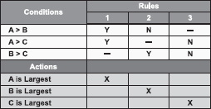

Figure 7.4 Decision Table for Finding the Largest of Three Numbers

7.5 Pseudocode
Pseudocode is made up of two words: pseudo and code. Pseudo means imitation and code refers to instructions, written in a programming language. As the name suggests, pseudocode is not a real programming code, but it models and may even look like programming code. It is a generic way of describing an algorithm without using any specific programming language-related notations. Simply put, pseudocode is an outline of a program, written in a form that can be easily converted into actual programming statements. Pseudocode uses plain English statements rather than symbols to represent the processes in a computer program. It is also known as PDL (program design language), as it emphasizes more on the design aspect of a computer program or structured English, because usually pseudocode instructions are written in normal English, but in a structured way.
Pseudocode strikes a fine balance between the understandability and informality of a natural language like English and the precision of a computer program code. It is somewhat halfway between English and a programming language. If an algorithm is written in English, the description may be at such a high level that it may prove difficult to analyse the algorithm and then to transform it into actual code. If instead, the algorithm is written in code, the programmer has to invest a lot of time in determining the details of an algorithm, which he may choose not to implement (since, typically, algorithms are analysed before deciding which one to implement). Therefore, the goal of writing pseudocode is to provide a high-level description of an algorithm, which facilitates analysis and eventual coding, but at the same time suppresses many of the details that are insignificant.
Pseudocode uses some keywords to denote programming processes. Some of them are as follows.
- Input: READ, OBTAIN, GET and PROMPT
- Output: PRINT, DISPLAY and SHOW
- Compute: COMPUTE, CALCULATE and DETERMINE
- Initialize: SET and INITIALIZE
- Add One: INCREMENT
The pseudocode given below calculates the area of a rectangle.

Pseudocode: To Calculate the Area of A Rectangle
PROMPT the user to enter the height of the rectangle
PROMPT theuser to enter the width of the rectangle
COMPUTE the area by multiplying the height with width
DISPLAY the area
STOP
Since pseudocode is detailed yet readable, it can be inspected by the team of designers and programmers as a way to ensure that actual programming is likely to match the design specifications. It is better to catch errors at the pseudocode stage rather than correcting them in later stages as it would prove expensive. Once the pseudocode is accepted, it is transformed into actual program code using the vocabulary and syntax of the chosen programming language. The benefit of pseudocode is that it enables the programmer to concentrate on the algorithms without worrying about all the syntactic details of a particular programming language. In fact, you can write pseudocode without even knowing what programming language you will use for the final implementation. Often computer textbooks use pseudocode in their examples so that all programmers can understand them, even if they do not know the same programming languages.

7.5.1 Pseudocode Guidelines
Writing pseudocode is not a difficult task. Even if you do not know anything about computers or computer languages, you can still develop effective and efficient pseudocodes, if you are writing in an organized manner. Although there are no established standards for pseudocode construction, a few general guidelines for developing pseudocodes are given as follows.
Statements should be written in simple English (or any preferable natural language) and should be programming language independent. Remember that pseudocodes only describe the logic plan to develop a program, it is not programming.
Steps must be understandable, and when the steps (instructions) are followed, they must produce a solution to the specified problem. If the pseudocode is difficult for a person to read or translate into code, then something is wrong with the level of detail you have chosen to use.
Pseudocodes should be concise.
Each instruction should be written in a separate line and each statement in pseudocode should express just one action for the computer. If the task list is properly drawn, then in most cases each task will correspond to one line of pseudocode.
Capitalize keywords such as READ, PRINT and so on.
Each set of instructions is written from top to bottom, with only one entry and one exit.
It should allow for easy transition from design to coding in the programming language.

7.5.2 Benefits of Pseudocode
Programming can be a complicated process when the program requirements are complex in nature. Pseudocode provides a simple method of developing the program logic as it uses everyday language to prepare a brief set of instructions in the order in which they appear in the completed program. It allows the programmer to focus on the steps required to solve a program rather than on how to use the computer language. Some of the most significant benefits of pseudocode are as follows.
Since it is language independent, it can be used by most programmers. It allows the developer to express the problem logic in plain natural language.
It is easier to develop a program from a pseudocode rather than from a flowchart or decision table. Programmers do not have to think about syntaxes; they simply have to concentrate on the underlying logic. The focus is on the steps to solve a problem rather than on how to use the computer language.
The words and phrases used in pseudocode are in line with basic computer operations. This simplifies the translation from the pseudocode to a specific programming language.
Unlike flowcharts, pseudocode is compact and does not tend to run over many pages. Its simple structure and readability makes it easier to Modify.

7.5.3 Limitations of Pseudocode
Although pseudocode is a very simple mechanism to simplify problem-solving logic, it has its limitations. Some of the most notable limitations are as follows.
It does not provide a visual representation of the program's logic.
There are no accepted standards for writing pseudocodes. Programmers use their own style of writing pseudocode.
It is quite difficult for the beginners to write pseudocode as compared to drawing a flowchart.

7.6 Program control structures
A program is usually not limited to a linear sequence of instructions. During its process, it may diverge, repeat code or take decisions. For these purposes, control structures specify what has to be done to perform the program. Program statements that affect the order in which statements are executed, or that affect whether statements are executed, are called control structures. They affect the flow of simulation code since a control structure evaluates statements and then executes code according to the result.
Control structures are used to express algorithms, flowcharts, decision tables and pseudocodes as actual computer programs. Essentially, there are three control structures.
Sequence: where information flows in a straight line.
Selection: (decision or branched), where the decisions are made according to some predefined condition.
Repetition: (looping), where the logic (sequence of steps) is repeated in a loop until the desired output is obtained.

7.6.1 Sequence Control Structure
As the name implies, in a sequence structure, the instructions to be computed simply follow one another in a logical progression. This structure is denoted by writing one action after another, each action on a line by itself, and all actions aligned with the logical indent. The actions are performed in the same sequence (top to bottom) in which they are written (see Figure 7.5).

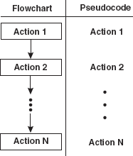

Figure 7.5 Flowchart and Pseudocode for Sequence Construct

Typical sequence operations consist of process and I/O steps. The following example illustrates a simple sequence control structure that adds two numbers. Note that the actions are flowing in a logical manner from top to bottom, as shown in Table 7.2. Not a single process branches out and no process is repeated. Each process is contributing something to the next process.

Table 7.2 Sequence Control Structure
Example Flowchart | Step-by-Step Instructions
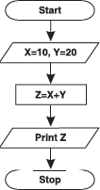 | Begin the flowchart.
 | Initialize value for memory variables X and Y.
 | Add X and Y and store the result in variable Z.
 | Print the value of variable Z as output.
 | End the flowchart.

7.6.2 Selection Control Structure
A selection structure allows the program to make a choice between two alternate paths, whether it istrue or false. The first statement of a selection structure is a conditional statement. Once the sequence of steps in the selected path has been carried out, the paths are rejoined and then the next instruction is carried out. Thus, the selection structure has only a single entry and a single exit. FromFigure 7.6 it is clear that if the condition is true, Action 1 will be performed, otherwise Action 2 will be performed. After performing the list of actions, the control of the program moves on to the other actions in the process flow.

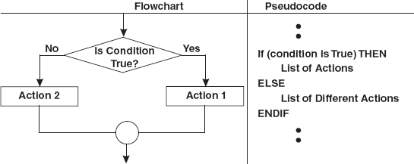

Figure 7.6 Flowchart and Psedocode for Selection Construct

The example given in Table 7.3 finds the larger of the two numbers.

Table 7.3 Selection Control Structure
Example Flowchart | Step-by-Step Instructions
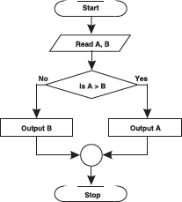 | Begin the flowchart.
 | Read two numbers and store the value in memory variables A and B, respectively.
 | Check whether the value of A is greater than the value of B.
 | If A is greater than B then display A, otherwise display B.
 | Connector symbol is used to join the flow lines.
 | End the flowchart.

7.6.3 Repetition Control Structure
Repetition or loop pattern causes an interruption in the normal sequence of processing. It directs the system to move back to a previous statement in the program, repeating the same sequence over and again, usually with new data. When a sequence of statements is repeated against a condition, it is said to be in a loop. Using looping, the programmer avoids writing the same set of instructions again (see Figure 7.7). The looping process can either be one time or multiple times until the desired output is obtained within a single program.

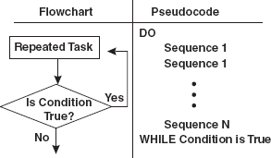

Figure 7.7 Flowchart and Pseudocode for Repetition Construct

The example shown in Table 7.4 prints the first 10 natural numbers. Notice that at the beginning, the value of COUNT variable is initialized to zero. After that, the value of COUNT is increased by one and is printed. If the value of COUNT is less than 10 (which represents the count of numbers to be displayed) then the same process is repeated. At the end of each iteration, if the condition evaluates to true, the loop repeats; otherwise the loop terminates.

Table 7.4 Repetition Control Structure
Example Flowchart | Step-by-Step Instructions
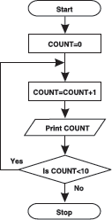 | Begin the flowchart.
 | Initialize the memory variable COUNT to zero.
 | Increment the value of COUNT by 1.
 | Print the value of COUNT.
 | Check whether the value of COUNT is less than 10. If yes, then move back to the third step otherwise go to the next step.
 | End the flowchart.
In all the above examples, we have used a term known as memory variable. Memory variable is a programming terminology used to represent the location in the memory where the values are stored.

7.7 Characteristics of a good program
Every computer requires appropriate instruction set (programs) to perform the required task. The quality of the processing depends upon the given instructions. If the instructions are improper or incorrect then it is obvious that the result will also be superfluous. Therefore, proper and correct instructions should be provided to the computer so that it can provide the desired output. Hence, a program should be developed in such a way that it ensures proper functionality of the computer. In addition, a program should be written in such a manner that it is easier to understand the underlying logic. A few important characteristics that a computer program should possess are as follows:
- Portability: Portability refers to the ability of an application to run on different platforms (operating systems) with or without minimal changes. Due to rapid development in hardware and software, nowadays platform change is a common phenomenon. Hence, if a program is developed for a particular platform then the life span of the program is severely affected.
- Readability: The program should be written in such a way that it makes other programmers or users to follow the logic of the program without much effort. If a program is written structurally, it helps the programmers to understand their own program in a better way. Even if some computational efficiency needs to be sacrificed for better readability, it is advisable to use a more user-friendly approach, unless the application's processing is of utmost importance.
- Efficiency: Every program requires certain processing time and memory to process the instructions and data. As you must have realized, processing power and memory are the most precious resources of a computer; a program should be laid out in such a manner that it utilizes the least amount of memory and processing time.
- Structural: To develop a program, the task must be broken down into a number of subtasks. These subtasks are developed independently, and each subtask is able to perform the assigned job without the help of any other subtask. If a program is developed structurally, the program not only becomes more readable, but the testing and documentation processes also get easier.
- Flexibility: A program should be flexible enough to handle most of the changes without having to rewrite the entire program. Most of the programs are developed for a certain period and they require modifications from time to time. For example, in case of payroll management, as the time progresses, some employees may leave the company while some others may join. Hence, the payroll application should be flexible enough to incorporate all the changes without having to reconstruct the entire application.
- Generality: Apart from flexibility, the program should also be general. By generality, we mean that if a program is developed for a particular task then it should also be used for all similar tasks of the same domain. For example, if a program is developed for a particular organization then it should suit all the other similar organizations.
- Documentation: Documentation is one of the most important components of an application development. Even if a program is developed following the best programming practices, it will be rendered useless if the end user is not able to fully utilize the functionality of the application. A well-documented application is also useful for other programmers because even in the absence of the author, they can understand it.

7.8 Programming languages
Previously, we discussed that a computer needs to be instructed using computer programs to perform all its tasks. To write computer programs, a computer or programming language is required, as computers do not understand natural languages (like English). A programming language consists of a set of characters, symbols and usage rules that allow the user to communicate with computers just as natural languages are used for communication among human beings.
You might be wondering why natural languages are not used to instruct the computers. There are mainly two reasons behind it. Firstly, the natural languages (English, Spanish) are ambiguous, vaguely structured, and have very large (and ever changing) vocabularies. In contrast, computer languages have relatively few, exactly defined rules for composition of programs, and strictly controlled vocabularies in which unknown words must be defined before they can be used. Secondly, in case of natural languages, we can understand even while using poor grammar and vocabulary. However, in the case of programming languages, the rules are very rigid and the programmer has to follow all the specified rules to create an accurate program and to obtain the desired results.
Computers understand only one language and that is binary language or the language of 0s and 1s. In the initial years of computer programming, all the instructions were given in binary form only. Although these programs were easily understood by the computer, it proved too difficult for a normal human being to remember all the instructions in the form of 0s and 1s. Therefore, the computer remained a mystery to a common person until other languages such as assembly and HLL were developed which were easier to learn and understand. These languages use commands that have some degree of similarity with English (such as “if else”, “exit”). Programming languages can be divided into three major categories:
- Machine Language: It is the native language of computers. It uses only 0s and 1s to represent data and instructions.
- Assembly Language: It correspondences symbolic instructions and executable machine codes and was created to use letters instead of 0s and 1s.
- High-level Language: These languages are written using a set of words and symbols following some rules similar to a natural language such as English. The programs written in HLL are known as source programs and these programs are converted into machine-readable form by using compilers or interpreters.

7.9 Generations of programming languages
Since early 1950s, programming languages have evolved tremendously. This evolution has resulted in the development of hundreds of different languages. With each passing year, the languages become user-friendly and more powerful. We can illustrate the development of all the languages in five generations.
First generation languages are machine languages, in which instructions are particular sequences of 0s and 1s that digital computers can understand. Second generation languages, assembly languages, allow programmers to use meaningful abbreviations for machine-specific instructions in place of the incomprehensible 0s and 1s form. Each instruction in an assembly language translates directly to a machine language instruction using a tool called an assembler. Programming became somewhat easier, but many users still wanted floating-point numbers and array indexing. Since these capabilities were not supported in hardware, HLL had to be developed to support them. The next few sections discuss the five generations of languages and how they revolutionized the computer industry.
The first language was binary, also known as machine language, which was used in the earliest computers and machines. We know that computers are digital devices, which have only two states, ON and OFF (1 and 0). Therefore, every instruction and data should be written using 0s and 1s. Machine language is also known as the computer's “native” language as this system of codes is directly understood by the computer.
The complexities of machine language led to the search of another language: the assembly language, developed in the early 1950s and its main developer was IBM. However, Jack Powell, Bob Nevelen, Clement and Michael Bradly also helped in the development of the assembly language. It was a stepping-stone for all subsequent language development. Assembly language allows the programmer to interact directly with the hardware. This language assigns a mnemonic code to each machine language instruction to make it easier to remember or write. It allows better human-readable method of writing programs as compared to writing in binary bit patterns. However, unlike other programming languages, assembly language is not a single language, but a group of languages. Each processor family (and sometimes individual processors within a processor family) has its own assembly language.
During 1960s, computers started to gain popularity and it became necessary to develop languages that were more like natural languages, such as English, so that a common user could use the computer efficiently. Since assembly language required deep knowledge of computer architecture, it demanded programming as well as hardware skills to use computers. Due to the computer's widespread usage, the early 1960s saw the emergence of the third generation programming languages (3GL). Languages such as COBOL, FORTRAN, BASIC and C are examples of 3GLs and are considered HLL.
In a high-level language, programs are written in a sequence of statements to solve a problem. For example, the following BASIC code snippet will calculate the sum of two numbers.
LET X = 10
LET Y = 20
LET SUM = X + Y
PRINT SUM
The first two statements store 10 in variable X (memory location name) and 20 in variable Y, respectively. The third statement again creates a variable named SUM, which will store the summation of X and Y value. Finally, the output is printed, that is, the value stored in SUM is printed on the screen.
Fourth generation languages (4GLs) have simple, English-like syntax rules, commonly used to access databases. The 3GLs are considered as procedural languages because the programmer must list each step and must use logical control structures to indicate the order in which instructions are to be executed. 4GLs, on the other hand, are non-procedural languages. The non-procedural method is simply to state the needed output instead of specifying each step one after another to perform a task. In other words, the computer is instructed what it must do rather than how a computer must perform a task.
Fifth generation languages are just the conceptual view of what might be the future of programming languages. These languages will be able to process natural languages. The computers would be able to accept, interpret and execute instructions in the native or natural language of the end users. The users will be free from learning any programming language to communicate with the computers. The programmers may simply type the instruction or simply tell the computer by way of microphones what it needs to do. Since these languages are still in their infancy, only a few are currently commercially available. They are closely linked to artificial intelligence and expert systems.

LET US SUMMARIZE
- A computer needs to be instructed to perform all its tasks. These instructions are provided in the form of a computer program. Programming involves many stages such as problem definition, task analysis, developing algorithm, testing algorithm, coding, program testing, documentation, implementation, and maintenance and enhancement.
- An algorithm is defined as a finite sequence of explicit instructions that when provided with a set of input values produces an output and then terminates. Algorithms can be represented as flowchart, pseudocode or decision table.
- A flowchart is a pictorial representation of an algorithm in which the steps are drawn in the form of different shapes of boxes and the logical flow is indicated by interconnecting arrows. The boxes represent operations and the arrows represent the sequence in which the operations are implemented.
- A decision table is a way of representing the problem statement in a tabular form. It contains all the possible conditions for a specific problem and the corresponding results using condition rules that connect conditions with results.
- Pseudocode is a generic way of describing an algorithm without the use of any specific programming language-related notations. It is an outline of a program, written in a form, which can easily be converted into real programming statements. Pseudocode uses plain English statements rather than symbols to represent the processes in a computer program.
- Program statements that affect the order in which statements are executed, or that affect whether statements are executed, are called control structures. They affect the flow of simulation code since a control structure evaluates statements and then executes code according to the result.
- There are three control structures, which are used in the case of designing a solution for a problem. These are sequential, selection and repetition. A sequence structure is a linear progression where one task is performed sequentially after another. A selection structure allows the program to make a choice between two alternate paths depending upon whether a conditional statement is true or false. A repetition or loop logic causes an interruption in the normal sequence of processing and directs the system to move back to a previous statement in the program, repeating the same sequence again.
- Programming paradigm refers to how a program is written in order to solve a problem. It provides (and determines) the view that the programmer has of the execution of the program. Broadly, programming can be classified in the following three categories: unstructured programming, structured programming and object-oriented programming.
- Unstructured programming refers to writing small and simple programs consisting of only one main program. All the actions such as providing input, processing and displaying output are done within one program only.
- Using structured programming, a program is broken down into small independent tasks, each having a single point of entry and exit. Each task has its own functionality and performs a specific part of the actual processing.
- In object-oriented programming, the programs are organized as cooperative collections of objects, each of which represents an instance of some class, and whose classes are members of a hierarchy of classes united by way of an inheritance relationship.
- Programming language is a language that a user employs to interact with the computer. It can be divided into three major categories: machine, assembly and high-level language.
- A good programming language should be easier to use and be portable. It should incur the minimum cost and provide concurrent support.

Exercises

Fill in the Blanks
- The sequence of instructions that instruct the computer to carry out a specific task is called..................
- An algorithm can be represented as.................or....................
- Broadly, programming can be classified into.............,...............and..............approaches.
- A program that translates the assembly language code into machine language code is called.................

Multiple-choice Questions
- The semantic and syntax errors in the program are checked in.................
  - Coding Phase
  - Testing Phase
  - Implementation Phase
  - Analysis Phase
- Choose the odd one out.................
  - Abstraction
  - Encapsulation
  - Inheritance
  - Linking
- Flow lines in a flowchart are used to connect............
  - Two Terminals
  - Two Connectors
  - Two Input/Output
  - All of these
- Programming tools helps in..................
  - Producing readable code
  - Making the program logic easier
  - Reducing the size of programs
  - None of these
- A high-level language is a programming language that is.......................
  - Easier to use
  - Considered a first generation language
  - Considered a third generation language
  - Both (a) and (c)

State True or False
- The graphical representation of an algorithm is called flowchart.
- The generic way of describing an algorithm without the use of programming language is known as program.
- The keyword, DETERMINE, used in a pseudocode is an input operation.
- The terminal symbol in a flowchart represents start of program logic.
- Programming is the art and science of creating computer programs.

Descriptive Questions
- Explain the program development cycle with the help of a block diagram.
- Define an algorithm. List the characteristics of a good algorithm.
- Define a flowchart. List some important reasons for using flowcharts.
- What benefits do decision tables offer over flowcharts?
- What are the advantages and disadvantages of using a pseudocode?
- Discuss the three basic program control structures with suitable examples.
  - Compiler
  - Interpreter
  - Loader
  - Linker

ANSWERS

Fill in the Blanks
- Computer program
- Flowchart, Decision table, Pseudocode
- Unstructured, Structured, Object-oriented
- Assembler

Multiple-choice Questions
- (b)
- (d)
- (d)
- (b)
- (d)

State True or False
- True
- False
- False
- True
- True

Chapter 8. Computer Sofware

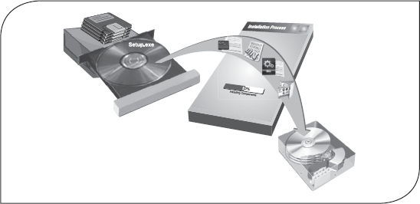

8.1 Introduction
A computer system consists of hardware, the electronic devices that are capable of computing and manipulating information, and software (set of instructions) that carries out predefined tasks to complete a given job. As we know, a computer cannot think or perform on its own. It performs operations like addition, subtraction, multiplication, and division only when the user instructs it to do so. The user issues instructions and the CPU acts in accordance with the instructions. The sets of instructions, which control the sequence of operations, are known as programs, and collectively programs are called software. It is an intangible commodity, that is, the part of a computer system that users cannot touch.
We can equate hardware and software with human body and human intelligence, respectively. All human physical actions such as walking and eating are based on the thoughts and feelings, which is raised by the brain. If the brain does not raise thoughts and feelings, we do not perform any physical activity. Similarly, the actions and functioning of every hardware equipment are driven by software. The combination of physical equipment (hardware) and logical instructions (software) gives modern computing systems their power and versatility.

8.2 Software: definition
Software is a generic term for organized collection of computer data and instructions. It is responsible for controlling, integrating, and managing the hardware components of a computer and to accomplish specific tasks. In other words, a software tells the computer what to do and how to do it. For example, software instructs the hardware what to display on the user's screen, what kinds of input to take from the user, and what kinds of output to generate. Thus, software communicates with the hardware by organizing the control sequences, and the hardware carries out the instructions defined by the software.
As discussed earlier, a computer needs to be instructed to perform any task. These instructions are given in the form of computer programs, which are written in computer programming languages. A program controls the activity of the processor. The moment the hardware (processor, memory, etc.) acts as per the instructions of a program, the program is said to be in running or executing state.
A set of programs, which are specifically written to provide the user a precise functionality like solving a specific problem, is termed as a software package. For example, word-processing software package provides functionality to the computer so that it can be used to create text documents like letters and mailing lists. Similarly, an image-processing software package assists a user in drawing and manipulating graphics.

Relationship between Software and Hardware
Software refers to the computer programs that are loaded into a computer system, and hardware refers to all the visible devices, which are assembled together to build a computer system (see Figure 8.1). Both software and hardware go hand in hand; you cannot have one without the other. Even though hardware is the physical part of a computer, it is nothing unless it has software to control it. In a way, hardware is like a car without a driver; one needs both to get the work done. Software is a set of instructions that tells the hardware what to do and how to perform the requested actions. Thus, hardware and software share a special relationship. If hardware is the “heart” of a computer system, software is its “soul.” Both are complementary to each other.



Figure 8.1 Hardware and Software

An analogy can be taken of a video game system, which comprises a console, games cassettes, joystick, and display screen as the hardware. The games in the cassettes can be considered as the software. To play a particular game, the cassette of that game has to be loaded on the console and then the game can be played. Similarly, to get a particular job done by a computer, the relevant software is loaded in the storage device, which makes a computer perform the desired functions. Therefore, it is evident that the software is vital. Another inference from this analogy is that different software can be used on the same hardware to perform different jobs, just as different games can be played on the same console by using different cassettes.

8.3 Categories of software
Software can be categorized as system software and application software (see Figure 8.2). System software is a generic term for referring to any computer program whose purpose is to help the user to run the computer system, whereas application software employs the capabilities of a computer directly to a task that the user wishes to perform. As an analogy, we can equate an electric bulb to an application and the electric power generation plant to a system. The power plant merely generates electricity. It is not really of any use until harnessed to an application like the electric bulb, which performs a service that the user desires.

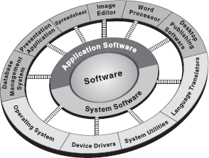

Figure 8.2 Software Categories

8.3.1 System Software
System software consists of several programs, which are directly responsible for controlling, integrating, and managing the individual hardware components of a computer system. You must have noticed that a new computer system is always accompanied with some software stored in either a CD or a DVD, which is supplied by the manufacturer. This software manages and supports the computer system and its information processing activities.
System software is more transparent and less noticed by the users as it usually interacts with the hardware or the applications. This software provides a programming environment in which programmers can create applications to accommodate their needs. This environment provides functions that are not available at the hardware level and performs the tasks related to the execution of an application program. Hence, system software acts as an interface between the hardware of the computer and the software applications (see Figure 8.3).

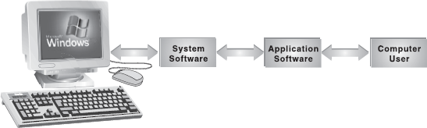

Figure 8.3 System Software, Application Software, and Hardware

In simple terms, system software makes the computer functional. It provides basic functionality like file management, visual display, keyboard input, etc., and are used by application software to accomplish these functions. Some examples of system software are operating systems, device drivers, language translators, and system utilities.
Operating System: It is the first layer of software loaded into the computer memory when it starts up. As the first software layer, all other software that gets loaded after it depends on it for various common core services. These common core services include disk access, memory management, task scheduling, and user interfacing. In addition, the operating system ensures that different programs executing at the same time do not interfere with each other. It provides a software platform on top of which other programs can run. In simple words, the operating system organizes and controls the hardware. Examples of operating systems are Windows, UNIX, and Linux. The basic functions of an operating system are (see Figure 8.4 also):

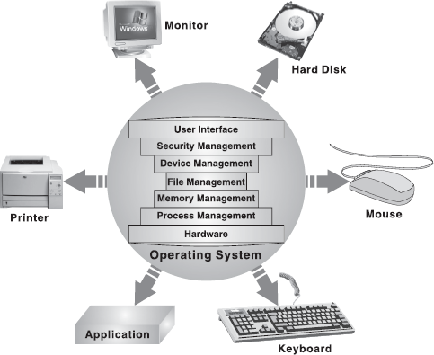

Figure 8.4 Operating System

- Process Management: It handles the creation, deletion, suspension, resumption, and synchronization of processes.
- Memory Management: It handles allocation and de-allocation of memory space as required by various programs.
- File Management: It is responsible for the creation and deletion of files and directories. It also organizes, stores, retrieves, names, and protects all the files.
- Device Management: It manages all the devices of the computer system such as printers and modems. If any device fails, it detects the device failure and notifies the same to the user.
- Security Management: It protects system resources and information against destruction and unauthorized use.
- User Interface: It provides the interface between the user and the hardware.
Device Drivers: Device drivers are system programs, which are responsible for proper functioning of devices. Every device, whether it is a printer, monitor, mouse, or keyboard, has a driver program associated with it for its proper functioning. Whenever a new device is added to the computer system, a new device driver must be installed before the device is used. In modern operating systems, most hardware drivers, such as the keyboard driver, come with the operating system. A driver acts like a translator between the device and program (typically, an operating system) that uses the device. For example, when a user prints a document, the processor issues a set of generic commands to the printer driver, and the driver translates those commands into specialized instructions that the printer understands. Note that each device has its own set of specialized commands that only its driver understands. A device driver is not an independent program; it assists and is assisted by the operating system for the proper functioning of the device (see Figure 8.5).

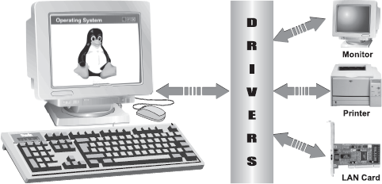

Figure 8.5 Device Drivers

Language Translators: Computers only understand machine language that is a language consisting of 0's and 1's. However, it is difficult for a programmer to understand the machine language. To ease the burden of a programmer, special programming languages called high-level programming languages were developed that resemble natural languages like English. Since computer understands only machine language, a tool is required which could translate a program written in a high-level programming language to machine language. Hence with every programming language, a language translator is also developed, which accepts the programs written in the programming language and transforms them into a form suitable for execution (see Figure 8.6). In other words, language translators help in converting programming languages into machine language. To be precise, they convert programming statements into the 0's and 1's that the computer is able to process
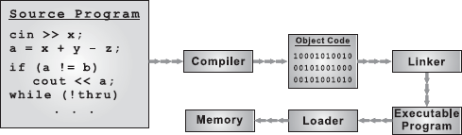

Figure 8.6 Translating Source Code into Executable Code

Typical software generally comprises millions of lines of programming statements or code. The code is divided into logical groups and stored in different independent modules so that debugging and maintenance of the code becomes easier. Before execution, different object codes resulting from the independent modules have to be linked together to create an executable program. A linker is a system program that links together several objects, modules, and libraries to form a single, coherent program (executable program). The part of the operating system that brings an executable file residing on disk into memory and executes it is known as loader.
System Utility: System utility programs perform day-to-day tasks related to the maintenance of the computer system. They are used to support, enhance, and secure existing programs and data in the computer system. They are generally small programs, having specific tasks to perform. Some utility programs are usually provided along with the operating system, some are free while some need to be purchased from the third-party commercial vendors. Most common functions of system utilities include:
- File Management: These utilities make it easier to manage data files. Many programs are written to help users to find the files, create and organize directories, copy, move, and remove files. For example, the Windows Explorer in Microsoft Windows operating system does all the said activities in a user-friendly interface.
- Backup: Sometimes, it may happen that some data files are corrupted or accidentally deleted. In such a case, data backups become very useful. A backup system utility is essential for those organizations that want to keep their data intact.
- Data Recovery: It is the process of retrieving deleted or inaccessible data from failed electronic storage media such as computer hard disk drives, removable media, optical devices, and tape cartridges. The data might become inaccessible due to a software problem, computer virus, mechanical or electrical malfunction, or a deliberate human act. Using data recovery tools, an experienced technician can successfully recover 80 to even 100 per cent of lost data.
- Virus Protection: Anti-virus programs are essential system utilities for a computer system functioning in a network. They provide security to the system from viruses that can damage the computer system. Viruses are small programs written with malicious intent, which copy themselves to hard disk from the Internet or other infected systems. Viruses keep on spreading to other computers through the network or exchange of infected storage devices such as floppies and CDs. To protect system from viruses, one needs anti-virus software. Once installed on the system, anti-virus software scans the hard disk for any kind of virus and, if found, removes them. In addition, it continuously monitors the computer and prevents viruses from getting inside. Examples of some anti-virus programs are Norton anti-virus and McAfee anti-virus.
- Disk Management: Disk management programs include various software like disk defragmenter, data compressor, and disk formatting tools. De-fragmentation implies putting fragments of files in a sequential order onto the disk, which reduces the time to access the file. It recognizes the data stored on the disk so that it can be arranged more effectively. Data compression programs squeeze out the slack space generated by the formatting schemes. Formatting tools format the hard drive in tracks and sectors for orderly storing of data in the disk.
- Firewalls: Firewalls form a barrier between networked computers within an organization and those outside the organization. They are commonly used to protect information such as e-mail and data files within a physical building or an organization. Essentially, a firewall is designed to protect a computer from unauthorized access, especially via network.
- Disk Cleanup: To keep a computer running smoothly, its regular maintenance is vital. Therefore, one should use the disk cleanup utility, which easily determines which files on the hard drive are no longer needed, and delete those files. In addition to freeing up potentially significant hard disk space; using disk cleanup on a regular basis can significantly improve the system performance.

8.3.2 Application Software
The most often seen software by a user is the application software. It is used to accomplish specific tasks rather than just managing a computer system. For a user, the computer system has no specific use without the application software. Application software may consist of a single program, such as Microsoft's Notepad (for writing and editing simple text), or a collection of programs, which work together to accomplish a task such as database management software. Application software may also include a larger collection of related but independent programs and packages (a software suite), which have a common user interface or shared data format, such as Microsoft Office suite.
Application software is dependent on system software. A system software (like operating system) acts as an interface between the user and the computer hardware, while application software performs specific tasks. Applications are softwares that perform tasks for the user besides helping the computer operate, which is the task of system software. Application software is controlled by system software, which manages hardware devices and performs background tasks for them. The distinction between the two is important. Without system software, the computer will not run, and without application software, the computer, no matter how powerful, will not be helpful in meeting user requirements. Think of it this way—applications apply the computer's thinking power to business tasks such as tracking the general ledger or billing your customers. Figure 8.7 illustrates that application software executes on the system software, which lies on the hardware layer.

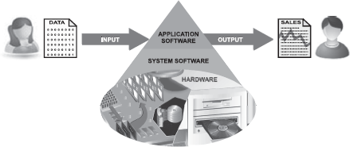

Figure 8.7 Relationaship between Application and System Software

Application software ranges from games, calculators, and word processors (document creating programs), to programs that paint images on screen (image editors). Applications represent real world tasks. They can be easily divided by looking at exactly what function they serve. Some of the most commonly used application software are discussed below.
Word Processors: A word processor is a software used to compose, format, edit, and print electronic documents (see Figure 8.8). Word processing is one of the earliest applications for Office productivity and the personal computer. It involves not only typing, but also checking the spelling and grammar of the text and arranging it correctly on the page. A variety of different typefaces are available for a variety of effects. It is possible to include pictures, graphs, charts, and many other things within the text of the document. It also allows for changes in margins, fonts, and colour. Nowadays, virtually all personal computers are equipped with a word-processing program, which has functions for writing letters, reports or other documents, and printing. Examples of some well-known word processors are Microsoft Word and WordPerfect.

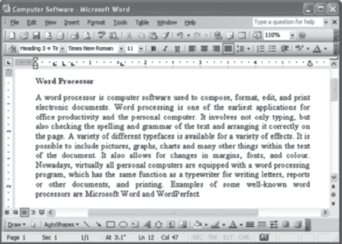

Figure 8.8 Word Processor

Spreadsheets: One of the first commercial uses of computers was in processing payroll and other financial records, so the programs were designed to generate reports in the standard “spreadsheet” format used by bookkeepers and accountants. A spreadsheet application is a rectangular grid, which allows text, numbers, and complex functions to be entered into a matrix of thousands of individual cells. The spreadsheet provides sheets containing cells, each of which may contain text and/or numbers. Cells may also contain equations that calculate the results from the data placed in other cells or a series of cells. A simple example might be a column of numbers totalled in a single cell containing an equation relating to that column (see Figure 8.9).

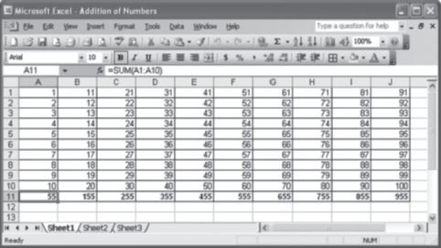

Figure 8.9 Spreadsheet Application

Spreadsheet software is used predominantly for accounting and other numerically based tasks, because financial and mathematical data and analysis are often managed in a tabular style, with columns of financial figures being manipulated and then influencing other data computations. Microsoft Excel and Lotus 1-2-3 are examples of spreadsheet applications.
Image Editors: Image editor programs are designed specifically for capturing, creating, editing, and manipulating images. These graphic programs provide a variety of special features for creating and altering images. In addition to offering a host of filters and image transformation algorithms, some image editors also enable the user to create and superimpose layers. Most graphic programs have the ability to import and export one or more graphic file formats. These computer programs enable the user to adjust an image to improve its appearance. With image editing software, one can darken or lighten an image, rotate it, adjust its contrast, crop out extraneous detail, and much more. Examples of these programs are Adobe Photoshop, Adobe Illustrator, and CorelDraw (see Figure 8.10).

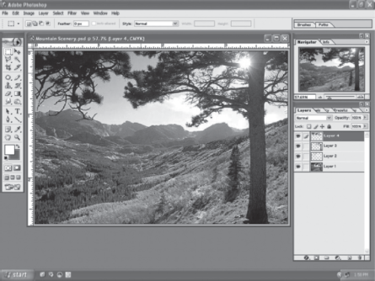

Figure 8.10 Image Editing Software

Database Management Systems: Database management software is a collection of computer programs that allow storage, modification, and extraction of information from a database (which is a collection of interrelated records) in an efficient manner. It supports the structuring of the database in a standard format and provides tools for data input, verification, storage, retrieval, query, and manipulation. When such software is used, information systems can be changed much more easily as the organization's information requirements change. New categories of data can be added to the database without disrupting the existing system. It also controls the security and integrity of the database from unauthorized access. FoxPro, MS-Access, and Oracle are database management systems (see Figure 8.11).

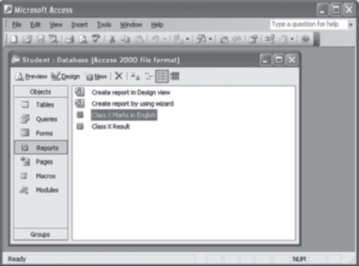

Figure 8.11 DBMS Application

Presentation Applications: A presentation is a means of expressing ideas in the form of visual images, audio, and animation. To prepare presentations, presentation software is used. Presentation software allows the users to create presentation by producing slides or handouts for presentation of projects. Essentially, such computer programs allow users to create a variety of visually appealing electronic slides for presentations. Microsoft PowerPoint is one of the most famous presentation applications (see Figure 8.12).

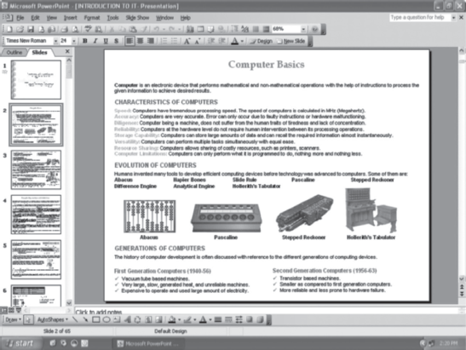

Figure 8.12 File System

8.4 Installing and uninstalling software
Once software (system or application) is carefully selected and purchased, it should be installed on the computer to start working with it. During the installation-process, files are copied to their appropriate folders and icons are added to the system menus and/or desktop. Software has recently become much more user friendly in this area. Most softwares handle the installation chores without a lot of input from the user.

Sometimes software is installed just for testing or perhaps it has been superseded by a better software. Hence, unwanted software should be uninstalled, that is, cleanly removed. Uninstall program completely removes all files of that program and all associated files in other directories. Note that simply deleting the folder in which the software is stored will not remove all the files related to that software; it needs to be uninstalled to remove all the linked files of the software. When a program is installed, its files are copied to the system disk, and changes are made to certain system files and folders to allow the program to work properly. Properly uninstalling a program means deleting all the files and undoing any changes made to system files.

8.5 Software piracy
Software piracy is the unauthorized copying of an organization's internally developed software or the illegal duplication of commercially available software. While purchasing software, the user gets a licence to use the application but it cannot be copied on other machines. The use of the software must comply with the product licence agreement that is included with the software. A software license is a type of proprietary licence, which acts as a memorandum of contract between the producer and the user of computer software. It is sometimes also called an end-user license agreement (EULA), which specifies the permissions granted by the owner to the user.
There are six basic forms of software piracy, and all are harmful for the software publisher as well as the for the end user.
Softloading: Softloading (also known as softlifting) means sharing a program with someone who is not authorized by the licence agreement to use it. A common form of softloading involves purchasing a single licensed copy of software and then loading the software onto several computers, in violation of licensing terms. For example, sharing software with friends, co-workers, and others.
Software Counterfeiting: Software counterfeiting means producing fake copies of software and making it look authentic. This involves providing the packaging box, CDs or floppies, and manuals, all designed to look like the original product. Most commonly, a copy of a CD is made with a CD burner, and a photocopy of the manual is made. Counterfeit software is sold on street corners, and sometimes unknowingly sold even in retail stores. Counterfeit software is sold at prices far below the actual retail price.
Internet Downloading: It is the fastest growing form of piracy. With the growing number of users online and with the rapidly increasing connection speeds, the exchange of software on the Internet has attracted an extensive following. Currently, there are hundreds of thousands of “warez” sites providing unlimited downloads to any user. Often, the software provided through these warez sites is cracked to eliminate any copy protection schemes.
Renting: It involves someone renting out a copy of software for temporary use, without the permission of the copyright holder. The practice, similar to that of renting a video of a movie, violates the licence agreement of software.
Hard Disk Loading: This form of piracy involves installing an unauthorized copy of software onto a computer being sold to the end user. It is often committed by hardware dealers. This makes the deal more attractive to the buyer, at virtually no cost to the dealer. Dealer usually does not provide the buyer with manuals or the original CDs of the software.
Licence Misuse: Software is distributed under special discount licences to high-volume customers, computer manufacturers, or academic institutions. After getting a copy of software, manufacturers, customers, or institutions redistribute the software to others who do not hold or qualify for these licences. This constitutes the misuse of licence. Some of the ways a licence can be misused are:
- Original Equipment Manufacturer (OEM) Unbundling: Often just called unbundling, it involves selling stand-alone software, which is originally meant to be included with a specific accompanying product. An example of this form of piracy is someone providing drivers with a specific printer without authorization.
- Academic Product Misuse: This form of licence misuse occurs when a product that has been specifically marked for distribution to educational institutions and students at reduced prices is diverted into normal commercial channels of distribution.
- Not for Resale (NFR) Product Misuse: This form of licence misuse occurs when a product that has been clearly marked Not for Resale is diverted into normal commercial channels of distribution. Such products are typically distributed as a promotional or sample product and are not licensed for normal commercial distribution and use.
Software piracy all over the world has become a major problem. To avoid this, several licence and copyrights are issued to the software and the users. A copyright is a form of intellectual property that grants its holder the legal right to restrict the copying of an original, creative expression for a defined period. Nowadays, some software developers use software copyrights in order to ensure that the software they develop will remain free, using licences such as the general public license (GPL). It is a good idea to put the copyright notice on the computer software both on the packaging and in the program as it serves as a warning to others that the software is protected by copyright. In addition to the copyright notice, warning against unauthorized use should also be mentioned. The general rule is that the creator of some work is the first owner of copyright on it. Here are some guidelines to prevent software piracy:
- Always buy software from authorized sellers and when in doubt, contact the software manufacturer for a list of authorized sellers.
- While purchasing software, consumers should make sure that they get authenticated software licences. In case of hardware purchase, do not allow dealers to install unlicensed software onto the computer.
- Unless authorized in the licensing agreement, employees of an organization should not make personal copies of software used in an organization.
- One should not make copies of software other than those allowed by the licence agreement.
- Software renting or reselling must not be practised.
- The best way to prevent software piracy is to report it to the concerned copyright holder.

8.6 Software terminologies
Some of the common terms used in the field of software are given below:
Public Domain Software: Public domain software refers to any program that is not copyrighted. This software is free and can be used without restrictions, that is, the user can copy, distribute, and even modify the software without obtaining permissions from the software developer. Usually, public domain software is offered through websites, electronic bulletin boards, user groups, and other sources.
Freeware: The term freeware is commonly used for copyrighted software that is given free by its owner. Though it is available for free, the owner retains the copyright, which means that a user does not have the right to modify anything in the software. Thus, freeware software permits redistribution but not modification. Freeware usually carries a licence that permits redistribution but may have other restrictions such as limitations on its commercial use. Freeware is an umbrella term that covers:
- Donationware: The authors of donationware ask that anyone using their software make a donation to the authors or to some third party such as a charity.
- Postcardware: It is freeware (no-charge software that is freely shared) that requires only that the user send the software provider a postcard as a form of payment.
- Abandonware: It is commercial software that has not been sold for a long time or whose copyright holder is defunct. The licences of most of such software forbid redistribution or require payment; hence distributing it violates the owner's copyright (even if the owner does not or cannot enforce it).
- Adware: It is distributed as freeware, but it requires the user to view advertisements to use the software. Note that adware is sometimes called spyware.
Shareware: Shareware is the software that is distributed free on a trial basis. It allows people to redistribute copies for a limited period. Anyone who continues to use a copy is required to pay a licence fee. Therefore, the free use of the software is usually limited to a certain period. It is distributed without payment ahead of time as is common for proprietary software. Typically shareware software is obtained free of charge by downloading, thus allowing one to try out the program ahead of time. It is accompanied by a request for payment, and often payment is required as per the terms of the licence past a set period. WinZip software is an example of shareware, which is distributed with a 30-day trial period.
Commercial Software: Commercial software represents the majority of software purchased from software publishers. This software comes pre-packaged, is available in software stores, and can be obtained through the Internet. It is developed by business organizations, which aim to earn profits from its use. It is always copyrighted. The licensing restrictions vary somewhat from vendor-to-vendor and product-to-product, and change frequently. It is generally more expensive than competing shareware products, for example Microsoft Windows.
Open-Source Software: Open-source software is created by generous programmers and released into the public domain for public use. The underlying programming code is available to the users so that they may read it, make changes to it, and build new versions of the software incorporating their changes for software. Usually these softwares are distributed under an open-source licence—GPL. Such a licence requires that the source code should be distributed along with the software, and that the source code is freely modifiable, with least restrictions, such as the requirement to preserve the author's names and copyright statement in the code. The Linux operating system is an example of open-source software.
Proprietary Software: In general, proprietary describes a technology or product that is owned exclusively by a single company that carefully guards knowledge about the technology or the product's internal working. Some proprietary products can only function properly, if at all, when used with other products owned by the same company. Example of a proprietary product is Adobe Acrobat, whose portable document format (PDF) files can only be read with Acrobat Reader. Proprietary software is also called as closed-source software (CSS). Its use, redistribution, or modification are prohibited or restricted so much that the user effectively cannot use it freely.
Firmware: Firmware is a program or data that has been written onto read-only memory (ROM). For example, the BIOS (which is installed inside a computer on a chip) checks different parts of the system before loading the operating system into memory. Being firmware, it ensures that it will always be available and will not be damaged in the case of a power failure. ROMs, PROMs, and EPROMs that have data or programs recorded on them are firmware (see Figure 8.13).

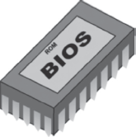

Figure 8.13 Firmware

LET US SUMMARIZE
- Software is a generic term for organizing collection of computer data and instructions. Computer software can be divided into two major categories: system software and application software.
- System software consists of several programs, which are directly responsible for controlling, integrating, and managing the individual hardware components of a computer system. Some examples of system software are operating system, device driver, language translators, andsystem utility.
- Application software is used to accomplish specific tasks rather than just managing a computer system. Word processors, spreadsheets, image editors, database management systems, presentation software, and desktop publishing applications are some of the examples of application software.
- Software installation is the process of copying software from CD-ROM (or floppy disks) to the hard disk and configuring it to work with the computer hardware.
- Software upgrade is the process of adopting a newer version of existing software with an enhanced feature.
- Software update is a new release (or version) of software that is generally understood to be an error-correction release and does not contain new functionality. It usually adds relatively minor new features to a product or corrects errors (bugs) found since the program has released.
- A software patch is a collection of one or more files that correct flaws in the performance, reliability, or security of a specific software product.
- Software piracy is an unauthorized copying of an organization's internally developed software or the illegal duplication of commercially available software. It includes illegal activities such as softloading, software counterfeiting, Internet downloading, renting, hard disk loading, and licence misuse.
- Public domain software refers to any program that is not copyrighted. This software is free and can be used without restrictions, that is, the user can copy, distribute, and even modify the software without obtaining permissions from the software developer.
- The term freeware is commonly used for copyrighted software that is given free by its owner. It permits redistribution but not modification and usually carries a licence that permits redistribution but may have other restrictions, such as limitations on its commercial use.
- Shareware is the software that is distributed free on a trial basis. It allows people to redistribute copies for a certain period.
- Commercial software represents the majority of software purchased from software publishers. This software comes pre-packaged, is available in software stores, and can be obtained through the Internet.
- Open-source software is created by generous programmers and released into the public domain for public use. The underlying programming code is available to the users so that they may read it, make changes to it, and build new versions of the software incorporating their changes for software.
- Proprietary software describes a technology or product that is owned exclusively by a single company that carefully guards knowledge about the technology or the product's internal working.
- Firmware is a program or data that has been written onto ROM.

Exercises

Fill in the Blanks
- .........is the set of coded instruction that brings the machinery to life.
- Software is often divided into two major categories, namely, ......... and .........
- A.........acts like a translator between the device and programs that use the device.
- The function of an operating system that allows creation, deletion, suspension, resumption, scheduling, and synchronization of processes is called..........
- .........program scans the hard disk for viruses and removes them.
- .........helps in converting programming language into machine language.
- .........is the process of copying software from CD-ROM (or floppy disks) to the hard disk and configuring it to work with the computer hardware.
- .........is the unauthorized copying of an organization's internally developed software or the illegal duplication of commercially available software.
- .........is the software, which comes with permission for people to redistribute copies for a limited period.
- Firmware is the program or data that has been written onto ........

Multiple-choice Questions
- Which of the following is system software?
  - Microsoft Word
  - Adobe Photoshop
  - Microsoft PowerPoint
  - Windows
- ........analyses and executes each line of source code in succession, without looking at the entire program.
  - Compiler
  - Operating System
  - Interpreter
  - Device Drivers
- The assembly language program must be translated into machine code by a separate program called.........
  - Assembler
  - Interpreter
  - Compiler
  - Loader
- Softloading is also known as .........
  - Softlifting
  - Softwarecopy
  - Both (a) and (b)
  - None of these
- If you change Windows XP operating system to Windows 7, you are actually performing.............
  - Update
  - Upgrade
  - Patch
  - None of these
- Which of the following is application software?
  - Database Management System
  - Image Editor
  - Spreadsheets
  - All of these
- Usually, installation files have the extension........
  - .doc
  - .gif
  - .exe
  - .jpeg
- Which of the following activity can be termed as software piracy?
  - Softloading
  - Counterfeiting
  - Renting
  - All of these
- Choose the odd one out
  - Donationware
  - Postcardware
  - Shareware
  - Adware
- Linux is a type of ........ software.
  - Shareware
  - Open Source
  - Commercial
  - Proprietary

State True or False
- Operating system is application software.
- A device driver allows another program to interact with a hardware device.
- Data recovery is the process of retrieving deleted or inaccessible data from failed electronic storage media.
- Anti-virus is the program to protect from the piracy.
- Installation files usually have the extension .EXE or .ZIP.
- Software update and software upgrade perform the same function.
- Software piracy is the authorized copying of an organization's internally developed software.
- Public domain software refers to any program that is not copyrighted.
- Firmware software is embedded in the hardware devices.
- Microsoft Word is an image editing software.

Descriptive Questions
- What do you understand by software? Discuss its types.
- Explain the difference between hardware and software with their definition and uses.
- Explain the concept of software installation and uninstallation.
- How is software update different from software upgrade? Explain.
- What is software piracy and how can it be avoided?

ANSWERS

Fill in the Blanks
- Software
- System Software, Application software
- Device Drivers
- Process Management
- Anti-Virus
- Language Translators
- Software Installations
- Software piracy
- Shareware
- Read-only memory (ROM)

Multiple-choice Questions
- (d)
- (c)
- (a)
- (a)
- (b)
- (d)
- (c)
- (d)
- (c)
- (b)

State True or False
- False
- True
- True
- False
- True
- False
- False
- True
- True

Chapter 9. Introduction to Microsoft Office 2007
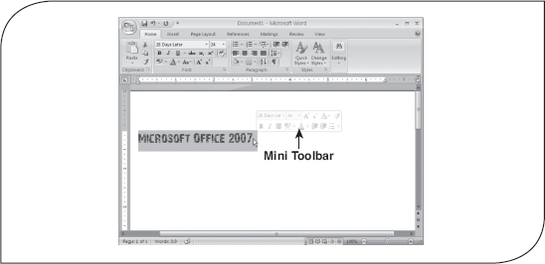

9.1 Introduction
Office 2007 is the version of Microsoft's productivity suite. Other than the applications in previous versions, it includes new applications like Groove 2007, OneNote 2007, and Communicator 2007. Some new server-side tools like Office SharePoint Server 2007 have also been added in Office 2007. In addition, it offers a variety of new and exciting features. The most noticeable features that are common to the core applications in the Office 2007 include the new task-oriented graphical user interface, the new Office XML formats, and the ability to easily attach custom XML data to a file. In this chapter, we introduce the Office 2007 user interface and discuss some of the new features or enhancements made in its core applications.

9.2 Introduction to office 2007 user interface
Microsoft has made significant changes in the user interface of most of the applications including Word, Excel, PowerPoint, Access, and Outlook (in the composing and reading window) of Office 2007. In the earlier versions of MS Office, there were menus and toolbars using which a user could find the features and commands to get the desired task done. In Office 2007, a new interface named as Office Fluent has been introduced in which these menus and toolbars have been replaced with the Ribbon and Office button. This new user interface is more intuitive and easier to navigate. Some of the highlights of this new interface are discussed in this section (Figure 9.1).

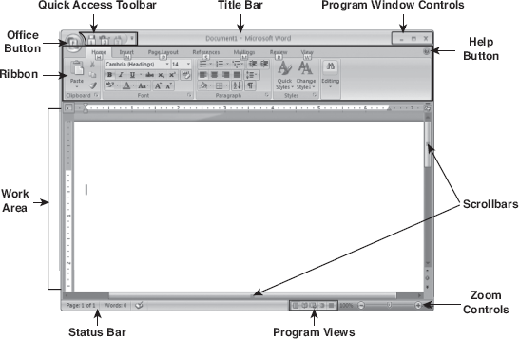

Figure 9.1 User Interface of Office Word 2007

Office Button: The Office Button () is located at the top left corner of the Office program window. It provides quick access to the basic commands that are common to all Office programs like creating, opening, saving, printing and closing a file. Other than these basic commands, it has some more commands like Prepare, Finish, and Publish depending on the program being used. Using this button, you can also access a list of documents you have most recently worked with and a set of various program options (Figure 9.2).

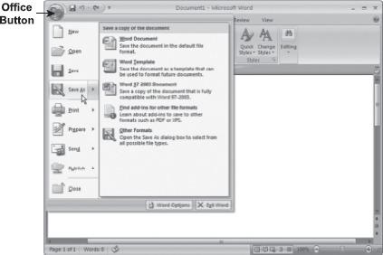

Figure 9.2 Office Button

Quick Access Toolbar: The Quick Access Toolbar is a customizable toolbar located to the right of the Office button on the Office program window. By default, it contains Save, Undo, and Redobuttons. You cannot only add or remove the buttons to the Quick Access Toolbar but also move the Quick Access Toolbar below the ribbon (that is, near the work area).
You can customize the Quick Access Toolbar by using the Customize Quick Access Toolbarbutton () which is present immediate right to the Quick Access Toolbar. When you click this button, a menu appears that contains a list of the commands. To add a command in the Quick Access Toolbar, select it from the menu. A check mark beside the command name indicates that the command is added to the Quick Access Toolbar. To remove a command from the Quick Access Toolbar, deselect the name of the command in the menu. You can also search for more commands to add to the Quick Access Toolbar by clicking the More Commands button in the menu (Figure 9.3).

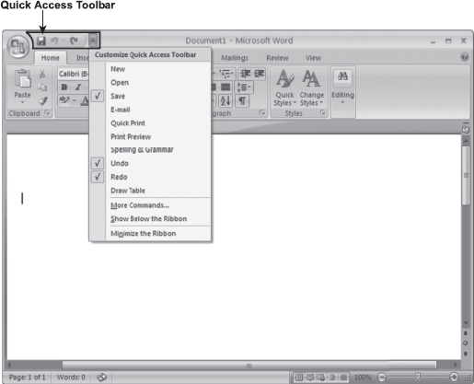

Figure 9.3 Customizing Quick Access Toolbar

Ribbon: As stated earlier, in some of the applications of Office 2007, the menus and toolbars have been replaced with the Ribbon. The Ribbon is located just below the title bar. It is designed specially to provide quick access to commands that you need to complete a task. It consists of the commands which are organized into logical groups; these groups are further organized under tabs. The ribbon along with its components is shown in (Figure 9.4).

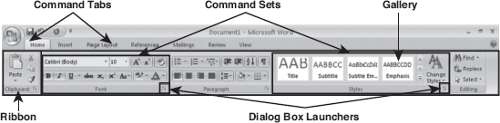

Figure 9.4 Ribbon

Note: You can minimize or restore the ribbon by pressing Ctrl+F1.
Command Tabs: A command tab or simply tab consists of commands that are related to a specific type of activity. For example, Page Layout tab consists of the commands related to the layout or formatting of a page or pages in your document. By default, the commands under theHome tab are displayed on the ribbon. You can view or use the commands under a different command tab by simply clicking on that command tab.
Command Sets: The commands in a command tab are organized under a group according to their functions. The group of commands related to the selected tab in the program window is known as command set.The commands specific to the formatting of font like Font, Font size, Bold, Italic, etc. are grouped under the Font command set. The name of the command set is displayed below the commands. The command sets under Home tab are Clipboard, Font, Paragraph, Styles, andEditing.
Dialog Launcher: MS Office 2007 also provides traditional style dialog boxes for some command sets on the Ribbon. The dialog boxes for the command sets are indicated by the presence of a small arrow () at the bottom right corner of a command set (known as dialog launcher). Clicking this arrow, you can open the dialog box that allows you to access the commands of that command set. For example, if you click the dialog launcher at the bottom of the Paragraph command set under theHome tab, a Paragraph dialog box appears (Figure 9.5).

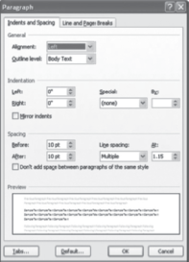

Figure 9.5 Paragraph Dialog Box

Contextual Tabs: All the available tabs do not appear on the ribbon; some tabs appear only when needed. Such tabs are called contextual tabs. These tabs become visible when you create or select a specific object in your document. For example, when you insert or select a table, the Table Toolssection with Design and Layout tab appears on the Ribbon (see Figure 9.6). The Design tab consists of a variety of command sets that allow you to format a table the way you want it to appear. The Layout tab provides command sets that allow you to position and organize data in the cells in the way you want. The purpose of the contextual tabs is to reduce cluttering of commands on the ribbon.

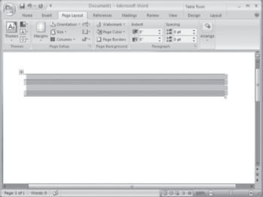

Figure 9.6 Contextual Tabs after Selecting Table
KeyTips: Like earlier versions of Office, Office 2007 also provides keyboard shortcuts to access the commands quickly. However, the users need not remember the keyboard shortcuts. Office 2007 provides you KeyTips that show a way to access the commands via the keyboard. KeyTips are nothing but the indicators that display the keyboard shortcuts for the commands. To activate the KeyTips, simply press Alt key. On pressing the Alt key, the KeyTip will appear on the Office button, tab names, and all command buttons in the Quick access toolbar (see Figure 9.7). Note that a KeyTip can be a single letter, digit, or a combination of letter and numbers.

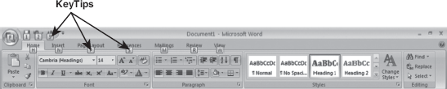

Figure 9.7 KeyTips

You can use the desired features by pressing the corresponding KeyTip. For example, if you want to insert a picture in your document, press N to activate the Insert tab. Doing this displays the KeyTip over each command under the Insert tab (see Figure 9.8). Now to insert picture, press P. Similarly, you can use any command under any tab.

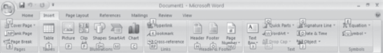

Figure 9.8 KeyTips under Insert Tab

Super ToolTips: A very convenient feature provided by the Office 2007 is the Super ToolTip. A Super ToolTip is the small window that provides information about a command along with an image. It is displayed when the user rests the mouse pointer on the command, as shown in (Figure 9.9). It can be considered as the enhanced form of the ToolTip as it has larger window that displays more descriptive text than a ToolTip and can have a link to a Help topic. To hide the Super ToolTip, simply move the mouse away from the command.

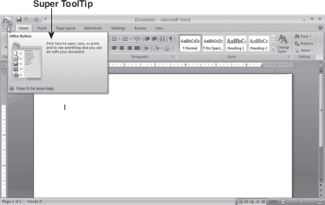

Figure 9.9 Super ToolTips

Live Preview: The Live Preview feature enables you to see the effect of the selected option from the drop-down menu or gallery on the selected object or current document before actually applying it. To use this feature, simply move the mouse pointer over an option. The effect of that command will be shown in the work area of application, thereby allowing users to try different options quickly and select the one that works best before actually applying it to the document. It saves time by avoiding the process of formatting, undoing, and redoing repeatedly to get the desired results.

9.3 Microsoft office applications
Microsoft has not only made changes in the user interface of Office 2007 but has also added new features as well as enhanced some existing features in each program also. This section covers the enhancements made in the four main Office 2007 programs including Word, Excel, Access, and PowerPoint.

9.3.1 Microsoft Office Word 2007
Today, MS Word is the most popular word processor that helps you produce professional-looking documents. Using Word 2007, you can create and format your document effortlessly than the earlier versions. Some of the new features/enhancements made in Word 2007 are as follows:
- Charting: The new charting and diagrammatic features of Word 2007 allow you to create high-impact graphics, thereby producing an effective document. These features include transparency, drop shadows, contour effects, etc.
- Document Comparison: In Word 2007, you can compare two versions of a document quickly. It allows you to find what changes were made to a document by marking the deleted, inserted, and moved text in the third version of the document.
- Digital Signature: Word 2007 allows you to add digital signature to your document, thereby ensuring the authenticity, integrity, and origin of the document. Once a digital signature has been added to the document, it becomes read-only so that no modifications can be made to its content.
- Mark as Final: The Mark as Final feature of Word 2007 prevents readers from making changes in a document by making it read-only. When this command is applied to a document, all the commands related to the editing are disabled or turned off and a Mark as Final icon appears in the status bar to indicate its final status. Note that it only conveys to the readers that you are sharing a final version of a document. Anyone who receives the document that has been marked as final can edit that document by removing Mark as Final status from the document.
- Conversion of Word Documents to PDF or XPS: Word 2007 allows you to save files in portable document format (PDF) or XML paper specification (XPS) which are the common file formats for sharing documents. Both these formats ensure that formatting of document remains intact whenever the document is viewed online or printed and its contents cannot be modified easily.

9.3.2 Microsoft Office Excel 2007
Microsoft Office Excel 2007 allows you to analyse, manage, and share the data easier than the earlier versions. Some of the new features/enhancements made in Excel 2007 are as follows:
- Increased Number of Rows and Columns: To manage large amount of data in a worksheet, the number of rows and columns has been increased. Excel 2007 provides you more than 1 million rows and 16 thousand columns in a worksheet.
- Conditional Formatting: In Excel 2007, conditional formatting can contain up to 64 conditions instead of only three conditions as in earlier versions of Excel. Moreover, it also provides new conditional formatting types like colour scales, data bars, or icon sets.
- Easy Formula Writing: In Excel 2007, writing formulas has become easier because of several enhancements like resizable formula bar, Function AutoComplete, and structured references. The formula bar is resized on entering long, complex formulas, which prevents other data from being hidden by the formulas in your worksheet. Function AutoComplete feature allows you to quickly write the proper formula syntax. Excel 2007 also facilitates to use the structured references to reference named ranges and tables in a formula. This makes it easier to work with table data while using formulas that reference a table, either portions of a table or the entire table.
- New OLAP Formulas and Cube Functions: In Excel 2007, some new OLAP formulas and functions have been introduced to work with multidimensional databases (such as SQL server analysis services). Using OLAP formulas, you can build complex, free form, OLAP data-bound reports. New cube functions can be used to extract OLAP data from analysis services and display it in a cell.
- Enhanced Sorting and Filtering: Excel 2007 allows you to arrange the data in some specific order more quickly and easily than the earlier versions of Excel using enhanced filtering and sorting features. In Excel 2007, you can sort data up to 64 levels instead of only three levels. You can filter data by a specific format also, such as cell colour, font colour, or dates instead of text only.
- Easy-to-use PivotTable and PivotCharts: Excel 2007 allows you to create PivotTables with much ease. You can create a PivotTable by simply selecting the fields that are needed instead of dragging the data as required in earlier versions. Once a PivotTable is created, you can sort, group, and calculate totals for a large amount of data with ease using new and enhanced features. Like PivotTables, PivotCharts can be created easily to observe comparisons, patterns, and trends. In addition, Excel 2007 offers many tools and menus specific to the PivotChart that makes the analysis of chart data easy.
- Saving to New File Formats: Like Word 2007, Excel 2007 also allows you to save files as PDF or XPS.

9.3.3 Microsoft Office Access 2007
Microsoft Office Access 2007 provides a wide variety of professionally designed database templates and other useful features that increase the productivity of the user as well as make the user learn faster. Some of the new features/enhancements made in Office Access 2007 are as follows:
- Layout View: Access 2007 includes a new layout view that lets you make design changes in forms and reports while viewing them. You can add or remove a field or apply formatting without switching to the design view as in earlier versions.
- Enhanced Quick Create by using the Create Tab: The Create tab on the ribbon lets you create new objects such as forms, reports, tables, SharePoint lists, queries, macros, etc. quickly. When you create an object, Excel 2007 considers the active object. As a result, a new object can be created quickly based on the active object. For example, if a table is opened, a new form can be created based on that table in just two mouse-clicks.
- Easy to Create Tables: In Access 2007, designing a table has become faster and easier due to the improvement in Datasheet view. You can add or remove a field to/from the table in the Datasheet view, that is, without switching to Design view as required in earlier versions. Moreover, Access infers common data types such as text, number, date and time, etc. when the first data is entered in a new column. Thus, you are no longer required to specify the common data types.
- Attachment Data Type: Access 2007 provides a new Attachment data type that allows you to store all types of documents (pictures, graphics, Office files, binary files, etc.) in your database. You can store multiple attachments with a single record. Moreover, Access automatically compresses the attachments whenever required, thereby maximizing the memory usage.
- Easy to Import and Export data: In Access 2007, you can perform import and export operations efficiently that you use on a regular basis. It lets you save the details of import and export operation that is needed to repeat the operation as a specification. Moreover, while saving the specification, Access offers the option to schedule the operation.
- Export to PDF and XPS: Access 2007 also allows you to save files in PDF or XPS.

9.3.4 Microsoft Office PowerPoint 2007
Microsoft PowerPoint 2007 comes with new interface, new templates, and enhanced formatting options that enable you to give a professional look to your presentations. Now you can quickly and easily design an impressive presentation that catches the attention of your audience. Some of the new features/enhancements made in PowerPoint 2007 are as follows:
- SmartArt Graphics: With SmartArt graphics feature, you can create designer-quality illustrations quickly and easily without the aid of a designer. PowerPoint 2007 lets you choose a type of SmartArt graphic while creating it. Each type contains several different layouts. After you choose a layout, you can easily switch layouts to try different layouts to find the best one that illustrates your information. Most of your text, text formatting, colours,styles, and effects are automatically applied to the new layout.
- New Graphics Effects: PowerPoint 2007 allows you to give professionally designed look to your presentation by adding 3D effects like reflection, shadow, glow, soft edges, rotation, etc. to shapes, SmartArt graphics, tables, text, and WordArt.
- Presenter View: One of the new exciting features offered by PowerPoint 2007 is the presenter view. Using this feature, you can deliver your presentation on two monitors; you can run your presentation on one monitor and the audience can view it on a second monitor. In this view, you can create a customized presentation for your audience by using thumbnails to select slides out of sequence.
- Slide Libraries: Using PowerPoint 2007 Slide Libraries, you can share and reuse the content of slides. You can store presentations as individual slides on a centralized storage (Slide Library) where you can publish your slides and reuse the slides on it.
- Mark as Final: Like Word 2007, in PowerPoint 2007 also, you can use the Mark as Final feature to prevent readers from making changes in a presentation by making it read-only.
- Export to PDF and XPS: PowerPoint 2007 allows you to save files in PDF or XPS.

LET US SUMMARIZE
- Office 2007 is the latest version of Microsoft's productivity suite. Other than the applications in previous versions, it includes new applications like Groove 2007, OneNote 2007, and Communicator 2007. Some new server-side tools like Office SharePoint Server 2007 have also been added in Office 2007.
- In Office 2007, a new interface named as Office Fluent has been introduced in which these menus and toolbars have been replaced with the Ribbon and Office button.
- The Office Button () is located at the top left corner of the Office program window. It provides quick access to the basic commands that are common to all Office programs like creating, opening, saving, printing, and closing a file.
- The Quick Access Toolbar is a customizable toolbar located to the right of the Office button on the Office program window. By default, it contains Save, Undo, and Redo buttons. You can not only add or remove the buttons to the Quick Access Toolbar but also move the Quick Access Toolbar below the ribbon (that is, near the work area).
- The Ribbon is located just below the title bar. It is designed specially to provide quick access to commands that you need to complete a task. It consists of the commands which are organized into logical groups; these groups are further organized under tabs.
- A command tab or simply tab consists of commands that are related to a specific type of activity. By default, the commands under the Home tab are displayed on the ribbon.
- The commands in a command tab are organized under a group according to their functions. The group of commands related to the selected tab in the program window is known as command set. The name of the command set is displayed below the commands.
- MS Office 2007 also provides traditional style dialog boxes for some command sets on the Ribbon. The dialog boxes for the command sets are indicated by the presence of a small arrow () at the bottom right corner of a command set (known as dialog launcher).
- All the available tabs do not appear on the ribbon; some tabs appear only when needed. Such tabs are called contextual tabs. These tabs become visible when you create or select a specific object in your document.
- Office 2007 provides you KeyTips that show a way to access the commands via the keyboard. KeyTips are nothing but the indicators that display the keyboard shortcuts for the commands.
- A Super ToolTip is the small window that provides information about a command along with an image. It can be considered as the enhanced form of the ToolTip as it has larger window that displays more descriptive text than a ToolTip and can have a link to a Help topic.
- A mini toolbar is a handy, miniature, and semitransparent toolbar that appears when you select some text in an Office program. It allows you to quickly access the commands that are frequently used while working in an Office program.
- The Live Preview feature enables you to see the effect of the selected option from the drop-down menu or gallery on the selected object or the current document before actually applying it.
- Using Word 2007, you can create and format your document effortlessly than the earlier versions.
- Microsoft Office Excel 2007 allows you to analyse, manage, and share the data easier than the earlier versions.
- Microsoft Office Access 2007 provides a wide variety of professionally designed database templates and other useful features that increase the productivity of the user as well as make the user learn faster.
- Microsoft PowerPoint 2007 comes with new interface, new templates, and enhanced formatting options that enable you to give a professional look to your presentations. Now you can quickly and easily design an impressive presentation that catches the attention of your audience.

Exercises

Fill in the Blanks
- In Office 2007, a new interface named as ......................... has been introduced.
- Using ........................., you can also access a list of documents you have most recently worked with and a set of various program options.
- The group of commands related to the selected tab in the program window is known as .........................
- ......................... become visible when you create or select a specific object in your document.
- The command sets under ......................... tab are Clipboard, Font, Paragraph, Styles, and Editing.
- ......................... are the indicators that display the keyboard shortcuts for the commands.
- The ......................... feature enables you to see the effect of the selected option from the drop-down menu or gallery on the selected object or the current document before actually applying it.

Multiple-choice Questions
- In Office 2007, a new interface named as Office Fluent has been introduced in which the menus and toolbars have been replaced with ..........................
  - Ribbon
  - Mini Toolbar
  - Office Button
  - Both (a) and (c)
- Which of the following keys is used to activate the KeyTips?
  - Ctrl
  - Alt
  - Shift
  - Ctrl+Alt
- Which of these programs do not support new file formats like PDF or XPS?
  - Word 2007
  - Excel 2007
  - Access 2007
  - None of these
- Which of the following tab(s) appear when you insert or select a table?
  - Design
  - Layout
  - Format
  - Both (a) and (b)
- Which of the following features makes a document read-only so that no modifications can be made to its content?
  - Digital Signature
  - Mark as Final
  - Inspect Document
  - Document Comparison
- In Excel 2007, you can sort data up to ......................... levels instead of only three levels.
  - 10
  - 32
  - 64
  - 24
- Using ........................., you can deliver your presentation on two monitors.
  - Layout View
  - Design View
  - Presenter View
  - Both (a) and (c)

State True or False
- You cannot move the Quick Access Toolbar.
- A mini toolbar is a handy, miniature, and semitransparent toolbar that appears when you select some text in an Office program.
- KeyTip can be considered as the enhanced form of the ToolTip.
- In Word 2007, you can compare two versions of a document quickly.
- The document that has been marked as final cannot be edited.
- In Excel 2007, you can filter data by text only.
- Access infers common data types such as text, number, date and time, etc. when the first data is entered in a new column.

Descriptive Questions
- How does the user interface of Office 2007 is different from the earlier versions?
- Discuss the various components of ribbon.
- How can you customize the Quick Access Toolbar?
- What is the purpose of contextual tabs?
- Why SuperToolTips are considered as the enhanced form of the ToolTip?
- What are structured references? Explain their significance?
- For which purpose, Presenter View is used?

ANSWERS

Fill in the Blanks
- Office Fluent
- Office Button
- Command Set
- Contextual Tabs
- Home
- KeyTips
- Live preview

Multiple-choice Questions
- (d)
- (b)
- (d)
- (d)
- (a)
- (c)
- (c)

State True or False
- False
- True
- False
- True
- False
- False
- True

Chapter 10. Data Communication and Computer Networks

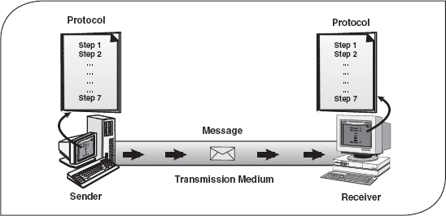

10.1 Introduction
The term communication in simple words means sending or receiving information. In ancient times, people used the beating of drums, smoke signals, mirrors reflecting sunlight, homing pigeons, and so on to send messages. Another way of long-distance communication was the use of homing pigeons to carry messages. With the advancement in science and technology, various devices were invented for communication. Telegraph was one of the most prevalent ways of data communication in the nineteenth century. In 1870, Alexander Graham Bell invented the telephone, which revolutionized the way long-distance communication used to take place. Voice communication became common after the invention of the telephone. In the 1940s and 1950s, a major breakthrough was made in the development of computers and setting up a network of computers for electronic transfer of information or data communication. In fact, the first network was established in 1940, when George Stibitz and Samuel Williams, researchers at Bell Laboratories, developed complex number generator—one of the earliest digital computers. They made it possible for the users to operate the computer remotely from teletype machines. They also developed a system to allow users to communicate with the machine even more remotely, through telex machines. The advancement of computer networks and later the Internet acted as a boost for data communication.
Whenever more than one computer is used at the same location, networking them together facilitates exchange of data and information (data communication) between connected computers in a fast and efficient manner. Networking also helps sharing expensive resources like printers, backup tape drives, scanners, Internet connections, and so on. In this chapter, we discuss how communication system works, various transmission medias and devices, different techniques of data communication, types of computer network, and various network topologies.

10.2 Data communication
Data communication is the exchange of data between two devices using some form of wired or wireless transmission medium. It includes the transfer of data, the method of transfer, and the preservation of the data during the transfer process. To initiate data communication, the communicating devices should be a part of an existing communication system. For data communication to be effective, the following three fundamental characteristics should be considered:
A communication system can be defined as the collection of hardware and software that facilitates intersystem exchange of information between different devices. When we communicate, we are sharing information. This sharing can be local (face-to-face communication) or it may be remote (communication over distance).
Delivery: The system must deliver data to the correct or the intended destination.
Accuracy: The system must deliver data accurately (error free).
Timeliness: The system must deliver data in a timely manner without enough time lags.

10.2.1 Components of Data Communication
There are five basic components in data communication system.
Message: The message is the information that is to be communicated.
Sender: The sender is the device that sends the message.
Receiver: The receiver is the device that receives the message.
Medium: The transmission medium is the physical path that communicates the message from the sender to receiver.
Protocol: Protocol refers to a set of rules that coordinate the exchange of information. Both sender and receiver should follow the same protocol to communicate data. Without the protocol, the sender and receiver cannot communicate with each other; just as a person speaking English cannot be understood by a person who knows only Hindi (Figure 10.1).

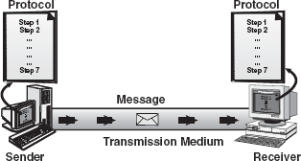

Figure 10.1 Data Communication Components

Suppose you want to convey your final marks to your mother. You call her via telephone and inform her about your marks. Here your marks is the message, you are the sender, your mother is the receiver, the telephone line is the medium, and the language in which you are conversing is the protocol.

10.2.2 Data Transmission Mode
Data transmission mode refers to the direction of signal flow between two linked devices. There are three types of transmission modes: simplex, half-duplex, and full-duplex (Figure 10.2).

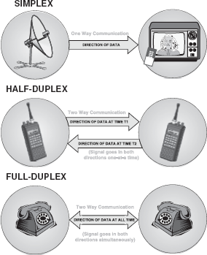

Figure 10.2 Data Transmission Modes

Simplex: Simplex transmission is unidirectional. The information flows in one direction across the circuit, with no capability to support response in the other direction. Only one of the communicating devices transmits information, the other can only receive it. Television transmission can be considered as an example of simplex mode of transmission where the satellite only transmits the data to the television, vice versa is not possible.
Half Duplex: In half-duplex mode, each communicating device can receive and transmit information, but not at the same time. When one device is sending, the other can only receive at that point of time. In half-duplex transmission mode, the entire capacity of the transmission medium is taken over by the device, which is transmitting at that moment. Radio wireless set is an example of half-duplex transmission mode where one party speaks and the other party listens.
Full Duplex: Full-duplex transmission mode, also known as the duplex mode, allows communicating devices to both transmit and receive data simultaneously. A full-duplex mode can be compared to a two-way road with traffic flowing in both directions. A standard voice telephone call is a full-duplex call because both parties can talk at the same time and be heard.

10.2.3 Analog and Digital Data Transmission
The major role of the physical medium is to move the data from one communicating device to another. The data can be transmitted by means of electromagnetic signals. These signals may be in one of the two forms: analog or digital. Depending on the form of signal used, data transmission can be analog data transmission or digital data transmission.
Analog Signals: An analog signal is a continuous waveform that changes smoothly over time. The sine wave is the most fundamental form of an analog signal (see Figure 10.3). Sine waves can be described by three characteristics.

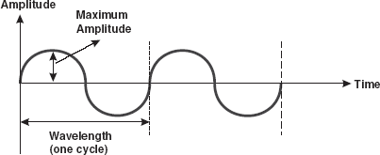

Figure 10.3 Analog Signal
Amplitude: It is the value of the signal at any point on the wave. The maximum amplitude of a sine wave is the highest value it reaches on the vertical axis. The unit for amplitude depends on the type of the signal. For electrical signals, the unit is normally volts and amperes.
Frequency: It refers to the number of cycles a signal completes in 1s. In other words, frequency means the number of times a signal wave goes up and down in a second and it is measured in Hertz (Hz). For example, if a signal wave completes one cycle in 1s, its frequency is 1 Hz.
Wavelength: It refers to the distance between successive similar points of a given wave, that is, one cycle of the waveform.
Analog signals are perfect for carrying data such as voice or sound. However, these signals are prone to errors or noise that can be caused by the outside sources. Attenuation is another problem with analog signals because the amplitude of the wave naturally changes over distance.
Digital Signals: Digital signal is the data stored in the form of 0s and 1s. When the signal is at a high point, its value is 1 and when it is low, its value is 0. A signal in digital format has precise voltages that are not affected by noise or attenuation as compared with analog signals, which are very prone to noise. Digital signals can be represented by a graph similar to a bar graph. In Figure 10.4, 1 can be encoded as a positive voltage and 0 as a zero voltage.

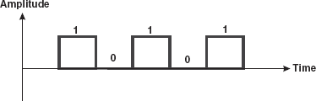

Figure 10.4 Digital Signal

To transmit data over analog telephone lines, a modem is required to convert the digital data signals to analog signals. When transmitted over long distances, analog signals require to be amplified, which can possibly distort the value of the data transmitted. When analog data is converted to digital data, it can be transmitted over digital signals faster and without distortion.

10.2.4 Data Communication Measurement
The measurement of the quantity of data that can be passed over a communication link in a given time is done in terms of bandwidth. Fundamentally, bandwidth refers to the maximum volume of data that can be transferred over any communication medium at a given point of time. The more the data needed to be transmitted in a given period, the more is the bandwidth required. On digital circuits, bandwidth is measured in bits per second (bps), which refers to the number of bits transmitted per second. A 1,000 bps is 1 kilobit per second or 1 kbps.
In the digital context, the level of bandwidth falls into three categories.
Narrowband: In narrowband, there is a single transmission channel of 64 kbps or less. With advances in network technology, narrowband has come to be associated with any channel operating at less than 1.544 Mbps.
Wideband: It is a medium-capacity communication channel, which carries data at speeds between 1.544 Mbps and 45 Mbps.
Broadband: It is a transmission medium, capable of supporting a wide range of frequencies. It can carry multiple signals by dividing the total capacity of the medium into multiple, independent bandwidth channels, where each channel operates only on a specific range of frequencies. The bandwidth capacity in broadband is equal to 45 Mbps. Broadcast television, cable television, microwave, and satellite are examples of broadband technologies. These technologies are capable of carrying a great deal of information in a short amount of time, but are more expensive to use than technologies like the telephone, which require less bandwidth.

10.3 Transmission media
Transmission media refers to the physical media through which data can be transmitted from one point to another. As already stated, the data is transmitted from one device to another through electromagnetic signals. An electromagnetic signal is the combination of electric and magnetic fields, vibrating in conjugation with each other. Electromagnetic signals include power, voice, radio waves, infrared light, visible light, ultraviolet light, X-rays, and gamma rays. All these together constitute an electromagnetic spectrum. These signals can travel through vacuum, air or any other transmission medium. Voice signals are generally transmitted as current over metal cables. Radio frequencies are generally transmitted through air or space. Third type of electromagnetic energy is the visible light, which is currently being used for communication through fibre optic cable. Transmission media can be divided into two broad categories: guided/wired media andunguided/wireless media.

10.3.1 Guided/Wired Media
Guided transmission media use a cabling system that guide the data signals along a specific path. Cable is the medium through which information usually moves from one network device to another. It consists of a cable composed of metals like copper, tin, or silver. The data signal in the guided medium is bound by the cabling system; hence, guided medium is also known as bound medium. There are three basic types of guided media—twisted pair, coaxial cable, and optical fibre.
Twisted Pair: The biggest network in the world, the telephone network, originally used only twisted-pair cabling and still does for most local connections. The name comes from the fact that each individually insulated conductor is part of a pair, making this a balanced medium, and that each pair is twisted together along its length, which helps to further protect it from interference from external sources. Each pair consists of a wire, used for receiving data signal, and a wire used for transmitting data signal. Twisted pairs are used in short-distance communication (less than 100 m). It comes in two forms, namely, unshielded and shielded with a metal sheath or braid around it. The two are commonly known as unshielded twisted pair (UTP) and shielded twisted pair (STP).
- UTP Cable: It is the most common type of telecommunication medium in use today. It is most suited for both data and voice transmission, hence is commonly used in telephone systems. The cable has four pairs of wires inside the jacket. Each pair is twisted with a different number of twists per inch to help eliminate interference from adjacent pairs and other electrical devices. The tighter the twisting, the higher the supported transmission rate and the greater the cost per foot. Each twisted pair consists of two metal conductors (usually copper) that are insulated separately with their own coloured plastic insulation (Figure 10.5).

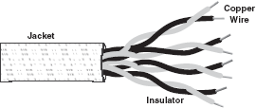

Figure 10.5 Unshielded Twisted-Pair Cable

- STP Cable: This cable has a metal foil or braided mesh covering that covers each pair of insulated conductors. The metal foil is used to prevent infiltration of electromagnetic noise. This shield also helps to eliminate crosstalk, a phenomenon that can be experienced during telephone conversation when one can hear another conversation in the background. A disadvantage of UTP is that it may be susceptible to radio and electrical frequency interference. Shielded twisted pair is suitable for environments with electrical interference; however, the extra shielding can make the cables quite bulky (Figure 10.6).

Figure 10.6 Shielded Twisted-Pair Cable

Note: All signalling over twisted pair is of the baseband type. Baseband transmission use the entire media bandwidth for a single channel, that is, only one signal can be carried at a time, and all the systems take turns using it.
Coaxial Cable: Coaxial cables have a single central conductor, which is made up of solid wire (usually copper). This conductor is surrounded by an insulator over which a sleeve of metal mesh is woven to block any outside interference. This metal mesh is again shielded by an outer covering of a thick material (usually PVC) known as jacket (Figure 10.7).

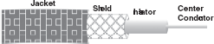

Figure 10.7 Coaxial Cable

Although coaxial cabling is difficult to install, it is highly resistant to signal interference. It can support greater cable lengths between network devices than twisted-pair cable. In addition, as compared to twisted pairs, it also offers higher bandwidth. A coaxial cable is capable of transmitting data at a rate of 10 Mbps. It is more expensive per foot, but cheaper per bytes of data transferred in a second. Coaxial cable is very robust and is commonly used in cable TV network.
Optical Fibre: Twisted-pair and coaxial cable transmit data in the form of current. Optical fibre, on the other hand, consists of thin glass fibres that can carry information in the form of visible light. The typical optical fibre consists of a very narrow strand of glass called the core. Around the core is a concentric layer of glass called the cladding. A typical core diameter is 62.5 microns (1 micron=10-6m). Cladding generally has a diameter of 125 microns. The cladding is covered by a protective coating of plastic, known as jacket (Figure 10.8).

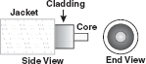

Figure 10.8 Optical Fibre

Optical fibre has the ability to transmit signals over much longer distances than coaxial and twisted pair. Light signal, unlike electrical signal, does not heat up the wire and is not susceptible to outside interference. It is extremely hard to tap into, making it desirable from the security point of view. Optical fibre also has the capability to carry information at vastly greater speeds. A single optical fibre can pack hundreds of fibres, where each fibre has the capacity equivalent to that of thousands of twisted-pair wires. This capacity broadens communication possibilities to include services such as video conferencing and interactive services. However, fibre optics cable is by far the most expensive per foot. Moreover, it is more difficult to install and modify (Figure 10.9).

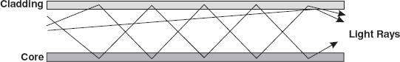

Figure 10.9 Signals Carried Over an Optical Fibre

10.3.2 Unguided/Wireless Media
Unguided media facilitates data transmission through earth's atmosphere (air, water, or vacuum) at a much faster rate and provides wide area coverage. The data signals are not guided or bound to a fixed channel to follow. Some commonly used unguided media of transmission include radio frequency (RF) propagation, microwave transmission, satellite transmission, infrared wave transmission, Bluetooth, and Wi-Fi.
RF Propagation: In RF propagation, the signal is carried over carrier waves (waves which carry signals over them), which have frequencies in the range of RF spectrum. There are three types of RF propagation, namely, ground wave, ionospheric, and line of sight.
Ground wave propagation follows the curvature of the earth. They have carrier frequencies of up to 2 MHz. AM radio is an example of ground wave propagation (Figure 10.10).

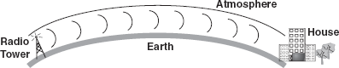

Figure 10.10 Ground Wave Propagation

In ionospheric propagation, the signal wave bounces off the earth's ionosphere layer in the upper atmosphere. It operates in the frequency range of 30–85 MHz. As this type of propagation depends on the earth's ionosphere, it changes with the day timings and weather (Figure 10.11).

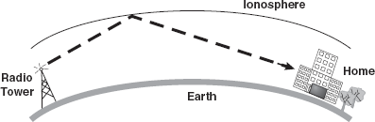

Figure 10.11 Ionospheric Propagation

Line of sight propagation transmits exactly in the line of sight. The receiving station must be in view of the transmitting station. It is sometimes called space waves or tropospheric propagation. It is limited by the curvature of the earth for ground-based stations (50 km) (Figure 10.12).

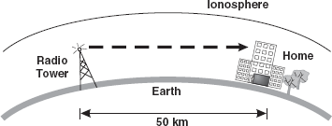

Figure 10.12 Line of Sight Propagation

Microwave Transmission: Microwave transmission use microwave signals that travel at a higher frequency and are popularly used for transmitting data over long distances. Microwave communication uses parabolic antennas (satellite TV dish antennas) that are mounted on the tower, which could be tens of kilometers away, but in line of sight. Due to long distances, repeaters are used at regular intervals in between the transmitter and the receiver to boost the signals. Normally, the distance between the repeaters goes up roughly with the square root of the tower height. For example, for a 100 m high tower, repeaters can be spaced at 80 km apart (Figure 10.13).

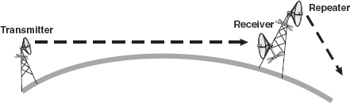

Figure 10.13 Microwave Transmission

Satellite Transmission: Satellite transmission is also a kind of line of sight transmission. Satellites are set in geostationary orbits directly over the equator, which rotates in synchronization to earth, hence they look stationary from any point on earth. These geostationary orbits are placed 36,000 km above the earth's surface. The communication is carried through uplinks and downlinks. The uplink transmits the data to the satellite and downlink receives the data from the satellite. Uplinks and downlinks are also called earth stations because they are located on the earth. The area shadowed by the satellite in which the information or data can be transmitted and received is called the footprint(Figure 10.14).

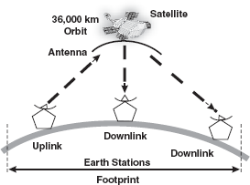

Figure 10.14 Satellite Transmission

Infrared Wave Transmission: Infrared frequencies are just below the visible light spectrum. These are the high-frequency waves used for short-range communication. The waves are cheap, directional, and can be easily built; however, the waves do not pass through solid objects. Infrared waves are used in TV remotes, garage doors, and wireless speakers. Computer machines in an office can easily be connected in a wireless local area network (LAN) using infrared waves (Figure 10.15).

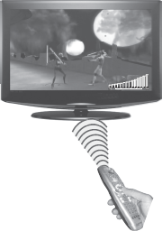

Figure 10.15 Infrared Wave Transmission

Bluetooth: Bluetooth system is named after a Danish king Harold Blatand (Bluetooth in English) who is known for his contribution to unification of tribes from Denmark, Norway, and Sweden. The Bluetooth technology is used to create a personal area network (PAN) or piconet that lets electronic devices, such as computers, cell phones, PDAs, wireless keyboards, etc., to communicate with each other within the range of 10 m. It uses radio signals that are omni-directional, that is, signals travel in all directions from the source. Hence, the communicating devices need not be aligned with each other.
When Bluetooth-capable devices come within range of one another, an electronic conversation takes place to determine whether they have data to share or whether one needs to control the other. The user does not have to manually operate on the devices, as connections are set automatically. Once the conversation has occurred, devices form a piconet. Once the piconet is established, the member devices randomly hop frequencies in unison so they stay in touch with one another and avoid other piconets that may be operating in the same room.
The key features of Bluetooth are its roubtness, low complexity, and low power requirements that make it suitable for handheld devices like cell phones, PDAs, etc. Today, almost all the small handheld devices are Bluetooth enabled. The Bluetooth radio-link uses a fast acknowledgement and frequency-hopping scheme to make. However, the maximum data transmission rate that it supports is only 1 Mbps, which makes it unsuitable for exchanging large files or folders. Moreover, the maximum range for this technology is 30 feet, which limits the space of PAN and the connection accessibility for electronic devices to perform an action (Figure 10.16).

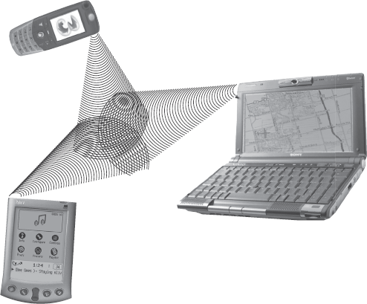

Figure 10.16 Bluetooth Communication

Wi-Fi: The term Wi-Fi which stands for Wireless Fidelity is widely used for creating wireless LANs and also for providing wireless Internet access. To create wireless LAN, the devices in the network, such as computer, laptop, PDA, etc., should be equipped with wireless network interface card (NIC) to send and receive Wi-Fi signals. A Wi-Fi-enabled device should be within a specific range (that is, up to 50 m) from the network to connect to it.
The major benefit of Wi-Fi is that it allows developing low-cost wireless networks by reducing the cost of wires for connecting devices. Elimination of wires enables the wireless devices to move from one location to another (within the range) without losing the connectivity. Though Wi-Fi enables availing network services at low cost, it has some disadvantages also.
The weak security is one of the disadvantages of Wi-Fi that makes the wireless network vulnerable to attack from the intruders. Wi-Fi signals are not confined to the boundaries of building (in which the wireless LAN is operating); thus any intruder can easily gain access to the network by standing outside the building Another disadvantage of Wi-Fi network is its susceptibility to interference from other devices operating in the same area such as wireless phones, other wireless networks, etc (Figure 10.17).

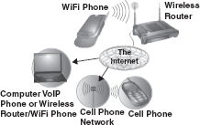

Figure 10.17 Wi-Fi

10.4 Computer network. Types of Computer Networks
A computer network is a collection of two or more computers, which are connected together to share information and resources. The keyword in the definition is “sharing”—the main purpose of computer networking. The ability to share information efficiently is what gives computer networking its power and appeal. Envision a network as a project team. Through the efforts of all involved—the sharing of time, talent, and resources—a goal is accomplished or a project is completed.
Personal computers are powerful tools that can process and manipulate large amounts of data quickly, but they do not allow users to share that data efficiently. Before networks, users needed either to print documents or to copy files to a disk for others to edit or use them Figure 10.18(a). If others made changes o the document, there was no easy way to merge the changes. This is known asstand-alone environment. However, when two computers are linked together using a cable that allows them to share data, it is known as networked environment. Observe in Figure 10.18(b), the computers and other devices (like printers) are connected together through a cable. This is called anetwork and the concept of connected computers sharing resources is called networking. Note that computers in a network are interconnected by telephone lines, coaxial cables, satellite links, radio, and so on.

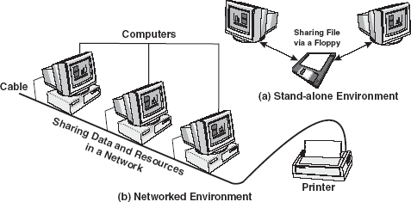

Figure 10.18 Stand-alone and Networked Environment

Technological advances in networking hardware and software have led to greater throughput on all scales and to increasingly tighter integration of networking with all aspects of computing. In tandem with these advances, the idea of networking has entered the common consciousness to an extent that would have been unimaginable a few years ago. This shift in perception has led to an expansion of networking beyond the workplace, which is already beginning to shape developments in networking technology.
Unlike operating system such as DOS that is designed for a single user to control one computer,network operating system (NOS) is an interconnected system of computing devices that provide shared and economical access to computer services. Thus, NOSs coordinate the activities of multiple computers across a network. NOSs are broadly divided into two types namely, client/server networksand peer-to-peer (P2P) networks.
Client/Server Network: In this network, each computer is either a client or a server. To complete a particular task, there exists a centralized host computer known as server and a user's individual workstation known as client. In simple words, client requests a service from the server and the server responds by providing that service. Note that a client/server network centralizes functions and applications in one or more dedicated file servers.
The servers provide access to resources, while the clients have access to the resources available on the servers. A typical example of client–server is sending an e-mail, where the e-mail is first transmitted to the source server. After this, the e-mail is transmitted to the destination server. Lastly, the destination server sends the e-mail to the client at the other end (Figure 10.19).

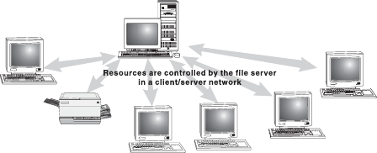

Figure 10.19 Client/Server Network

Generally, the server software runs on a computer, dedicated solely for hosting that software and supporting its services. On the other hand, client software runs on common personal computers or workstations. In a client/server relationship, both the client and server carry out some of the data processing on their ends.
P2P Network: A P2P network does not rely on dedicated servers for communication; instead, it uses direct connections between clients (peers). A pure P2P network does not have the notion of clients or servers, but only equal peer nodes that simultaneously function as both “clients” and “servers” to the other nodes on the network. That is, every node is able to initiate or complete any supported transaction (file transfer) with the other connected node (Figure 10.20).

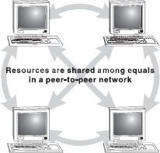

Figure 10.20 P2P Networks

The upper limit of the number of nodes that can function as both clients and servers on a P2P network is between 10 and 25. If there are more nodes, then a P2P machine can be used as a dedicated server with additional high-performance hardware. Note that the peer nodes involved in the network may differ in local configuration, processing speed, network bandwidth, and storage quantity.
P2P networks have been designed primarily for small to medium LANs. Many file-sharing services such as Morpheus and Kaaza are used extensively to find files (sound, images, and videos) on the network. However, most of these file-sharing services actually integrate both P2P and client/server networking design. Therefore, these file-sharing applications are technically known as hybrid networks.
Generations in P2P Networks: P2P file-sharing networks can be classified according to their “generations,” which are based on the popular Internet-based file-sharing networks. These generations are listed below:
- First Generation: This generation had a centralized file list like Napster. In the United States of America, judiciary ruled that whoever controlled this centralized file list was responsible for any infringement of copyright, or any other illegal activities, which might occur while transferring files.
- Second Generation: This generation had decentralized file lists such as Gnutella and FastTrack. This was a necessary step for network creators, as a central authority (creators) will be held liable for copyright infringement.
- Third Generation: This generation is an improvement upon previous generations. These networks have in-built features such as efficiency, reliability, and anonymity. Examples of anonymous networks are Freenet, I2P, GNUnet, and Entropy. These networks allow only the known users (friends) to connect to your computer. After connecting, each node can forward requests and files anonymously between its own “friends” nodes.
Difference between P2P and Client/Server Network: Both P2P and client/server networks have associated advantages and disadvantages. These advantages and disadvantages form a part of distinction between the two. These differences are listed in Table 10.1.
A network can be as few as several personal computers on a small network or as large as the Internet, a worldwide network of computers. Today, when talking about networks, we are generally referring to three primary categories: LAN, metropolitan area network (MAN), and wide area network (WAN). These categories are defined depending upon various factors like the size of the network, the distance it covers, and the type of link used in interconnection.
Table 10.1 Difference between Peer-to-Peer Network and Client/Server Network
Basis | P2P Network | Client/Server Network
Client/Server Network | No central repository for files and applications | Resources and data security controlled through the server
Maintenance | Low maintenance cost file | A large network requires extra staff to ensure efficient operation
Installation | Can be easily installed | Requires experts for proper installation of the network
Expensive | No need for a dedicated server, thus not much expensive | Expensive, as it requires a dedicated server
Security | Lack of proper drawback | Provides high level of security
Dependence | All nodes are independent of each other. Failure occurring in one node does not affect the functioning of other nodes in the network | When server goes down, it affects the functioning of the entire network

LAN: A LAN is a computer network that covers only a small geographical area (usually within a square mile or less) such as an office, home, or building. In a LAN, connected computers have a NOS installed onto them. One computer is designated as the file server, which stores all the software that controls the network. It also stores the software that can be shared by the computers attached to the network. Other computers connected to the file server are called workstations. The workstations can be less powerful than the file server, and they may have additional software on their hard drives. On most LANs, cables are used to connect the computers. Generally, LAN offers a bandwidth of 10–100 Mbps (Figure 10.21).

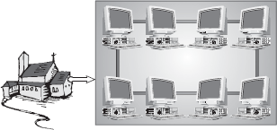

Figure 10.21 Local Area Network

MAN: A MAN is a network of computers spread over a “metropolitan” area such as a city and its suburbs. As the name suggests, this sort of network is usually reserved for metropolitan areas where the city bridges its LANs with a series of backbones, making one large network for the entire city. It may be a single network such as a cable television network or it may be a means of connecting a number of LANs. Note that MAN may be operated by one organization (a corporate with several offices in one city), or be shared and used by several organizations in the same city (Figure 10.22).

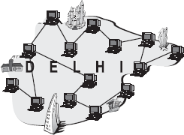

Figure 10.22 Metropolitan Area Network

WAN: A WAN is a system of interconnecting many computers over a large geographical area such as cities, states, countries, or even the whole world. These kinds of networks use telephone lines, satellite links, and other long-range communications technologies to connect. Such networks are designed to serve an area of hundreds or thousands of miles such as public and private packet switching networks and national telephone networks. For example, a company with offices in New Delhi, Chennai, and Mumbai may connect the LANs for each of those locations to each other through a WAN. Although a WAN may be owned or rented by private business, it is usually a public network designed to connect small-and intermediate-sized networks together. The largest WAN in existence is the Internet (Figure 10.23).

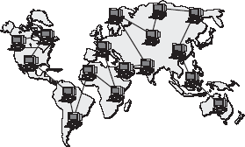

Figure 10.23 Wide Area Network

WAN offers many advantages to business organizations. Some of them are as follows:
- It offers flexibility of location because not all the people using the same data have to work at the same site.
- Communication between branch offices can be improved using e-mail and file sharing. It facilitates a centralized company-wide data backup system.
- Companies located in a number of small, interrelated offices can store files centrally and access each other's information.

10.5 Network topologies
The term topology refers to the way a network is laid out, either physically or logically. A topology can be considered as the network's shape. It is the geometric representation of the relationship of all the links. There are five basic topologies: Bus, Ring, Star, Tree, and Mesh.

10.5.1 Bus Topology
Bus topology uses a common bus or backbone (a single cable) to connect all devices with terminators at both other. As the message passes each station, the station checks the message's destination address. If the address in the message matches the station's address, the station receives the message. If the addresses do not match, the bus carries the message to the next station, and so on. Figure 10.24 illustrates how devices such as file servers, workstations, and printers are connected to the linear cable or the backbone.

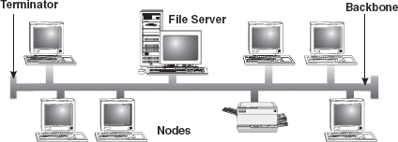

Figure 10.24 Bus Topology

Advantages of Bus Topology: The advantages of bus topology are:
- Connecting a computer or peripheral to a linear bus is easy.
- This topology requires least amount of cabling to connect the computers and, therefore, less expensive than other cabling arrangement.
- It is easy to extend a bus since two cables can be joined into one longer cable with a connector.
Disadvantages of Bus Topology: The disadvantages of bus topology are:
- Entire network shuts down if there is a failure in the backbone.
- Heavy traffic can slow down a bus because computers on such networks do not coordinate with each other to reserve time to transmit.

10.5.2 Ring Topology
In ring topology, computers are placed on a circle of cable without any terminated ends since there are no unconnected ends. Every node has exactly two neighbours for communication purposes. All messages travel through a ring in the same direction (clockwise or counter-clockwise) until it reaches its destination. Each node in the ring incorporates a repeater. When a node receives a signal intended for another device, its repeater regenerates the bits and passes them along the wire (Figure 10.25).

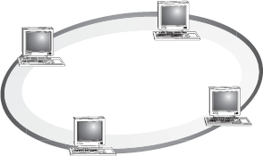

Figure 10.25 Ring Topology

Advantages of Ring Topology: The advantages of ring topology are:
- Ring topology is easy to install and reconfigure.
- Every computer is given equal access to the ring. Hence, no single computer can monopolize the network.
Disadvantages of Ring Topology: The disadvantages of ring topology are:
- Failure in any cable or node breaks the loop and can take down the entire network.
- Maximum ring length and number of nodes are limited.

10.5.3 Star Topology
In star topology, devices are not directly linked to each other, but they are connected via a centralized network component known as hub or concentrator. The hub acts as a central controller and if a node wants to send data to another node, it boosts up the message and sends the message to the intended node. This topology commonly uses twisted-pair cable; however, coaxial cable or fibre optic cable can also be used Figure 10.26

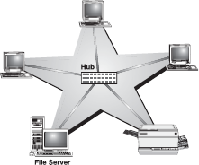

Figure 10.26 Star Topology

Advantages of Star Topology: The advantages of star topology are:
- Star topology is easy to install and wire.
- The network is not disrupted even if a node fails or is removed from the network.
- Fault detection and removal of faulty parts is easier in star topology.
Disadvantages of Star Topology: The disadvantages of star topology are:
- It requires a longer length of cable.
- If the hub fails, nodes attached to it are disabled.
- The cost of the hub makes the network expensive as compared to bus and ring topologies.

10.5.4 Tree Topology
A tree topology combines the characteristics of linear bus and star topologies. It consists of groups of star-configured workstations connected to a bus backbone cable. Not every node plugs directly to the central hub. The majority of nodes connect to a secondary hub that, in turn, is connected to the central hub. Each secondary hub in this topology functions as the originating point of a branch to which other nodes connect (Figure 10.27).

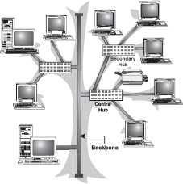

Figure 10.27 tree Topology

Advantages of Tree Topology: The advantages of Tree Topology are:
- The distance to which a signal can travel increases as the signal passes through a chain of hubs.
- Tree topology allows isolating and prioritizing communications from different nodes.
- Tree topology allows for easy expansion of an existing network, which enables organizations to configure a network to meet their needs.
Disadvantages of Tree Topology: The disadvantages of tree topology are:
- If the backbone line breaks, the entire segment goes down.
- It is more difficult to configure and wire than other topologies.

10.5.5 Mesh Topology
In a mesh topology, every node has a dedicated point-to-point link to every other node. Messages sent on a esh network can take any of several possible paths from source to destination. A fully connected mesh network has n(n - 1)/2 physical links to link n devices. For example, if an organization has five nodes and wants to implement a mesh topology, then 5(5 - 1)/2, that is, 10 links are required. In addition, to accommodate those links, every device on the network must have n - 1 communication (input/output) ports (Figure 10.28).

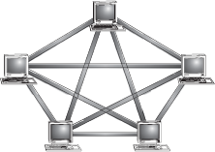

Figure 10.28 Mesh Topology

Advantages of Mesh Topology: The advantages of mesh topology are:
- The use of large number of links eliminates network congestion.
- If one link becomes unusable, it does not disable the entire system.
Disadvantages of Mesh Topology: The disadvantages of mesh topology are:
- The amount of cabling required is very large.
- As every node is connected to the other, installation and reconfiguration is very difficult.
- The amount of hardware required in this type of topology makes it expensive to implement.

10.6 Communication protocol. The OSI Model
Imagine yourself standing near a traffic crossing. You can notice that for smooth movement of the traffic, a functioning traffic light is essential. The red signal sends a message to stop, a yellow signal to wait, and a green signal to cross. This set of rules, which tells a driver when to move and when to stop, are traffic protocols. Similarly, computers adhere to certain protocols that define the manner in which communication takes place. A communication protocol is a set of rules that coordinate the exchange of information. If one computer is sending information to another and they both follow the same protocol, the message gets through, regardless of what types of machines they are and on what operating systems they are running. As long as machines have software that can manage the protocol, communication is possible.
Open Systems Interconnectione (OSI) is the standard reference model for communication between two end-users in a network. In 1983, International Organization for Standardisation (ISO) published a document called “The Basic Reference Model for Open Systems Interconnection,” which visualizes network protocols as a seven-layered model. The model lays a framework for the design of network systems that allow for communication across all types of computer systems. It consists of seven separate but related layers, namely, physical, data link, network, transport, session, presentation,and application layer.
A layer in the OSI model communicates with two other OSI layers, the layer directly above it and the layer directly below it. For example, the data link layer communicates with the network layer and the physical layer. When a message is sent from one machine to another, it travels down the layers on one machine and then up the layers on the other machine. This route is illustrated in Figure 10.29. As the message travels down the first stack, each layer (except the physical layer) adds header information to it. These headers contain control information that are read and processed by the corresponding layer on the receiving stack. At the receiving stack, the process happens in reverse. As the message travels up the other machine, each layer strips off the header added by its peer layer.

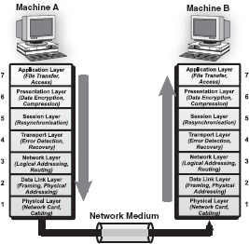

Figure 10.29 Message Transfer in Layered Architecture

Physical Layer: The physical layer defines the physical and electrical characteristics of the network. This layer acts as a conduit between computer's networking hardware and its networking software. It handles the transfer of bits (0s and 1s) from one computer to another. This is where the bits are actually converted into electrical signals that travel across the physical circuit. Physical layer communication media include various types of copper or fibre optic cable, as well as many different wireless medias.
Data Link Layer: The function of the data link layer is to provide service interface to the network layer and is responsible for error-free transmission and preventing the slow receivers from being overflow by the fast senders. To achieve this, the data link layer divides the packets received from the network layer into manageable form known as frames. These data frames are then transmitted sequentially to the receiver. On the receiver end, data link layer detects and corrects any errors in the transmitted data, which it gets from the physical layer.
Network Layer: The network layer is responsible for transporting traffic between devices that are not locally attached. For example, a router (a network layer device) provides the routing services in a network. When a packet is received on a router interface, the destination IP address is checked. If the packet is not destined for the router, then the router will look up the destination network address in the routing table. Once an exit interface is chosen, the packet will be sent to the interface to be framed and sent out on the local network. If the entry for the destination network is not found in the routing table, the router drops the packet.
Transport Layer: The basic function of the transport layer is to handle error recognition and recovery of the data packets. This layer establishes, maintains, and terminates communications between the sender and the receiver. At the receiving end, transport layer rebuilds packets into the original message, and to ensure that the packets arrived correctly, the receiving transport layer sends acknowledgments.
Session Layer: The session layer comes into play primarily at the beginning and end of a transmission. At the beginning of the transmission, it lets the receiver know its intent to start transmission. At the end of the transmission, the session layer determines if the transmission was successful. This layer also manages errors that occur in the upper layers such as a shortage of memory or disk space necessary to complete an operation, or printer errors.
Presentation Layer: The function of presentation layer is to ensure that information sent from the application layer of one system would be readable by the application layer of another system. This is the place where application data is packed or unpacked and is made ready to use by the running application. This layer also manages security issues by providing services such as data encryption and compresses data so that fewer bits need to be transferred on the network.
Application Layer: The application layer is the entrance point that programs use to access the OSI model and utilize network resources. This layer represents the services that directly support applications. This OSI layer is closest to the end-user. Application layer includes network software that directly serves the end-users of the netwrork by providing them user interface and application features like electronic mail, USENET, etc.

10.7 Network devices
Networks are becoming more complicated and more pervasive everyday. Terms like switch, router, gateway, and hub have become part of our everyday language, yet many people do not fully understand the differences between these devices or how to choose the right one for their network. These devices interconnect individual computers and ensure that they communicate efficiently. This section provides some background information on how each device works and gives some guidance in picking the right solution.
NIC: NIC is a hardware device that connects clients, servers, and peripherals to the network through a port. Most network interfaces come as small circuit board that can be inserted onto one of the computer motherboard's slots. Alternatively, modern computers sometimes include the network interface as part of their main circuit boards (motherboards). Each network interface is associated with a unique address called its media access control (MAC) address. The MAC address helps in sending information to its intended destination(Figure 10.30)

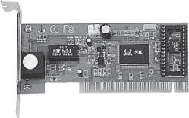

Figure 10.30 Network Interface Card

NICs are a major factor in determining the speed and performance of a network. It is a good idea to use the fastest network card available for the type of workstation one is using.
Repeater: A repeater is the most basic device on a network. Signals that carry information within a network can travel a fixed distance before attenuation endangers the integrity of the data. A repeater installed on the link receives signal, regenerates it, and sends the refreshed copy back to the link. Doing this means that the new signal is clean, free from any background noise introduced while travelling down the wire. In Figure 10.31, two sections in a network are connected by the repeater.

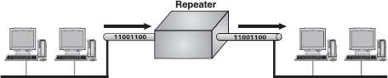

Figure 10.31 Repeater

Repeaters are most commonly used to extend a network cable. All network cable standards have maximum cable length specification. If the distance between two network devices is longer than this specification, a repeater is needed to regenerate the signal. Without the repeater, the signal will be too weak for the computers on each end to reliably understand. A good example of the use of repeaters would be in a LAN using a star topology with unshielded twisted-pair cabling. The length limit for unshielded twisted-pair cable is 100 m. The repeater amplifes all the signals that pass through it allowing for the total length of cable on the network to exceed the 100 m limit. Nonetheless, repeaters have no in-built intelligence and do not look at the contents of the packet as they regenerate the signal. Thus, there is no processing overhead in sending a packet through a repeater. This also means that a repeater will repeat any errors in the original signal.
Hub: A hub is a small box that connects individual devices on a network so that they can communicate with one another. The hub operates by gathering the signals from individual network devices, optionally amplifying the signals, and then sending them onto all other connected devices. Amplification of the signal ensures that devices on the network receive reliable information. A hub can be thought of as the centre of a bicycle wheel, where the spokes (individual computers) meet.
Nowadays, the terms repeater and hub are used synonymously, but they are actually not the same. Although at its very basic level, a hub can be thought of as a multi-port repeater. Typically, hubs have anywhere from 4 to over 400 ports. When a signal is received on one port of the hub, it is regenerated out to all the other ports. It is most commonly used to connect multiple machines to the same LAN. Administrators connect a computer to each port on the hub, leaving one port free to connect to another hub or to a higher-level device like a bridge or router.
Bridge: A bridge is a device that allows division of a large network into two or more smaller and efficient networks. It monitors the information traffic on both sides of the network so that it can pass packets of information to the correct location. Most bridges can “listen” to the network and automatically figure out the address of each computer on both sides of the bridge. It examines each packet as it enters though one of the ports. A bridge first looks at the MAC address of the sender and creates a mapping between the port and the sender's MAC address. It then looks at the address of the recipient, comparing the MAC address to the list of all learned MAC addresses. If the address is in the list, the bridge looks up the port number and forwards the packet to the port where it thinks the recipient is connected. If the recipient's MAC address is not in the list, the bridge then does a flood; it sends the signal to all the ports except the one from where it was received. As a result, a bridge reduces the amount of traffic on a LAN by dividing it into two segments. It inspects incoming traffic and decides whether to forward or discard it (Figure 10.32).

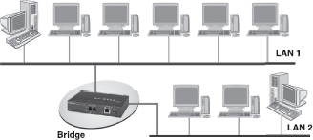

Figure 10.32 Bridge

Bridges can be used to connect networks with different types of cabling or physical topologies. They must, however, be used between networks with the same protocol. Since a bridge examines the packet to record the sender and lookups the recipient, there is overhead in sending a packet through a bridge. On a modern bridge, this overhead is miniscule and does not affect network performance.
Switch: A switch is a multi-port bridge. It connects individual devices on a network so that they can communicate with one another. The behaviour of a switch is the same as that of a bridge. It is capable of inspecting the data packets as they are received, determining the source and destination device of that packet, and forwarding that packet appropriately. The difference is that most switches implement these functions in hardware using a dedicated processor. This makes them much faster than traditional software-based bridges.
Router: A router is an essential network device for interconnecting two or more networks. Router's sole aim is to trace the best route for information to travel. As network traffic changes during the day, routers can redirect information to take less congested routes. A router creates and/or maintains a table, called a routing table that stores the best routes to certain network destinations. While bridges know the addresses of all computers on each side of the network, routers know the addresses of computers, bridges, and other routers on the network. Routers can even “listen” to the entire network to determine which sections are the busiest—they can then redirect data around those sections until they clear up (Figure 10.33).

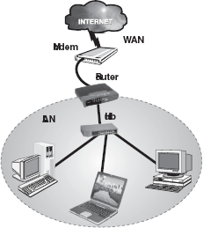

Figure 10.33 Router

Routers are generally expensive and difficult to configure and maintain. They are critical components of a network and if they fail, the network services will be significantly impaired. Most routers operate by examining incoming or outgoing signals for information at the network layer. In addition, they can permit or deny network communications with a particular network.
Gateway: A gateway is an internetworking device, which joins networks operating on different protocols together. It is also known as protocol converter. A gateway accepts the packet formatted for one protocol and converts the formatted packet into another protocol. It can be implemented completely in software, hardware, or as a combination of both. For example, a gateway can receive e-mail message in one format and convert it into another format. One can connect systems with different protocols, languages, and architecture using a gateway (Figure 10.34).

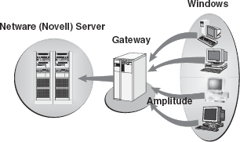

Figure 10.34 Gateway

LET US SUMMARIZE
- Data communication is the exchange of data between two devices using some form of wired or wireless transmission medium. There are five basic components in data communication system:message, sender, receiver, medium, and protocol.
- Data transmission mode refers to the direction of signal flow between two linked devices. There are three types of transmission modes: simplex (unidirectional data flow), half-duplex (bi-directional data flow, but one at a time), and full-duplex (simultaneous bi-directional data flow).
- The data can be transmitted from one point to another by means of electromagnetic signals. These signals may be in one of the two forms: analog or digital. An analog signal is a continuous waveform that changes smoothly over time. Digital data refer to the data stored in the form of 0s and 1s.
- Bandwidth refers to the maximum volume of data that can be transferred over any communication medium at a given point of time. The more the data needed to be transmitted in a given period, the more is the bandwidth required.
- Transmission media refers to the physical media through which data can be transmitted from one point to another. It can be divided into two broad categories: guided/wired media andunguided/wireless media.
- There are three basic types of guided media: twisted-pair, coaxial cable, and optical fibre. Some commonly used unguided media of transmission include RF propagation, microwave transmission, satellite transmission, infrared wave transmission, Bluetooth, and Wi-Fi.
- Modulation refers to the process of superimposing the signals on a carrier wave by changing some of the wave's characteristics (such as amplitude, frequency, or phase) so that it is more suitable for transmission over the medium between transmitter and receiver. Generally, there are three forms of modulation: amplitude, frequency, and phase.
- Multiplexing is a technique used for transmitting several signals simultaneously over a single communication channel. Signals are multiplexed using two basic techniques: FDM and TDM.
- Asynchronous transmission refers to the data transmission of one character at a time, with intervals of varying lengths between transmittals, and with start bits at the beginning and stop bits at the end of each character, to control the transmission.
- Synchronous transmission is a method of communication in which data are sent in blocks, without the need for start and stop bits between each byte. Synchronization is achieved by sending a clock signal along with the data.
- Switching refers to routing traffic by setting up temporary connections between two or more network points. A temporary connection is achieved by devices located at different locations on the network, called switches. Switching traditionally employs three methods: circuit switching, packet switching, and message switching.
- A computer network is a collection of two or more computers, which are connected together to share information and resources. A network can be classified into three categories: LAN, MAN,and WAN.
- Topology refers to the way a network is laid out, either physically or logically. It is the geometric representation of the relationship of all the links. There are five basic topologies: bus, ring, star, tree, and mesh.
- OSI is a standard reference model for communication between two end-users in a network. It consists of seven separate but related layers, namely, physical, data link, network, transport, session, presentation, and application layer.
- To communicate over a network, a particular set of network devices such as NIC, repeater, hub, bridge, switch, router, and gateway are used. These devices interconnect individual computers and ensure that they communicate efficiently.

Exercises

Fill in the Blanks
- .................. is the exchange of data between two devices using some form of wired or wireless transmission medium.
- The three types of data transmission modes are.................., and ..................
- The maximum volume of data that can be transferred over any communication medium at a given point of time is known as..................
- In .................. modulation, the amplitude of a carrier wave is varied in accordance with the characteristic of the modulating signal.
- The communication technique, which combines several signals from different devices and transmits over a common medium, is called ..................
- The switching technique where messages are stored and then forwarded to the nearby communicating device is ..................
- A network spread around Los Angeles and its suburbs can be termed as .................. network.
- A tree topology combines characteristics of .................. and .................. topologies.
- The device, which joins networks operating on different protocols together, is ..................
- The device, ftted onto the computer's motherboard, which enables computer to communicate over the network, is ..................

Multiple-choice Questions
- The transmission mode which allows both communicating devices to transmit and receive data simultaneously is ..................
  - Simplex
  - Full duplex
  - Half duplex
  - None of these
- Which of the following medias does not come under the guided media?
  - Optical fibres
  - Coaxial cable
  - Microwave
  - Twisted Pair
- LAN stands for ..................
  - Long area network
  - Local area network
  - Local audible network
  - Limited area network
- A public switched telephone network (PSTN) uses .................. switching technique.
  - Packet
  - Message
  - Circuit
  - None of these
- The network topology in which devices are not linked to each other and where hub acts as a central controller is ..................
  - Mesh topology
  - Star topology
  - Ring topology
  - Tree topology
- In ring topology, each ..................
  - Node is connected to exactly two others for communication purposes.
  - Device is connected to a control unit; communication between one device and another must go through the central unit.
  - Node in the ring incorporates a repeater.
  - Both (a) and (c).
- The network device that connects two or more networks together and whose sole aim is to trace the best route for the information to travel is ..................
  - Hub
  - Gateway
  - Switch
  - Router
- Which of the following cables support the highest bandwidth and faster transmission rate?
  - Fibre optic cable
  - Coaxial cable
  - UTP cable
  - Twisted-pair cable
- A computer network, which provides long-distance transmission of data, images, and sound over a large distance, is ..................
  - MAN
  - WAN
  - LAN
  - VAN

State True or False
- LANs operate within a wide area network.
- A telephone line can only send analog signals.
- In a bus topology, the communications channel consists of only one path for a message to travel to the destination.
- Twisted-pair cable is an example of unguided media for data communication.
- Hub is also called as protocol converter.
- Phase modulation is the encoding of information into a carrier wave by variation of its phase in accordance with an input signal.
- Coaxial cable can be easily tapped.
- Mesh topology involves minimum cabling.
- Optical fibre use copper wires for data transmission.
- In full-duplex transmission, both parties can communicate at the same time.

Descriptive Questions
- Write down the advantages and disadvantages of optical fibre.
- Differentiate:
  - Time-division multiplexing and frequency-division multiplexing
  - Guided and unguided media
  - Asynchronous and synchronous transmission
- What is modulation? List its types.
- Explain any three guided and unguided data transmission media.
- What do you mean by computer network? Explain various types of computer networks.
- Explain three basic switching techniques used in the computer network.
- With the help of a diagram, explain various network topologies used to connect computers in a network.
- Describe the following network devices:
  - Router
  - Hub
  - Gateway
  - Bridge

ANSWERS

Fill in the Blanks
- Data communication
- Simplex, half duplex, full duplex
- Bandwidth
- Amplitude
- Multiplexing
- Message switching
- Metropolitan area
- Bus, Star
- Gateway
- Network interface card

Multiple-choice Questions
- (b)
- (c)
- (b)
- (c)
- (b)
- (d)
- (d)
- (a)
- (b)

State True or False
- False
- True
- True
- False
- False
- True
- True
- False
- False
- True

Chapter 11. The Internet

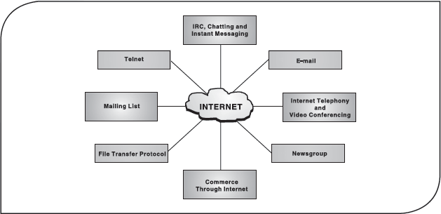

11.1 Introduction
In the past two decades, computers have played a significant role in our everyday life. With the growth in popularity and networking of computers, intercommunication between different computers became easier, which led to the evolution of Internet. It is the most talked about computer technology in recent years. For a majority of people, who are unaware of computer technology, Internet depicts some enigmatic computer gizmo, which has something to do with games, music, and generally entertainment. However, Internet is a much broader concept than mere entertainment and recreational activities. It is revolutionizing and enhancing the ways of human interaction and communication.
The word Internet is derived from two words: interconnection and networks. Also referred to as “the Net,” Internet is a worldwide system of computer networks, that is, a network of networks, which allows the participants (users) to share information. It consists of thousands of separately administered networks of various sizes and types. Each of these networks comprises tens of thousands of computers. Moreover, the total number of users of the Internet is known to be in millions. This high level of connectivity encourages an unparalleled degree of communication, resource sharing, and information access. It is probably the most powerful and important technological advancement since the introduction of the desktop computer. In order to benefit from what the net has to offer, a basic understanding of what it is and how it works is helpful.

11.2 Evolution of internet
The foundation of Internet was laid in 1969 by the Department of Defense (DoD) of United States of America. They wanted to create a computer network that could continue to function in the event of a disaster, such as a nuclear war. Even if a part of the network was damaged or destroyed, the rest of the system would continue to work. That network was known as ARPANET (Advanced Research Projects Agency Network), which linked US scientific and academic researchers. It was the forerunner of today's Internet.
Later in 1980, another agency, the National Science Foundation (NSF), created a new network of computers based on ARPANET, called NSFNET, which turned out to be more efficient and capable. Initially, NSFNET was designed to link five super computers situated at the major universities of NSF and allowed only academic research. Over the time, this network expanded to include sites for business, universities, government, etc. and finally becoming a network consisting of millions of computers, now known as the Internet.
In the 1980s, Usenet newsgroups and electronic mail (e-mail) came into picture. To keep track of the information on the Internet, indices such as archie and the wide area information server (WAIS) were also created in this decade. To give users an easy-to-use interface to work with, the University of Minnesota created Gopher, a simple menu-driven system for accessing files.
Internet really became popular in the 1990s after the development of the World Wide Web (WWW). Before that, it was open for a handful of sites only. It is amazing that as recently as June 1993, there were only 130 Web sites, but now there are millions.
With the growth of Internet, the quality, quantity, and variety of information also grew. The Internet today is a repository of every type of information. Nowadays, an Internet user can get all sorts of information ranging from how to add to the design of a functional spaceship to choosing a product for personal use (Figure 11.1).

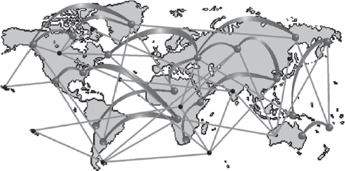

Figure 11.1 Hypothetical Diagram of the Internet

11.3 Basic internet terms
Now let us familiarize ourselves with some basic Internet terms.
WWW: The World Wide Web (abbreviated as the Web or WWW) is a collection of linked documents or pages, stored on millions of computers and distributed across the world. The concept of the Web began at CERN (the European Center for Nuclear Research), Geneva, Switzerland, in the year 1989. Since then, WWW is the most popularly used Internet subnetwork. One of the main reasons that led to its popularity is that it provides information in multimedia form, that is, in more than one medium such as, text, graphics, video, and audio. Further, it provides a simple and consistent way of accessing the information available on the Internet by using hypertext system. In hypertext system, the documents are connected to other related documents on the Internet through links. The Web uses a specific Internet protocol called HTTP to support hypertext documents.
Note: Although the WWW is often referred to as the Internet, they are actually two different concepts. The WWW is one of the most popular services available on Internet.
Web Page: The hypertext documents on the WWW are known as Web pages. A Web page is written in a language called HTML (hypertext markup language) which enables to embed hypertext links (discussed later in this section) in the document. Using these hyperlinks, the user can jump from one Web page to another.
Note: Web pages are also known as HTML documents.
Web site: A Web site is a set of related Web pages (linked through hypertext links), published by an organization or an individual. Typically, a Web site contains a home page along with other additional Web pages. Each Web site is accessed by its own address known as URL (uniform resource locator). All the Web sites on the Internet constitute the WWW.
Home Page: When you browse the WWW, you will often see the term “home page.” A home page (also called index page) is the starting point or a doorway to the Web site; it refers to the Web page that identifies a Web site and contains the hyperlinks to other Web pages in the Web site. It may contain links to other Web sites also. Like the table of contents of a book, the home page usually provides an overview of what could be found at the Web site. If there is not much information, the home page may be the only page of the Web site. However, usually you will find at least a few other pages.
Browser: A browser (short for Web browser) is a special software that enables users to read/view Web pages and jump from one Web page to another. It is the software that is needed to find, retrieve, view, and send information over the Internet. The most popular browsers are Microsoft Internet Explorer and Netscape Navigator.
Browsers are of two types:
- Graphical Browsers: allow retrieval of text, images, audio, and video. Navigation is accomplished by pointing and clicking with a mouse on highlighted words and graphics. Netscape Navigator, Internet Explorer, and Mozilla are graphical browsers.
- Text Browsers: provide access to the Web in text-only mode. Navigation is accomplished by highlighting emphasized words on the screen with the arrow up and down keys, and then pressing the Enter key to follow the link. Lynx is an example of a text-based browser (Figure 11.2).

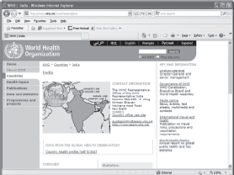

Figure 11.2 A Web Page on a Graphical Browser

URL: Each Web page has a unique address, called a URL (uniform resource locator), which identifies its location on the Internet. Usually, the format of an URL consists of four parts: protocol, name of the Web server (or domain name), path, and filename. Here is an example,http://www.xyz.com/tutor/start/main.htm. The structure of this URL is:
- Protocol: http
- Web server name/domain name: www.xyz.com
- Path: tutor/start/
- File Name: main.htm
The first part of the address, the part before the colon, is the protocol. Most of the time you see http(hypertext transfer protocol) for accessing a Web page. Apart from http, you could also find other protocols such as ftp (file transfer protocol), news (news server), and telnet (for accessing remote computers). After the protocol, comes the domain name. The protocol and the domain name are separated by colons and slashes (Figure 11.3).



Figure 11.3 Uniform Resource Locator

A domain name is a unique name that identifies a particular Web site and represents the name of the server where the Web pages reside. They are the human-readable addresses and hence are easier to remember. Domain names have two or more parts separated by dots. The letters occurring after the dot (.) identify the domain type. A domain type represents the type of organization or countries to which the Web server (sometimes called host computer) belongs.

Domain Types
Some of the domains that are typical on the Internet are:

com | Commercial and for-profit organizations
edu | Colleges and universities (education providers)
gov | Federal government agencies
mil | US military sites
net | Internet infrastructure and service providers
org | Miscellaneous and non-profit organizations
Dozens of domain types have been assigned to identify and locate files stored on host computers in countries across the world. These are referred to as two-letter Internet country codes and have been standardized by the International Standards Organization (ISO). For example, uk for the United Kingdom, de for Germany, au for Australia, and in for India. The last part of a URL consists of the path and the file name. Path name specifies the hierarchic location of the said file on the computer. For instance, in http://www.xyz.com/tutor/start/main.htm, the file main.htm is located in start, which is a subdirectory of tutor.
Hypertext: The hypertext is a system that provides a simple and consistent way to organize large data (that includes text, images, pictures videos, etc.) available on the Internet. In hypertext systems, the documents contain links to other related documents on the Internet. These links are calledhyperlinks, hotlink, or simply links. A hyperlink is used to jump to another part of the same page or to load a different Web page. Usually hypertext links appear in a different colour (typically in blue and underlined) from the rest of the text. When the cursor is moved over a text link or over a graphic link, it will change from an arrow to a hand. The hypertext words often provide a hint about the connected page. When the user returns to a page with a link he/she had already visited, the hypertext words will often be in a different colour (usually magenta), indicating that the link has already been used. However, the user can certainly use that link again (Figure 11.4).

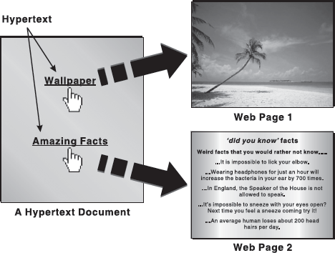

Figure 11.4 Hypertext Links

Hyperlinks are the foundation of the Web and the operation of the Web relies primarily on them as it is a means of information retrieval. Producing hypertext for the Web is accomplished by creating documents with HTML (hypertext markup language).
Internet Service Provider (ISP): An ISP is an organization that connects its subscribers’ computer using modem to the Internet. The connections can be provided by telephone lines, cable lines, or wireless connections. In order to use the Internet connection, the user has to first log on to the host computer using the username and password provided by the ISP. Some of the well-known ISPs are America Online (AOL), Microsoft Network (MSN), Yahoo!, etc.
While choosing an ISP, many factors should be kept in mind for subscribing. First, the user should check the speed and consistency of the Internet access. He/she should also check ISP's reliability, that is, whether the ISP provides consistent access to the Internet or does it have frequent downtimes. Apart from these two criteria, the price of the ISP and other additional services provided by it should also be considered. For example, many ISPs provide free Web space so that users can create their own Web site, free e-mail address, and much more. Last but not the least, the user should also check whether the ISP provides a round-the-clock technical assistance.
Web Server: A server is a computer equipped with server software, which provides a specific kind of services to client software running on other computers. It can refer to a particular piece of software, for example, a Web server, or to a machine on which the server software is running. A Web server receives request from the clients, processes this request, and sends the result back to the client. In other words, Web server fulfils the client's (browser) requests (Figure 11.5).

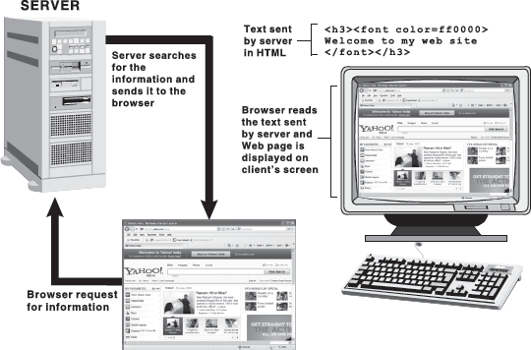

Figure 11.5 Data Transfer from Web Server to Browser

To view a Web site, the browser sends a request to the server. On receiving the request, the server sends the appropriate Web page to the client's machine. The client's machine (browser) receives the information in the form of HTML commands. The browser interprets the HTML, finds all the pictures (or other types of media), and displays the information onto the user's screen.
Download and Upload:Download refers to the act of transmitting data from a remote computer on the Internet or other network to one's own computer. When the user downloads a file, he/she is actually copying a particular file from the remote computer and placing it on his/her hard drive. Downloading allows a user to save file for later use, thereby reducing the time spent online and the corresponding charges.
Upload is just the opposite of download. Upload refers to the act of transmitting data from local computer to any other computer on the Internet or network. For example, a software company may upload a demonstration of its new software onto the Web so that users can then download the software.
Online and Offline: The term online is commonly referred to the state of being connected to the networked computer system or Internet. For example, if you are browsing the WWW, your computer is said to be online. Being online also refers to any peripheral device (like printer) that is connected to the system and ready to use.
Offline is just the opposite of online; it refers to the state of not being connected to the remote computer or Internet. A printer or other peripheral that is not ready to use is also considered Offline.

11.4 Getting connected to the internet
Now you are aware of the basic Internet terms, let us shift our focus on how to connect to the Internet. The basic requirements for getting connected to the Internet (Figure 11.6) are discussed in this section.

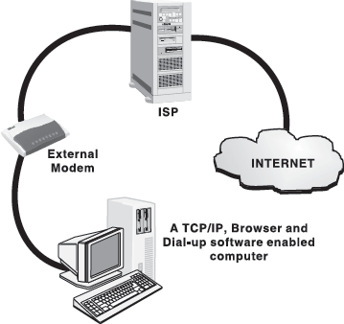

Figure 11.6 Connecting to the Internet

The Computer: The computer must have at least 386-microprocessor chip with a minimum of 16 MB of RAM. For a good browsing experience, use a faster chip (Pentium III/Pentium IV) with more RAM (128/256 MB). In addition, a colour monitor, with at least 640 × 480 resolution and a capability of displaying a minimum of 256 colours, is also vital. The system should also possess a hard disk, with at least 200 MB of free space, to store Internet software and temporary Internet files. Since the Web is a multimedia medium, you can also enjoy sound on your system with a sound card and a pair of speakers.
Modem: Apart from the previously mentioned configuration, a computer system must have a device called modem, which enables a computer to transmit data over telephone lines. A modem(acronym for modulator–demodulator) is a hardware, which converts digital data into analog signals (that is, modulation) that can be sent over an analog telephone line and convert the analog signal back into digital data (that is, demodulation). Thus, when the modem receives the data from a Web server via telephone system, it reconstitutes the analog signal into digital form so that the computer can understand it. The most critical aspect of the modem is its speed of operation. The speed of modem is measured in kilobits per second (kbps). Modern modem supports 28 kbps to 56 kbps speeds. Modems are of two types:
- Internal Modem: is a card, which is fitted inside the computer with a lead running directly from the computer to the telephone socket.
- External Modem: is a small external box wired between the computer and the telephone socket.
Internet Connection: Before connecting to the Internet, you need to buy an Internet connection from an authorized ISP. The speed of accessing the Internet entirely depends upon the type of connection you bought from the ISP. Some of connections available for the users these days are briefed below:
- Dial-up: A dial-up connection is the access method that uses telephone lines to connect to the Internet. It is the most common way for individuals who use home computers to connect to the Internet. To connect to the Internet by using dial up, the user needs to specify a username, a password, and a telephone number. After the connection is established, the user can start browsing sites on the Internet.
- ISDN: It stands for integrated services digital network and is more common in business and commercial use. It was the first high-speed alternative to regular analog telephone modems. ISDN involves the digitization of telephone network so that voice, graphics, text, and other data can be provided to users from a single terminal over existing telephone wiring. Digital connections have fewer errors in transmission, which means speed of downloading graphics, Web pages, sound, and so on is increased to four times faster than with dial-up modems.
- Cable Modem: A cable modem connects the user to the Internet through a cable television line. Nowadays, many cable companies offer Internet along with television accessibility. A cable modem will typically have two connections, one to the television outlet and the other to the computer. Cable modems not only provide a faster Internet access (10 to 100 times as fast as the dial-up modem), but interactivity to the television also.
- Leased Line: This facility provides reliable, high-speed Internet access ranging from 2.4 kbps to 45 Mbps. A leased line connection is an affordable way to link two or more sites for a fixed monthly charge. Usually leased lines facility can be provided via a fibre optic or copper lines. Leased line service provides a consistent amount of bandwidth and is an excellent way to provide data, voice, and video links between sites.
- DSL: DSL or digital subscriber line service is provided through an existing telephone line, but it works differently than regular analog modem dial-up access. DSL operates over normal telephone lines and it can be used simultaneously with the telephone. DSL can increase the connection speed by as much as ten-fold from a standard dial-up modem.
- Broadband: This type of access is good for remote locations, where ISDN, cable, or DSL are not available. It gives a decent download speed, but to upload data, the user still needs a regular analog modem to dial in, via a telephone line. Satellite connection can be either a two-way service or a one-way service. In case of two-way satellite service, the data are transmitted via satellite to a dish antenna at the user's house. In one-way system, the user needs a conventional modem and telephone link to an ISP. Satellite connection is expensive but sometimes is the only fast option for people who are beyond the service area of cable and DSL providers.
- Before deciding the type of Internet connectivity, one should first decide what his requirements are. If the user wants the Internet mainly for sending e-mail, occasional chats, and infrequent browsing, then he should work with regular modem dial-up access. In this case, user should invest in a good-quality 56 kbps modem and a good ISP. If the user is using the Internet frequently for research, downloading or uploading a fair amount of data, to play multi-player games or to use the Internet's multimedia capabilities like live audio or video streaming, then he should look into other high-speed accesses such as cable modem or ISDN.
Internet Software: To connect to the Internet, a computer requires mainly three different kinds of software:
- TCP/IP: TCP/IP, or transmission control protocol/Internet protocol, is the basic communication protocol of the Internet. It allows programs on user's computer to communicate over the Internet. Usually, when you are set up with direct access to the Internet, your computer is provided with a copy of the TCP/IP. Similarly, every other computer that you may send messages to or get information from also has a copy of TCP/IP.
- Dialler Software: This software is provided by the ISP to instruct the modem to dial the telephone number and to identify the user's machine to the access provider's system for access to the network.
- Browser: To use the Internet, a Web browser is essential which allows the user to view the information available on the WWW.

11.5 Internet applications
Today, the Internet has grown from a small network to biggest network of computers. Due to this colossal growth, the Internet has become the biggest domain of information. Nowadays, an Internet user has access to a wide variety of services such as e-mail, file transfer, vast information resources, interest group membership, interactive collaboration, multimedia displays, real-time broadcasting, shopping opportunities, and much more. Some of the important services provided by the Internet are briefed in the following few sections (Figure 11.7).

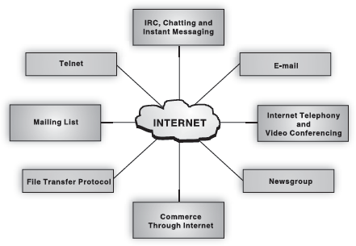

Figure 11.7 Internet Applications

11.5.1 Electronic Mail (E-mail)
Electronic mail, or e-mail, is a fast, easy, and inexpensive way to communicate with other Internet users around the world. It is one of the basic and earliest services of the Internet and the most used application on the Internet too. E-mail overcomes most of the problems and delays of getting a physical document from one person to another. Rather, it has the dual advantage of not only being faster but cheaper to use as well.
Each user of e-mail has a mailbox address to which messages are sent and the mailbox can be accessed from anywhere and at anytime. It does not matter what type of connectivity the user is having, he will always be able to use this service. One can receive and send e-mails from all systems whether it is a Windows PC or a UNIX machine. Not only this, e-mail can also be used to send documents, images, audio, video, and so on as an attachment along with the mail.

11.5.2 File Transfer Protocol (FTP)
The FTP is a set of rules that enables a user to transfer files from one system to another. It was the first service developed for the Internet so that government and educational institutions could easily exchange files. It allows the user to get access to the files stored in the directory of a remote computer that is connected to the Internet. Using FTP, one can upload and download files from the remote computer (known as FTP servers), if he/she has access permission on the remote machine. Though files can be transferred using e-mail, this is not a good choice if the file size is large or when there are many files. FTP sites can consist of hundreds to thousands of files with information on books, music, software, games, images, sounds, multimedia, course ware, etc. FTP can be done using the command prompt, browsers, and various GUI-based FTP software such as CuteFTP and WS_FTP (Figure 11.8).

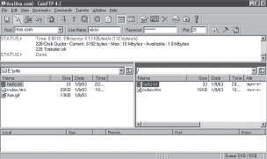

Figure 11.8 FTP Using Graphical FTP Software

11.5.3 Telnet
The word “telnet” is derived from telecommunications and network and is a protocol that allows a user to log on to a remote computer. Telnet is also known as remote login, which means connecting one machine to another in such a way that a person may interact with another machine as if it is being used locally. It means that someone in New Delhi could connect to a computer in the New York City Public Library and search the card catalogue the same way as someone located at a terminal in the library. Once connected, the user's computer emulates the remote computer. When the user types in commands, they are executed on the remote computer. The user's monitor displays what is taking place on the remote computer during the telnet session (Figure 11.9).

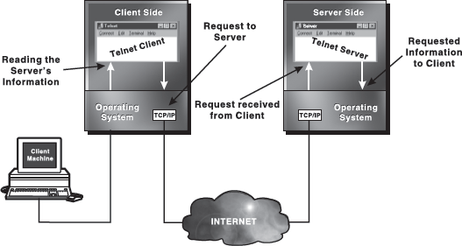

Figure 11.9 Remote Login through Telnet
The user's computer, which initiates the connection, is referred to as the local computer or telnet client, and the machine being connected to, which accepts the connection, is referred to as the remote computer or telnet server.
.

11.5.4 Video Conferencing
Video conferencing uses the same technology as IRC, but also provides sound and video pictures. It enables direct face-to-face communication across networks. A video conferencing system has two or more parties in different locations, which have the ability to communicate using a combination of video, audio, and data. A video conference can be person to person (referred to as “point-to-point”) or can involve more than two people (referred to as “multipoint”), and the video conferencing terminals are often referred to as “endpoints” (Figure 11.10).

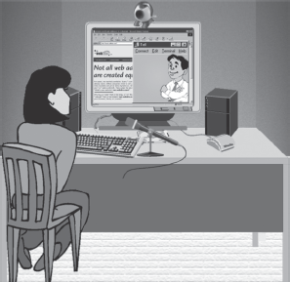

Figure 11.10 Video Conferencing

In this form of meeting, participants in remote locations can view each other and carry on discussions via Web cameras, microphones, and other communication tools. The following five elements are common to all video conferencing endpoints:
- Web Camera: It captures live images to send across the network.
- Visual Display: It displays the images of the people taking part in the video conference.
- Audio System: It includes both microphones to capture audio from the endpoint and loudspeakers to play back the audio received from other endpoints across the network connection.
- Compression: Videos are very bandwidth intensive and they take a long time to load. Therefore, video systems include technologies, often referred to as codecs, to compress and decompress video and audio data, allowing transmission across a network connection in near-real time.
- User Interface and Control System: The user interface allows the users to control interactions, for example, placing calls, storing and locating numbers, and adjusting environment settings such as volume. The control system handles the underlying communication that takes place between endpoints.
Video conferencing has many benefits, as a tool for both teaching and learning. A key factor is that it provides real-time, visual communication, unlike other communications methods such as e-mail. Video conferencing technology is still in its infancy, and one of its major limitations is the bandwidth (the volume of information per unit time that a computer or transmission medium can handle) available on the Internet. As the protocols and applications for video conferencing develop higher resolution and improved speed, participation will increase.

11.5.5 Commerce through the Internet
Today business is taking place through electronic telecommunication media. Nowadays, various organizations offer the facility of shopping online. This type of business model is known as electronic commerce or E-commerce. E-commerce refers to buying and selling goods and services online. It integrates communication, data management, and security capabilities, which allow organizations to exchange information about the sales of goods and services. Essentially, it is the end-to-end digital exchange of information needed to conduct business including electronic data interchange (EDI)and electronic funds transfer (EFT). EDI is the computer-to-computer exchange of routine business transactions including payments, information exchange, and purchase order requests. EFT is a technology that allows the transfer of funds from the bank account of one person or organization to that of another (Figure 11.11).

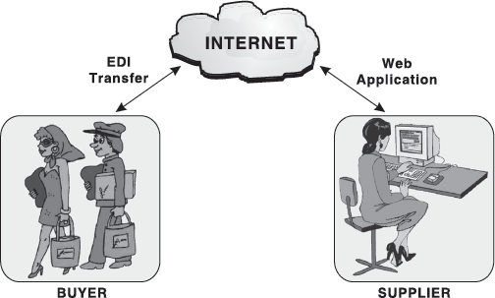

Figure 11.11 Electronic Commerce

While discussing about e-commerce, we normally talk about virtual shopping malls, up front store where the user virtually visits and selects the product(s) of his/her choice. After selecting the desired product(s), the payment for the purchase is done. Online payment can be done through credit card. Techniques for cash transactions have also been developed in the form of Internet money such as Cyber cash and Digital money. After transfer of money, the items are received at the doorstep, which means delivery of the product is done at the address desired by the buyer.
Through the development of e-commerce, the Internet has established an electronic global worldwide market that operates 24 hours and 365 days a year. Organizations and individuals are able to market goods and services, while purchasing is supported by secure facilities such as digital signatures (the process that operates on a message to assure message source authenticity and integrity) and encryption (a method of ensuring data secrecy). Developments in software mean that an increased number of facilities are becoming available all the time. Some of the well-known e-commerce sites are http://www.amazon.com and http://www.ebay.com.
The increased use of mobile devices such as PDAs (personal digital assistants) and mobile phones has opened a new horizon of proliferation in the electronic market and has coined a new term “mobile commerce.” Mobile commerce or M-commerce refers to transactions through a mobile phone network and data connection that result in the transfer of value (monetary or otherwise) in exchange for goods and services. Mobile commerce has evolved as a new and simpler concept to operate financial transaction through mobile phones and it includes services such as banking, payment, and ticketing. M-commerce users may view and interact with information that appears through SMS (short message service), WAP (wireless application protocol), or a standard HTML browser on a PDA, Web-enabled mobile phone or laptop computer connected to a mobile phone on a wireless network.

11.6 Data over the internet
The data, in terms of Internet, primarily comprises the hypertext documents containing links that connects to other documents or files. These documents may even include animations, and multimedia components. Depending upon how information is displayed in the browser, we can classify the displayed data into two categories: Static Component and Dynamic Component.

11.6.1 Static Component
Static component includes the information displayed on the browser that does not interact with the user. For example, the text written in the form of a paragraph on the Web page is static component. Producing static component for the Web page is accomplished by creating documents in HTML.

11.6.2 Dynamic Component
Dynamic component imparts life to a Web page. This component refers to a specification by which a user can interact with a Web server. For example, when a user fills a form on the Web page, the text filled in various fields is sent back to the originating point of the Web page. This way a user is able to interact with the server hosting that Web page. To impart dynamism, a special program (often called scripts) is written in any programming language including Perl, VBScript, JavaScript, and so on. Some of the programming languages used to provide dynamism to a Web page are listed below:
Perl: Web server uses external programs, called CGI scripts or CGI program, usually written in Perl to communicate with other programs such as database and mail running on the server. CGI programs are generally used to process the information from an interactive form on a Web page. A typical application would be to search a database. For example, a user might search for the word “white papers” on a Web site. The server receives the request, passes it to the CGI script, which looks up a database, and responds with the appropriate result formatted in HTML.
JavaScript and JScript: JavaScript is a programming language, which runs on the browser. It was developed by Sun Microsystems and was first implemented in Version 2 of the Netscape browser. JScript is Microsoft's implementation of JavaScript for the Internet Explorer.
JavaScript runs on the browser (client) and does not require any server software. Therefore, it is often called client-side scripting language. As all execution takes place on the browser, JavaScript is responsible for most of the interactivity on a Web page. Effects like changing of images, text colours, and other things can be made possible through JavaScript. The language has also been widely used for basic form validation.
VBScript: Like JavaScript, VBScript is also a client-based language that has been developed by Microsoft and it runs only on the Internet Explorer. Although JavaScript runs on both Netscape and Internet Explorer, VBScript is easier to code when developing active server pages.
Active Server Pages (ASP): ASP is a technology promoted by Microsoft. It uses some special tags, which can be embedded in the HTML code to generate dynamic Web pages. ASP scripts run on the server side. A typical user can use VBScript, JavaScript/ Jscript, or a combination of both to write ASP pages. The great advantage in using ASP is the ease of maintenance of the Web site.
PHP: PHP is an open-source development environment to develop dynamic Web pages. PHP works almost like an ASP, but it is more secure and handles databases more easily. PHP code is embedded inside the HTML and can be linked to databases for generating dynamic content.
XML (eXtensible Markup Language): XML is a markup language that enables programmers to create customized tags. These tags can provide the much-needed functionality presently unavailable with HTML. XML documents can be accessed using ASP, PHP, and so on.
Java: Java is a very powerful and object-oriented language developed by Sun Microsystems. Web-based Java applications are generally in the form of “Java applets.” They are small programs written in Java, which are called by an HTML page from a Web server and run on a Java-compatible Web browser.

LET US SUMMARIZE
- Internet is a worldwide system of computer networks, which allows the participants to share information. The foundation of Internet was laid in 1969 by the DoD of United States of America.
- The World Wide Web (abbreviated as the Web or WWW) is a collection of linked documents or pages, stored on millions of computers and distributed across the world.
- A Web page is a document on the WWW, which is created with HTML. The Web pages are linked together through hyperlinks, which enables the user to jump from one Web page to another by clicking on a link.
- A Web site is a set of related (linked through hypertext links) Web pages, published by an organization or an individual. All the Web sites on the Internet constitute the WWW.
- A home page (also called index page) is the starting point or a doorway to the Web site; it refers to the Web page that identifies a Web site and contains the hyperlinks to other Web pages in the Web site.
- A browser (short for Web browser) is a special software that enables users to read/view Web pages and jump from one Web page to another. It is the software that is needed to find, retrieve, view, and send information over the Internet.
- Each Web page has a unique address, called a URL, which identifies its location on the Internet.
- The hypertext is a system that provides a simple and consistent way to organize large data (that includes text, images, pictures videos, etc.) available on the Internet. In hypertext systems, the documents contain links to other related documents on the Internet. These links are calledhyperlinks, hotlink, or simply links.
- An ISP is an organization that connects its subscribers’ computer using modem to the Internet. Some of the well-known ISPs are America Online (AOL), Microsoft Network (MSN), Yahoo!, etc.
- A Web server receives request from the clients, processes this request, and sends the result back to the client. In other words, Web server fulfils the client's (browser) requests.
- Download refers to the act of transmitting data from a remote computer on the Internet or other network to one's own computer. On the other hand, upload refers to the act of transmitting data from local computer to any other computer on the Internet or network.
- Modem is a device that allows computers to communicate over telephone lines. It converts digital data into analog signals that can be sent over an analog telephone line and converts the analog signal back into digital data.
- TCP/IP is the basic communication protocol of the Internet. It allows programs on user's computer to communicate over the Internet.
- The FTP is a set of rules that enables a user to transfer files from one system to another.
- Telnet is a protocol that allows a user to log on to a remote computer. Also known as remote login, it connects the user's machine to another in such a way that the user may interact with another machine as if it is being used locally.
- Video conferencing is a form of meeting in which participants in remote locations can view each other and carry on discussions via Web cameras, microphones, and other communication tools.
- E-commerce refers to buying and selling goods and services online and if the transaction is done through a mobile phone network, it is known as mobile commerce or m-commerce.
- Mailing list enables people with similar interests from all over the world to communicate and share information with each other.
- Depending upon how information is displayed in the browser, we can classify the displayed data into two categories: static component and dynamic component.

Exercises

Fill in the Blanks
- A computer on a network that requests files from another computer is known as ..................
- Each Web page has a unique address, called .................. that identifies its location on the Internet.
- The .................. is a collection of linked documents or pages, stored on millions of computers and distributed across the world.
- A program that enables users to read/view Web pages and jump from one Web page to another is known as ..................
- .................. refers to the act of transmitting data from a remote computer on the Internet or other network to one's own computer.
- The US Department of Defense laid the foundation of the Internet with a network called ..................
- AltaVista, Google, and HotBot are the examples of ..................
- The Web uses a specific Internet protocol called .................. to support hypertext documents
- The technique for .................. is known as Telnet.
- The mailing list groups, administered by a software program, are known as ..................

Multiple-choice Questions
- URL is ..................
  - a computer software program.
  - a type of Web server.
  - the address of a document or “page” on the WWW.
  - an acronym for unlimited resources for learning.
- What would you use for immediate, real-time communication with a friend?
  - e-mail
  - IRC
  - Usenet
  - Mailing list
- What does the URL http://www.uni.edu tell you about the source?
  - It is associated with an educational institution
  - It is associated with a military establishment
  - It is associated with a commercial organization
  - None of the above
- When a user subscribes to a newsgroup, ..................
  - All new posts are e-mailed to the user automatically.
  - The user must agree with everything said in that newsgroup.
  - The user is billed annually for the subscription.
  - The user is barraged with spam.
- The Internet is owned by ..................
  - The US government
  - A consortium of telecommunications companies
  - The IETF
  - None of the above
- A home page is ..................
  - a Web page created by an individual home user, as opposed to the one created by a corporation.
  - the Web page you like to visit the most.
  - the Web page that identifies a Web site.
  - a Web page you eventually reach by clicking a series of hyperlinks.
- Which of the following is not a type of Internet connection?
  - ISDN
  - Dial up
  - Leased line
  - ISP
- E-mail is ..................
  - Mail concerning electronic devices
  - Transaction of letters, messages, and memos over a communication network
  - Transaction of messages within a computer
  - None of the above
- Which one is not the language of Internet?
  - Perl
  - HTML
  - XML
  - COBOL
- Choose the odd one out.
  - Web page
  - Home page
  - Index page
  - Cover page

State True or False
- WWW cannot incorporate sound.
- All URLs are unique.
- Telnet cannot be used for remote login.
- .EDU is a valid domain type.
- Internet Explorer is a character-based browser.
- Messengers can be used to send e-mails.
- Dial up is the fastest possible Internet connection.
- Microsoft owns Internet.
- Outlook Express can be used for reading news.
- Listserv is a Web browser.

Descriptive Questions
- Explain a typical structure of a URL.
- List the various services provided by the Internet.
- What is a newsgroup? How can you subscribe to it?
- Distinguish between Internet and WWW.
- Define the following
  - Web page
  - Home page
  - Web site
- Write short notes on the following:
  - Chatting
  - Instant messaging
  - Internet telephony
  - Video conferencing

ANSWERS

Fill in the Blanks
- Client
- URL
- WWW
- Web browser
- Downloading
- ARPANET
- Search engines
- Hypertext transfer protocol
- Remote login
- Listserver

Multiple-choice Questions
- (c)
- (b)
- (a)
- (a)
- (d)
- (c)
- (d)
- (b)
- (d)
- (d)

State True or False
- False
- True
- False
- True
- False
- True
- False
- False
- True
- False

BIBLIOGRAPHY

- Benninga S. Financial Modeling Uses Excel, 3rd Ed / Simon Benninga. – The MIT Press, 2008. – 1168 p.
- Bucki L. A. Word 2013 Bible / Lisa A. Bucki., 2013. John Wiley & Sons, Inc. – 1256 p.
- Calberg C. Business Analysis: Microsoft Excel 2010 / Conrad Calberg. – 2012: Que Publishing. – 528 p.
- Chambers M. MacBook For Dummies / Mark L. Chambers., 2012. – (For Dummies). – 327 p
- Elmasri R. Fundamentals of Database Systems (7th Edition) / Ramez Elmasri., 2015: Pearson. – 1272 p.
- Gookin D. Word 2013 For Dummies / Dan Gookin. – Wiley, 2004. – 408 p.
- Habraken J. Microsoft Office 2010 In Depth / J. Habraken. – Que Publishing, 2010. – 973 p.
- Harris D. M. Digital Design and Computer Architecture, Second Edition / David Money Harris., 2012. – 721 p.
- Harvey G. Excel Timesaving Techniques For Dummies - Over 60 Timesavers / Greg Harvey. – Wiley, 2004. – 408 p.
- Hennessy, J. Computer Architecture / J. Hennessy,, D. Patterson. – Morgan Kaufmann, Elsevier, 2019. – 788 p.
- Johnson S. Microsoft Office Word 2007 On Demand / Steve J ohnson., 2007: Que Publishing. – 512 p.
- Kiriaty Y. Introducing Windows 7 for Developers / Y. Kiriaty, L. Moroney, S. Goldshtein. – Ms Press, 2009. – 416 p.
- Kurose J. F. Computer Networking: A Top Down Approach, 6th Edition / J. F. Kurose, K. W. Ross., 2012: Addison Wesley. – 862 p.
- Kurose J. F. Computer Networking: A Top Down Approach, Global Edition / J. F. Kurose, K. W. Ross. – Pearson Education Limited, 2016. – 856 p.
- Mertz D. Functional Programming in Python / David Mertz. – Published by O’Reilly Media, Inc., 2015. – 612 p.
- Mueller S. Upgrading and Repairing PCs (21st Edition) / Scott Mueller., 2013. – 1285 p.
- Murray K. Microsoft Office 365: Connect and Collaborate Virtually Anywhere, Anytime / Katherine Murray. – Microsoft Press, 2011. – 337 p.
- Odom S. MCTS Windows 7 Configuring 70-680 Exam Study Guide / Sean Odom. – MediaWorks Publishing, 2009. – 375 p.
- Russinovich M. E. Windows Internals, Part 1, 6th Edition / M. E. Russinovich, D. A. Solomon, A. Ionescu. – Microsoft Press, 2012. – 752 p.
- Sandler C. Laptops All-in-One For Dummies, 2nd Ed / Corey Sandler., 2010. – 820 p.
- Schmuller J. Statistical Analysis with Excel For Dummies / Joseph Schmuller. – Wiley, 2009. – 506 p.
- Sedgewick R. An Introduction to the Analysis of Algorithms (2nd Edition) / R. Sedgewick, P. Flajolet. – Addison-Wesley Professional, 2013. – 593 p.
- Stephens, R. SQL in 24 Hours, 6th Edition / R. Stephens,, R. Plew, A. Jones. – Sams Publishing, 2015. – 464 p.
- Tanenbaum A. Computer Networks, 5th edition / A. Tanenbaum, D. Wetherall. – Prentice Hall, 2010. – 962 p.
- West J. Network+ Guide to Networks / J. West, J. Andrews, T. Dean. – Cengage Learning, 2019. – 881 p.
- Windows Internals, Part 1, 7th Edition / P.Yosifovich, A. Ionescu, M. Russinovich M.E.,, D. Solomon. – Microsoft Press, 2017. – 800 p.
- Wong A. Network Infrastructure Security / A. Wong, A. Yeung. – Springer, 2009. – 264 p.

Textbook
GORELOV Yurii Petrovich
KOBZEV Igor Volodimirovich
MOROZOVA Lana Yurjevna
LUKYANOVA Victorija Anatoljevna

INFORMATICS

for foreign students
of training faculties

Responsible person V.A.Lukyanova

Editor
Yu.P.Gorelov
І.V.Kobzev
V.A.Lukyanova
L.Yu. Morozova

Plan 2019, поз.

Signed to print. “__”____2019. Format . Paper print.
Cond.print.sheet .Count print.sheet .Circulation 100 copies.
Order. № Negotiated Price. Printing method - rhizography.

------------------------------------------------------------------------------
NURE.Ukraine. 61166 Kharkiv, Science ave.,14.
------------------------------------------------------------------------------
Printed in educational and production,
publishing and printing center of NURE.

61166 Kharkiv, Science ave.,14

