Distribution of permutations with different cyclic structure in mathematical models of transportation problems

Igor Grebennik
System Engineering Department
Kharkiv National University of Radio Electronics
Kharkiv, Ukraine
igorgrebennik@gmail.com
Olga Chorna
System Engineering Department
Kharkiv National University of Radio Electronics
Kharkiv, Ukraine
olha.chorna@nure.ua
Inna Urniaieva
System Engineering Department
Kharkiv National University of Radio Electronics
Kharkiv, Ukraine
inna.urniaieva@nure.ua

Abstract—The paper is devoted to the investigation of problems of the class Pick-up and Delivery routing problems (PDP). This class is characterized by the multidimensionality of the input data, the requirement for decision-making in conditions of uncertainty and the requirement for rapid generation of solutions. Therefore, heuristic algorithms have proven to be good for solving PDP problems.
Among the heuristic algorithms used to solve such problems is a wide class of Large-scale neighborhood algorithms, in which algorithms based on the use of cyclic transfer theory deserve special attention. If the collection and delivery of goods from many senders to many recipients is served by several trucks - the question arises of the distribution of points to visit between vehicles.
One approach to solving the problem of splitting multiple shipping points into non-intersecting clusters is an approach that uses heuristic start splitting and then improves it by moving some shipping points between clusters using cyclic transfers.
The study of the properties of cyclic permutations and the study of the cyclic structure of arbitrary elements of the permutations set is a promising direction for increasing of efficiency of the cyclic transfer approach to solve PDP problems.
This paper is devoted to the study of the distribution of permutations with different cyclic structure in the set of permutations for increasing the efficiency of solving PDP problems. Experiments were conducted to study the distribution of permutations with different cyclic structure among sample populations with different qualitative characteristics. On the basis of the analysis and results of experiments the conclusions concerning features of distribution of permutations with various cyclic structure are made. Taking into account these features allows you to increase the efficiency of the cyclic transfer method in solving transport routing problems.
Keywords—pickup and delivery problem, permutations, cycles, cyclic transfers, clusterization

Introduction
Transport routing and logistics problems for many years occupy a significant part of modern research. These problems become more urgent the more connected, open and barrier-free the modern world becomes. The speed of dissemination of information leads to the fact that in case of any disasters or difficult conditions almost simultaneously the whole world learns about humanitarian requests for assistance from ordinary people and public organizations located in hot spots. The strength of the volunteer movement and the horizontal links between people means that the necessary humanitarian aid can be collected in small portions from many senders and sent to many recipients in different parts of the disaster or combat zone. Special area called Pick-up and Delivery vehicle routing problem is devoted to solving transportation problems of this type. This is a wide class of optimization problems that describe a variety of real-life situations, such as the need to deliver goods in certain time windows, considering general or specific restrictions on loading trucks, restrictions on the order of loading and unloading of vehicles. It should be noted that depending on the scope of each individual problem, it may be more important to obtain an approximate solution with a given accuracy when allowing the use of any number of computing and time resources. Or the field of application may be one in which time costs are critical, so it is more important to get some heuristic, acceptable solution and start delivering vital cargo faster.
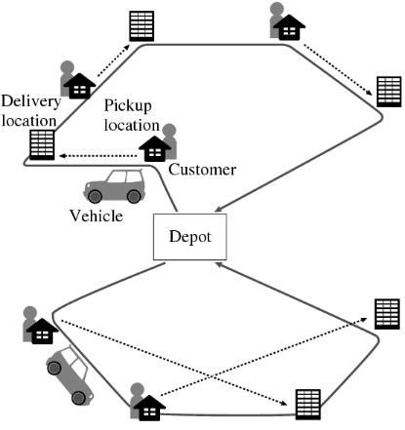
- Example of a one-to-one Pickup and Delivery Problem soluthion
In cases when in solving the pick-up and delivery problem of goods from many senders to many recipients several trucks are involved, it is possible to clusterize the points that need to be visited and then allocate clusters between vehicles. To create clusters corresponding to each vehicle, it is possible to use a variety of clustering methods and further evaluation of the solution obtained on some specific clustering.
It should be noted that in such case solving Pick-up and Delivery vehicle routing problem involves the use methods of combinatorial optimization for the clustering of pick-up and delivery points, the allocation of clusters between vehicles, the search for routes for detours by vehicles of specified points.
One of the ways to improve the solution of the PDP is to create a starting clustering of pickup and delivery points and further improve this starting clusterization. This is where Large-scale neighborhood algorithms can be used. Such an algorithms are a wide class of modern improvement algorithms, which is based on finding the best solution in some, perhaps very wide, area around the starting solution of the combinatorial optimization problem [1].
For the creation of cyclic transfers, the use of which will lead to the improvement of starting solutions, several approaches are known. Among them there are general strategies, such as one described in [2-3], and methods that use features of specific problems, for which the cyclic transfer strategy is proposed [10]. These studies are devoted to the analysis of the features of the cyclic structure of permutations, and in particular, the study of permutations that contain one cycle, i.e. cyclic permutations. The usage of cyclic permutations for the formation of cyclic transfers that improve the starting clusterization of pickup and delivery points is described in [10].
This paper is devoted to further study of the properties of permutations, cyclic structure of permutations and distribution of permutations with a certain cyclic structure in the set of permutations and their application in methods based on cyclic transfers in solving PDP problems.

Problem Formulation
In paper [11] an heuristic approach for solving the one-to-one Pickup and Delivery Problem with three-dimensional loading constraints is proposed.
In paper [10] a strategy that uses heuristic solution [11] as a starting solution is proposed. Improving starting solutions through cyclical transfers is considered in the sense of reducing the value of the objective function, which is the total cost of delivery of all the goods. Improving the initial solutions is achieved by changing the initial clusterization of pickup and delivery points. Change of clusters is realized by the cyclic transfer of pickup and delivery points between clusters.
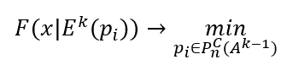
Сonstruction of cyclic transfers using a set of cyclic permutations and its properties to improve the initial clusterization is proposed. For this purpose, the combinatorial optimization problem on cyclic permutations is formulated:
(1)

Where k=1,2,… – the number of steps, which may depend on the number of clusters, the power of the set of input data or computing capabilities; E^{k}(p_{i}) – clusterization of the set of pickup and delivery points obtained in the k-th step by applying a cyclic transfer described by the cyclic permutation p_{i}, belonging to a cyclic permutations set constructed in the (k-1)-th step using A^{k-1} set of generating elements; 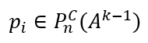.

Cyclic Structure Of Permutations
Cyclic transfers are a tool for improving the solution of combinatorial optimization problems, and the concept of a cycle and a cyclic permutation are the formalization of cyclic transfers. The definition of a cycle of permutation elements is given, for example, by R. Stanley, and the sets of cyclic permutations by M. Bona. When considering these concepts, we will use the following definition of a permutation [12–13]:
The linear ordering of elements of a single generating set A={a₁, a₂,…, a_{n}} is called a permutation π = (a₁, a₂,…, a_{n}) = (π (a₁), π (a₂),…, π (a_{n})), or, if it is necessary to emphasize the fact that it contains n elements, n– permutation. The set of permutations generated by the elements a₁ < a₂ < … < a_{n} will be writing as P_{n}.
One of the fundamental properties of permutations is their cyclic structure. Permutation π might be represented as a combination of non-intersecting cycles, writing as π = C₁C₂…C_{k} [13].
Cyclic permutation is a permutation π of n elements that contains a single cycle length n. Such permutations will be denoted π_{C}, and the set of such permutations — P_{n}^{C}. A number of modern publications are devoted to the properties of cyclic permutations and features of the cyclic structure of arbitrary permutations, among them R. Stanley, M. Bona, V.O. Emelichev, Ch.A. Charalambides, O.M. Isachenko, S. Elizalde [12–16]. Many publications elucidate the use of a set of cyclic permutations and its subsets in the data archiving and cryptography [17], quantum computing [18], bioinformatics [19].
In the papers [8, 9] an approximate method of constructing a cyclic permutation from a permutation with an arbitrary cyclic structure is proposed. Thus, to increase the efficiency of the approximate method of constructing cyclic permutations for use as cyclic transfers in transport routing problems, the question arises: How many permutations of different cyclic structure will be most frequent as starting permutations.

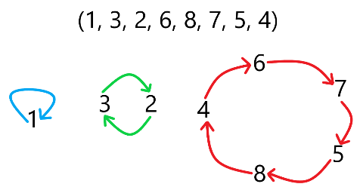
- Random permutation cyclic structure example

Destribution Of Permutations
The distribution of permutations with different number of cycles in the set of permutations is known and is described by Stirling numbers of the first order [13]. One possible area of the cyclic structure of permutations research is the random selection of a certain number of permutations and the study of the mass fraction of permutations with different number of cycles in various populations. The choice of random permutations can be implemented in a variety of ways. In this paper, an approach using the solution of an auxiliary problem of optimizing a linear function without additional constraints on the set of permutations is chosen. The solution of a problem of this type on a set of permutations is known and obtained with the ordering the elements of permutation [20]. If the coefficients of linear functions are random numbers, then the permutations obtained as a result will also be random. In the computational experiments of our research, the coefficients of linear functions were generated using random number generators of the Python.
For the first part of the experiments, a linear function was selected with integer coefficients generated using a random integer generator from the NumPy library numpy.random.randint(low, high=None, size=None, dtype=int). This is a generator that returns random integers from the lower specified limit (inclusive) to the higher specified limit (exclusive). Returned random integers have a discrete uniform distribution in the "semi-open" interval [low, high). The limits of the interval were chosen [low = -1000; high = 1000).
As part of experiments for a linear function with generated coefficients, a minimum of the function on a set of permutations without additional constraints was found. After that, the cyclic structure of the obtained permutation was analyzed and the number of its cycles was counted. Each sector of the pie chart corresponds to the percentage, and the bar chart column corresponds to the number of solutions of the corresponding problem, as a solution of which a permutation with the specified number of cycles is obtained.
A comparative analysis of Stirling numbers of the first order and the number of permutations with different cyclic structures that were obtained as a result in solving problems of minimization of a linear function is presented in Fig. 5.

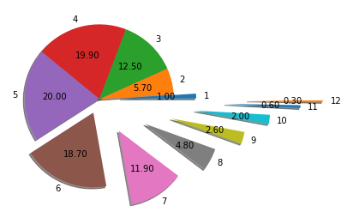
- Random permutation cyclic structure pie chart for dimention 100
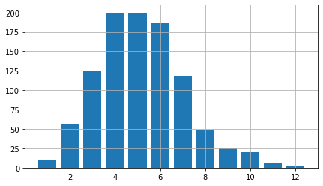
- Random permutation cyclic structure histogram for dimention 100
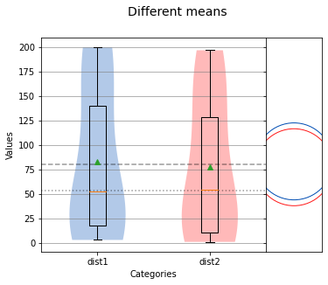
- Box-and-whiskers chart
Consider a set of Stirling numbers for the permutation dimension 100 and a random set of permutations of different cyclic structure, which are solutions of the optimization problems of linear functions as two samples. In this case, it is possible to apply statistical criteria to these two samples and test the equality of variances and the hypothesis whether the empirical distribution is subject to a particular model. This can be done by using the analyze() function from sci-analysis. Sci-analysis is a python package for quickly performing exploratory data analysis. This function implements the Levene test and checks the Kolmogorov-Smirnov agreement criterion for two data sets. As a result of the experiments in this work analyze() function showed zero hypothesis acceptance declaring that the samples are identical and obey one distribution law at the selected reliability level of 0.05 in both cases.
From the visualization of the results of experiments, it can be concluded that even with a significant increase in the dimension of problems, the number of cycles in permutations that are the result of solving the problem of optimizing a linear function almost does not increase. With the dimension of the original problem 10 – the maximum number of cycles in the resulting permutations is 7. When the size of the starting problem increases to 40, the resulting permutations of cyclic structure containing 11 cycles appear. Note that the fraction of such permutations is insignificant and is only 0.1% of all solved problems.
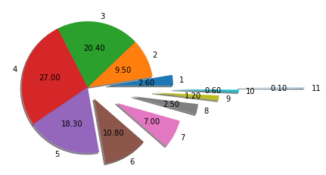
- Random permutation cyclic structure pie chart for dimention 40
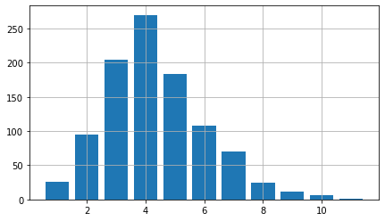
- Random permutation cyclic structure histogram for dimention 40
Further increase in the dimension of the optimization problem of a linear function does not lead to any significant increase in the number of cycles in the cyclic structure of the resulting permutations.
The papers [8-9] describe a strategy called the transposition method. This is a general strategy for obtaining an approximate solution to the problem of minimizing a linear function on a set of cyclic permutations. It is based on the use of a minimum of linear function on permutations set and the subsequent transpositions of a certain type to transform the resulting permutation with arbitrary cyclic structure to the cyclic permutation. A detailed analysis of the application of 1 to 4 transpositions of a certain type for permutation with an arbitrary cyclic structure was implemented.

Conclusion
As a result of this research we can conclude that further study of the influence of special type transpositions on permutations with an arbitrary cyclic structure is important for improving effectiveness of combinatorial optimization methods. It is advisable to study the use of no more than 11 transpositions of adjacency, regardless of the dimension of the original problem.
The results of this work demonstrate the prospects for further use of the transposition method for constructing cyclic permutations. If the objective function of the problem (1) is linear, it is possible to use the transposition method for its solving immediately. With the dimension of the original problem on permutations close to 100, the problem of constructing a cyclic permutation by the transpositions method can be solved as a problem of dimension of less order. This leads to a decrease of dimension of the problem (1) by an order of magnitude when using the transposition method. Cyclic permutations obtained as solutions of the problem (1) can be used for generating cyclic transfers when solving PDP problems to improve heuristic methods of their solving.

References
- R.K. Ahuja, Ö. Ergun, J.B. Orlin and A.P. Punnen, “A survey of very large-scale neighborhood search techniques,” in Discrete Applied Mathematics, vol. 1–3(123), pp.75–102, 2002.
- P.M. Thompson, J.B. Orlin, “The theory of cyclic transfers: working paper,” Massachusetts Institute of Technology, Operations Research Center, 1989.
- P.M. Thompson, H.N. Psaraftis, “Cyclic transfer algorithms for multivehicle routing and scheduling problems,” in Operations Research, vol. 5(41), pp. 935-946, 1993.
- M. Yagiura, Т. Ibaraki, and F.W. Glover, “An ejection chain approach for the generalized assignment problem,” in INFORMS Journal on Computing, vol.2(16), pp. 133-151, 2004.
- C. Rego, T.L. James, F.W. Glover, “An ejection chain algorithm for the quadratic assignment problem,” in Networks, vol. 3(56), pp. 188-206, 2010.
- R.K. Ahuja, J.B. Orlin, D. Sharma, “Multi-exchange neighborhood structures for the capacitated minimum spanning tree,” in Mathematical Programming, vol. 1(91), pp. 71–97, 2001.
- G. Post, S. Ahmadi, F. Geertsema, “Cyclic transfers in school timetabling,” in OR Spectrum, vol. 1(34), pp. 133–154, 2012
- I. V. Grebennik, O. S. Chorna, “Influence of Certain Transpositions on the Cyclic Structure of Permutations,” in Cybernetics and Systems Analysis, vol. 51(6), pp.947–955, 2015.
- I. V. Grebennik, O. S. Chorna, “Special Transpositions of Permutation Elements and Properties of Their Composition,” in Cybernetics and Systems Analysis, vol. 53(1), pp. 67–77, 2017.
- R. Dupas, I. Grebennik, I. Litvinchev, T. Romanova, O. Chorna, “Solution strategy for one-to-one pickup and delivery problem using the cyclic transfer approach,” in EAI Endorsed Transactions on Energy Web, vol. 20 (27), pp. 1–9, 2020.
- R. Dupas, I. Grebennik, O. Lytvynenko, O. Baranov, “An Heuristic Approach to Solving the one-to-one Pickup and Delivery Problem with Three-dimensional Loading Constraints,” in International Journal of Information Technology and Computer Science Information Technology and Computer Science(IJITCS), vol. 10(9), pp. 1–12, 2017.
- M. Bona, “Combinatorics of permutations,” Chapman & Hall/CRC, 2004.
- R.P. Stanley, “Enumerative combinatorics,” Cambridge: Cambridge University Press, 1999.
- A.N. Isachenko, Y.A. Isachenko, “Polyhedral aspects of the optimization problem on cyclic permutations,” Problems of theoretical cybernetics. Proceedings of the XVI International Conference, pp. 187-190, 2011.
- Ch.A. Charalambides, “Enumerative combinatorics,” Chapman and Hall/CRC, 2002.
- S. Elizalde, J.M. Troyka, “Exact and asymptotic enumeration of cyclic permutations according to descent set,” in Journal of Combinatorial Theory, vol. 165(А), pp. 360–391, 2019.
- C. Gravel, D. Panario, D. Thomson , “Unicyclic strong permutations,” in Cryptography and Communications, vol. 6(11), pp. 1211–1231, 2019.
- T. Isdrailă, C. Kusko, R. Ionicioiu, “Cyclic permutations for qudits in d dimensions,” in Scientific Reports, vol. 6337, 2019.
- M.A. Alekseyev, P.A. Pevzner , “Multi-break rearrangements and chromosomal evolution,” in Theoretical Computer Science, vol. 395(2-3), pp. 193– 202, 2008.
- Yu.G. Stoyan, S.V. Yakovlev, “Properties of convex functions on permutation polyhedron,” Reports of the Academy of Sciences of Ukraine, vol. 3 (A), pp.238–240, 1988.

