ANALYSIS OF AERODYNAMIC SIMULATION OF AIR FLOW MODES WITH NASAL BREATHING DISORDERS
Ibrahim Younouss Abdelhamid
Scientific Supervisor –Dr. Techn.Sc., prof. Avrunin O.G.,
KharkivNationalUniversity of Radio Electronics
(61166, Kharkiv, 14 Nauka Ave., Dept. BME, Tel. (057) 702-13-64)
E-Mails: ibrahim.younouss.abdelhamid@nure.ua, me9edo@gmail.com

The pathologies of the upper respiratory tract (with the exception of foreign bodies and neoplasm’s) curvature of the nasal septum, chronic rhinosinusitis and adenoid vegetations. To determine the mode of air flow in the nasal cavity, it is necessary to construct sections of the nasal canal perpendicular to the movement of air, determine their areas and wetted perimeters as well as understanding of the anatomical structures. Objective information about the physiological processes occurring in the nasal airways allows us to select a suitable treatment strategy based on functional information.

For a good study and understanding of the nasal aerodynamics with typical nasal breathing disorders, the air passageway as well as an appropriate contact of the air flux with the mucous membrane is important. Under normal conditions the healthy nasal anatomy forms special aerodynamic elements that control the air flux by way that all respiratory functions can be fulfilled adequately [1]. It is thus interesting to study the most important aerodynamic processes occurring in the nasal airway specifically with breathing disorders, and to identify the most important respiratory functions of the upper respiratory system [2].
The curvature of the nasal septum is the deviation of the septum into both or one side of the midline (see Fig. 1, b, e, h). It is manifested by difficulty or lack of nasal breathing through one or both halves of the nose. Minor curvatures of the nasal septum, which do not cause any symptoms, occur in more than 90% of the population. The main types of curvature of the nasal septum are:
- Physiological - is associated with heredity or is a consequence of improper development of the facial skeleton due to a discrepancy in the growth rate of cartilage and bone tissue;
- Compensatory - result of influence of any irritating factors, for example, polyps, foreign bodies;
- Traumatic - the result of a dislocation or fracture of the nose.
Chronic rhinosinusitis is a long (at least 3-4 weeks) inflammation of the mucous membrane of the nasal cavity, passing to the nasal mucosa and causing severe edema of the tissues (see Fig 1, c, f and i). As shown in Fig 1, a), d), g) - schematic illustration and computer tomograms in the frontal and axial projections are respectively normal; b), e), h) is a schematic illustration and computer tomograms in the frontal and axial projections, respectively, with the distortion of the nasal septum to the right; c), f), i) - schematic illustration and computer tomograms in the frontal and axial projections, respectively, in chronic rhinosinusitis (Cx - middle line, SR, SL - denotes the plan of the right and left nasal passages respectively).

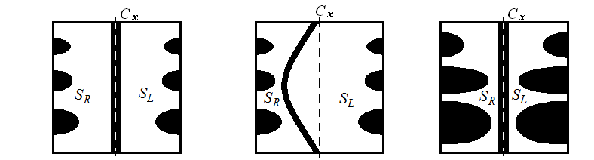
а) b) c)
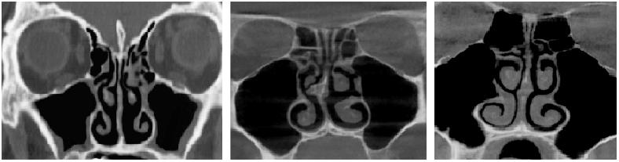
d) e) f)
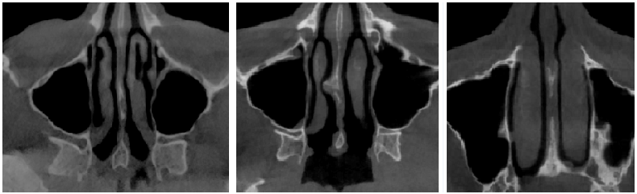
g) h) i)

Figure 1 – Nasal cavity, normal and with typical chronic diseases

Changes in the architectonics of the nasal cavity lead to a disruption in the aerodynamics of the nose, making it difficult to remove secretions from the paranasal sinuses, which leads to an increased propensity to develop inflammatory and allergic diseases of the upper respiratory tract

References:
1. Mlynski G, Gruetzenmacher S, Lang C, Mlynski B (2000) Aerodynamik der Nase. Physiologie and Pathophysiologie. HNO Praxis Heute 20:61–81 c.
2. A.K. Al_Omari, H.F. Ismail Saied, and O.G. Avrunin, “Analysis of Changes of the Hydraulic Diameter and Deter-mination of the Air Flow Modes in the Nasal Cavity,” Image Processing & Communications, challenges3, AISC 102. Springer - Verlag Berlin Heidelberg.-2011: P. 303-310.

