Mafamane Mariem, Student of group BEBMI-17-2
Avrunin O. G., Dr.Tech.Sc., Prof.
Tymkovych M.Y. PhD.
Kharkiv National University of Radio Electronics

PATIENT-SPECIFIC METHODS OF DESIGNING FOR NASAL PROSTHETICS

Patients with congenital malformations, traumatic or pathological mutilation and nasal defects developmental disorders can be restored aesthetically and emotionally by the production and use of facial prostheses. The aim of this study was to review the literature about the retention and processing methods of nasal prostheses and discuss their characteristics. From adhesives to the placement of implants, and different processing methods such as imaging techniques, rapid prototyping technologies have been reported. There are advantages and disadvantages of each procedure, and none can be classified as better compared to others.
Nasal defects are one of the most common examples of human facial injuries. Restoration of these part of human body is the very important task in World, and in Ukraine, especially with the conflict in the Eastern part of Ukraine (pilots including). Most cases concerns accidents, birth-problems, war conflicts etc. All of them lead to the low self-esteem, difficulties in integration to the society, especially for kids, and worsening quality of life [1]. Plastic restoration of nasal part of a human face is a complex process with the need to be analyzed and improved.
To create patient-specific implant we should use some medical imaging techniques, which represent anatomical structures. The implant design techniques are based on a patient's medical data especially imaging data (fig. 1) such as X-Ray, CT, MRI, laser scanning, etc [3].
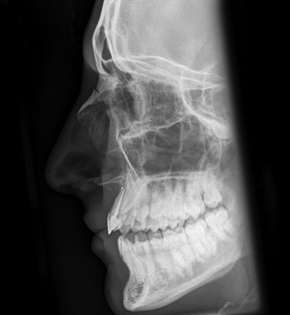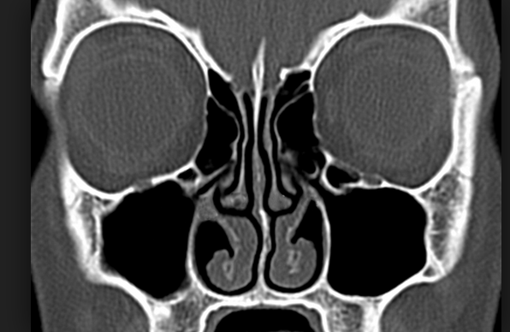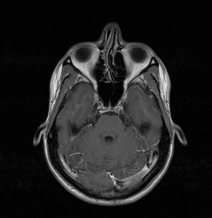
a b c
Figure 1 – Medical imaging techniques

During the review of medical visualization methods, we compare methods using three main parameters: the level of radiation dose, possibility to give 3d information of human body and possibility to visualize internal structures (table 1).
Table 1 – Imaging techniques comparison
Method | Irradiation dose | Store 3d information | Can display internal structures
X-ray | Yes | Yes | Yes
CT | Yes | Yes | Yes
MRI | No | Yes | Yes
Laser scanning | No | No | Not

Based on that we can conclude that the choice of methods must be specified for each patient case. By the way, X-ray cannot help us to create a 3d model of prosthetics and at the same time, X-ray had big irradiation of patient. Meanwhile, Laser scanning can be used to reconstruct external fine details and for the internal structure we use MRI and CT. That led us to the idea of using multiple techniques for design of medical implants.
By using this data we can create the 3D design with the help of specific software. Currently most commonly used 3D Slicer, which can generate STL model based on hand selection tool or other segmentation methods. STL model is widely used file format which can allow connecting general software with the software of 3d printer [4].
3D Printing is the technique used to manufacture a variety of medical devices, including those with complex anatomical structures. Benefits of using 3D printing are the following: shorter production time and less costly (for single copies). To produce implant most important part is material because choosing the right polymer is critical to get the right properties for a 3D printed part, especially if the part has a functional use [5].
Finally, based on this thesis the implantation method might serve to help people to have a normal life, it increased implant stability due to the imaging techniques. For that, we can combine the imaging techniques to have a perfect final result. To do that we should improve software for designing of the patient-specific implants.
References:
1.Chang T.-L. Treatment satisfaction with facial prostheses / T.-L. Chang, N. Garret, E. Roumanas, J. Beumer // The Journal of Prosthetic Dentistry. – 2005. – Vol.94 (3). – P. 275-280.
2. Li A.-Q. Anatomy of the Nasal Cartilages of the Unilateral Complete Cleft Lip Nose / A.-Q. Li, Y.-G. Sun, G.-H. Wang, Z.-K. Zhong, C. Cutting // Plastic and Reconstructive Surgery. – 2002. – Vol.109 (6). – P.1835-1838.
3. Els H. Comparison of X-ray CT and MRI of watercore disorder of different apple cultivars / H. Els, M. Angela – 2014 – vol.87 – P .42-50 .
4. Cercos-Pita J.L. I.R.C // Computer physics communications . – 2018. – vol 223. – P 55-68.
5.Unkovskiy A. Direct 3D printing of silicone facial prostheses: A preliminary experience in digital workflow / A. Unkovskiy, S. Sebastian, B. Joern, H. Fabian, K. Constanze // The Journal of Prosthetic Dentistry. – 2018. – vol. 199. – P 58-69.

